Source-Grouped Evaluation of Temporal Stacking for Seismic Phase Picking with Three-Component Data
Rahmat Catur Wibowo¹*, Razki Alfatah Khairu Mahli², Karyanto³, Hendra Amijaya⁴, Aristoteles⁵, Maman Hermana⁶, Muh Sarkowi⁷
¹ Geological Engineering Department, Engineering Faculty, Universitas Lampung, Jl. Prof. Dr. Soemantri Brojonegoro No. 1, Bandar Lampung 35145, Indonesia; ORCID: 0000-0003-2754-1803
² Geophysics Engineering Department, Engineering Faculty, Universitas Lampung, Jl. Prof. Dr. Soemantri Brojonegoro No. 1, Bandar Lampung 35145, Indonesia; ORCID: 0009-0008-9676-7842
³ Geophysics Engineering Department, Engineering Faculty, Universitas Lampung, Jl. Prof. Dr. Soemantri Brojonegoro No. 1, Bandar Lampung 35145, Indonesia; ORCID: 0000-0003-0189-4109
⁴ Geological Engineering Department, Engineering Faculty, Universitas Gadjah Mada, Jl. Grafika No. 2, Yogyakarta 55284, Indonesia; ORCID: 0000-0002-9602-2903
⁵ Computer Science Department, Mathematics and Natural Science Faculty, Universitas Lampung, Jl. Prof. Dr. Soemantri Brojonegoro No. 1, Bandar Lampung 35145, Indonesia; ORCID: 0000-0002-9369-4528
⁶ Geosciences Department, Universiti Teknologi Petronas, Bandar Seri Iskandar, 32610 Perak, Malaysia; ORCID: 0000-0002-0205-4446
⁷ Geophysics Engineering Department, Engineering Faculty, Universitas Lampung, Jl. Prof. Dr. Soemantri Brojonegoro No. 1, Bandar Lampung 35145, Indonesia; ORCID: 0000-0001-8554-3407
*Corresponding author: rahmat.caturwibowo@eng.unila.ac.id

Abstract
Source overlap can compromise evaluation of seismic phase pickers and stacked models. We evaluate a source-grouped temporal stacking workflow combining STA/LTA, AIC, CNN, and TCN outputs with waveform context. A curated STEAD subset contains 2,234 records from 2,114 sources; 335 test records represent 317 sources excluded from fitting and validation. Source-grouped out-of-fold predictions supply meta-training features. On one fixed split, three base seeds crossed with three meta seeds yielded Full3C mean F1 at ±100 ms of 0.8694 for P and 0.5780 for S, versus 0.8723 and 0.3384 for Z-only. The S difference was 0.2396, with a conditional paired source-cluster 95% interval of 0.1874–0.2905; the P interval included zero. A PhaseNet-style MATLAB baseline trained from scratch on the same records achieved Full3C P/S F1 of 0.9661/0.6267 and Z-only F1 of 0.9637/0.3689 across three seeds. The Full3C baseline advantage was supported by conditional intervals for both phases; the Z-only S interval included zero. Original ablations did not establish a dilation benefit. The principal contribution is an inspectable evaluation workflow and evidence of a component-access difference, rather than superior stacking performance. Seed repetitions condition on one curated source split; station, regional, and dataset generalization remain untested.
Keywords: seismic phase picking; meta-learning; ensemble learning; data leakage; seismology; STEAD

1. Introduction
Accurate P- and S-wave arrival times support earthquake location and subsurface analysis. Classical onset detectors use energy changes or change-point criteria (Allen, 1978; Baer and Kradolfer, 1987; Maeda, 1985; Sleeman and van Eck, 1999). Recent characteristic-function methods combine adaptive signal representations with STA/LTA and AIC for automatic P-wave arrival estimation (Cheng et al., 2024). Neural pickers learn probability sequences from waveforms (Zhu and Beroza, 2019; Mousavi et al., 2020). Performance depends on data distribution and evaluation protocol, motivating reproducible benchmarks and shared software (Münchmeyer et al., 2022; Woollam et al., 2022).
Stacked generalization trains a second-level learner from base-model predictions (Wolpert, 1992). Temporal stacking retains probability sequences rather than reducing each picker to one arrival or one scalar score. These sequences expose disagreement in timing and confidence to a trainable fusion model. They also create a validation dependency: a meta-learner trained on predictions from bases fitted to the same examples receives a different input distribution from that encountered on unseen sources. Grouping the outer test partition alone does not resolve this dependency if observations of the same earthquake enter different inner folds.
The computational problem addressed here is maintaining source identity through a two-level temporal pipeline, including augmentation, fold-specific fitting, early stopping, feature assembly, and evaluation. We implement source-grouped out-of-fold (OOF) construction with separate inner validation for each held fold, a canonical 15-channel interface, source-membership assertions, and input/output provenance. This makes the relationship between training records and derived predictions inspectable. The final base and meta stages reuse the outer validation population for checkpoint selection, which is documented explicitly; the workflow does not claim complete independence between all model-selection stages.
Existing neural pickers and shared benchmark tools provide important reference points (Zhu and Beroza, 2019; Mousavi et al., 2020; Münchmeyer et al., 2022; Woollam et al., 2022). Their relevance here is that architecture comparisons require identifiable data access, consistent output interpretation, and reproducible evaluation. We do not infer leakage in any cited study from its headline performance. Instead, the present experiment fixes its own population and scoring rules and exposes the dependencies introduced by stacking. Source grouping addresses repeated observations of an earthquake; it does not remove station or regional dependence.
Recent work extends phase picking through complementary input representations. TwoStream-EQT combines time-domain and time-frequency features and evaluates feature-fusion strategies using STEAD, DiTing, and Geysers data (Peng et al., 2025). SeismoDual integrates waveforms and spectrograms for P-phase picking and reports evaluation across STEAD, INSTANCE, and CWA datasets (Tang and Chen, 2026). These studies motivate examining how information is combined and where performance is evaluated. Here, fusion operates on the temporal probability outputs of heterogeneous pickers together with waveform context. We focus on source-grouped OOF membership and evaluation provenance throughout this two-level construction; the comparison does not establish that the cited approaches lack equivalent controls.
A useful fusion study must establish whether the additional model improves performance relative to a strong standalone picker. We compare individual bases, fixed ensembles, temporal stackers, and a PhaseNet-style MATLAB baseline trained from scratch under matched data-access and decoding rules. We also separate component removal across the full pipeline from removal of only the final waveform-context channels. The contribution is an explicit evaluation implementation and a component comparison; the additional baseline outperforms the stacker on average, and universally superior fusion is not claimed.
The geoscientific question is how access to horizontal information affects P- and S-arrival timing for unseen earthquake sources within the curated population. Full3C and Z-only use identical records, source assignments, labels, and evaluation rules, but each mode fits its own bases and meta-learners. Figure 1 summarizes the workflow. Standalone and ablation comparisons identify which observed differences support component access and which remain unresolved at the fusion-architecture level.
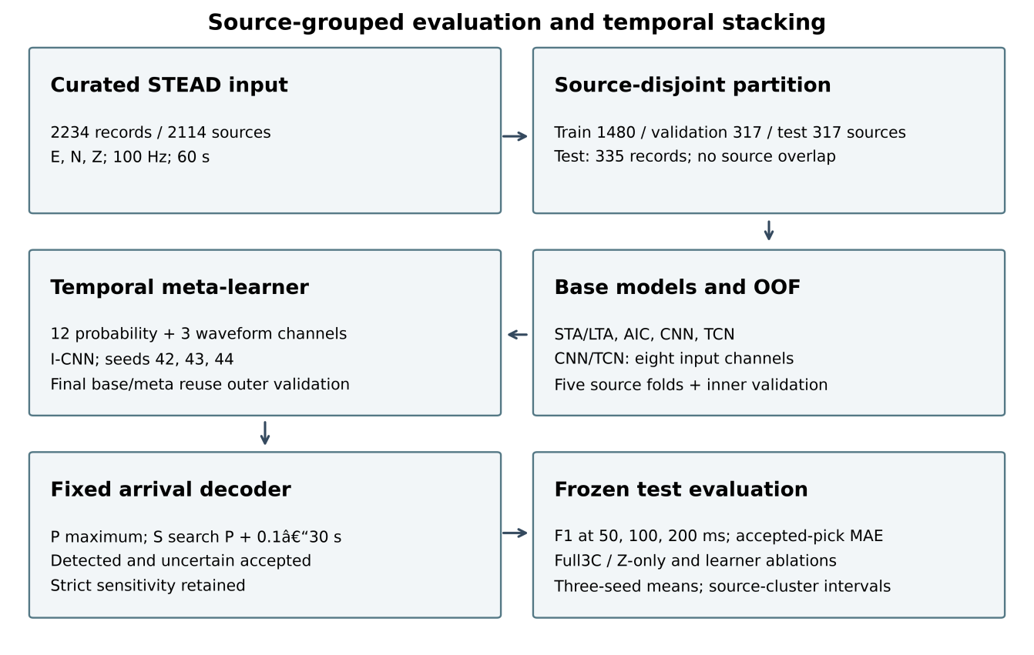
Fig. 1. Source-grouped evaluation workflow: curation, outer partitioning, OOF feature generation, canonical temporal inputs, I-CNN fusion, deterministic phase-ordering constraints, and held-out evaluation. Outer validation selects final base and meta checkpoints; it is reused across these levels. The diagram was drawn programmatically with scripting assistance from ChatGPT/Codex (OpenAI; accessed September 2026) and checked against the implemented workflow by the authors.

2. Data and dataset curation

2.1. Source dataset
We used the STanford EArthquake Dataset (STEAD; Mousavi et al., 2019). Metadata filters retained local earthquakes with epicentral distance ≤15 km, magnitude ≥1.5, minimum component SNR ≥10 dB, and manual P and S arrivals. The final matched population contains 2,234 records from 2,114 sources (Fig. 2; Table 1). It is a curated high-SNR subset, not a representative global or continuous-monitoring sample.

2.2. Waveform representation and record format
Each event–station observation contains 6000 samples at 100 Hz (60 s), with ordered E, N, and Z components and reference arrivals in seconds. The waveform representation is given in equation 1; equation 2 converts an arrival time to a zero-based sample index.
$X_{i}=\left[\begin{matrix}E_{i}(t_{1}) & N_{i}(t_{1}) & Z_{i}(t_{1}) \\ E_{i}(t_{2}) & N_{i}(t_{2}) & Z_{i}(t_{2}) \\ ⋮ & ⋮ & ⋮ \\ E_{i}(t_{6000}) & N_{i}(t_{6000}) & Z_{i}(t_{6000})\end{matrix}\right]$ (1)
where $X_{i}∈ℝ^{6000×3}$ is the three-component waveform for record $i$. The associated ground-truth arrival times are denoted by $t_{i}^{P}$ and $t_{i}^{S}$. Sample indices were derived only when required by the processing functions (equation 2):
$n_{i}^{P}=round\left(t_{i}^{P} f_{s}\right), n_{i}^{S}=round\left(t_{i}^{S} f_{s}\right)$ (2)
Here fs = 100 Hz. A zero-based sample n maps to MATLAB array index n+1; an array index j maps back to time (j−1)/fs. CSV arrival times in seconds remain authoritative, and evaluation does not replace them with rounded metadata indices.
CSV arrival times were authoritative for evaluation; original STEAD source_id values defined grouping. Record identifiers link each waveform to metadata and prediction rows. Keeping record and source identity separate prevents multiple stations observing one earthquake from being mistaken for independent sources.

2.3. Metadata integration and identifier recovery
Metadata were matched to available waveform CSVs by record identity; unmatched candidates were not added to the evaluated population. The retained metadata table records source identity, receiver, magnitude, distance, SNR, arrivals, sampling, and quality flags. Fixed source lists and file hashes identify the computational inputs.
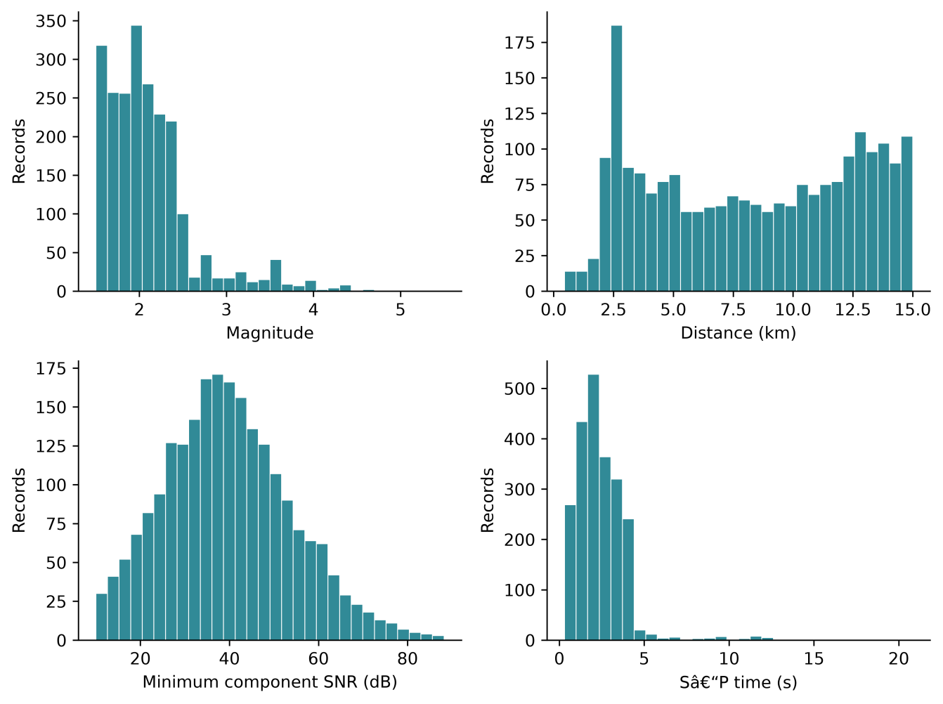
Fig. 2. Characteristics of the curated STEAD-derived dataset (N=2234 records): magnitude, epicentral distance, minimum component SNR, and S–P time. Each histogram uses 30 bins.
Table 1. Summary statistics of the curated STEAD-derived dataset used in this study.
Item | Value
Records | 2234
Sources | 2114
Sampling rate | 100 Hz
Duration | 60 s
Components | E, N, Z
Minimum component SNR | ≥10 dB

2.4. Waveform quality control
Quality checks covered record length, monotonic time, 0.01 s sampling, finite amplitudes, component variance, clipping-like behavior, and in-window ordered P/S arrivals. Record-level flags retain reasons for rejection. The final run loaded all 2,234 matched records without read failures; upstream metadata screening was not repeated during evaluation.

2.5. Signal conditioning
Conditioning removes the component mean, detrends linearly, and applies a 1–45 Hz Butterworth band-pass filter using MATLAB butter with order argument 4 followed by filtfilt. Each component is normalized as (x−mean(x))/(std(x)+10⁻¹⁰), so an all-zero component remains zero. Explicit clipping was disabled. The same deterministic transforms were used in all subsets (equation 3). Supplementary Implementation Details specify the enhanced features and edge handling.
For an input component $x_{c}(t)$, where $c∈\{E,N,Z\}$, the conditioning operation can be summarized as (equation 3):
${\tilde{x}}_{c}(t)=N\left\{ℬ_{1\text{–}45\text{Hz}}\left[D\left(x_{c}(t)−{\overset{‾}{x}}_{c}\right)\right]\right\}$ (3)
where $D$ denotes detrending, $ℬ_{1\text{–}45\text{Hz}}$ denotes band-pass filtering, and $N$ denotes component normalization. The same deterministic conditioning parameters were applied to training, validation, and test records. Data augmentation was not part of dataset curation and was applied only after splitting, exclusively to training data.
Base CNN/TCN inputs contain eight channels: conditioned E/N/Z, their three envelopes, short-term Z energy, and a Z characteristic function. The final three waveform-context channels of the meta tensor retain conditioned E/N/Z; they are distinct from the eight-channel base representation.

2.6. Ground-truth label construction
Manual arrivals were converted to Gaussian phase targets (equation 4), following probabilistic sequence-labelling practice (Zhu and Beroza, 2019; Mousavi et al., 2020).
For phase $k∈P,S$, the target at time $t$ was defined as (equation 4):
$y_{k}\left(t\right)=\exp\left[−\frac{{\left(t−t_{k}\right)}^{2}}{2σ_{k}^{2}}\right],$ (4)
Targets were truncated at ±4 standard deviations, with P/S widths of 0.06/0.08 s. The noise target is max(0, 1−max(yP,yS)); targets are not additionally normalized to sum to one where phase tails overlap (Fig. 3). Neural predictions, in contrast, use softmax. Target mass is 1+min(yP,yS). Overlapping masks occur in only 2 training, 2 validation, and 1 test records (Supplementary Table S14). The implemented loss and its local weighting interpretation are given in Supplementary Implementation Details.
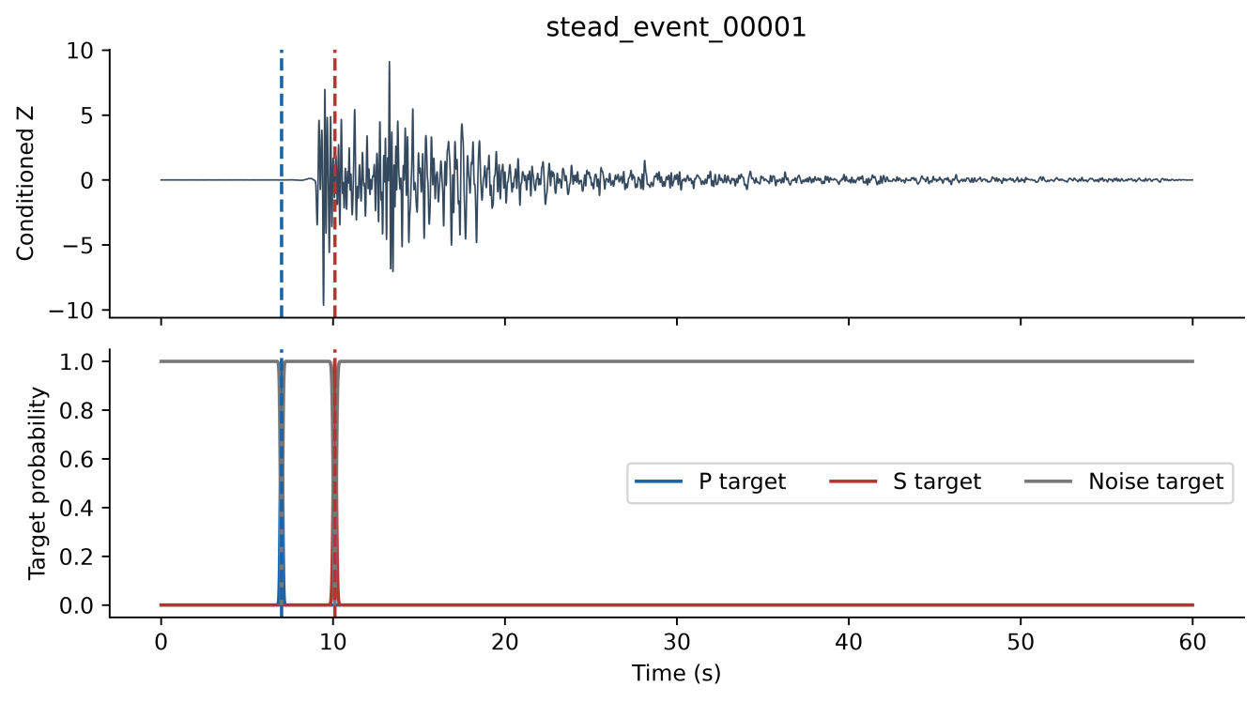
Fig. 3. Gaussian probability label formulation. (a) Vertical (Z) seismic component with true P- and S-wave arrival markers. (b) Gaussian probability masks used as training targets for the I-CNN meta-learner. The P-wave mask (blue) and S-wave mask (red) are centred on their respective true arrival times with standard deviations σP and σS (in samples). The noise/background mask (grey) equals max(0, 1−max(yP,yS)), the continuous complement of the larger phase mask.

2.7. Source-level partitioning
Source_id lists allocate 70%, 15%, and 15% of unique sources to training, validation, and test. All records of one earthquake stay together (Table 2). The test set contains 335 records from 317 sources, including 18 sources with two records each. Pairwise source intersections are zero; station or regional overlap was not excluded. Subset distributions are shown in Supplementary Fig. S2.
The test metadata identify 37 network–receiver keys across 13 network codes; 30 keys also occur in training. PB and HV account for 285 of 335 test records (85.1%). Codes were parsed from trace identifiers and combined with receiver_code; they are not geographic coordinates or verified station epochs. The curated metadata lack coordinates, so geographic or tectonic coverage is not inferred (Supplementary Table S12).
Table 2. Source-level partitioning of the final curated dataset showing the number of unique earthquake sources and waveform records in each subset.
Subset | Sources | Records
Training | 1480 | 1556
Validation | 317 | 343
Test | 317 | 335
Total | 2114 | 2234

2.8. Leakage controls after dataset partitioning
Augmentation was restricted to training records: one augmented copy per original used additive noise at 20 dB target SNR, amplitude scaling in [0.5, 2.0], and horizontal-channel dropout with probability 0.20 (E, N, or both). Time shifting and polarity reversal were disabled. Validation and test records were not augmented. Source assignments were preserved throughout processing.

3. Methodology
Experiments used MATLAB R2024a with fixed source partitions. The original 40-fit experiment used CNN/TCN base seed 42 and meta seeds 42, 43, and 44. An additional 66 fits repeated the complete base/OOF/meta workflow with base seeds 43 and 44 and trained six standalone PhaseNet-style baselines. Each base seed was crossed with all three meta seeds in both modes. OOF fold seed 42, inner split seeds 101–105, fold augmentation seeds 1001–1005, and final/OOF augmentation seed 4242 remained fixed. Thus initialization and training-order variability is examined conditional on the same partition and augmentation protocol; meta fits sharing a base are not independent full-pipeline replicates.
Conditioning follows equation 3. STA/LTA and AIC supply deterministic probability-like scores rather than calibrated class probabilities (Allen, 1978; Maeda, 1985). Gaussian curves are centred on the global normalized STA/LTA peak or the AIC minimum. P uses Z; S uses the E/N resultant only when both horizontal components are nonzero, otherwise it falls back to Z. The AIC centre search is restricted to the first 10 s. Supplementary Implementation Details give the exact windows, normalization, fallback, and score construction. Learned bases emit P/S/noise softmax probabilities (equation 5).
The CNN has two convolutional blocks with 32/64 filters, kernel 7, batch normalization, ReLU, and dropout 0.30; its receptive field is 13 samples. TCN has four 32-filter blocks with kernel 3, dilations 1/2/4/8, dropout 0.20, and no residual connections; its receptive field is 31 samples (Bai et al., 2018). Both process the eight-channel representation at 100 Hz and finish with a 1×1 convolution and softmax. Base training used Adam at 10⁻³, batch size 16, at most 30 epochs, and validation patience of seven evaluations (Table 3).
$P_{P}\left(t\right)+P_{S}\left(t\right)+P_{N}\left(t\right)=1$ (5)
Five source-grouped OOF folds were formed within outer training. For each held fold, the other four were split by source into fitting and inner validation, reserving approximately 15% for checkpoint selection. Held sources entered neither subset. Those fold models supplied OOF features for held originals and their augmented copies. Final bases fitted weights using augmented outer training only; outer validation selected their checkpoints. Final bases then supplied outer-validation and test meta-features. Meta weights fitted OOF training features; the same outer validation selected meta checkpoints. This is adaptive validation reuse across levels, not an independent nested validation estimate. Test sources were excluded from fitting and checkpoint selection. Supplementary Table S8 maps each role.
The meta input is a 6000×15 tensor: twelve P/S/noise channels from four pickers, followed by conditioned E/N/Z (equation 6; Fig. 4). Channel count and order are asserted. Supplementary Table S1 describes all held-out test tensors; Supplementary Fig. S5 illustrates one record.
$X_{\text{meta}}∈ℝ^{6000×15}$ (6)
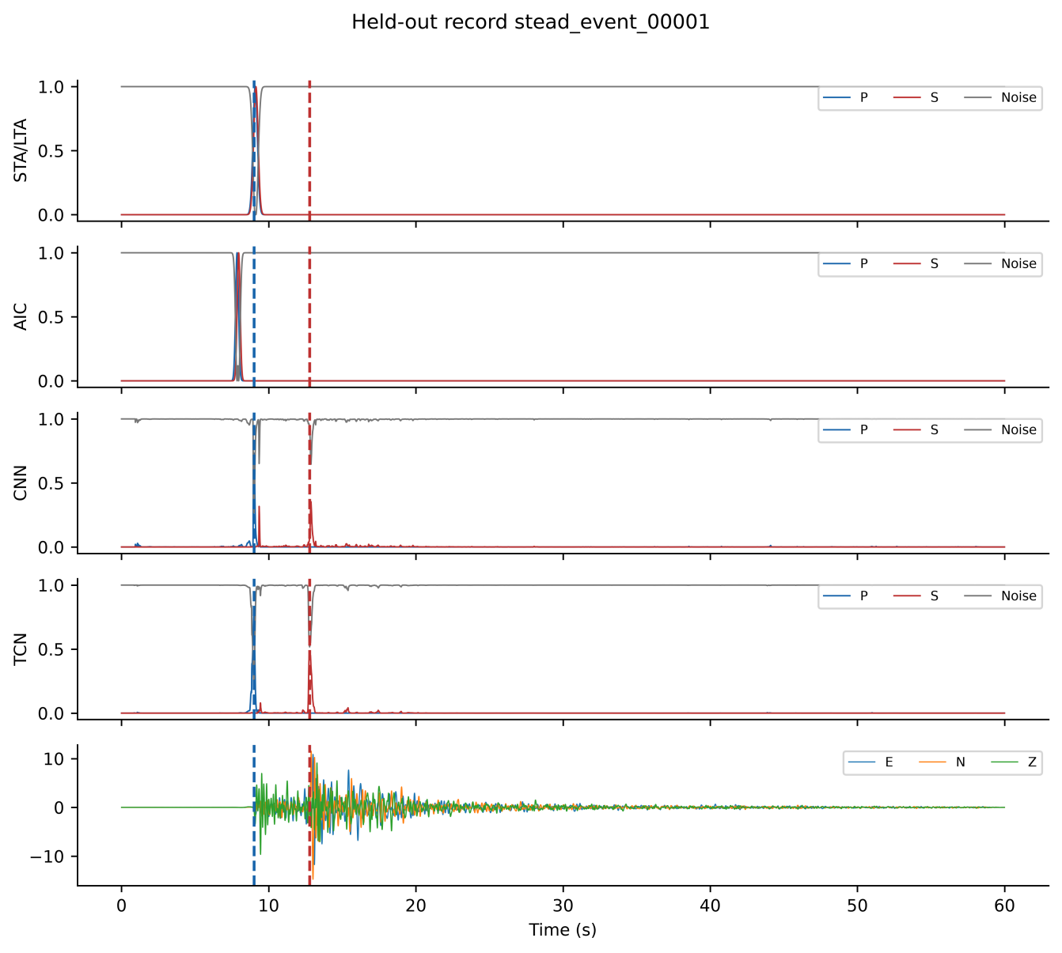
Fig. 4. Final 15-channel tensor for held-out stead_event_00001. Four groups contain P/S/noise from STA/LTA, AIC, CNN, and TCN; the last group contains conditioned E/N/Z. Dashed lines mark true arrivals. These are final-base test features, not OOF training features.
I-CNN has four sequential kernel-5 blocks with filters 64/128/64/64, dilations 1/1/2/4, batch normalization, ReLU, and dropout 0.30. With h0 = Xmeta, equations 7–8 define the blocks and head. Its receptive field is 33 samples (330 ms); architectural capacity alone does not establish an empirical benefit.
For blocks i = 1,…,4, the forward operation is:
$h_{i}= Dropout({ReLU(BN}_{i}(W_{i}∗_{dᵢ}h_{i−1}+b_{i})))$ (7)
Here d = (1,1,2,4), the convolution uses dilation di and same padding, and dropout probability is 0.30 during training only. The 1×1 head returns three probabilities at each time:
$p(t) = softmax(W_{head}h_{4}(t) +b_{head})$ (8)
Let G = {0,0.01,…,59.99} s. The P candidate maximizes pP over G. If it is accepted, the S search domain is restricted relative to that candidate; otherwise the S domain is empty:
$Dₛ = \left\{\begin{aligned}\{t ∈ G : 0.1 ≤ t − t̂ₚ ≤ 30\}, if P is accepted \\ ∅, otherwise\end{aligned}\right.$ (9)
DS is empty when P is not accepted. For each nonempty phase domain Dk, t̂k maximizes pk on Dk. Ties use the earliest sample, matching MATLAB max. The peak-to-mean quality score is computed on that phase domain:
The I-CNN used Adam at 5×10⁻⁴, batch size 16, at most 50 epochs, and weighted cross-entropy with P/S/noise weights 1.5/2.5/0.5. All neural models used L2 = 10⁻⁴, learning-rate halving every 20 epochs, validation once per epoch, and the best-validation-loss checkpoint. Meta patience was ten evaluations. Histories appear in Supplementary Fig. S1. A candidate is detected when peak ≥0.30 and quality ≥3.0, otherwise uncertain when peak ≥0.15, and not detected below 0.15. Primary acceptance includes both detected and uncertain; strict reporting includes detected only.
The quality score and reported S time follow the actual conditional decoder:
$q_{k}=\frac{pₖ(t̂ₖ)}{mean[t ∈ Dₖ] pₖ(t) + 10⁻⁶}$ (10)
DP = G. Report tS = t̂S only when S is accepted; otherwise return NaN. An empty DS returns no S pick. The 0.1–30 s rule enforces bounded S-after-P ordering within the record; it is not a learned physical objective. Detected-only scoring is applied after this decoder, so its S gate still uses primary accepted P. Thresholds are fixed in the archived configuration; no new threshold search was performed for these diagnostics.
Training-only augmentation is specified in Section 2.8 and Table 3. Adam (Kingma and Ba, 2015), batch normalization (Ioffe and Szegedy, 2015), and dropout (Srivastava et al., 2014) were used for neural models. Supplementary Table S4 records the final configuration, including disabled augmentation operations and seed scope. Horizontal dropout is triggered with total probability 0.20 per augmented copy; E-only, N-only, and both are then selected with equal probability. Losing either horizontal component activates the Z fallback in both classical bases.
Table 3. Hyperparameters and configuration settings used for training the CNN, TCN, and I-CNN MetaPicker framework.
Category | Parameter | Final setting
Input | Waveform / base / meta channels | 3 / 8 / 15
Input | Sampling; length | 100 Hz; 6000 samples
Partition | Outer grouping | source_id; 70/15/15%
OOF | Folds / inner validation | 5 / 15% of non-held sources
Conditioning | Band-pass; normalization | 1–45 Hz; per component
Labels | Gaussian P / S widths | 6 / 8 samples; truncation ±4σ
Base CNN | Filters; kernel; dropout | 32,64; 7; 0.30
Base TCN | Filters; kernel; dilation; dropout | 32×4; 3; 1,2,4,8; 0.20
Base training | Adam LR; max epochs | 1×10⁻³; 30
Base training | Batch; validation patience | 16; 7 evaluations
I-CNN | Filters; kernel; dilation | 64,128,64,64; 5; 1,1,2,4
I-CNN | Dropout; P/S/noise weights | 0.30; 1.5/2.5/0.5
Meta training | Adam LR; max epochs | 5×10⁻⁴; 50
Meta training | Batch; validation patience | 16; 10 evaluations
All neural models | LR schedule; L2 | Halve every 20 epochs; 1×10⁻⁴
Training | Output network | Best validation loss
Seeds | Base / neural meta | 42 / 42,43,44
Augmentation | Training population | Original + one augmented copy
Augmentation | Noise; scale; dropout | 20 dB; 0.5–2.0; probability 0.20
Augmentation | Time shift / polarity flip | Disabled / disabled
Decoder | Detected / uncertain | ≥0.30 and quality≥3 / otherwise≥0.15
Decoder | S after accepted P | 0.1–30 s; within record
Evaluation | Primary / strict | Detected+uncertain / detected
Evaluation | Matching tolerances | ±50, ±100, ±200 ms
Uncertainty | Mean-F1 source bootstrap | 10,000 draws; NumPy seed 42
Evaluation used 335 test records from 317 sources and tolerances of ±50, ±100, and ±200 ms. The primary policy accepted finite detected or uncertain picks. Accepted picks within tolerance were true positives; accepted picks outside tolerance contributed both a false positive and a false negative. Missing picks contributed false negatives. Thus FP = Naccepted − TP and FN = N − TP. Detected-only sensitivity and seed-42 confusion counts are reported in Supplementary Tables S10 and S7. The primary policy retains lower-confidence candidates to expose the coverage–timing tradeoff; accepted coverage must not be interpreted as accurate detection.
The conventional F1-score is (equation 11):
$F1=\frac{2TP}{2TP+FP+FN}$ (11)
MAE was calculated over all accepted arrivals, including uncertain picks and errors outside the matching tolerance (equation 12):
$MAE=\frac{1}{N_{d}}\sum_{i=1}^{N_{d}}{\left|t_{i}−{\overset{ˆ}{t}}_{i}\right|,}$ (12)
In equation 12, Nd is the number of accepted finite picks. Accepted coverage Nd/N differs from strict-detected coverage and recall within tolerance. The expanded stacking summary averages the three meta seeds within each base seed, then averages the three base means. Reported between-base SD is the sample SD of those three means, not an SD from nine independent pipelines. Baseline summaries average three independently initialized fits. New paired source-cluster intervals use 10,000 NumPy default_rng draws with seed 42, retaining all records from each of the 317 sampled sources. Each draw recomputes per-fit F1 before averaging; the same source draws are used for both methods or modes. These intervals condition on the fitted models and single split, exclude training and split uncertainty, and are exploratory without family-wise or false-discovery-rate control. Original base-42 summaries retain their explicitly labelled three-meta-seed scope.
For Z-only, E and N were zeroed before preprocessing and again after augmentation. Population, source partitions, labels, channel layout, architecture settings, and evaluation were unchanged; mode-specific bases and meta-learners were fitted. The comparison removes horizontal information throughout the pipeline, rather than masking only waveform-context channels after full-component base inference. All 3,790 available Z-only meta tensors were finite with zero E/N channels; classical P/S score channels were identical under the specified fallback (Supplementary Table S13).
The standalone comparator, termed PhaseNetMatched, is a PhaseNet-style MATLAB adaptation trained from scratch (Zhu and Beroza, 2019; Woollam et al., 2022). It has five encoder levels with 8/16/32/64/128 filters, kernel 7, stride-4 downsampling, batch normalization, ReLU, transposed convolutions, and skip concatenation. MATLAB same padding and centre-cropped skips support 6,000-sample records. Padding, initialization, convolution biases, and batch-normalization defaults differ from the reference implementation. The input is the same conditioned E/N/Z waveform used in meta channels 13–15, without a second normalization; E/N remain zero in Z-only. Labels, augmentation, weighted loss, outer split, validation selection, decoder, and scoring are shared. Adam uses learning rate 5×10⁻⁴, batch size 2, at most 50 epochs, patience 10, L2=10⁻⁴, and learning-rate halving every 20 epochs. Three seeds (42–44) are fitted per mode. Data access is matched; feature inputs, minibatch statistics, and compute budgets are not equivalent. Supplementary Table S18 accounts for all additional fits.
AI-assisted software development and computational workflow. ChatGPT/Codex (OpenAI; accessed September 2026) assisted with software revision and debugging, workflow implementation, computational execution support, and numerical-output checking. Assistance included scripts for generating tables, data plots, and the workflow diagram. Figures were produced programmatically from study data, model outputs, or the documented workflow, without generative-image synthesis. AI tools did not generate seismic observations or reference phase labels. The authors reviewed and verified code changes, executed analyses, numerical results, and interpretations. Verification included source-membership assertions, numerical consistency checks, and comparison of frozen outputs with reported tables. The original public package and accompanying strengthening audit package identify the respective scripts, configurations, predictions, and provenance records.

4. Results and Discussion
The evaluation combines the original 40-fit experiment with 66 additional fits, for 106 training invocations in total. The extension repeats the CNN/TCN/OOF/meta pipeline at two additional base seeds and adds three PhaseNet-style fits per input mode. Tables 4–5 and Figures 5–12 retain the original base-42 experiment and its record-level diagnostics; Tables 6–7 report the expanded experiment. Supplementary Tables S15–S18 document seed-level results, strict scoring, and fit accounting. The extension followed inspection of the original experiment, so it is not an independently preregistered confirmation. Test scores were not used for checkpoint selection.

4.1. Performance of the proposed framework
In the original base-42 experiment, Full3C mean F1 at ±100 ms was 0.8680 ± 0.0170 for P and 0.5737 ± 0.0137 for S across three meta seeds. Mean per-run MAE was 70.00 ± 2.35 ms and 657.29 ± 42.23 ms. Accepted coverage averaged 99.70% and 98.41%; it includes uncertain picks and is not recall within 100 ms. Table 4 and Fig. 5 retain these reference results. The expanded base-seed and baseline comparison is reported in Section 4.4.1.
Table 4. Original base-42 test performance at ±100 ms, mean ± sample SD across three meta seeds on fixed partitions (335 records, 317 sources). MAE includes all accepted picks; coverage includes detected and uncertain picks. Expanded results appear in Table 6.
Mode | Phase | F1 mean ± SD | MAE ms mean ± SD | Accepted coverage %
Full3C | P | 0.8680 ± 0.0170 | 70.00 ± 2.35 | 99.70
Full3C | S | 0.5737 ± 0.0137 | 657.29 ± 42.23 | 98.41
Z-only | P | 0.8664 ± 0.0031 | 95.05 ± 22.38 | 99.60
Z-only | S | 0.3296 ± 0.0056 | 972.50 ± 61.38 | 92.04
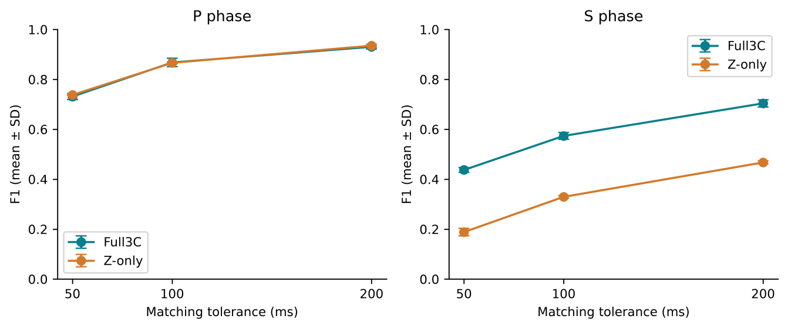
Fig. 5. Original base-42 F1 versus matching tolerance. Points and bars show mean and sample SD across its three meta seeds. Accepted picks include detected and uncertain outputs.
P errors were smaller and F1 higher than S errors and F1. High S accepted coverage coexisted with many picks outside 100 ms: candidate availability is distinct from precise timing. Record-level figures use base seed 42 and meta seed 42; Table 4 averages its three meta seeds. These figures are not summaries of the expanded base-seed experiment.
F1 increased with wider tolerance (Fig. 5 and Supplementary Fig. S3). Fig. 6 presents residual distributions and Fig. 7 compares predicted and true times. Bootstrap intervals and detailed errors appear in Supplementary Tables S2 and S3. Tolerance dependence alone does not establish a causal explanation for phase difficulty.
In the original base-42 experiment, with detected-only scoring, Full3C P/S F1 was 0.8684/0.5773, versus Z-only 0.8673/0.3351; S coverage fell to 94.73% and 75.82%, respectively (Supplementary Table S10). The S difference therefore persists under the stricter reporting mask. P rejection blocked the S search on 1/1/1 Full3C and 1/2/1 Z-only records across seeds 42–44; none had an ungated S pick within 100 ms. This paired diagnostic also changes the S search domain and quality calculation, so it does not isolate a gate-only intervention. Conditional S metrics appear in Supplementary Table S11.
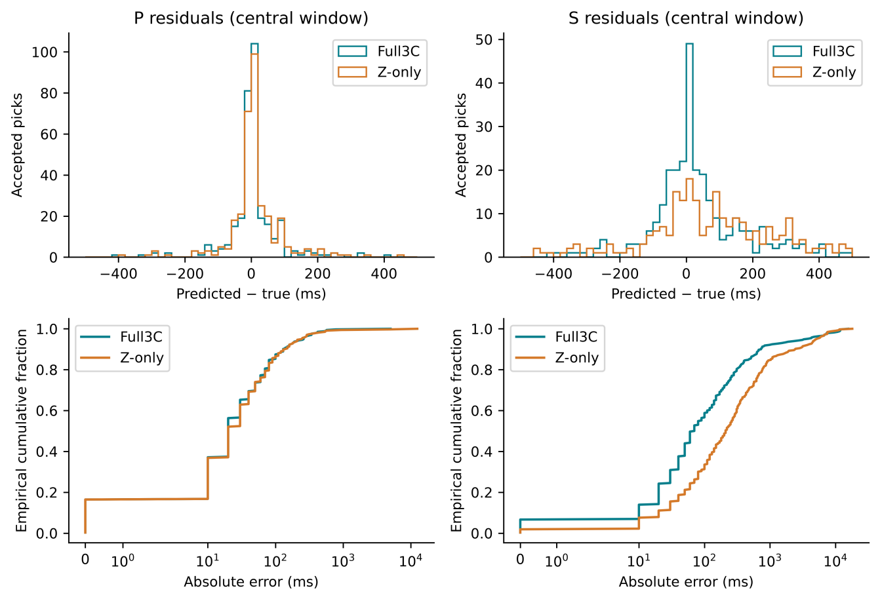
Fig. 6. Base-42/meta-42 accepted residuals. Top: histograms within the central ±500 ms display window. Bottom: full-range cumulative absolute-error distributions on symmetric logarithmic axes. Metrics include errors outside the top display window.
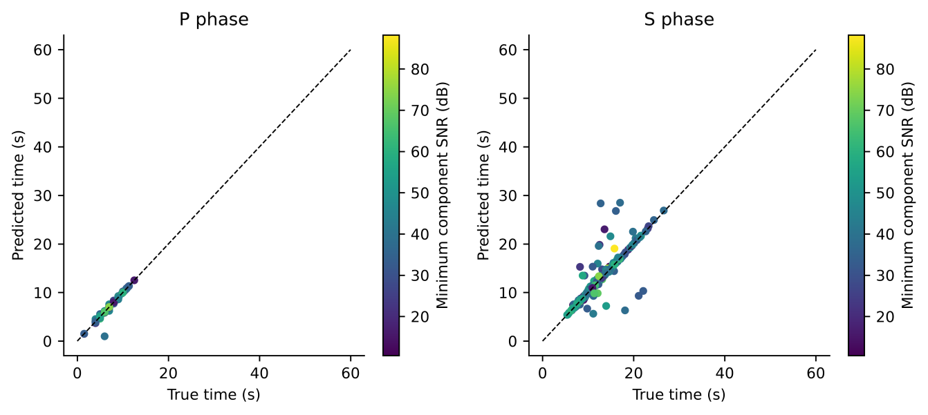
Fig. 7. Base-42/meta-42 Full3C predicted versus true P and S arrival times for accepted picks. Colour denotes minimum component SNR; dashed lines show equality.

4.2. Effect of source-level validation
No earthquake source was shared across training, validation, and test. This evaluates unseen sources in the curated population but not unseen stations or regions. A matched record-random split was not fitted, so no numerical claim of leakage-induced inflation is made.

4.3. Contribution of three-component seismic information
Across the expanded 3×3 base/meta grid, mean P F1@100 ms remained close between modes (0.8694 Full3C versus 0.8723 Z-only), while mean S F1 was 0.5780 versus 0.3384. The Full3C S advantage persisted in all nine matched base/meta combinations. Table 5 retains the original base-42 comparison for continuity; Table 7 reports the expanded conditional intervals.
Table 5. Original base-42 Full3C minus Z-only at ±100 ms. F1 values average three meta seeds; paired percentile 95% source-cluster intervals use 10,000 draws and condition on those fitted models and the single partition. See Table 7 for the expanded comparison.
Phase | Full3C F1 | Z-only F1 | ΔF1 | 95% CI for Δ | Relative change %
P | 0.8680 | 0.8664 | +0.0016 | [-0.0141, 0.0172] | +0.18
S | 0.5737 | 0.3296 | +0.2441 | [0.1892, 0.2979] | +74.08
The component-access difference is consistent with horizontal motion contributing useful shear-wave information and persists across the three tested base seeds. It also includes changes to the classical-base fallback and separately fitted learned bases, so it does not isolate any individual channel. Source-split, station, and regional stability remain untested.
For the expanded stacking average, the paired 95% interval for Full3C minus Z-only F1@100 ms was −0.0135 to 0.0076 for P and 0.1874 to 0.2905 for S. The former does not establish equivalence; the latter supports an S advantage conditional on the fitted models and test sources. The PhaseNet-style baseline also showed an S component-access difference (0.2578; interval 0.2094–0.3057), indicating that this observation is not unique to temporal stacking.
Figures 8 and 9 describe residuals versus metadata attributes and SNR-stratified performance. These analyses did not drive model selection and do not establish causal relationships or controlled noise robustness.
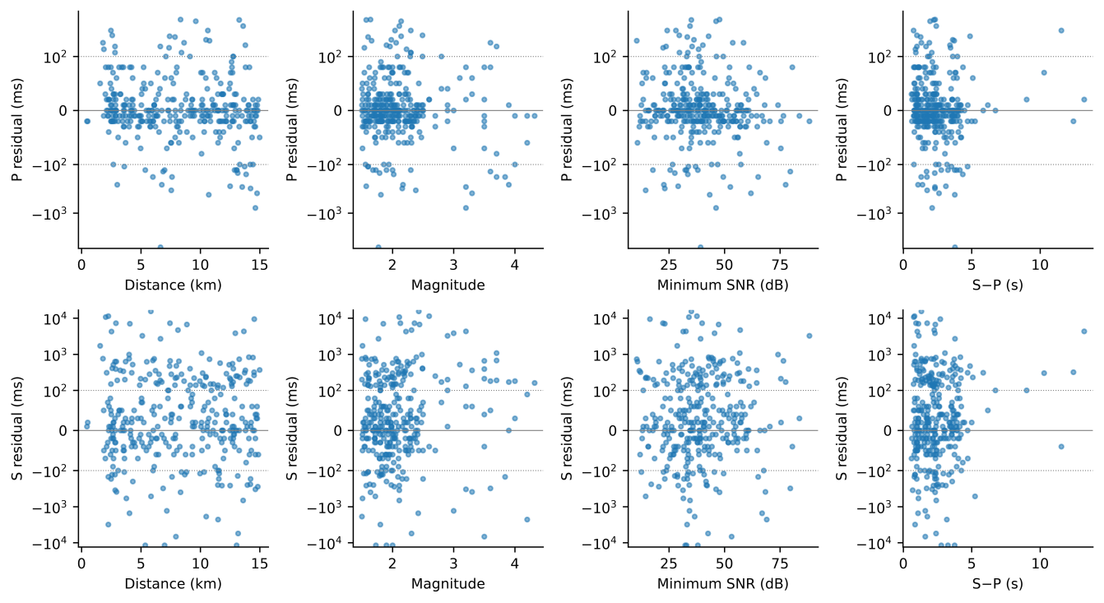
Fig. 8. Base-42/meta-42 Full3C residuals versus distance, magnitude, minimum component SNR, and S–P time. Rows show P and S. Symmetric logarithmic axes retain large errors; dotted lines mark ±100 ms. Plots are descriptive.
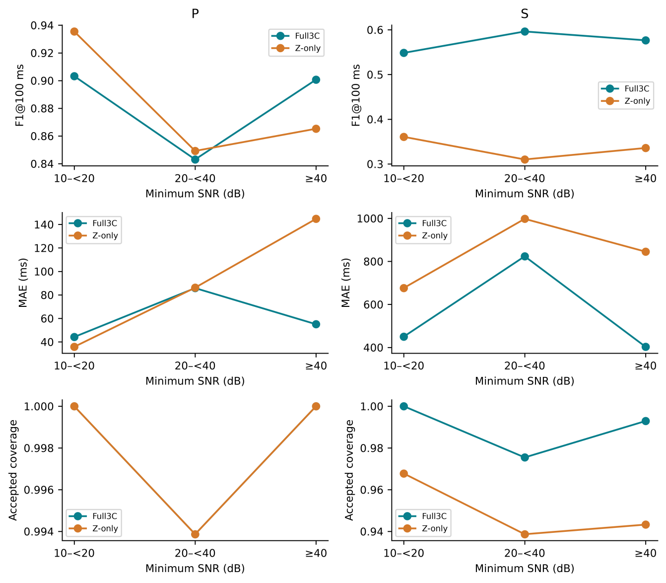
Fig. 9. Base-42/meta-42 performance by minimum component SNR: 10–<20, 20–<40, and ≥40 dB. Rows show F1@100 ms, accepted-pick MAE, and accepted coverage. Bins were not used for model selection.

4.4. Temporal meta-learning and heterogeneous fusion
Within the original base-42 comparator set, TCN P/S F1@100 ms was 0.8606/0.5568 versus I-CNN means 0.8680/0.5737 (Supplementary Table S5). The S difference of 0.0169 had an exploratory paired 95% interval of −0.0126 to 0.0475. S F1 was 0.1982 for mean averaging and 0.5223 for validation-weighted averaging. Weights were normalized phase-specific validation F1@100 ms, fixed before test evaluation. TCN is the strongest of the original four bases, but it is not the strongest standalone method in the expanded study.
In the original base-42 experiment, full 15-channel, probability-only 12-channel, waveform-only 3-channel, and no-dilation meta-learners used seeds 42–44 with shared OOF inputs within Full3C. Supplementary Table S6 reports mean ± sample SD and paired source-cluster intervals. Seeds vary the meta-learner only; SD is descriptive, not a two-SD significance threshold. Multiple ablation intervals are exploratory.
Probability-only mean P/S F1@100 ms was 0.8653/0.5675, close to full; absence of clear separation does not prove equivalence. It removes three waveform channels but retains all twelve base-picker outputs. Waveform-only achieved 0.8315/0.5449 and no-dilation 0.8670/0.5768. One logistic stacker achieved 0.8469/0.5379, with lower accepted coverage than the full model. Its two independent binary phase heads used standardized OOF features every tenth sample, ridge penalty 0.01, targets defined by phase masks >0.3, and a converged Newton solver. It changes context and objective as well as learner type and does not isolate nonlinearity. Logistic S accepted coverage was 73.13%, versus full-model mean 98.41%. These ablations do not establish essential nonlinearity or a dilation benefit.
Seed-42 percentile errors are shown in Fig. 10. Supplementary Fig. S4 identifies the largest residuals and Fig. 12 shows selected waveform cases.
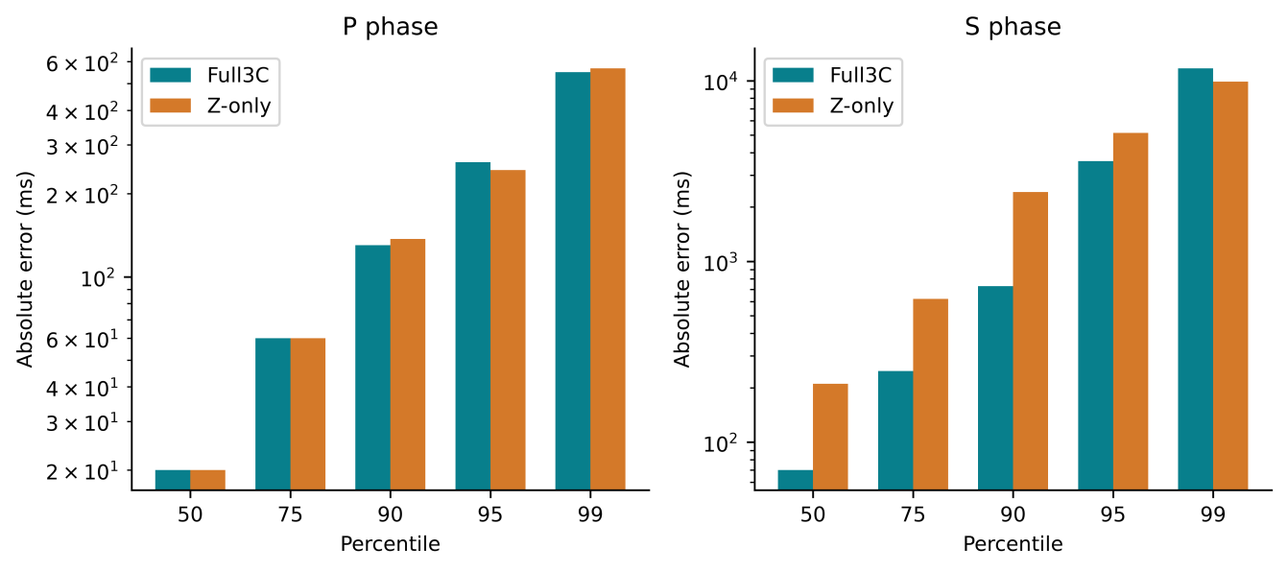
Fig. 10. Base-42/meta-42 accepted absolute-error percentiles (50, 75, 90, 95, 99) for Full3C and Z-only. The vertical axis is logarithmic. Compare error distributions together with acceptance rates.

4.4.1. Base seed repetitions and the standalone neural baseline
Across the three base-seed means, Full3C stacking F1@100 ms was 0.8694 ± 0.0078 for P and 0.5780 ± 0.0064 for S; Z-only values were 0.8723 ± 0.0060 and 0.3384 ± 0.0096. Each base mean averages three meta fits. Full3C exceeded Z-only S F1 in all nine paired fits, while P differences were small and changed direction. Table 6 separates these summaries from the three-seed standalone baseline.
Table 6. Expanded results at ±100 ms. Stacking SD is across three base-seed means after averaging meta seeds; baseline SD is across three fits. MAE includes all accepted picks.
Method | Mode | P F1 | S F1 | P MAE ms | S MAE ms
Stack | Full3C | 0.8694 ± 0.0078 | 0.5780 ± 0.0064 | 81.07 | 682.14
Stack | Zonly | 0.8723 ± 0.0060 | 0.3384 ± 0.0096 | 126.37 | 939.97
PhaseNetMatched | Full3C | 0.9661 ± 0.0067 | 0.6267 ± 0.0183 | 21.90 | 216.77
PhaseNetMatched | Zonly | 0.9637 ± 0.0082 | 0.3689 ± 0.0167 | 26.08 | 469.59
PhaseNetMatched achieved higher mean F1 and lower accepted-pick MAE than stacking in both modes. For Full3C, stack minus baseline ΔF1 was −0.0967 for P and −0.0488 for S, with both conditional intervals below zero. Z-only P also favoured the baseline; the Z-only S interval included zero despite its higher mean (Table 7). Full3C S coverage was 98.44% for stacking and 99.40% for the baseline; Z-only values were 93.30% and 99.60%. Thus the baseline improvement is not explained by a lower accepted-pick rate. These results do not justify a performance advantage from temporal stacking over this comparator.
Table 7. Expanded mean ΔF1@100 ms and paired source-cluster 95% intervals (10,000 draws). Differences follow the order shown. Intervals condition on fixed fits and one split and are not multiplicity-adjusted.
Comparison | Phase | Mean ΔF1 | 95% interval
Stack Full3C minus Zonly | P | -0.0029 | [-0.0135, 0.0076]
baseline Full3C minus Zonly | P | 0.0024 | [-0.0075, 0.0125]
Stack minus baseline Full3C | P | -0.0967 | [-0.1340, -0.0614]
Stack minus baseline Zonly | P | -0.0914 | [-0.1284, -0.0569]
Stack Full3C minus Zonly | S | 0.2396 | [0.1874, 0.2905]
baseline Full3C minus Zonly | S | 0.2578 | [0.2094, 0.3057]
Stack minus baseline Full3C | S | -0.0488 | [-0.0821, -0.0148]
Stack minus baseline Zonly | S | -0.0305 | [-0.0712, 0.0101]

4.5. Phase-ordering constraint and practical implications
The decoder restricts S to 0.1–30 s after accepted P, within the record. Disabling this restriction also changes the quality-score search domain, so the comparison is not an isolated post hoc safeguard with otherwise identical decoding.
In the original base-42 experiment, constrained versus unconstrained decoding changed S time or availability in 1, 1, and 2 Full3C records at seeds 42–44; Z-only counts were 1, 2, and 2. One accepted-to-accepted timing change occurred at seed 44 in each mode. P picks were unchanged. Ordered constrained outputs do not show that the network independently learned the physical rule.
S timing remains a practical limitation: in the original base-42/meta-42 stacker, accepted S RMSE was 2063.33 ms and 7.88% of accepted S errors exceeded 1 s. High candidate coverage is therefore insufficient evidence for automatic catalogue use. The PhaseNet-style baseline improves mean timing accuracy under the matched protocol, but neither workflow has been validated for continuous monitoring or downstream location accuracy. These outputs require application-specific quality control and independent validation before use in location or tomography.

4.6. Limitations
The study is limited to one curated high-SNR STEAD subset. It does not assess station-held-out or regional transfer, continuous monitoring, overlapping events, or operational latency. Three base seeds and three meta seeds characterize limited initialization variability on one fixed split. Meta fits within a base share OOF features, and the source bootstrap does not incorporate training or split uncertainty. Original ablations were not repeated at the additional base seeds. Multiple intervals are exploratory and do not establish equivalence. Outer validation is reused for final-base selection, meta stopping, and ensemble weighting. The event-only test set does not measure continuous-stream false alarms.
The additional comparator is a PhaseNet-style MATLAB adaptation, not the official PhaseNet implementation or a pretrained benchmark. It uses the same data and decoder but differs in architecture, input representation, minibatch size, and optimizer-step budget; the observed advantage cannot be assigned to one design choice. TwoStream-EQT and SeismoDual report evaluation across additional datasets or acquisition settings (Peng et al., 2025; Tang and Chen, 2026); their scores are not directly comparable here. The AIC score centre cannot exceed 9.99 s, whereas 245 of 335 test S arrivals and 22 test P arrivals occur later. This limits the classical comparator and supplied features; the study is not a general comparison against optimized AIC picking. These counts concern score centres before conditional decoding, not final error counts.
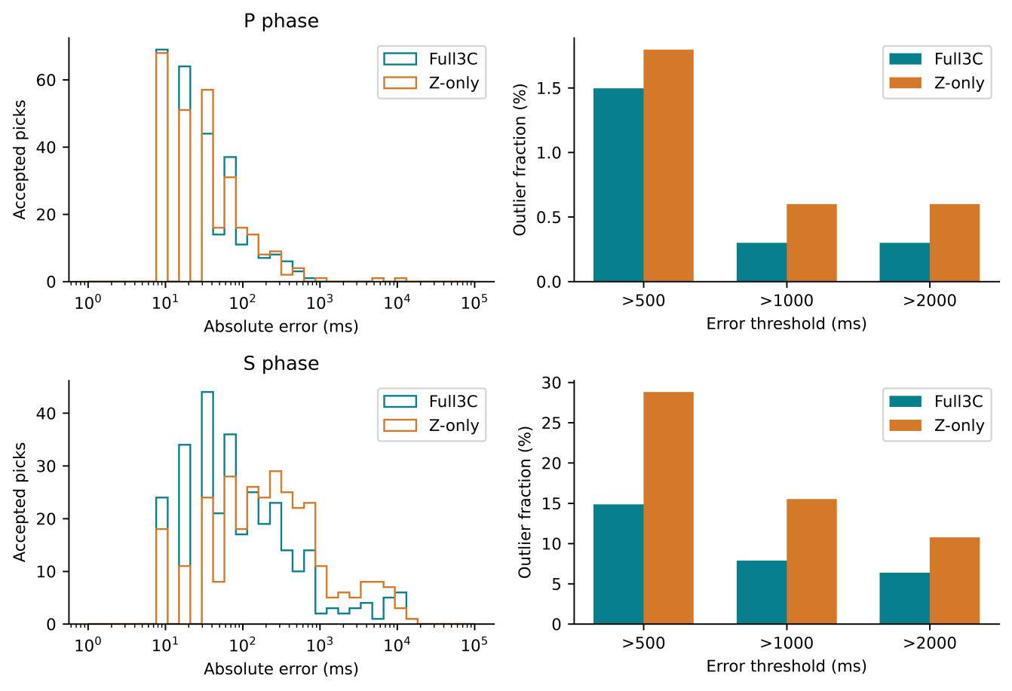
Fig. 11. Base-42/meta-42 accepted errors. Left: full-range histograms on logarithmic axes. Right: fractions exceeding 500, 1000, and 2000 ms. Rows show P and S; denominators are accepted picks.
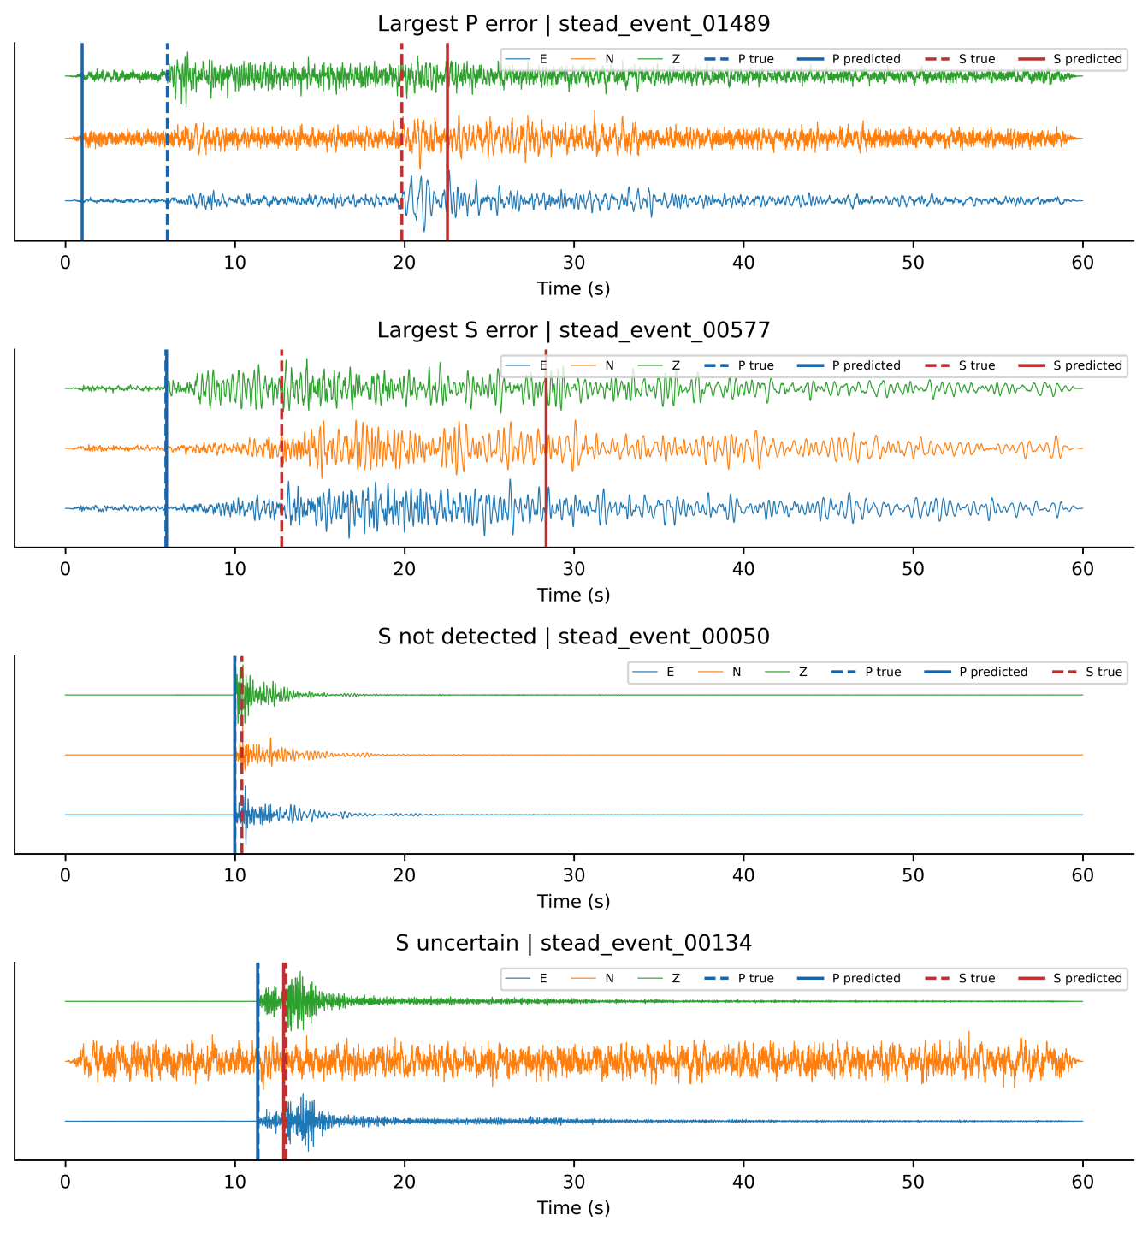
Fig. 12. Selected Full3C base-42/meta-42 cases: largest accepted P error, largest accepted S error, and first S not-detected and uncertain cases when present. Components are normalized individually and offset. Dashed lines mark true arrivals; solid lines mark reported predictions. Event IDs identify the selection.

4.7. Future directions
Further work should vary source-grouped splits, separate model-selection stages through nested validation, and evaluate independent stations and datasets. The official PhaseNet implementation and other contemporary pickers should be benchmarked under matched data access, with controlled input and compute budgets. Continuous-record evaluation should measure false alarms and operational latency. Controlled noise perturbations and comparators isolating temporal context from nonlinearity would clarify robustness and mechanism.

5. Conclusions
The source-grouped workflow makes training membership, temporal feature construction, and evaluation provenance explicit. Across three base seeds crossed with three meta seeds, the Full3C–Z-only S difference persisted on the same curated source-held-out test set. This supports a component-access finding within that population, while transfer to other populations remains untested.
On 335 records from 317 unseen sources, expanded stacking mean F1@100 ms was 0.8694 for P and 0.5780 for S with Full3C, compared with 0.8723 and 0.3384 for Z-only. Between-base SDs of the meta-seed means were 0.0078/0.0064 and 0.0060/0.0096, respectively. Full3C mean accepted-pick MAE was 81.07 ms for P and 682.14 ms for S; coverage was 99.60% and 98.44%. Acceptance includes detected and uncertain picks.
The stacking S component-access difference was 0.2396 (conditional paired 95% interval 0.1874–0.2905). The PhaseNet-style baseline achieved higher mean F1 in both modes: Full3C P/S 0.9661/0.6267 and Z-only 0.9637/0.3689. Conditional intervals supported its P advantage in both modes and S advantage in Full3C; the Z-only S interval included zero. Temporal stacking therefore did not improve on this standalone comparator. Original ablations did not establish a dilation benefit or essential nonlinearity. Independent source splits, stations, and datasets remain necessary for broader robustness claims.

CRediT authorship contribution statement
Rahmat Catur Wibowo: Conceptualization, Methodology, Software, Validation, Formal analysis, Investigation, Data curation, Writing – original draft, Writing – review & editing, Visualization, Supervision, Project administration. Razki Alfatah Khairu Mahli: Software, Investigation, Validation, Visualization, Writing – review & editing. Karyanto: Software, Data curation, Investigation, Writing – review & editing. Hendra Amijaya: Methodology, Resources, Writing – review & editing. Aristoteles: Formal analysis, Validation, Writing – review & editing. Maman Hermana: Validation, Writing – review & editing. Muh Sarkowi: Conceptualization, Methodology, Supervision, Writing – review & editing.

Code availability
Code, configurations, source lists, frozen predictions, and numerical audit scripts for the original experiment and 66-fit extension are publicly archived in release v1.3.0 at https://doi.org/10.5281/zenodo.22782746. The release corresponds to Git commit e235f749540a56b763eca5903abb9592b9ed02b8 at https://github.com/rcw3712/ICNN_MetaPicker_Curated_STEAD_MATLAB/tree/v1.3.0. The submission_20260915 directory retains the original 40-fit experiment; strengthening_20260916 contains the additional runner, record-level results, portable numerical audit, and hash manifest. All 367 entries in the extension manifest were verified against the published Zenodo archive. The earlier v1.2.0 DOI 10.5281/zenodo.22760733 identifies only the original release. Raw waveforms, large probability curves, caches, and trained checkpoints are excluded; reproducing training requires the identified STEAD inputs. This manuscript includes a subsequent availability-statement update; the archived manuscript snapshot predates DOI assignment, while its numerical results are unchanged.

Data availability
The primary waveform data used in this study were derived from the publicly available STanford EArthquake Dataset (STEAD) (Mousavi et al., 2019). The curated dataset employed in this work comprises 2234 three-component waveform records corresponding to 2114 unique earthquake sources and includes derived metadata, source-level split assignments, and associated processing information.
The original public submission package supplies curated metadata, source assignments, and record-level predictions for the 40-fit experiment. Additional prediction tables accompany the strengthening audit package. Raw STEAD waveforms remain available under the original distribution terms and are not redistributed here. Event IDs and original trace names identify the required observations. Prediction-based checks do not require waveform access.

Declaration of Competing Interests
The authors declare that they have no known competing financial interests or personal relationships that could have appeared to influence the work reported in this paper. The development of the I-CNN MetaPicker framework was conducted solely for academic research purposes and did not receive commercial sponsorship or involve any commercial entity.

Funding
This research was conducted as part of ongoing academic activities of the authors and did not receive dedicated external funding. The authors received no financial support for the research, authorship, or publication of this article.

Declaration of generative AI and AI-assisted technologies in the manuscript preparation process
During manuscript preparation, the authors used ChatGPT/Codex (OpenAI) and Claude (Anthropic) for language editing, organization, and assistance drafting tables and captions. After using these tools, the authors reviewed and edited the text, verified references and consistency with the study results, and take full responsibility for the content of the publication. AI assistance with the computational workflow is described in Section 3.

References
Allen, R.V., 1978. Automatic earthquake recognition and timing from single traces. Bulletin of the Seismological Society of America 68 (5), 1521–1532. https://doi.org/10.1785/BSSA0680051521
Baer, M., Kradolfer, U., 1987. An automatic phase picker for local and teleseismic events. Bulletin of the Seismological Society of America 77 (4), 1437–1445. https://doi.org/10.1785/BSSA0770041437
Bai, S., Kolter, J.Z., Koltun, V., 2018. An empirical evaluation of generic convolutional and recurrent networks for sequence modeling. arXiv preprint arXiv:1803.01271. https://doi.org/10.48550/arXiv.1803.01271
Cheng, A., Xu, E., Yao, P., Zhou, Y., Huang, S., Ye, Z., 2024. An automatic arrival time picking algorithm of P-wave based on adaptive characteristic function. Computers & Geosciences 185, 105544. https://doi.org/10.1016/j.cageo.2024.105544
Ioffe, S., Szegedy, C., 2015. Batch normalization: accelerating deep network training by reducing internal covariate shift. Proceedings of the 32nd International Conference on Machine Learning, PMLR 37, 448–456. https://doi.org/10.48550/arXiv.1502.03167
Kingma, D.P., Ba, J., 2015. Adam: a method for stochastic optimization. Proceedings of the 3rd International Conference on Learning Representations (ICLR 2015). https://doi.org/10.48550/arXiv.1412.6980
Maeda, N., 1985. A method for reading and checking phase times in auto-processing system of seismic wave data. Zisin (Journal of the Seismological Society of Japan, Second Series) 38 (3), 365–379. https://doi.org/10.4294/zisin1948.38.3_365
Mousavi, S.M., Sheng, Y., Zhu, W., Beroza, G.C., 2019. STanford EArthquake Dataset (STEAD): A global data set of seismic signals for AI. IEEE Access 7, 179464–179476. https://doi.org/10.1109/ACCESS.2019.2947848
Mousavi, S.M., Ellsworth, W.L., Zhu, W., Chuang, L.Y., Beroza, G.C., 2020. Earthquake transformer—An attentive deep-learning model for simultaneous earthquake detection and phase picking. Nature Communications 11, 3952. https://doi.org/10.1038/s41467-020-17591-w
Münchmeyer, J., Woollam, J., Rietbrock, A., Tilmann, F., Lange, D., Bornstein, T., Diehl, T., Giunchi, C., Haslinger, F., Jozinović, D., Michelini, A., Saul, J., Soto, H., 2022. Which picker fits my data? A quantitative evaluation of deep learning based seismic pickers. Journal of Geophysical Research: Solid Earth 127 (1), e2021JB023499. https://doi.org/10.1029/2021JB023499
Peng, L., Li, L., Mousavi, S.M., Zeng, X., Beroza, G.C., 2025. TwoStream-EQT: A microseismic phase picking model combining time and frequency domain inputs. Computers & Geosciences 204, 105991. https://doi.org/10.1016/j.cageo.2025.105991
Sleeman, R., van Eck, T., 1999. Robust automatic P-phase picking: An on-line implementation in the analysis of broadband seismogram recordings. Physics of the Earth and Planetary Interiors 113 (1–4), 265–275. https://doi.org/10.1016/S0031-9201(99)00007-2
Srivastava, N., Hinton, G., Krizhevsky, A., Sutskever, I., Salakhutdinov, R., 2014. Dropout: a simple way to prevent neural networks from overfitting. Journal of Machine Learning Research 15, 1929–1958. https://www.jmlr.org/papers/v15/srivastava14a.html
Tang, K.-W., Chen, K.-Y., 2026. SeismoDual: A dual-domain deep learning framework for robust seismic phase picking. Computers & Geosciences 207, 106080. https://doi.org/10.1016/j.cageo.2025.106080
Wolpert, D.H., 1992. Stacked generalization. Neural Networks 5 (2), 241–259. https://doi.org/10.1016/S0893-6080(05)80023-1
Woollam, J., Münchmeyer, J., Tilmann, F., Rietbrock, A., Lange, D., Bornstein, T., Diehl, T., Giunchi, C., Haslinger, F., Jozinović, D., Michelini, A., Saul, J., Soto, H., 2022. SeisBench—A toolbox for machine learning in seismology. Seismological Research Letters 93 (3), 1695–1709. https://doi.org/10.1785/0220210324
Zhu, W., Beroza, G.C., 2019. PhaseNet: A deep-neural-network-based seismic arrival-time picking method. Geophysical Journal International 216 (1), 261–273. https://doi.org/10.1093/gji/ggy423

