Supplementary Material

Source-Grouped Evaluation of Temporal Stacking for Seismic Phase Picking with Three-Component Data
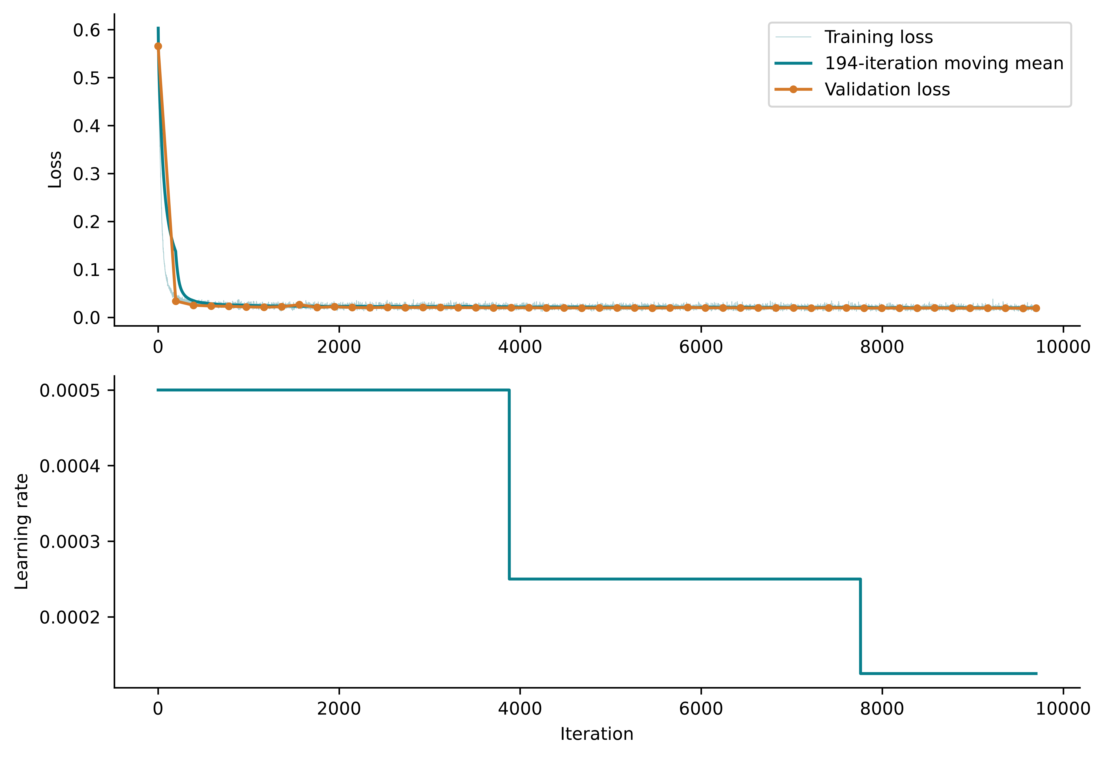
Scope of results. Figures S1–S5 and Tables S1–S14 retain the original base-seed-42 experiment and its implementation audit. Unless otherwise stated there, seed 42 denotes base seed 42 and meta seed 42; three-seed summaries vary only the meta learner. Tables S15–S18 below report the 66-fit extension and the expanded base/meta comparison.
Supplementary Fig. S1. Full3C full15ch seed-42 training and validation loss from the final checkpoint, with a 194-iteration moving mean (one epoch) and learning-rate schedule. Output network iteration was 9555; training continued to 9700 iterations. Validation histories are retained.
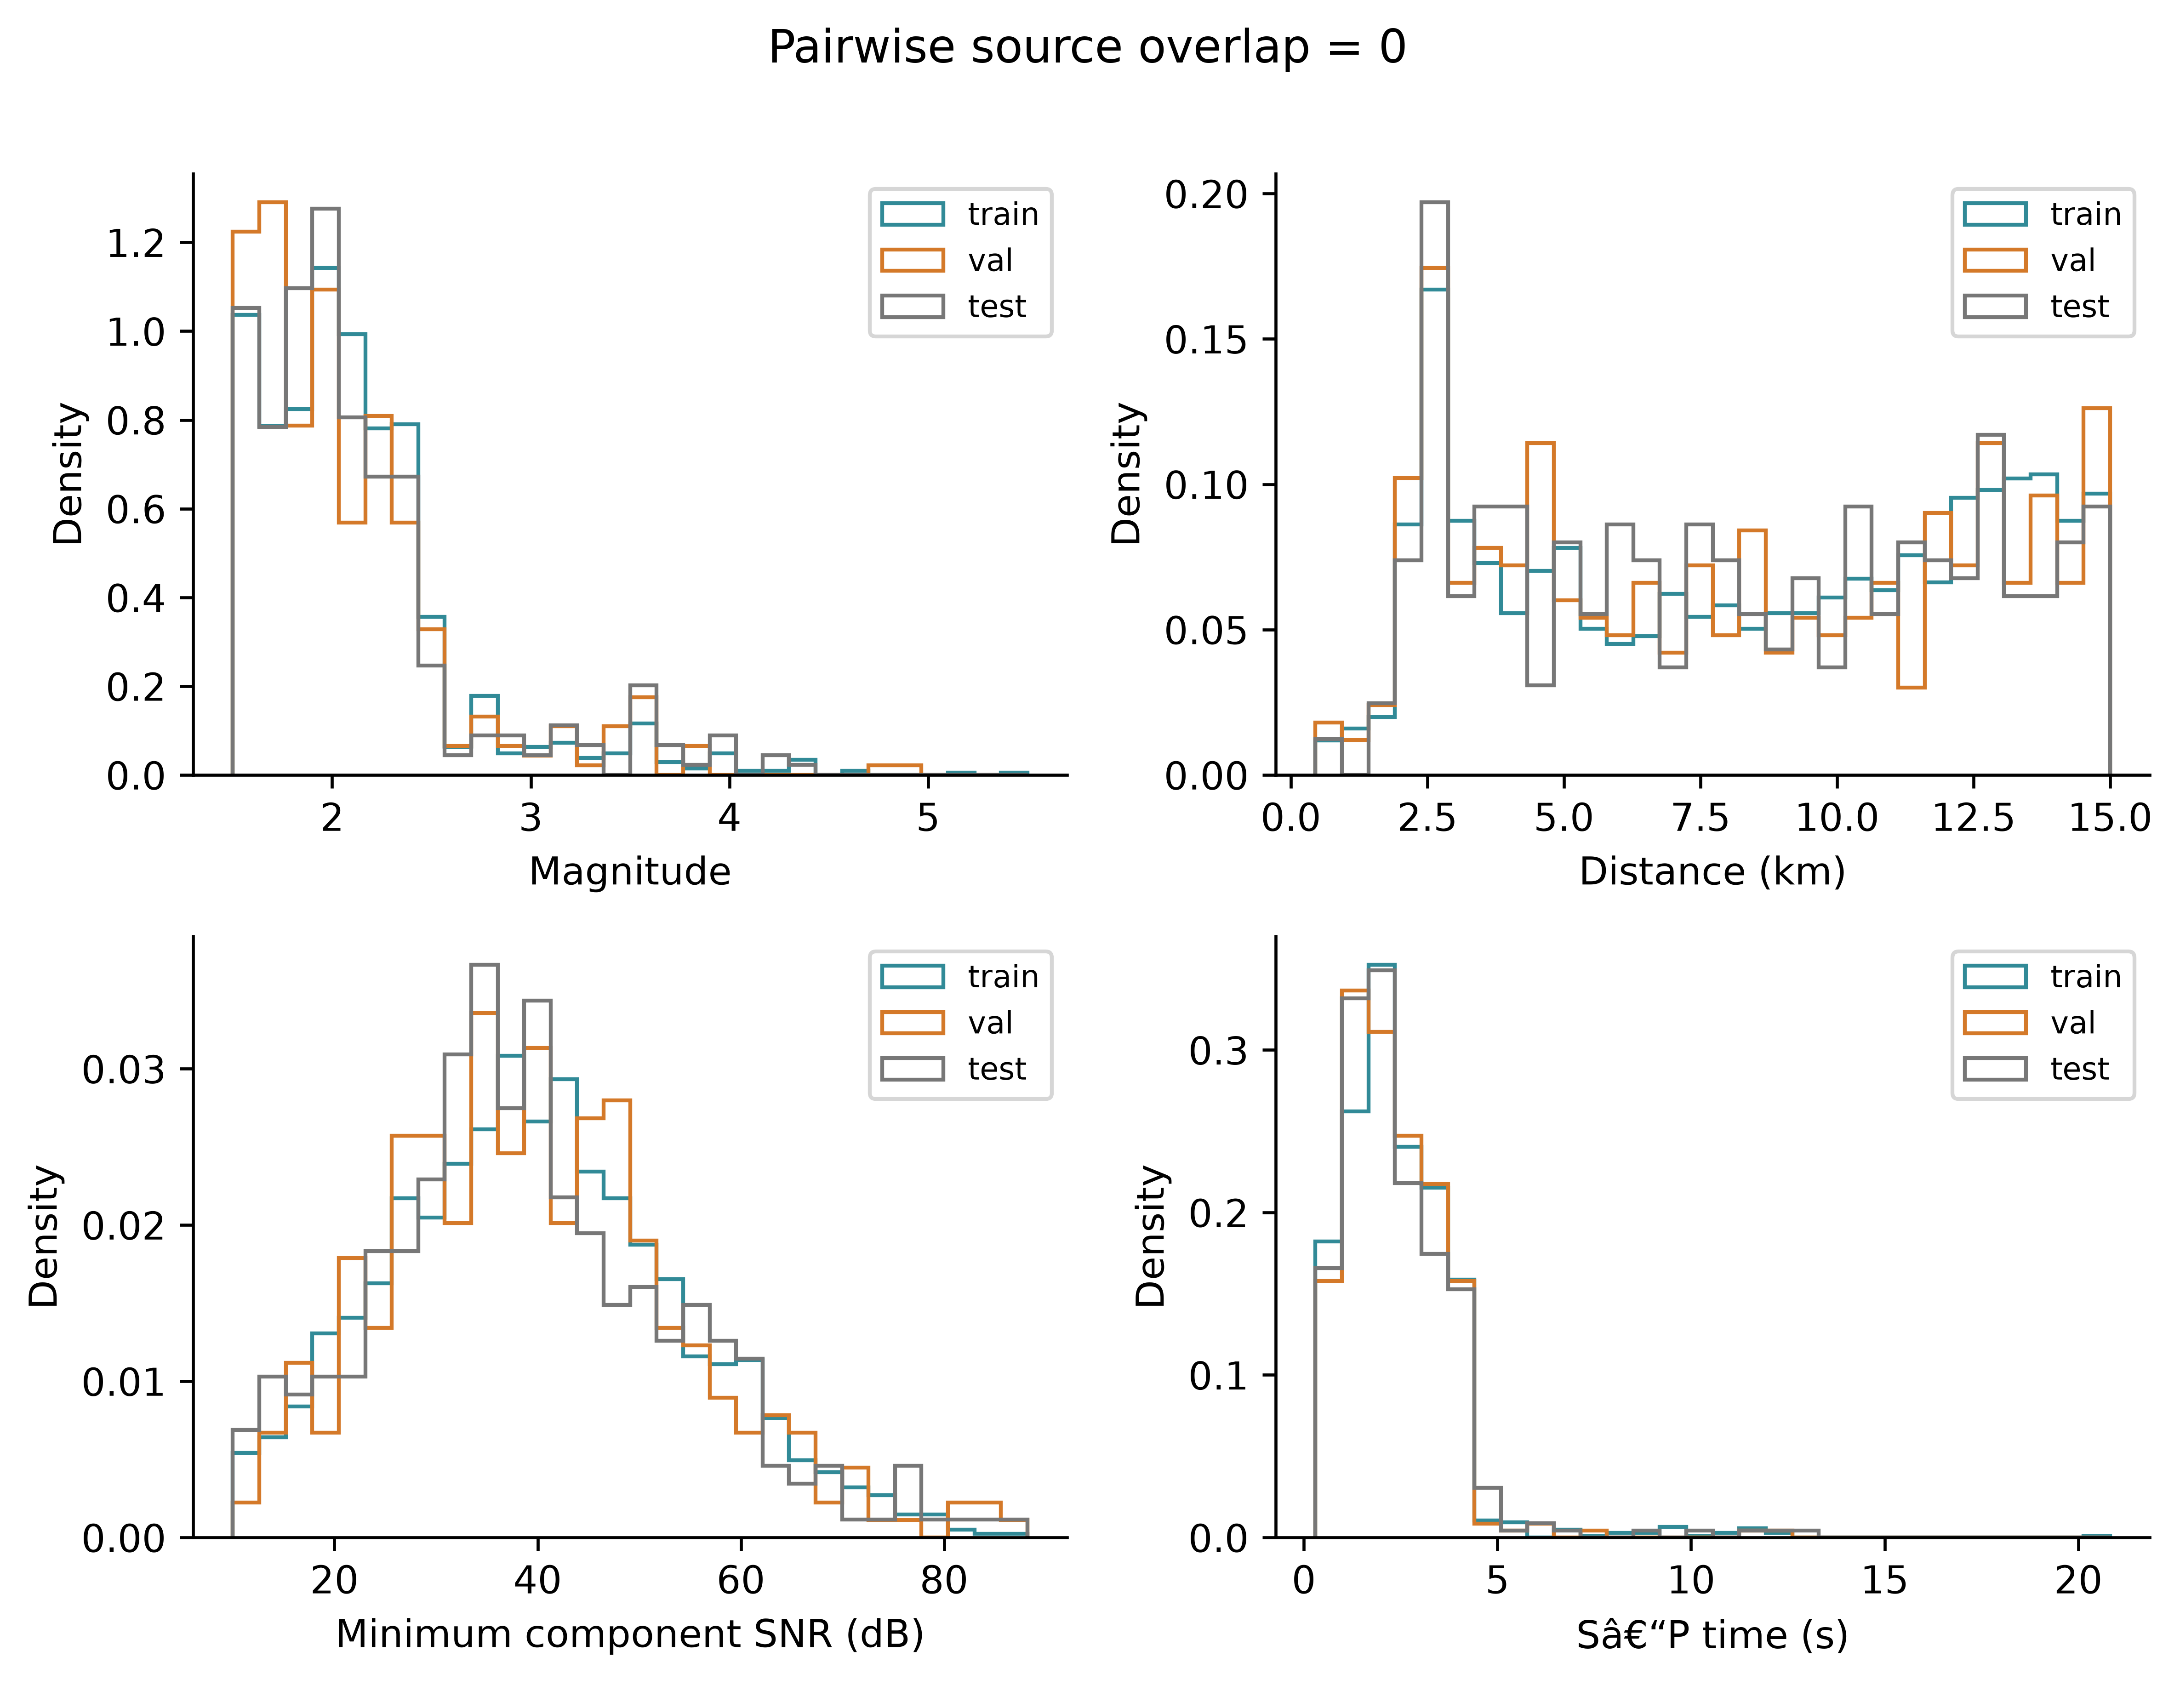
Supplementary Fig. S2. Diagnostic visualization of the source-level partitioning procedure demonstrating the absence of overlap among training, validation, and test earthquake sources.
Supplementary Table S1. Statistics over all 335 Full3C test tensors (6000 samples each; 2,010,000 time samples per channel), using final-base features in the verified Full3C cache. SD uses n−1.
Ch. | Feature | Min | Max | Mean | SD | NaN / Inf
1 | P_STA | 0 | 1 | 0.006267 | 0.06627 | 0 / 0
2 | S_STA | 0 | 1 | 0.006267 | 0.06627 | 0 / 0
3 | Noise_STA | 0 | 1 | 0.992 | 0.07617 | 0 / 0
4 | P_AIC | 0 | 1 | 0.004178 | 0.05419 | 0 / 0
5 | S_AIC | 0 | 1 | 0.004178 | 0.05419 | 0 / 0
6 | Noise_AIC | 0 | 1 | 0.9939 | 0.06638 | 0 / 0
7 | P_CNN | 7.157e-09 | 0.9772 | 0.002136 | 0.02715 | 0 / 0
8 | S_CNN | 2.724e-13 | 0.9982 | 0.003071 | 0.0191 | 0 / 0
9 | Noise_CNN | 0.001823 | 1 | 0.9948 | 0.03321 | 0 / 0
10 | P_TCN | 9.637e-09 | 0.9865 | 0.002548 | 0.03519 | 0 / 0
11 | S_TCN | 1.11e-10 | 0.9573 | 0.002805 | 0.02416 | 0 / 0
12 | Noise_TCN | 0.01352 | 1 | 0.9946 | 0.04262 | 0 / 0
13 | E conditioned | -29.64 | 33.28 | -1.215e-12 | 0.9999 | 0 / 0
14 | N conditioned | -31.13 | 31.65 | -3.26e-11 | 0.9999 | 0 / 0
15 | Z conditioned | -32.83 | 33.38 | 9.734e-12 | 0.9999 | 0 / 0
Supplementary Table S2. Three-seed mean F1 and percentile 95% source-cluster intervals, with paired Full3C minus Z-only differences.
Mode / comparison | Phase | Tolerance ms | Mean F1 / Δ | 95% CI
Full3C | P | 50 | 0.7314 | [0.6855, 0.7768]
Z-only | P | 50 | 0.7378 | [0.6922, 0.7833]
Full3C - Z-only | P | 50 | -0.0063 | [-0.0266, 0.0141]
Full3C | P | 100 | 0.8680 | [0.8333, 0.9019]
Z-only | P | 100 | 0.8664 | [0.8296, 0.9018]
Full3C - Z-only | P | 100 | 0.0016 | [-0.0141, 0.0172]
Full3C | P | 200 | 0.9307 | [0.9038, 0.9562]
Z-only | P | 200 | 0.9352 | [0.9085, 0.9601]
Full3C - Z-only | P | 200 | -0.0045 | [-0.0150, 0.0060]
Full3C | S | 50 | 0.4373 | [0.3881, 0.4862]
Z-only | S | 50 | 0.1885 | [0.1509, 0.2271]
Full3C - Z-only | S | 50 | 0.2488 | [0.1981, 0.2988]
Full3C | S | 100 | 0.5737 | [0.5233, 0.6234]
Z-only | S | 100 | 0.3296 | [0.2805, 0.3795]
Full3C - Z-only | S | 100 | 0.2441 | [0.1892, 0.2979]
Full3C | S | 200 | 0.7041 | [0.6568, 0.7501]
Z-only | S | 200 | 0.4673 | [0.4142, 0.5200]
Full3C - Z-only | S | 200 | 0.2368 | [0.1828, 0.2922]
We resampled the 317 sources with replacement, retaining all records of each sampled source. Exactly 18 sources contributed two records. We used 10,000 draws with NumPy default_rng seed 42. Each draw recomputed per-seed F1 and averaged seeds 42–44; both modes used the same source resamples. Intervals condition on fixed models and split and exclude base-training or split variability. No claim of equivalence with record-level bootstrap is made.
Supplementary Table S3. Seed-42 absolute-error statistics for accepted (detected or uncertain) picks. Percentiles use linear interpolation; outlier percentages use accepted denominators. These single-seed diagnostics accompany Main Table 4 three-seed summaries.
Metric | Full3C P | Full3C S | Z-only P | Z-only S
Accepted picks | 334 | 330 | 334 | 316
Strict detected picks | 333 | 319 | 333 | 265
MAE (ms) | 68.95 | 610.03 | 106.23 | 903.01
Median AE (ms) | 20.00 | 70.00 | 20.00 | 210.00
RMSE (ms) | 295.30 | 2063.33 | 743.10 | 2235.47
P90 (ms) | 130.00 | 730.00 | 137.00 | 2420.00
Error >500 ms (%) | 1.50 | 14.85 | 1.80 | 28.80
Error >1 s (%) | 0.30 | 7.88 | 0.60 | 15.51
Error >2 s (%) | 0.30 | 6.36 | 0.60 | 10.76
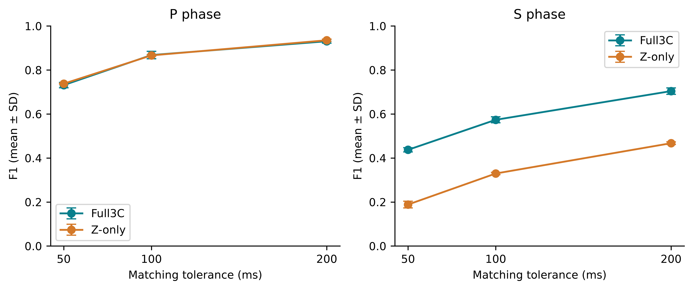
Supplementary Fig. S3. Mean F1 versus tolerance. Error bars show sample SD over three meta-learner seeds, not source-bootstrap intervals.
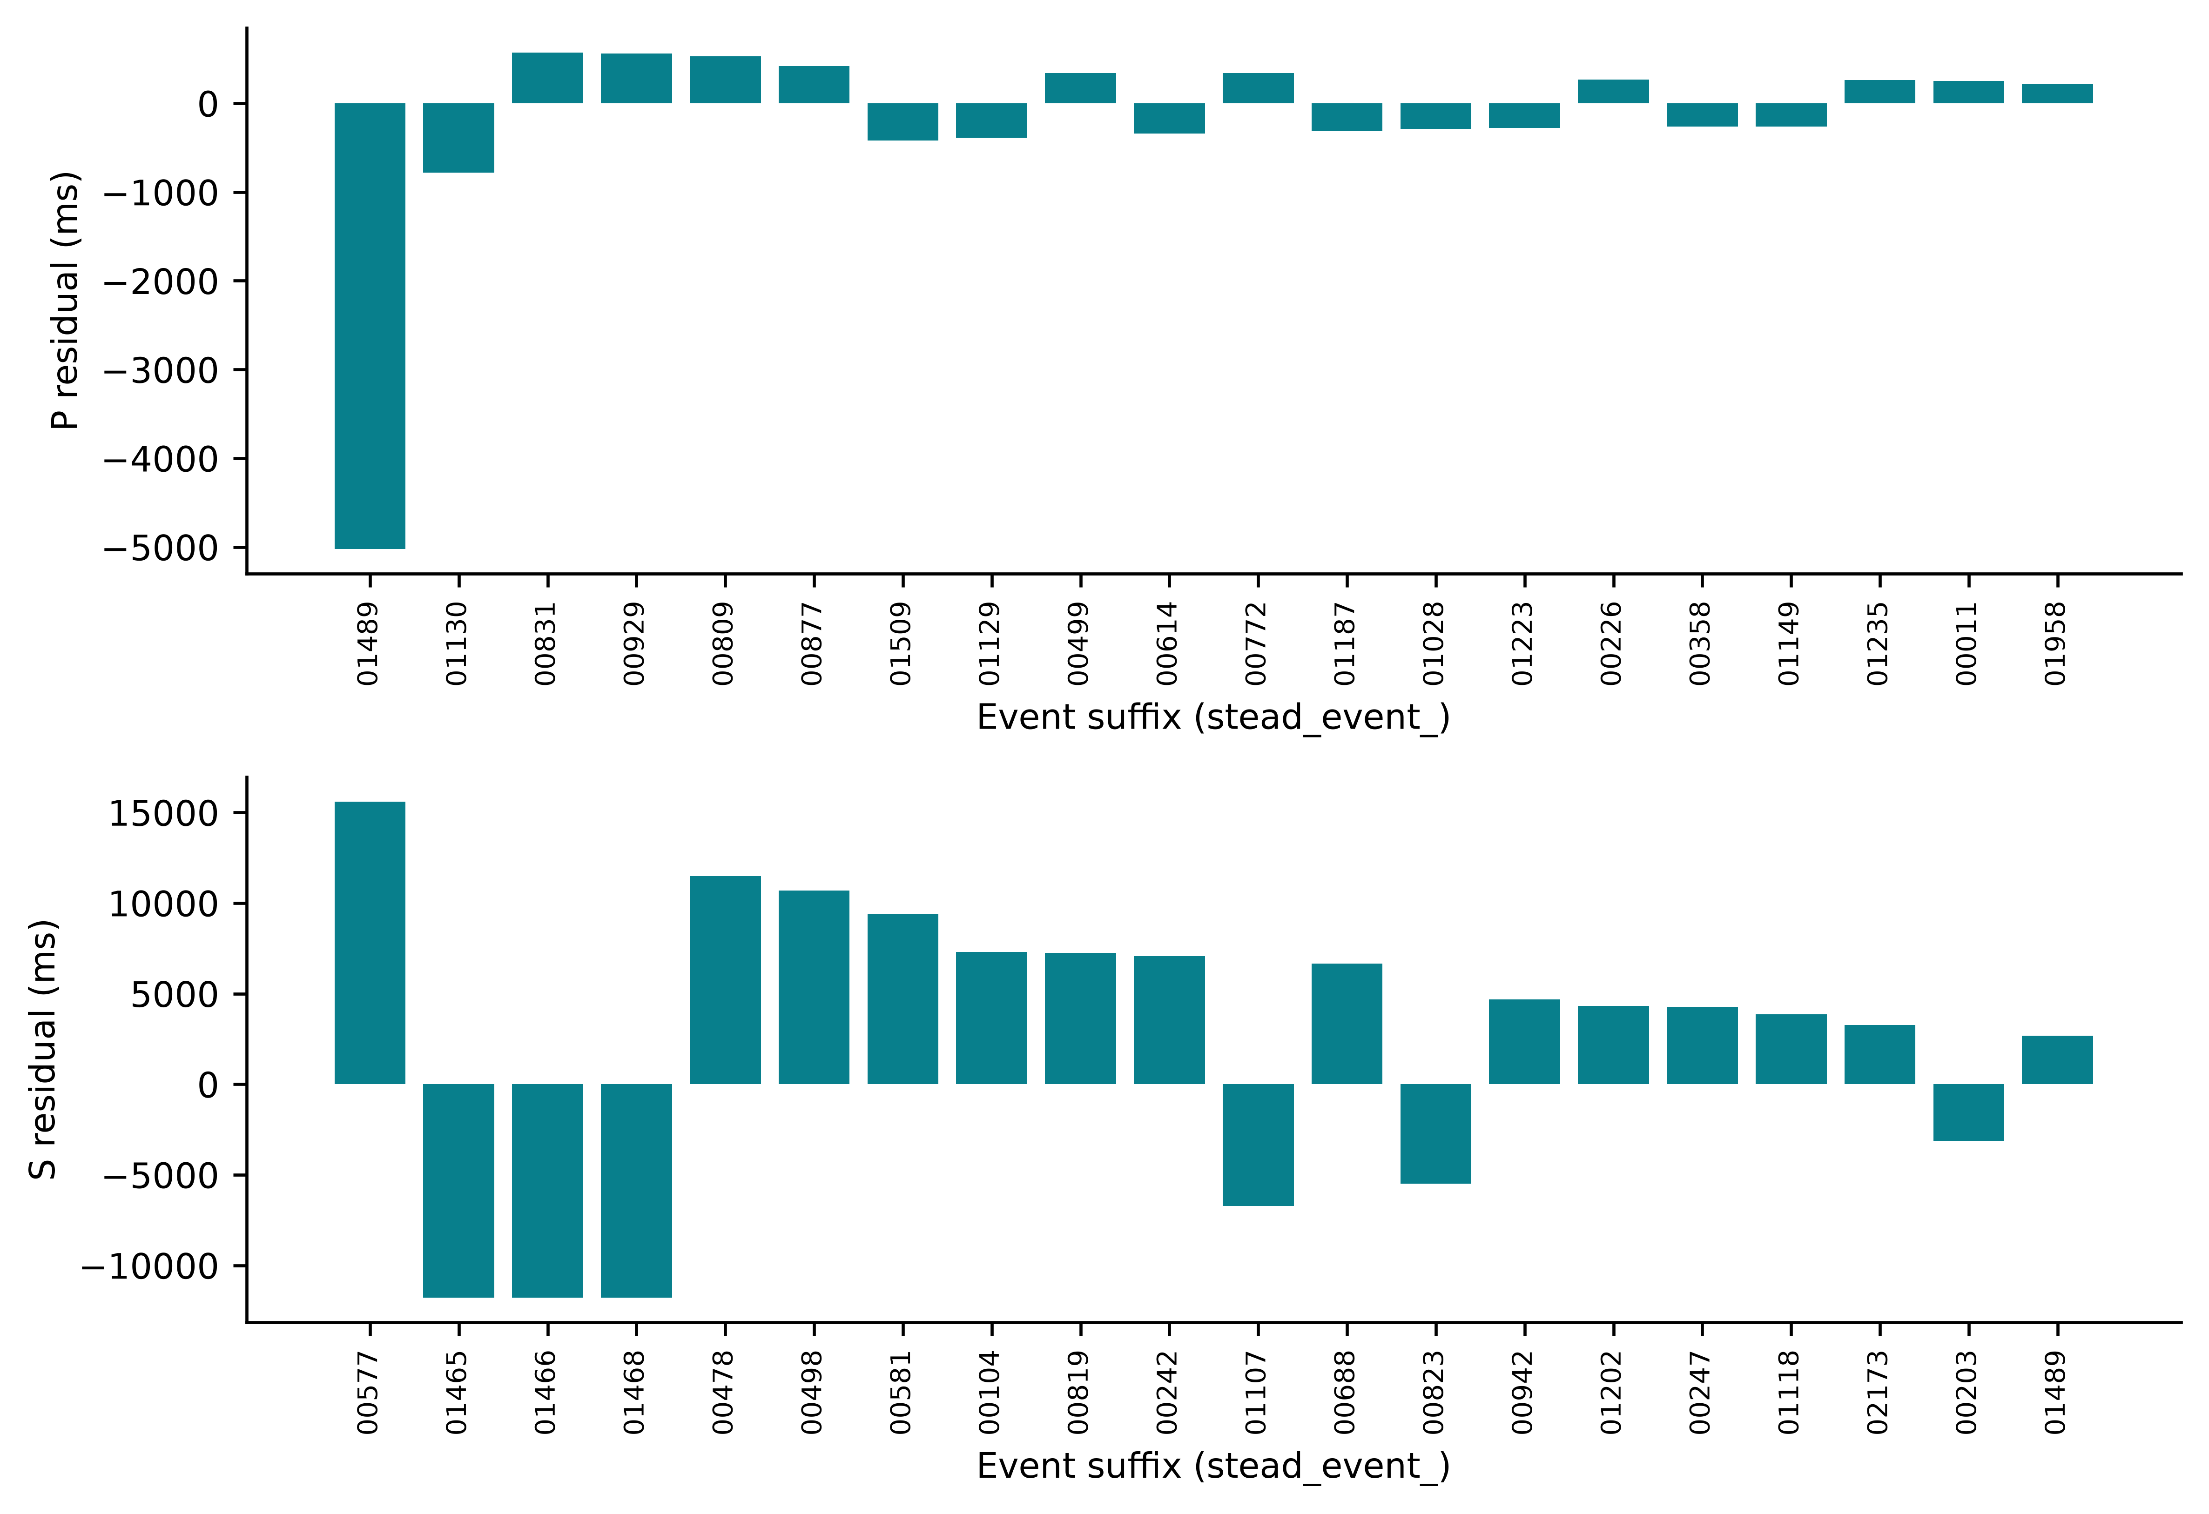
Supplementary Fig. S4. The 20 largest absolute P and S residuals among Full3C seed-42 accepted picks, with signed errors and event-ID suffixes. This is a ranked diagnostic, not an exhaustive waveform panel; selected waveforms appear in Main Fig. 12.
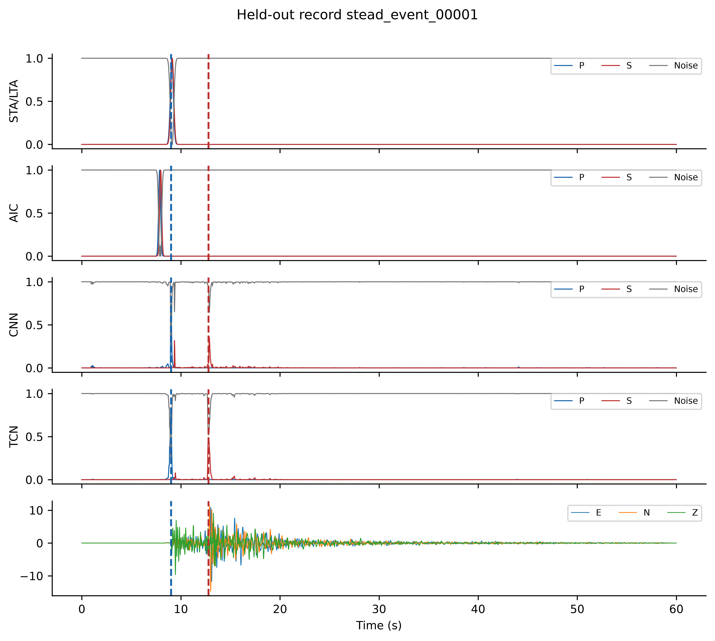
Supplementary Fig. S5. Final Full3C test tensor for stead_event_00001. Twelve P/S/noise channels are followed by conditioned E/N/Z. Dashed lines show true arrivals; Table S1 covers all 335 test tensors.
Supplementary Table S4. Final settings for the completed 40-fit workflow; Main Table 3 provides architecture and optimizer details. Logistic uses independent binary phase heads and does not isolate nonlinearity. All calculations use frozen submission40_v5_oofstream outputs.
Category | Parameter | Value
Dataset | Population | 2234 records / 2114 sources
Dataset | Sampling; duration | 100 Hz; 6000 samples; 60 s
Curation | Distance; magnitude; SNR | ≤15 km; ≥1.5; ≥10 dB
Curation | Reference arrivals | Manual P and S
Partition | Train sources / records | 1480 / 1556
Partition | Validation sources / records | 317 / 343
Partition | Test sources / records | 317 / 335
Partition | Source intersections | Zero for every pair
OOF | Grouping; folds; inner validation | source_id; 5; 15% of non-held sources
Meta input | Augmented training records | 3112 per mode
Meta input | Full / prob-only / waveform-only | 6000×15 / 6000×12 / 6000×3
Training | Completed fits | 40 (25 Full3C; 15 Z-only)
Seeds | Base / neural meta | 42 / 42,43,44
Augmentation | Noise; amplitude range | 20 dB; 0.5–2.0
Augmentation | Horizontal dropout | Probability 0.20
Augmentation | Time shift / polarity flip | Disabled / disabled
Logistic | Heads; target | P,S binary; phase mask >0.3
Logistic | Normalization | OOF-training mean and sample SD
Logistic | Subsampling / ridge penalty | Every 10th sample / 0.01
Logistic | Optimization | Newton; ≤100 iterations; gradient∞<1×10⁻⁶
Evaluation | Accepted / strict masks | Detected+uncertain / detected; finite
Evaluation | Tolerances | ±50, ±100, ±200 ms
Evaluation | MAE denominator | All accepted, including outliers
Bootstrap | Mean intervals | 10,000 source draws; NumPy seed 42
Software | Training | MATLAB R2024a
Software | Tables / figures | Python; NumPy, pandas, Matplotlib
Provenance | Frozen results | submission40_v5_oofstream
Provenance | Manifest at audit | 2279 file hashes matched
Supplementary Table S5. Full3C F1 on 335 records. Bases use final seed-42 fits; I-CNN entries are three-seed means (SD in Table S6). All methods use the primary decoder and acceptance policy. Weighted coefficients derive from phase-specific validation F1@100 ms, fixed before test evaluation.
Method | P50 | P100 | P200 | S50 | S100 | S200
STA/LTA | 0.2358 | 0.4836 | 0.7910 | 0.0030 | 0.0151 | 0.0605
AIC | 0.3582 | 0.4149 | 0.4657 | 0.0000 | 0.0031 | 0.0031
CNN | 0.6937 | 0.8258 | 0.9129 | 0.3047 | 0.4149 | 0.5284
TCN | 0.7166 | 0.8606 | 0.9265 | 0.4064 | 0.5568 | 0.6464
Mean ensemble | 0.6896 | 0.8119 | 0.9075 | 0.1471 | 0.1982 | 0.2192
Validation-weighted | 0.7164 | 0.8478 | 0.9224 | 0.3769 | 0.5223 | 0.6248
I-CNN mean | 0.7314 | 0.8680 | 0.9307 | 0.4373 | 0.5737 | 0.7041
Within the original four-base comparison, TCN was strongest standalone at 100 ms: P/S F1 0.8606/0.5568 versus I-CNN means 0.8680/0.5737. The exploratory S difference interval includes zero (−0.0126 to 0.0475), so a clearly established advantage over TCN is not claimed. The additional PhaseNet-style baseline is reported separately in Table S16 and Main Table 6.
Supplementary Table S6. Full3C ablation. Neural variants report mean ± sample SD over seeds 42–44 on shared OOF features; logistic was fitted once. The last column gives control minus variant ΔF1@100 ms and paired source-cluster 95% interval (10,000 draws). These multiple intervals are exploratory and not multiplicity-adjusted.
Variant | Phase | F1@50 ms | F1@100 ms | F1@200 ms | Control − variant  Δ and 95% CI
Full15 control | P | 0.7314 ± 0.0124 | 0.8680 ± 0.0170 | 0.9307 ± 0.0086 | —
Full15 control | S | 0.4373 ± 0.0096 | 0.5737 ± 0.0137 | 0.7041 ± 0.0146 | —
Probability12 | P | 0.7196 ± 0.0138 | 0.8653 ± 0.0108 | 0.9301 ± 0.0017 | +0.0027  [-0.0071, 0.0129]
Probability12 | S | 0.4097 ± 0.0083 | 0.5675 ± 0.0028 | 0.6929 ± 0.0122 | +0.0062  [-0.0159, 0.0278]
Waveform3 | P | 0.6901 ± 0.0093 | 0.8315 ± 0.0102 | 0.9097 ± 0.0016 | +0.0365  [0.0099, 0.0638]
Waveform3 | S | 0.3572 ± 0.0143 | 0.5449 ± 0.0180 | 0.6462 ± 0.0154 | +0.0288  [0.0022, 0.0558]
No dilation | P | 0.7434 ± 0.0165 | 0.8670 ± 0.0055 | 0.9297 ± 0.0026 | +0.0010  [-0.0114, 0.0133]
No dilation | S | 0.4083 ± 0.0148 | 0.5768 ± 0.0143 | 0.6820 ± 0.0116 | -0.0031  [-0.0291, 0.0220]
Logistic (n=1) | P | 0.7094 | 0.8469 | 0.9000 | +0.0211  [-0.0003, 0.0436]
Logistic (n=1) | S | 0.3966 | 0.5379 | 0.6379 | +0.0358  [0.0025, 0.0708]
No two-SD threshold is used. Probability-only and no-dilation results do not establish equivalence or a dilation benefit. Logistic S F1 is 0.5379 with accepted coverage 73.13%, which qualifies interpretation of its low MAE. Run metrics are retained in multiseed_runs_clean.csv; paired analyses derive from frozen predictions.
Supplementary Table S7. Seed-42 counts and precision/recall at ±100 ms, preserving the record-level details underlying the three-seed summaries. Each mode has N=335 records; accepted includes detected and uncertain.
Mode | Phase | TP | FP | FN | Precision | Recall | F1
Full3C | P | 292 | 42 | 43 | 0.8743 | 0.8716 | 0.8729
Full3C | S | 194 | 136 | 141 | 0.5879 | 0.5791 | 0.5835
Z-only | P | 289 | 45 | 46 | 0.8653 | 0.8627 | 0.8640
Z-only | S | 106 | 210 | 229 | 0.3354 | 0.3164 | 0.3257

Supplementary Table S8. Dataset roles in the two-level workflow. Outer validation is intentionally reused across final model-selection stages. Test labels are used for scoring, not weight fitting or checkpoint selection.
Stage | Weight fitting / feature source | Selection / evaluation
OOF bases (each fold) | 85% of non-held training sources; augmented fitting records | 15% non-held sources for early stopping; held fold excluded from both
OOF meta features | Held-fold originals and augmented copies; matching fold bases | No held source in base fitting or inner validation
Final CNN/TCN | Outer training only; original + augmented | Outer validation for base checkpoint
Neural meta models | OOF features from outer training | Outer validation features from final bases for checkpoint
Logistic comparator | Subsampled OOF training; training-only scaling | Convergence criterion; no validation checkpoint
Weighted ensemble | Phase-specific validation F1 fixes coefficients | Outer validation reused; no test fitting
Decoder | Fixed archived thresholds and S window | No new threshold optimization in diagnostic analyses
Final evaluation | 335 test records / 317 sources | Fixed predictions; source-cluster bootstrap and diagnostic scoring

Supplementary Table S9. Accounting of the 40 completed training invocations. One logistic invocation fits two binary heads. Classical pickers and ensemble weighting are not neural training fits.
Training group | Full3C | Z-only | Total
CNN + TCN, five OOF folds | 10 | 10 | 20
CNN + TCN, final bases | 2 | 2 | 4
Full15, meta seeds 42–44 | 3 | 3 | 6
Probability12, Waveform3, no dilation; three seeds each | 9 | 0 | 9
Logistic comparator | 1 | 0 | 1
Total | 25 | 15 | 40

Supplementary Table S10. Detected-only results at ±100 ms on all 335 test records. Mean ± sample SD over meta seeds 42–44; fixed bases and split. S gating remains based on primary accepted P. Coverage is the mean percentage of finite detected picks.
Mode | Phase | F1 | MAE (ms) | Coverage (%)
Full3C | P | 0.8684 ± 0.0172 | 69.65 ± 2.65 | 99.60
Full3C | S | 0.5773 ± 0.0105 | 622.59 ± 46.16 | 94.73
Z-only | P | 0.8673 ± 0.0035 | 70.23 ± 1.78 | 99.40
Z-only | S | 0.3351 ± 0.0040 | 654.76 ± 59.65 | 75.82

Supplementary Table S11. Conditional S diagnostics at ±100 ms. The denominator is each stated P-defined subset, so these F1 values are not whole-test performance. Accepted includes detected and uncertain. Failure of P acceptance blocks S on 1/1/1 Full3C and 1/2/1 Z-only records; no corresponding ungated S pick is correct within 100 ms.
Mode / seed | P subset | N | S F1 | S MAE ms
Full3C/42 | P accepted | 334 | 0.5843 | 610.03
Full3C/42 | P within 100 ms | 292 | 0.6276 | 535.03
Full3C/43 | P accepted | 334 | 0.5805 | 691.33
Full3C/43 | P within 100 ms | 295 | 0.6201 | 638.66
Full3C/44 | P accepted | 334 | 0.5589 | 670.52
Full3C/44 | P within 100 ms | 284 | 0.6121 | 573.60
Z-only/42 | P accepted | 334 | 0.3262 | 903.01
Z-only/42 | P within 100 ms | 289 | 0.3552 | 882.12
Z-only/43 | P accepted | 333 | 0.3370 | 1019.34
Z-only/43 | P within 100 ms | 289 | 0.3617 | 998.30
Z-only/44 | P accepted | 334 | 0.3276 | 995.15
Z-only/44 | P within 100 ms | 291 | 0.3565 | 1002.30

Supplementary Table S12. Network–receiver coverage from curated metadata. Network codes are parsed from trace_name; station keys combine that code with receiver_code. They do not identify station epochs. Thirty of 37 test keys also occur in training. Coordinates are unavailable in this curated metadata, so these counts do not establish geographic coverage.
Subset | Records | Sources | Station keys | Network codes
train | 1556 | 1480 | 61 | 21
val | 343 | 317 | 39 | 17
test | 335 | 317 | 37 | 13
The most frequent test network codes are PB (147 records), HV (138), MN (29), and AV (9); the remaining nine codes contribute 12 records. PB and HV together contribute 85.1% of test records. Full network counts and parsing code accompany metadata_coverage.json.

Supplementary Implementation Details

Classical score construction
The following definitions describe the frozen implementation at release v1.2.0; no picker was changed or retrained for these checks. The four bases comprise two deterministic score generators and two learned softmax models. Classical P/S/noise scores are bounded in [0,1] but are not calibrated probabilities and need not sum to one.
STA/LTA uses fs=100 Hz, staSec=0.10, ltaSec=1.00, trigOn=3.0, and Gaussian width 0.15 s. For MATLAB indices i=101,…,6000, LTA is mean(x(i−100:i−1)) and STA is mean(x(i−10:i)); the latter therefore contains 11 samples. The first 100 ratio values are zero. The ratio is STA/max(LTA,10⁻¹⁰), followed by record-wise min–max normalization. A range below 10⁻¹⁰ yields an all-zero normalized ratio. P uses abs(Z). S uses sqrt(E²+N²) only when both E and N contain nonzero values; otherwise it uses abs(Z).
The first global maximum of each normalized ratio determines the score centre. The threshold is trigOn/(trigOn+1)=0.75 on that normalized curve. Every nonconstant normalized ratio has maximum 1, so it produces a unit-height Gaussian exp(−(t−tpeak)²/(2×0.15²)); this is not raw-ratio threshold triggering. The alternative branch smooths the normalized curve using smoothdata with a Gaussian window of 15 samples. Scores are clipped to [0,1]. trigOff=1.5 is present in configuration but unused; no hysteresis is implemented.
AIC uses signed Z for P and the same horizontal-resultant/fallback rule for S. Candidate indices are k=2,…,min(T−2,1000). The criterion is k log(max(var(x(1:k)),10⁻¹⁵))+(T−k−1) log(max(var(x(k+1:T)),10⁻¹⁵)), where MATLAB var uses sample variance. Noncandidate indices are Inf; the earliest finite minimum determines a Gaussian score with sigma=0.10 s and height 1. The right segment extends to the end of the record: this is an initial-index search, not a sliding 10 s window. Time is (k−1)/100, so the latest centre is 9.99 s. Both classical generators define noise=max(0,1−max(P,S)).
The AIC centre bound precedes 121/1556 training P and 1150/1556 training S arrivals, 30/343 validation P and 260/343 validation S arrivals, and 22/335 test P and 245/335 test S arrivals. These counts describe centre-search coverage, not final decoded errors. In the archived Full3C example stead_event_00001, STA P/S peak indices (zero-based) are 908/913 and AIC P/S indices are 785/796. Thus similar aggregate statistics do not establish identical Full3C curves; under Z-only fallback the classical P/S channels are identical by construction.

Conditioning and enhanced representation
Each channel is demeaned, linearly detrended, filtered using butter(4,[1,45]/50,"bandpass") and filtfilt, and normalized by (x−mean(x))/(std(x)+10⁻¹⁰). Clipping is disabled. An all-zero channel remains zero. Hilbert-envelope channels are divided by their standard deviation only if it exceeds 10⁻¹⁰. Z short-term energy uses movmean(Z²,10), with MATLAB default endpoint handling, and is similarly divided by its standard deviation. The Z characteristic-function channel uses the same 11/100-sample indexing as above, but leaves the ratio zero when LTA≤10⁻¹⁰; it is divided by its standard deviation only when that deviation exceeds 10⁻¹⁰. No other feature normalization is applied.

Augmentation and fallback
One augmented copy is added per original training record. Operations are additive Gaussian noise (20 dB), one common scale sampled uniformly from [0.5,2], then horizontal dropout. Noise power is based on mean waveform power across all components in Full3C and Z alone in Z-only; Z-only noise is zero on E/N. With total probability 0.20, dropout selects E-only, N-only, or both uniformly. Each mode has probability 0.20/3, and each individual horizontal channel is dropped with probability 0.20×2/3. Time shift and polarity reversal are disabled. E/N are forced to zero again in Z-only. Enhanced features are rebuilt without repeating conditioning; labels are regenerated from the unchanged time grid and arrival times. Neural-layer dropout is separate from this augmentation: CNN 0.30, TCN 0.20, and I-CNN 0.30.

Soft targets and weighted loss
Targets are Gaussian masks with sigmaP=0.06 s and sigmaS=0.08 s, truncated at four standard deviations. Noise=max(0,1−max(yP,yS)); targets are not normalized. Their sum is 1+min(yP,yS). For neural training the per-position contribution is −Σk wk yk log(pk), with weights [1,1,1] for CNN/TCN and [1.5,2.5,0.5] for neural meta-models. Datastore targets are multiplied by the weights before MATLAB trainnet with crossentropy. Its default reduction and the stated L2 regularization are retained. Writing ak=wk yk and A=Σk ak, this contribution equals −AΣk(ak/A)log(pk): target mass supplies a local weight. It is not crossentropy against normalized targets with uniform sample weight.
A MATLAB R2024a numerical check with predictions [0.2,0.3,0.5] and preweighted targets [1.5,0,0] returned 2.41415691, matching −1.5 log(0.2)=2.41415687. The overlap counts in Table S14 use the original CSV sec grid and the exact truncation expression; rebuilding the grid can alter a boundary sample through floating-point rounding.

Decoder details and verification
The earliest P maximum is selected on the full record. Quality is peak/(mean(score)+10⁻⁶). A candidate is detected for peak≥0.30 and quality≥3; otherwise it is uncertain for peak≥0.15 and not detected below 0.15. Both detected and uncertain P candidates open the S search. Its domain is the record grid 0.1–30 s after accepted P; a numerical tolerance of 10⁻¹⁰ s includes endpoints. If P is not accepted or the domain is empty, no S candidate is returned. S quality uses the mean only inside that domain. Unconstrained decoding removes both the gate and interval. Detected-only scoring filters the resulting statuses; it does not rerun the gate using detected P alone.
MATLAB checks passed for zero-waveform normalization, enhanced-feature finiteness, Z-only and one-horizontal-component fallback, preweighted crossentropy, accepted-uncertain P gating, rejected-P gating, and both S-window endpoints. The checks establish current implementation behavior, not the historical rationale for selecting thresholds. The final code and provenance records alone do not establish which data informed their earliest development; no stronger claim about historical threshold selection is made.
Supplementary Table S13. Complete scan of available Z-only meta-feature caches. Each tensor has 6,000×15 values. Counts refer to cached train, validation, and test features; they do not assert inspection of every temporary historical 8-channel OOF tensor.
Cache | Tensors | NaN/Inf | Nonzero E/N | Unequal STA P/S | Unequal AIC P/S
Augmented train | 3112 | 0 | 0 | 0 | 0
Validation | 343 | 0 | 0 | 0 | 0
Test | 335 | 0 | 0 | 0 | 0
Supplementary Table S14. Overlap of positive P/S target masks. Original populations use the stored time grid; augmented train counts refer to the available Z-only cache.
Population | Records | Overlap records | Overlap samples
Original train | 1556 | 2 | 28
Original validation | 343 | 2 | 25
Original test | 335 | 1 | 13
Z-only augmented train | 3112 | 4 | 56
Availability of implementation checks. Tables S13–S14 report additional checks against locally retained Z-only caches and original CSV time grids. These large artifacts and the additional audit scripts are not part of the v1.2.0 public release; the tables are supplied here as audit receipts. The archived release remains the source for the original result tables and figures. These checks do not change the fitted models or their predictions.

Additional base seed experiments and PhaseNetMatched
The extension retains the frozen source split, OOF assignments, augmentation seeds, conditioning, labels, and decoder. Each additional base seed (43, 44) rebuilds its own OOF scores before meta training at seeds 42–44. Original ablations remain restricted to base seed 42. There are 106 fits overall: 40 original, 60 additional stacking fits, and six baseline fits. Repeated meta fits sharing base models must not be counted as independent pipeline replicates.
Supplementary Table S15. Stacking F1@100 ms by base seed. Values are mean ± sample SD across its three meta seeds; this within-base SD differs from Main Table 6.
Mode | Base seed | P F1 | S F1
Full3C | 42 | 0.8680 ± 0.0170 | 0.5737 ± 0.0137
Full3C | 43 | 0.8778 ± 0.0010 | 0.5749 ± 0.0064
Full3C | 44 | 0.8624 ± 0.0060 | 0.5853 ± 0.0071
Zonly | 42 | 0.8664 ± 0.0031 | 0.3296 ± 0.0056
Zonly | 43 | 0.8785 ± 0.0024 | 0.3370 ± 0.0071
Zonly | 44 | 0.8720 ± 0.0029 | 0.3486 ± 0.0079
Supplementary Table S16. PhaseNetMatched per-seed accepted-pick results at ±100 ms. All fits use 335 test records; coverage is a percentage.
Mode | Seed | Phase | F1 | MAE ms | Coverage %
Full3C | 42 | P | 0.9596 | 21.71 | 99.70
Full3C | 42 | S | 0.6467 | 204.35 | 99.40
Full3C | 43 | P | 0.9656 | 22.34 | 99.70
Full3C | 43 | S | 0.6228 | 221.56 | 99.40
Full3C | 44 | P | 0.9731 | 21.65 | 99.40
Full3C | 44 | S | 0.6108 | 224.38 | 99.40
Zonly | 42 | P | 0.9596 | 27.87 | 99.70
Zonly | 42 | S | 0.3767 | 561.56 | 99.70
Zonly | 43 | P | 0.9731 | 25.70 | 100.00
Zonly | 43 | S | 0.3802 | 381.08 | 99.40
Zonly | 44 | P | 0.9582 | 24.66 | 100.00
Zonly | 44 | S | 0.3498 | 466.14 | 99.70
Supplementary Table S17. Expanded detected-only F1@100 ms and coverage. Stacking averages nine crossed fits; PhaseNetMatched averages three fits. S gating still uses accepted P before applying the detected-only mask.
Method | Mode | Phase | F1 | Coverage %
Stack | Full3C | P | 0.8697 | 99.30
Stack | Full3C | S | 0.5792 | 94.23
Stack | Zonly | P | 0.8721 | 98.91
Stack | Zonly | S | 0.3378 | 75.75
PhaseNetMatched | Full3C | P | 0.9671 | 99.40
PhaseNetMatched | Full3C | S | 0.6280 | 99.00
PhaseNetMatched | Zonly | P | 0.9626 | 99.50
PhaseNetMatched | Zonly | S | 0.3697 | 98.11
Supplementary Table S18. Training accounting for the original experiment and extension.
Experiment | Calculation | Fits
Original experiment | Table S9 | 40
Additional CNN/TCN | 2 base seeds × 2 modes × 12 fits | 48
Additional full stacker | 2 base seeds × 2 modes × 3 meta seeds | 12
PhaseNetMatched | 2 modes × 3 seeds | 6
Total | Original plus extension | 106

PhaseNetMatched architecture and protocol
PhaseNetMatched follows the encoder–decoder pattern described by Zhu and Beroza (2019), with the SeisBench PhaseNet source as the implementation reference (Woollam et al., 2022; https://github.com/seisbench/seisbench/blob/main/seisbench/models/phasenet.py). It is an independent MATLAB adaptation, not the official implementation. Five levels use 8–128 filters, kernel 7 and stride 4, BN epsilon 10⁻³, ReLU, transposed convolutions and skip concatenation. Same padding and centre cropping replace explicit asymmetric padding; initialization, biases and BN defaults also differ. No dropout is used. Input is three conditioned waveforms. Training uses batch 2 and the meta-model loss weights [1.5,2.5,0.5]; remaining optimization settings are stated in Methods. Consequently the comparison matches data and evaluation, not feature or compute budgets.

Independent numerical audit
The audit recomputed 288 accepted/strict metric rows from 24 prediction tables (18 stacking fits including the six original base-42/meta combinations, and six baseline fits). Every table contained the same 335 unique records from 317 sources. Counts, precision, recall, F1, coverage, MAE, median absolute error, RMSE and one-second outlier rates agreed within numerical tolerance. All 22,830 entries across ten extension manifests matched current files, representing 2,283 unique code/data inputs. Expanded intervals in Main Table 7 recompute per-fit F1 on 10,000 common source-cluster draws before averaging. They are distinct from the runner’s per-fit 2,000-draw intervals and exclude training/split uncertainty. Full audit code and CSV outputs accompany the strengthening audit package.
Archive scope. Release v1.3.0, DOI 10.5281/zenodo.22782746, archives the original experiment and additional runner, predictions, numerical audit, and manuscript snapshot at Git commit e235f749540a56b763eca5903abb9592b9ed02b8. All 367 extension-manifest hashes were verified against the published archive. DOI 10.5281/zenodo.22760733 identifies the earlier v1.2.0 release. This availability statement was updated after DOI assignment; the archived snapshot contains the same numerical results with pre-publication availability wording. The extension was motivated by inspection of the original experiment and is exploratory.

