Supplementary Material

Source-Grouped Evaluation of Temporal Stacking for Seismic Phase Picking with Three-Component Data
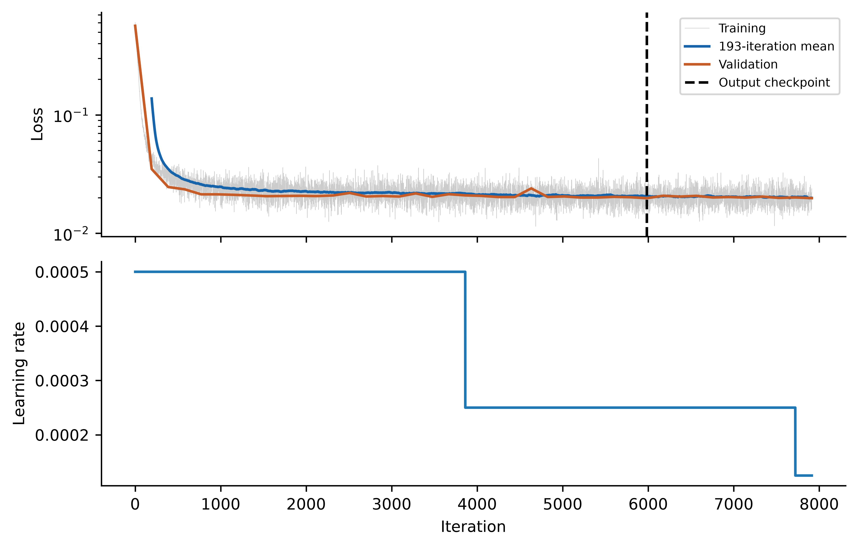
Scope of results. Empirical tables and figures use the corrected source-verified v2 run. Base-42 diagnostics vary meta seeds 42–44; expanded summaries cross base seeds 42–44 with those meta seeds. Fresh inference replay verifies the current artifacts. Historical data roles, reference-label sensitivity and station/threshold diagnostics qualify predictive interpretation.
Supplementary Fig. S1. Current Full3C base-42/meta-42 training and validation loss. The moving mean spans 193 iterations (one epoch). Output network iteration was 5983; training continued to iteration 7913. The learning-rate schedule is shown below.
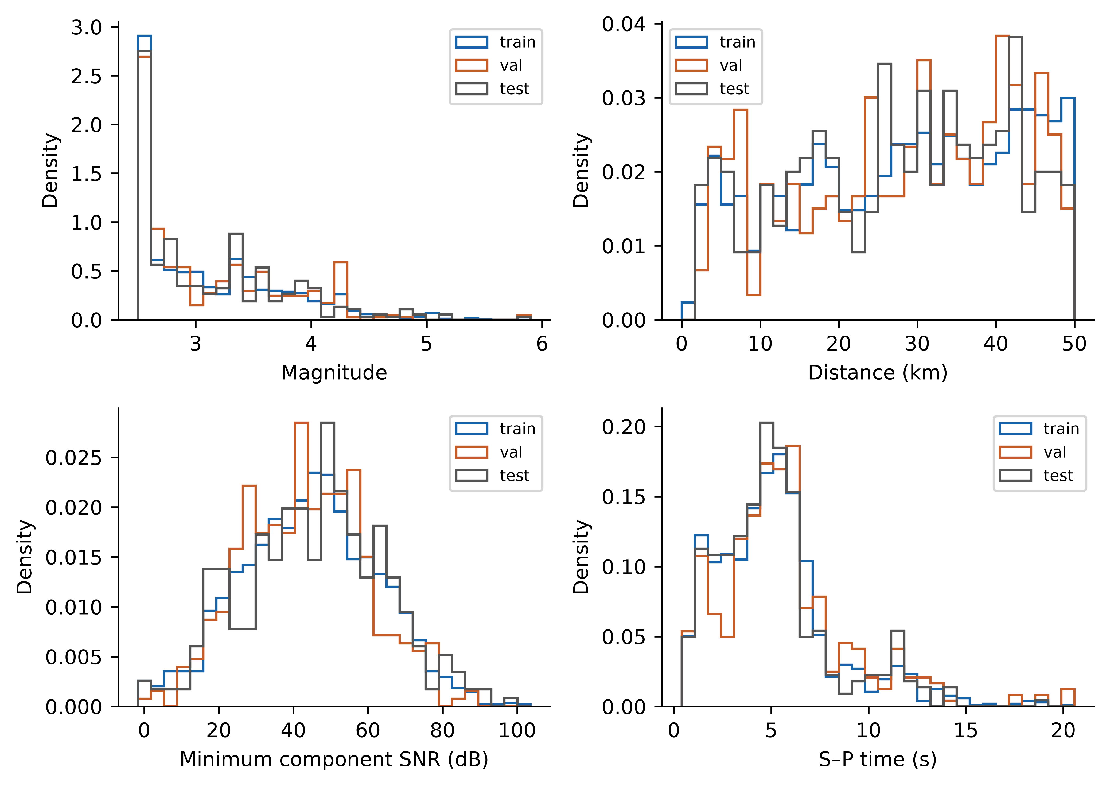
Supplementary Fig. S2. Recovered magnitude, distance, minimum component SNR and S–P time distributions by subset. Source disjointness is verified from identifiers, not from these distributions.
Supplementary Table S1. Statistics over all 330 current Full3C test tensors (6000 samples each; 1,980,000 time samples per channel). Sample SD uses n−1.
Ch. | Feature | Min | Max | Mean | SD | NaN / Inf
1 | P_STA | 0 | 1 | 0.0062666 | 0.066271 | 0 / 0
2 | S_STA | 0 | 1 | 0.0062666 | 0.066271 | 0 / 0
3 | Noise_STA | 0 | 1 | 0.99219 | 0.075265 | 0 / 0
4 | P_AIC | 0 | 1 | 0.0041777 | 0.054191 | 0 / 0
5 | S_AIC | 0 | 1 | 0.0041777 | 0.054191 | 0 / 0
6 | Noise_AIC | 0 | 1 | 0.99389 | 0.066808 | 0 / 0
7 | P_CNN | 1.0103e-08 | 0.98778 | 0.0024867 | 0.028303 | 0 / 0
8 | S_CNN | 2.6443e-12 | 0.9966 | 0.0029396 | 0.015484 | 0 / 0
9 | Noise_CNN | 0.0034005 | 0.99999 | 0.99457 | 0.032189 | 0 / 0
10 | P_TCN | 2.9367e-09 | 0.98743 | 0.0024009 | 0.032685 | 0 / 0
11 | S_TCN | 1.8046e-11 | 0.97655 | 0.0029954 | 0.024957 | 0 / 0
12 | Noise_TCN | 0.012574 | 1 | 0.9946 | 0.041079 | 0 / 0
13 | E | -30.302 | 36.117 | 4.203e-12 | 0.99992 | 0 / 0
14 | N | -36.129 | 42.767 | 1.9321e-11 | 0.99992 | 0 / 0
15 | Z | -34.743 | 25.54 | 7.8224e-12 | 0.99992 | 0 / 0
Supplementary Table S2. Three-seed mean F1 and percentile 95% source-cluster intervals, with paired Full3C minus Z-only differences.
Mode / comparison | Phase | Tolerance ms | Mean F1 / Δ | 95% CI
Full3C | P | 50 | 0.7049 | [0.6427, 0.7627]
Zonly | P | 50 | 0.6768 | [0.6121, 0.7380]
Full3C minus Zonly | P | 50 | 0.0280 | [0.0030, 0.0555]
Full3C | P | 100 | 0.8296 | [0.7807, 0.8753]
Zonly | P | 100 | 0.8059 | [0.7554, 0.8539]
Full3C minus Zonly | P | 100 | 0.0237 | [-0.0012, 0.0510]
Full3C | P | 200 | 0.9067 | [0.8701, 0.9394]
Zonly | P | 200 | 0.8963 | [0.8592, 0.9296]
Full3C minus Zonly | P | 200 | 0.0104 | [-0.0032, 0.0254]
Full3C | S | 50 | 0.3634 | [0.3063, 0.4186]
Zonly | S | 50 | 0.1691 | [0.1283, 0.2108]
Full3C minus Zonly | S | 50 | 0.1942 | [0.1380, 0.2507]
Full3C | S | 100 | 0.5455 | [0.4803, 0.6074]
Zonly | S | 100 | 0.2818 | [0.2274, 0.3347]
Full3C minus Zonly | S | 100 | 0.2637 | [0.2046, 0.3231]
Full3C | S | 200 | 0.6725 | [0.6122, 0.7298]
Zonly | S | 200 | 0.4176 | [0.3538, 0.4817]
Full3C minus Zonly | S | 200 | 0.2549 | [0.1959, 0.3155]
The 221 test sources were resampled with replacement, retaining all records from each selected source. We used 10,000 NumPy default_rng draws with seed 42. Each draw recomputed per-fit F1 before averaging the three meta fits. Modes share source draws. Intervals condition on the fixed models and split; they exclude training and split uncertainty.
Supplementary Table S3. Seed-42 absolute-error statistics for accepted (detected or uncertain) picks. Percentiles use linear interpolation; outlier percentages use accepted denominators. These single-seed diagnostics accompany Main Table 4 three-seed summaries.
Metric | Full3C P | Full3C S | Z-only P | Z-only S
Accepted picks | 327.00 | 322.00 | 328.00 | 315.00
MAE (ms) | 126.97 | 492.20 | 169.54 | 1170.00
Median AE (ms) | 30.00 | 80.00 | 30.00 | 250.00
RMSE (ms) | 649.26 | 1596.78 | 947.78 | 2532.54
P90 (ms) | 160.00 | 629.00 | 203.00 | 3980.00
Error >500 ms (%) | 2.14 | 13.35 | 2.44 | 34.60
Error >1 s (%) | 1.22 | 6.21 | 1.52 | 22.86
Error >2 s (%) | 1.22 | 5.28 | 1.52 | 16.19
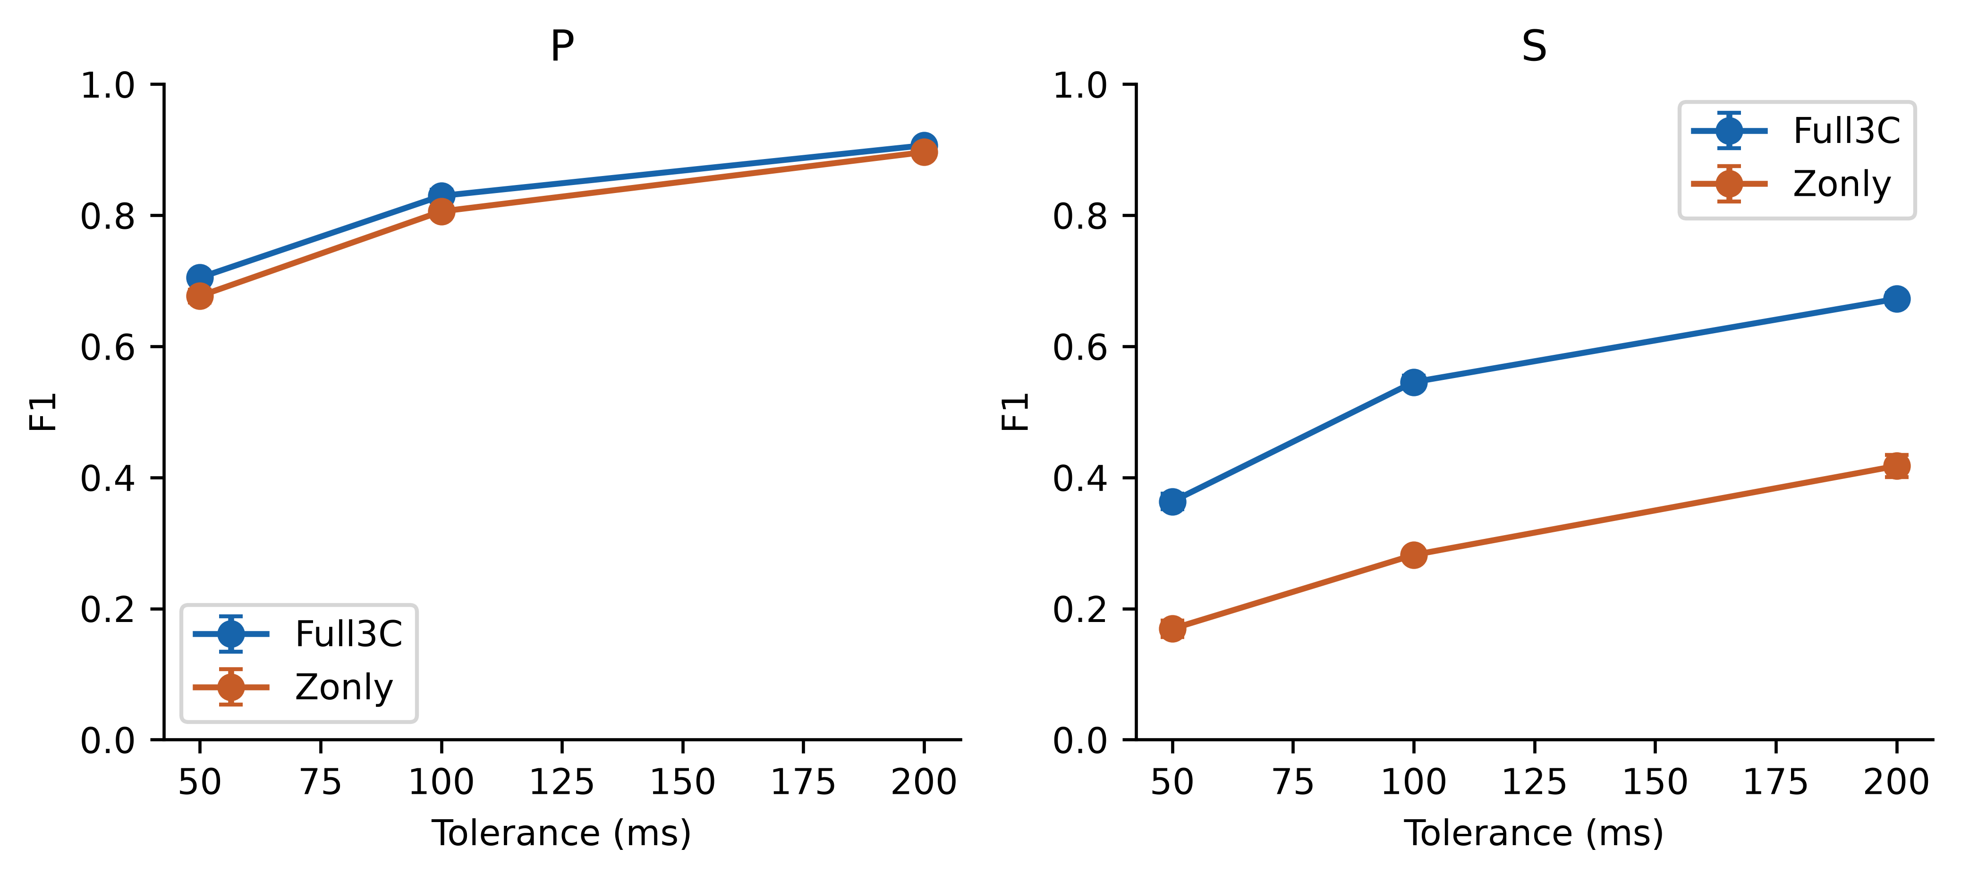
Supplementary Fig. S3. Mean F1 versus tolerance. Error bars show sample SD over three meta-learner seeds, not source-bootstrap intervals.
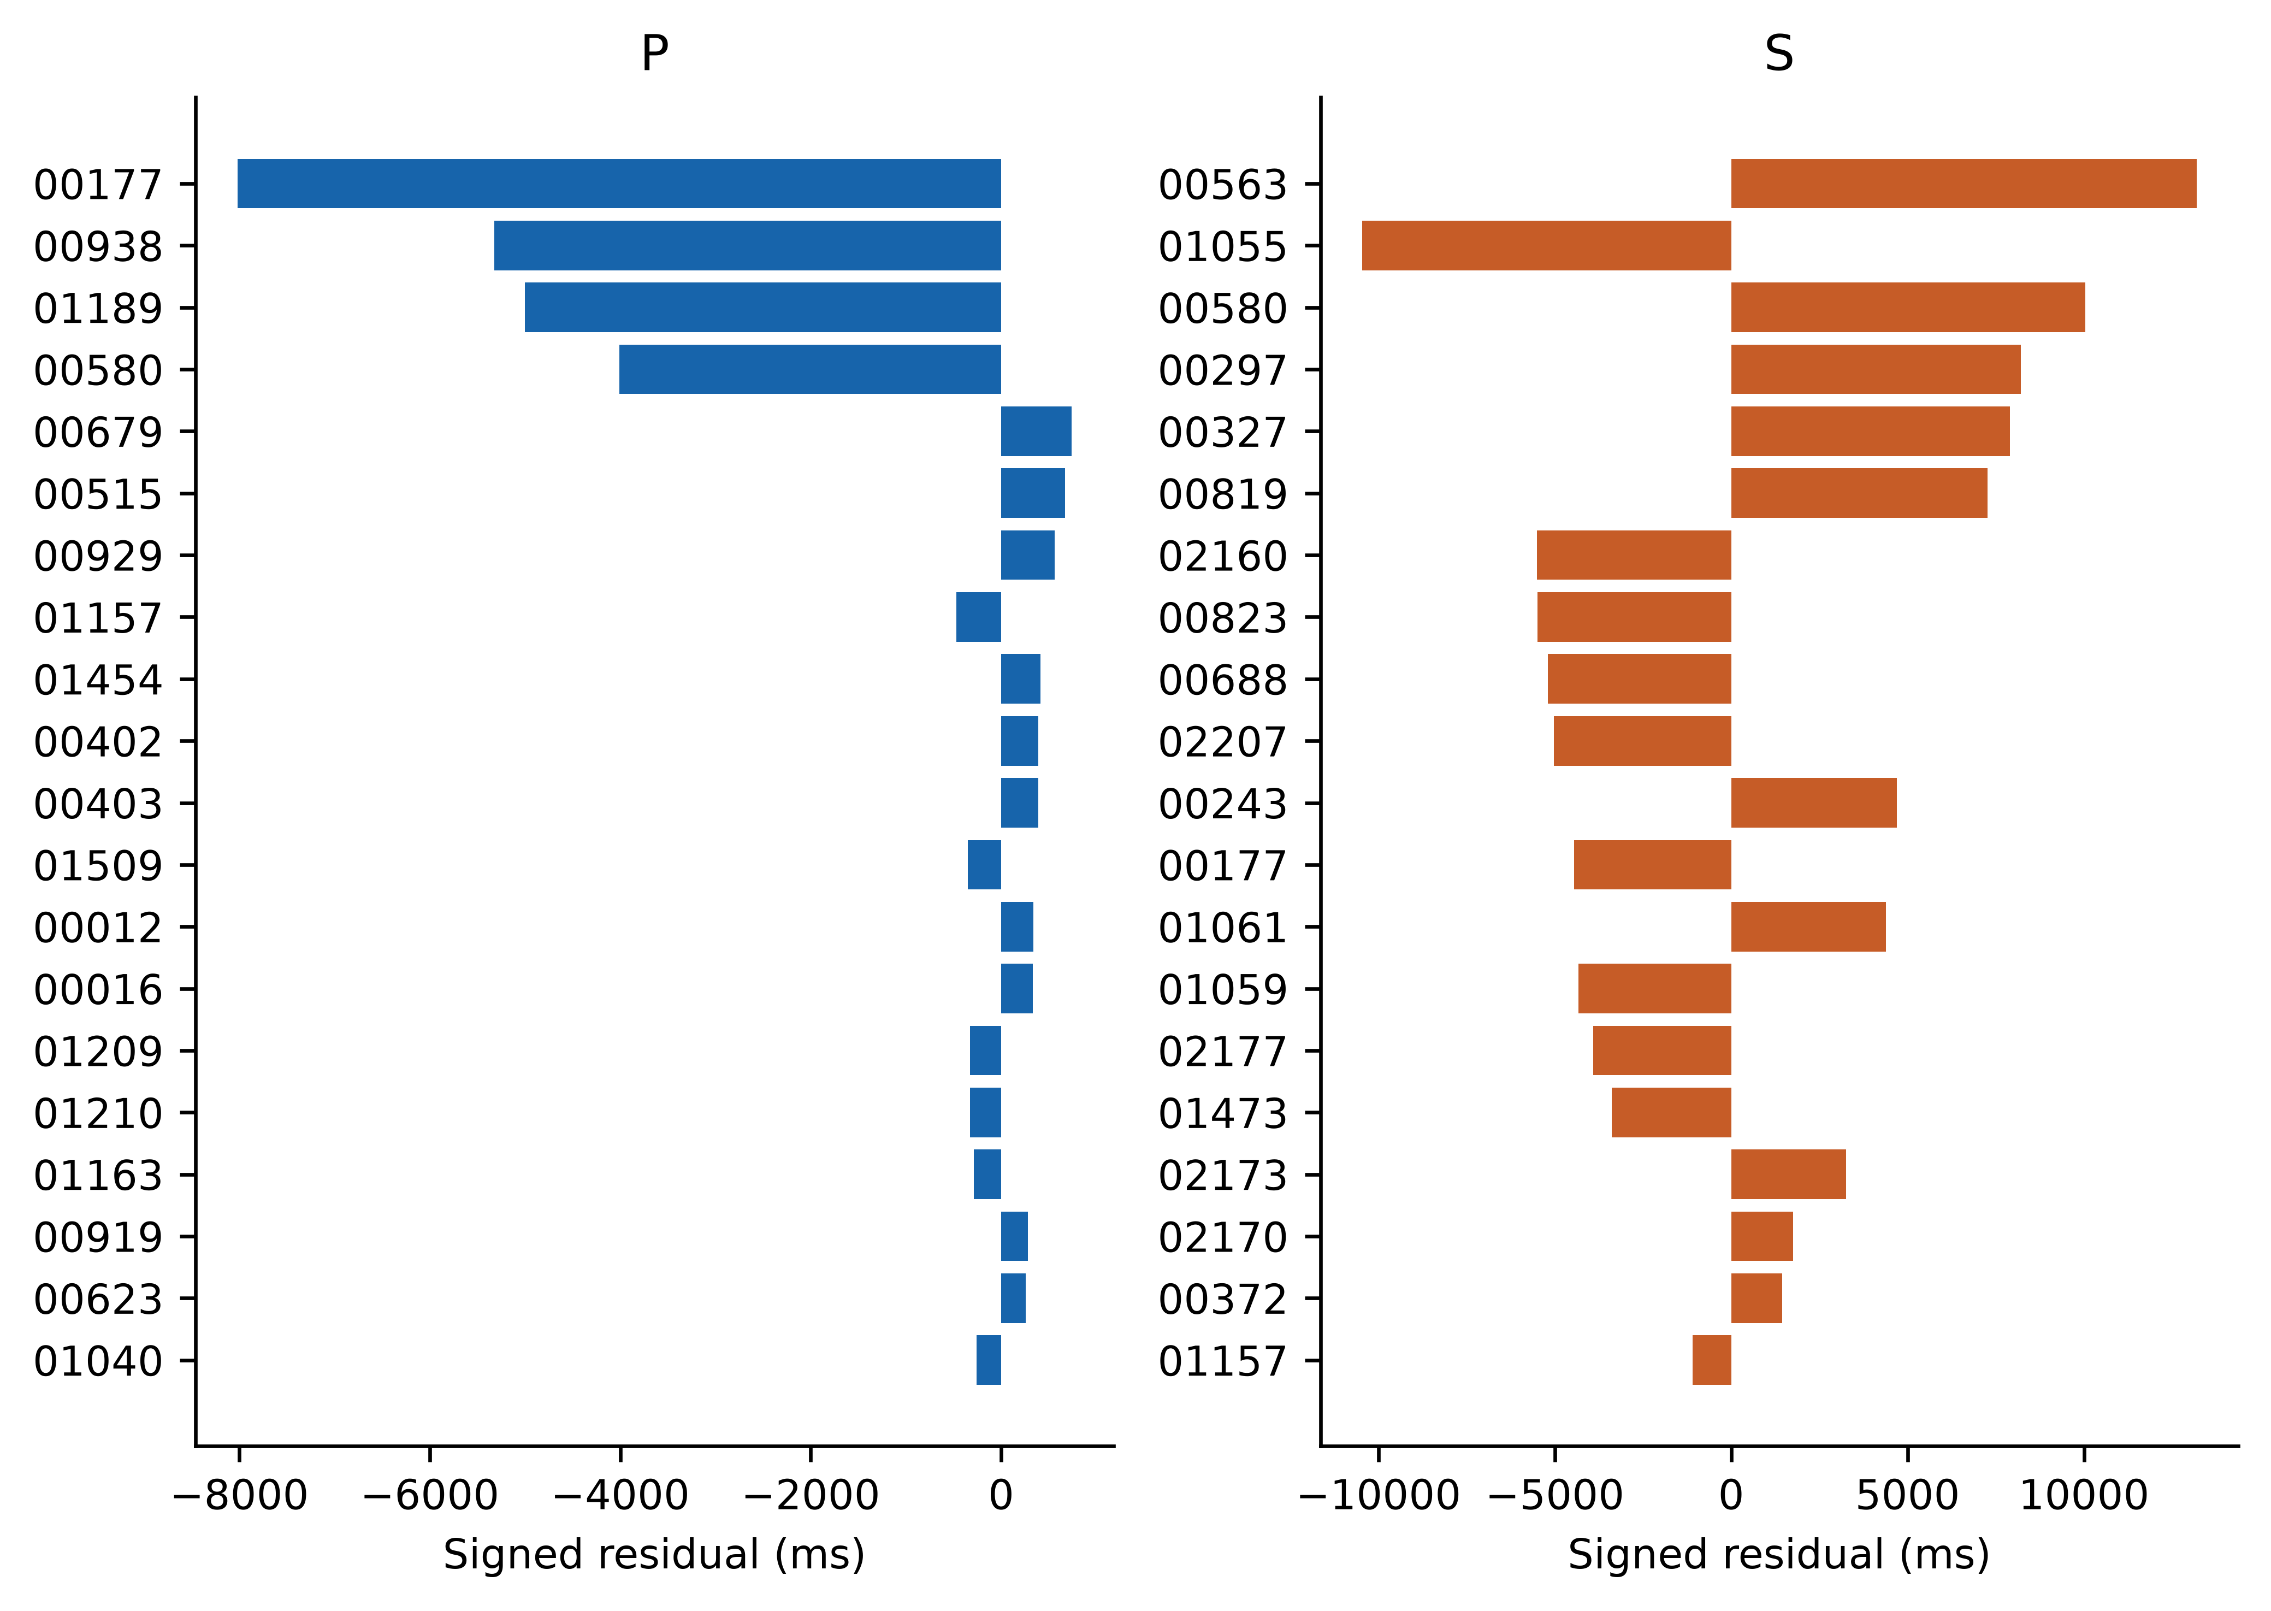
Supplementary Fig. S4. The 20 largest absolute P and S residuals among Full3C seed-42 accepted picks, with signed errors and event-ID suffixes. This is a ranked diagnostic, not an exhaustive waveform panel; selected waveforms appear in Main Fig. 14.
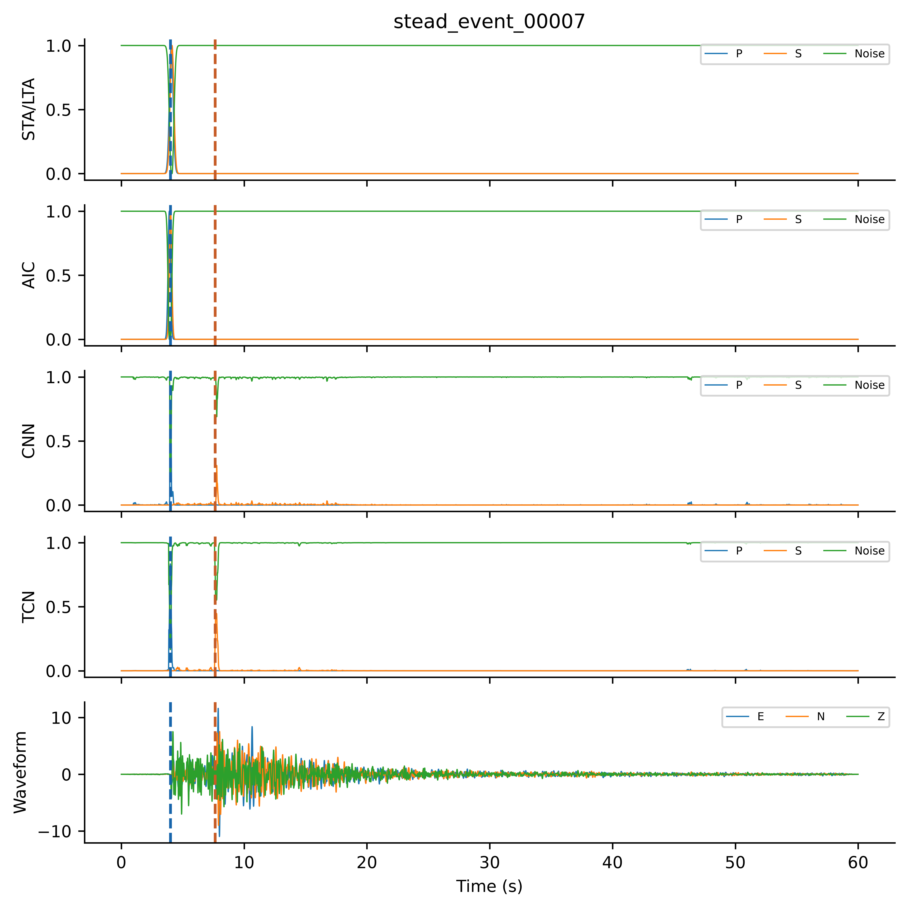
Supplementary Fig. S5. Current final Full3C test tensor for stead_event_00007. Twelve P/S/noise channels precede conditioned E/N/Z. Dashed lines show true arrivals; Table S1 covers all 330 test tensors.
Supplementary Table S4. Final settings for the completed source-verified 40-fit main workflow. Main Table 3 provides architecture and optimizer details. Logistic uses independent binary phase heads and does not isolate nonlinearity.
Category | Parameter | Value
Dataset | Population | 2234 records / 1477 sources
Dataset | Sampling; duration | 100 Hz; 6000 samples; 60 s
Curation | Distance; magnitude; SNR | Recovered population; see Main Table 1
Curation | Reference arrivals | 1817 records both manual; 417 include automatic/autopicker
Partition | Train sources / records | 1034 / 1544
Partition | Validation sources / records | 222 / 360
Partition | Test sources / records | 221 / 330
Partition | Source intersections | Zero for every pair
OOF | Grouping; folds; inner validation | source_id; 5; 15% of non-held sources
Meta input | Augmented training records | 3088 per mode
Meta input | Full / prob-only / waveform-only | 6000×15 / 6000×12 / 6000×3
Training | Completed fits | 40 (25 Full3C; 15 Z-only)
Seeds | Base / neural meta | 42 / 42,43,44
Augmentation | Noise; amplitude range | 20 dB; 0.5–2.0
Augmentation | Horizontal dropout | Probability 0.20
Augmentation | Time shift / polarity flip | Disabled / disabled
Logistic | Heads; target | P,S binary; phase mask >0.3
Logistic | Normalization | OOF-training mean and sample SD
Logistic | Subsampling / ridge penalty | Every 10th sample / 0.01
Logistic | Optimization | Newton; ≤100 iterations; gradient∞<1×10⁻⁶
Evaluation | Accepted / strict masks | Detected+uncertain / detected; finite
Evaluation | Tolerances | ±50, ±100, ±200 ms
Evaluation | MAE denominator | All accepted, including outliers
Bootstrap | Mean intervals | 10,000 source draws; NumPy seed 42
Software | Training | MATLAB R2024a
Software | Tables / figures | Python; NumPy, pandas, Matplotlib
Provenance | Frozen results | source-verified v2 / submission40
Provenance | Manifest at audit | 25,248 manifest entries matched across all runs
Supplementary Table S5. Full3C F1 on 330 records. Bases use final seed-42 fits; I-CNN entries are three-seed means (SD in Table S6). All methods use the primary decoder and acceptance policy. Weighted coefficients derive from phase-specific validation F1@100 ms, fixed before test evaluation.
Method | P50 | P100 | P200 | S50 | S100 | S200
STA/LTA | 0.2152 | 0.4576 | 0.7879 | 0.0062 | 0.0154 | 0.0463
AIC | 0.2848 | 0.3697 | 0.4364 | 0.0000 | 0.0000 | 0.0000
CNN | 0.6881 | 0.7890 | 0.8716 | 0.2595 | 0.3599 | 0.4533
TCN | 0.7003 | 0.8226 | 0.9021 | 0.3506 | 0.4935 | 0.6558
Mean ensemble | 0.6818 | 0.7879 | 0.8667 | 0.1131 | 0.1407 | 0.1590
Validation-weighted | 0.6848 | 0.7939 | 0.8667 | 0.3551 | 0.4958 | 0.6298
Stacker mean | 0.7049 | 0.8296 | 0.9067 | 0.3634 | 0.5455 | 0.6725
At base seed 42, TCN P/S F1@100 ms was 0.8226/0.4935 versus stacker means 0.8296/0.5455. The S difference had an exploratory paired interval of 0.0165–0.0902; the P interval included zero. This result concerns the current fixed split and these comparators. PhaseNetMatched appears separately in Table S16.
Supplementary Table S6. Full3C ablation. Neural variants report mean ± sample SD over seeds 42–44 on shared OOF features; logistic was fitted once. The last column gives control minus variant ΔF1@100 ms and paired source-cluster 95% interval (10,000 draws). These multiple intervals are exploratory and not multiplicity-adjusted.
Variant | Phase | F1@50 ms | F1@100 ms | F1@200 ms | Control − variant  Δ and 95% CI
Full15 control | P | 0.7049 ± 0.0033 | 0.8296 ± 0.0093 | 0.9067 ± 0.0060 | —
Full15 control | S | 0.3634 ± 0.0121 | 0.5455 ± 0.0099 | 0.6725 ± 0.0086 | —
Probability12 | P | 0.6947 ± 0.0094 | 0.8327 ± 0.0051 | 0.9087 ± 0.0082 | -0.0030  [-0.0162, 0.0105]
Probability12 | S | 0.3534 ± 0.0026 | 0.5177 ± 0.0143 | 0.6646 ± 0.0099 | +0.0278  [0.0056, 0.0523]
Waveform3 | P | 0.6762 ± 0.0097 | 0.7957 ± 0.0080 | 0.8815 ± 0.0033 | +0.0339  [-0.0055, 0.0774]
Waveform3 | S | 0.3110 ± 0.0061 | 0.4716 ± 0.0111 | 0.5923 ± 0.0092 | +0.0739  [0.0327, 0.1161]
No dilation | P | 0.7127 ± 0.0017 | 0.8325 ± 0.0068 | 0.9137 ± 0.0023 | -0.0029  [-0.0149, 0.0095]
No dilation | S | 0.3282 ± 0.0080 | 0.5133 ± 0.0062 | 0.6524 ± 0.0062 | +0.0322  [0.0059, 0.0600]
Logistic (n=1) | P | 0.7110 | 0.8117 | 0.8669 | +0.0179  [-0.0055, 0.0445]
Logistic (n=1) | S | 0.3791 | 0.5090 | 0.6354 | +0.0365  [-0.0021, 0.0786]
No two-SD significance threshold is used. Full-minus-probability-only, waveform-only and no-dilation intervals are above zero for S but include zero for P. Full-minus-logistic intervals include zero for both phases. These exploratory findings do not establish equivalence or essential nonlinearity.
Supplementary Table S7. Seed-42 counts and precision/recall at ±100 ms, preserving the record-level details underlying the three-seed summaries. Each mode has N=330 records; accepted includes detected and uncertain.
Mode | Phase | TP | FP | FN | Precision | Recall | F1
Full3C | P | 276 | 51 | 54 | 0.8440 | 0.8364 | 0.8402
Full3C | S | 181 | 141 | 149 | 0.5621 | 0.5485 | 0.5552
Zonly | P | 264 | 64 | 66 | 0.8049 | 0.8000 | 0.8024
Zonly | S | 90 | 225 | 240 | 0.2857 | 0.2727 | 0.2791

Supplementary Table S8. Dataset roles in the two-level workflow. Outer validation is intentionally reused across final model-selection stages. Current test labels are used for scoring, not v2 weight fitting or checkpoint selection; historical roles before correction are documented in Table S23.
Stage | Weight fitting / feature source | Selection / evaluation
OOF bases (each fold) | 85% of non-held training sources; augmented fitting records | 15% non-held sources for early stopping; held fold excluded from both
OOF meta features | Held-fold originals and augmented copies; matching fold bases | No held source in base fitting or inner validation
Final CNN/TCN | Outer training only; original + augmented | Outer validation for base checkpoint
Neural meta models | OOF features from outer training | Outer validation features from final bases for checkpoint
Logistic comparator | Subsampled OOF training; training-only scaling | Convergence criterion; no validation checkpoint
Weighted ensemble | Phase-specific validation F1 fixes coefficients | Outer validation reused; no test fitting
Decoder | Fixed archived thresholds and S window | No new threshold optimization in diagnostic analyses
Final evaluation | 330 test records / 221 sources | Fixed predictions; source-cluster bootstrap and diagnostic scoring

Supplementary Table S9. Accounting of the 40 completed training invocations. One logistic invocation fits two binary heads. Classical pickers and ensemble weighting are not neural training fits.
Training group | Full3C | Z-only | Total
CNN + TCN, five OOF folds | 10 | 10 | 20
CNN + TCN, final bases | 2 | 2 | 4
Full15, meta seeds 42–44 | 3 | 3 | 6
Probability12, Waveform3, no dilation; three seeds each | 9 | 0 | 9
Logistic comparator | 1 | 0 | 1
Total | 25 | 15 | 40

Supplementary Table S10. Detected-only results at ±100 ms on all 330 test records. Mean ± sample SD over meta seeds 42–44; fixed bases and split. S gating remains based on primary accepted P. Coverage is the mean percentage of finite detected picks.
Mode | Phase | F1 | MAE (ms) | Coverage (%)
Full3C | P | 0.8337 ± 0.0065 | 127.12 ± 2.04 | 97.98
Full3C | S | 0.5487 ± 0.0074 | 480.49 ± 41.75 | 94.75
Zonly | P | 0.8045 ± 0.0032 | 144.92 ± 20.44 | 97.88
Zonly | S | 0.2606 ± 0.0130 | 871.31 ± 161.18 | 64.55

Supplementary Table S11. Conditional S diagnostics at ±100 ms. Each denominator is the stated P-defined subset, not the whole test set. P-rejected and constrained/unconstrained difference counts are also retained in decoder_diagnostics.csv. Unconstrained decoding changes both search domain and quality scoring.
Mode / seed | P subset | N | S F1 | S MAE ms
Full3C/42 | P accepted | 327 | 0.5578 | 492.20
Full3C/42 | P within 100 ms | 276 | 0.6058 | 445.92
Full3C/43 | P accepted | 326 | 0.5387 | 617.62
Full3C/43 | P within 100 ms | 271 | 0.5885 | 573.65
Full3C/44 | P accepted | 329 | 0.5469 | 553.51
Full3C/44 | P within 100 ms | 271 | 0.5874 | 512.66
Zonly/42 | P accepted | 328 | 0.2799 | 1170.00
Zonly/42 | P within 100 ms | 264 | 0.3217 | 1090.87
Zonly/43 | P accepted | 324 | 0.2825 | 1220.65
Zonly/43 | P within 100 ms | 265 | 0.3095 | 1182.09
Zonly/44 | P accepted | 326 | 0.2885 | 1150.56
Zonly/44 | P within 100 ms | 264 | 0.3198 | 1081.96

Supplementary Table S12. Network–receiver coverage from recovered upstream metadata. Keys combine network_code and receiver_code and do not identify station epochs. Source grouping does not exclude station reuse or establish geographic generalization.
Subset | Records | Sources | Station keys | Network codes
train | 1544 | 1034 | 101 | 31
val | 360 | 222 | 59 | 23
test | 330 | 221 | 64 | 23
The most frequent test codes are PB (99 records), AV (36), HV (26) and MN (23). PB contributes 30.0% of test records. Geographic coordinates are available in recovered metadata, but no geographic holdout was designed or evaluated. Fifty-five of 64 test network–receiver keys occur in training (318 records). Nine unseen keys contain 12 records from ten sources and are also absent from validation. Table S26 gives retrospective performance strata; these keys do not identify station epochs.

Supplementary Implementation Details

Classical score construction
These definitions describe the retained classical implementations used in the corrected v2 run. Two deterministic score generators and two learned softmax models supply the base features. Classical P/S/noise scores are bounded but uncalibrated and need not sum to one.
STA/LTA uses fs=100 Hz, staSec=0.10, ltaSec=1.00, trigOn=3.0, and Gaussian width 0.15 s. For MATLAB indices i=101,…,6000, LTA is mean(x(i−100:i−1)) and STA is mean(x(i−10:i)); the latter therefore contains 11 samples. The first 100 ratio values are zero. The ratio is STA/max(LTA,10⁻¹⁰), followed by record-wise min–max normalization. A range below 10⁻¹⁰ yields an all-zero normalized ratio. P uses abs(Z). S uses sqrt(E²+N²) only when both E and N contain nonzero values; otherwise it uses abs(Z).
The first global maximum of each normalized ratio determines the score centre. The threshold is trigOn/(trigOn+1)=0.75 on that normalized curve. Every nonconstant normalized ratio has maximum 1, so it produces a unit-height Gaussian exp(−(t−tpeak)²/(2×0.15²)); this is not raw-ratio threshold triggering. The alternative branch smooths the normalized curve using smoothdata with a Gaussian window of 15 samples. Scores are clipped to [0,1]. trigOff=1.5 is present in configuration but unused; no hysteresis is implemented.
AIC uses signed Z for P and the same horizontal-resultant/fallback rule for S. Candidate indices are k=2,…,min(T−2,1000). The criterion is k log(max(var(x(1:k)),10⁻¹⁵))+(T−k−1) log(max(var(x(k+1:T)),10⁻¹⁵)), where MATLAB var uses sample variance. Noncandidate indices are Inf; the earliest finite minimum determines a Gaussian score with sigma=0.10 s and height 1. The right segment extends to the end of the record: this is an initial-index search, not a sliding 10 s window. Time is (k−1)/100, so the latest centre is 9.99 s. Both classical generators define noise=max(0,1−max(P,S)).
The AIC centre bound precedes 128/1544 training P and 1148/1544 training S arrivals, 30/360 validation P and 273/360 validation S arrivals, and 15/330 test P and 234/330 test S arrivals. These counts describe centre-search coverage, not final decoded errors. Under Z-only fallback the classical P/S channels are identical by construction; Table S13 verifies this for all current cached meta tensors.

Conditioning and enhanced representation
Each channel is demeaned, linearly detrended, filtered using butter(4,[1,45]/50,"bandpass") and filtfilt, and normalized by (x−mean(x))/(std(x)+10⁻¹⁰). Clipping is disabled. An all-zero channel remains zero. Hilbert-envelope channels are divided by their standard deviation only if it exceeds 10⁻¹⁰. Z short-term energy uses movmean(Z²,10), with MATLAB default endpoint handling, and is similarly divided by its standard deviation. The Z characteristic-function channel uses the same 11/100-sample indexing as above, but leaves the ratio zero when LTA≤10⁻¹⁰; it is divided by its standard deviation only when that deviation exceeds 10⁻¹⁰. No other feature normalization is applied.

Augmentation and fallback
One augmented copy is added per original training record. Operations are additive Gaussian noise (20 dB), one common scale sampled uniformly from [0.5,2], then horizontal dropout. Noise power is based on mean waveform power across all components in Full3C and Z alone in Z-only; Z-only noise is zero on E/N. With total probability 0.20, dropout selects E-only, N-only, or both uniformly. Each mode has probability 0.20/3, and each individual horizontal channel is dropped with probability 0.20×2/3. Time shift and polarity reversal are disabled. E/N are forced to zero again in Z-only. Enhanced features are rebuilt without repeating conditioning; labels are regenerated from the unchanged time grid and arrival times. Neural-layer dropout is separate from this augmentation: CNN 0.30, TCN 0.20, and I-CNN 0.30.

Soft targets and weighted loss
Targets are Gaussian masks with sigmaP=0.06 s and sigmaS=0.08 s, truncated at four standard deviations. Noise=max(0,1−max(yP,yS)); targets are not normalized. Their sum is 1+min(yP,yS). For neural training the per-position contribution is −Σk wk yk log(pk), with weights [1,1,1] for CNN/TCN and [1.5,2.5,0.5] for neural meta-models. Datastore targets are multiplied by the weights before MATLAB trainnet with crossentropy. Its default reduction and the stated L2 regularization are retained. Writing ak=wk yk and A=Σk ak, this contribution equals −AΣk(ak/A)log(pk): target mass supplies a local weight. It is not crossentropy against normalized targets with uniform sample weight.
A MATLAB R2024a numerical check with predictions [0.2,0.3,0.5] and preweighted targets [1.5,0,0] returned 2.41415691, matching −1.5 log(0.2)=2.41415687. The overlap counts in Table S14 use the original CSV sec grid and the exact truncation expression; rebuilding the grid can alter a boundary sample through floating-point rounding.

Decoder details and verification
The earliest P maximum is selected on the full record. Quality is peak/(mean(score)+10⁻⁶). A candidate is detected for peak≥0.30 and quality≥3; otherwise it is uncertain for peak≥0.15 and not detected below 0.15. Both detected and uncertain P candidates open the S search. Its domain is the record grid 0.1–30 s after accepted P; a numerical tolerance of 10⁻¹⁰ s includes endpoints. If P is not accepted or the domain is empty, no S candidate is returned. S quality uses the mean only inside that domain. Unconstrained decoding removes both the gate and interval. Detected-only scoring filters the resulting statuses; it does not rerun the gate using detected P alone.
MATLAB checks passed for zero-waveform normalization, enhanced-feature finiteness, Z-only and one-horizontal-component fallback, preweighted crossentropy, accepted-uncertain P gating, rejected-P gating, and both S-window endpoints. The checks establish current implementation behavior, not the historical rationale for selecting thresholds. The final code and provenance records alone do not establish which data informed their earliest development; no stronger claim about historical threshold selection is made. Documentary threshold evidence is now provided in Table S20; the July values predate the September extension, while the original data-informed rationale remains unknown. Table S27 reports a predefined sensitivity grid applied to fresh fixed-model predictions, without selecting a replacement threshold.
Supplementary Table S13. Complete scan of available Z-only meta-feature caches. Each tensor has 6,000×15 values. Counts refer to cached train, validation, and test features; they do not assert inspection of every temporary historical 8-channel OOF tensor.
Cache | Tensors | NaN/Inf | Nonzero E/N | Unequal STA P/S | Unequal AIC P/S
Augmented train | 3088 | 0 | 0 | 0 | 0
Validation | 360 | 0 | 0 | 0 | 0
Test | 330 | 0 | 0 | 0 | 0
Supplementary Table S14. Overlap of positive P/S target masks on original stored CSV time grids. Augmented copies preserve the labels; doubled counts therefore follow the unchanged-label augmentation rule.
Population | Records | Overlap records | Overlap samples
train | 1544 | 4 | 53
val | 360 | 0 | 0
test | 330 | 1 | 12
Augmented train (labels preserved) | 3088 | 8 | 106
Availability of implementation checks. Tables S13–S14 were regenerated from the current v2 caches and CSV labels. They are not receipts for historical release caches. The numerical audit scripts and regenerated figures accompany this revision.

Additional base seed experiments and PhaseNetMatched
The extension retains the frozen source split, OOF assignments, augmentation seeds, conditioning, labels, and decoder. Each additional base seed (43, 44) rebuilds its own OOF scores before meta training at seeds 42–44. Base-42 ablations remain restricted to base seed 42. There are 106 fits overall: 40 main, 60 additional stacking fits, and six baseline fits. Repeated meta fits sharing base models must not be counted as independent pipeline replicates.
Supplementary Table S15. Stacking F1@100 ms by base seed. Values are mean ± sample SD across its three meta seeds; this within-base SD differs from Main Table 6.
Mode | Base seed | P F1 | S F1
Full3C | 42 | 0.8296 ± 0.0093 | 0.5455 ± 0.0099
Full3C | 43 | 0.8319 ± 0.0047 | 0.5682 ± 0.0022
Full3C | 44 | 0.8189 ± 0.0068 | 0.5472 ± 0.0129
Zonly | 42 | 0.8059 ± 0.0041 | 0.2818 ± 0.0042
Zonly | 43 | 0.8138 ± 0.0024 | 0.2519 ± 0.0050
Zonly | 44 | 0.8205 ± 0.0030 | 0.2721 ± 0.0161
Supplementary Table S16. PhaseNetMatched per-seed accepted-pick results at ±100 ms. All fits use 330 test records; coverage is a percentage.
Mode | Seed | Phase | F1 | MAE ms | Coverage %
Full3C | 42 | P | 0.9818 | 41.09 | 100.00
Full3C | 42 | S | 0.5788 | 179.55 | 100.00
Full3C | 43 | P | 0.9848 | 28.33 | 100.00
Full3C | 43 | S | 0.6198 | 164.00 | 98.48
Full3C | 44 | P | 0.9833 | 33.98 | 99.70
Full3C | 44 | S | 0.5584 | 166.81 | 99.70
Zonly | 42 | P | 0.9879 | 21.48 | 100.00
Zonly | 42 | S | 0.2939 | 602.42 | 100.00
Zonly | 43 | P | 0.9833 | 26.50 | 99.70
Zonly | 43 | S | 0.3196 | 441.99 | 99.09
Zonly | 44 | P | 0.9788 | 28.94 | 100.00
Zonly | 44 | S | 0.2848 | 468.48 | 100.00
Supplementary Table S17. Expanded detected-only F1@100 ms and coverage. Stacking averages nine crossed fits; PhaseNetMatched averages three fits. S gating still uses accepted P before applying the detected-only mask.
Method | Mode | Phase | F1 | Coverage %
Stack | Full3C | P | 0.8306 | 97.81
Stack | Full3C | S | 0.5565 | 94.58
Stack | Zonly | P | 0.8141 | 97.78
Stack | Zonly | S | 0.2571 | 70.81
PhaseNetMatched | Full3C | P | 0.9833 | 99.90
PhaseNetMatched | Full3C | S | 0.5860 | 98.59
PhaseNetMatched | Zonly | P | 0.9838 | 99.39
PhaseNetMatched | Zonly | S | 0.3002 | 97.88
Supplementary Table S18. Training accounting for the corrected main experiment and extension.
Experiment | Calculation | Fits
Corrected main experiment | Table S9 | 40
Additional CNN/TCN | 2 base seeds × 2 modes × 12 fits | 48
Additional full stacker | 2 base seeds × 2 modes × 3 meta seeds | 12
PhaseNetMatched | 2 modes × 3 seeds | 6
Total | Main plus extension | 106

PhaseNetMatched architecture and protocol
PhaseNetMatched follows the encoder–decoder pattern described by Zhu and Beroza (2019), with the SeisBench PhaseNet source as the implementation reference (Woollam et al., 2022; https://github.com/seisbench/seisbench/blob/main/seisbench/models/phasenet.py). It is an independent MATLAB adaptation, not the official implementation. Five levels use 8–128 filters, kernel 7 and stride 4, BN epsilon 10⁻³, ReLU, transposed convolutions and skip concatenation. Same padding and centre cropping replace explicit asymmetric padding; initialization, biases and BN defaults also differ. No dropout is used. Input is three conditioned waveforms. Training uses batch 2 and the meta-model loss weights [1.5,2.5,0.5]; remaining optimization settings are stated in Methods. Consequently the comparison matches data and evaluation, not feature or compute budgets.

Independent numerical audit
The independent audit recalculated 1,260 metric rows from 70 prediction sets under accepted, strict and unconstrained scoring. Each table contains the same 330 records from 221 verified sources and agrees with the frozen reference labels. Counts, precision, recall, F1, coverage, MAE, median absolute error, RMSE and one-second outlier rates agreed within absolute tolerance 1e-6 and relative tolerance 1e-10. All 25,248 entries across current input manifests matched 2,336 unique files. All 106 checkpoints loaded and passed source-exclusion checks. Expanded intervals use 10,000 common source draws with per-fit F1 recomputation before averaging; they exclude training/split uncertainty and are not multiplicity-adjusted. Fresh waveform-to-inference replay is detailed in Table S21.
Archive scope. Source-verified v2 results supersede historical partition assignments and predictions. Release source-verified-v2.0.0 (Git commit 8e82c781a1641191b6b56b15688d68e269b24918) is archived at https://doi.org/10.5281/zenodo.22824997. All 1,241 package-manifest entries, including 106 checkpoints, match the downloaded archive. Earlier release DOIs identify historical states. This availability wording was updated after DOI assignment; the archived code, protocol, checkpoints, predictions and numerical results are unchanged.
Executable software contribution and provenance
Supplementary Table S19. Reusable workflow contracts and executable demonstration. These are integration and auditing capabilities; the underlying grouped-OOF, stacking and hashing techniques are established.
Component | Contract or failure detected | Implementation and scope
Identity propagation | Source identity survives record duplication and augmentation | pipeline_contracts.py; 42 augmented-parent checks
Grouped OOF | Held-out source excluded from fold fitting | grouped_folds / validate_oof; three synthetic folds
Feature interface | Explicit STA/AIC/CNN/TCN P/S/noise plus E/N/Z order | validate_features; makeMeta.m; assertRepresentation.m
Artifact provenance | Checkpoint and waveform identities match recorded hashes | checkpoint_manifest.csv; replay_models.m
Dependency-aware summary | Meta fits are averaged within their shared base before between-base SD | summarize_crossed_seed; archived numerical audit
Model replay | Saved networks reproduce pick times/statuses under the retained decoder | Fresh v2 replay: all 106 checkpoints; test predictions and OOF tensors (Table S21)
Negative controls | Overlap, changed parent, contaminated OOF, swapped features and changed bytes rejected | demonstrate_contracts.py; five expected rejections
Supplementary Table S20. Documentary threshold provenance. Dates below are Git author dates, not evidence of which observations informed initial parameter selection.
Version / commit | Date | Recorded settings
Initial code f566a26b3be5 | 21 July 2026 | peak 0.30; quality P/S 3; S lag 0.1–30 s
Configuration 2a3a87d95a2f | 12 August 2026 | Same five numerical settings
Original package 767be754d415 | 15 September 2026 | Same settings in original clean configuration
Expanded package e235f749540a | 16 September 2026 | Same settings; current uncertain threshold = 0.5 × 0.30
The public v1.0.0 release metadata reports publication on 21 July 2026 at 04:34 UTC. Full commit identifiers, configuration blob hashes and extracted assignments are supplied in threshold_history.json. This establishes documentary continuity of the settings before the September extension. It does not establish validation-only initial calibration or absence of all historical test-informed decisions, and it does not imply identical behavior of legacy and current decoder implementations. No recalibration was performed for this revision. The subsequent 27-setting sensitivity analysis retains the primary configuration and does not resolve the unknown initial calibration history.
Supplementary Table S21. Current numerical, source-verification and fresh inference replay scope and outcomes.
Check | Scope | Outcome
Prediction/label identity | 70 sets × 330 records / 221 sources | All match the frozen test protocol
Metric recomputation | 1260 rows; accepted, strict, unconstrained | Zero discrepancies within stated tolerances
Input manifests | 25,248 entries / 2,336 unique files | All SHA-256 values match
Checkpoint loading and source audit | 106 current fitted models | All load; fit/validation disjoint and test excluded
Actual OOF memberships | 6 mode/base manifests × 1544 records | Match the frozen source-disjoint folds
Fresh test inference | 70 sets × 330 records; two decoders | Zero pick/status mismatches; times within 1e-7 s
Fresh test meta features | 6 mode/base groups × 330 tensors | Maximum absolute difference 0; tolerance 1e-6
Fresh OOF features | 6 groups × 3088 original/augmented tensors | Maximum absolute difference 0; tolerance 1e-6
Replay integrity | 106 checkpoint hashes and 89 code files | Unchanged after replay; no training
Fresh GPU inference replay loaded all 106 v2 checkpoints and rebuilt features from the original waveform CSVs. Across six mode/base combinations, all 18,528 original and augmented OOF tensors and 1,980 test meta tensors agreed with their saved counterparts within absolute tolerance 1e-6 (maximum differences 0 and 0, respectively). All 70 final prediction sets, each with 330 records, reproduced constrained and unconstrained pick availability, statuses and times within 1e-7 s, with zero mismatches. Saved validation-derived ensemble weights were retained. This verifies inference and feature reconstruction for the frozen artifacts, not retraining determinism or independent predictive validation. Replay reads the original CSV time grids and waveforms, reapplies conditioning and each input mode, and reconstructs original and augmented OOF inputs in saved order with augmentation seed 4242. Each OOF model excludes its held source from fitting and inner validation. Checkpoint hashes are checked before loading, and all code/model hashes are checked again after completion. Frozen ensemble weights are not re-estimated. Prediction receipts separately report pick/status mismatch counts and numerical quality-score differences. No training is performed.
Supplementary Table S22. Recovery of physical waveform identities and consequences for evaluation. The current run uses recovered source identities and new source-disjoint partitions.
Check | Scope | Outcome
Waveform identity recovery | 2234 exported waveforms | 2234 numerical matches; 1477 sources
Upstream metadata cross-check | Recovered trace/source identities | 2234 agreements
Historical test overlap with train | 335 historical test records | 151 records share a physical source
Historical test overlap with train or validation | 335 historical test records | 168 records share a physical source
Corrected outer source overlap | 1034 / 222 / 221 sources | Zero in every pair
Original filter claim | Distance ≤15 km and min SNR ≥10 dB | Not valid for the full retained population
Recovered label convention | CSV labels versus upstream sample | floor(sample)/100 for both phases
Reference pick status | 2234 recovered records | 1817 both manual; 417 include automatic/autopicker
Exhaustive fingerprint multiplicity | 1,265,657 local waveform datasets | 2234 distinct selected hashes; one match each
Ambiguous identity / read failures | All selected matches / full archive | 0 conflicting sources / 0 read errors
Content matching recovered all 2,234 waveform identities and 1,477 original STEAD source IDs. Upstream metadata agreed for every recovered trace. The earlier ordinal metadata join produced physical-source overlap: 151/335 historical test records shared a source with training, and 168/335 with training or validation. This motivated a complete rerun, rather than relabeling historical model outputs.
The exhaustive audit hashed all 1,265,657 waveform datasets in the local HDF5 archive, with no phase-label or metadata filtering. All 2,234 selected fingerprints were distinct and each matched exactly one trace, with zero conflicting source assignments or read errors. Hashes use little-endian float32 values in column-major E/N/Z order, without normalization. Current CSV fingerprints independently agree with the frozen mapping. This verifies exact numerical multiplicity in this archive version, not near duplicates or catalogue identity truth. Initial identity recovery and split freezing preceded v2 training; exhaustive uniqueness verification followed training. The original export recipe remains unavailable. All CSV P/S labels equal floor(upstream arrival sample)/100; 94 P and 124 S labels differ from fractional upstream samples by at most 9.01 ms. These labels were retained consistently for all corrected training and evaluation.

Retrospective sensitivity and provenance
Supplementary Table S23. Historical-to-current role transitions. Record counts are exclusive; source counts indicate any membership and are nonexclusive.
Unit | Historical role | Current train | Current validation | Current test
Record | Train | 1072 | 251 | 233
Record | Validation | 249 | 48 | 46
Record | Test | 223 | 61 | 51
Source | Train | 804 | 177 | 177
Source | Validation | 225 | 46 | 44
Source | Test | 209 | 53 | 48
A physical source could occupy several historical roles, so source rows must not be summed. Of 221 current test sources, 196 had at least one historical training/validation record, covering 304 current test records. The remaining 25 sources (26 records) had historical test exposure. This role audit does not reconstruct every research decision or prove that every exposed record influenced one. It establishes no development-naive test subset. Exclusive source-role patterns and record-level transitions are supplied as CSVs.
Supplementary Table S24. Recovered upstream reference-pick status by current split.
Split | All records | Both phases manual | At least one nonmanual
Train | 1544 | 1224 | 320
Validation | 360 | 306 | 54
Test | 330 | 287 | 43
Nonmanual denotes automatic or autopicker status for at least one arrival. Manual status is a metadata category, not an independent reannotation. The manual-only test sensitivity retains 287 records from 188 sources; the complement contains 43 records from 36 sources. Some sources contribute to both strata. All original model fits are retained.
Supplementary Table S25. S component-access sensitivity at ±100 ms under accepted scoring. Values average nine stackers or three baseline fits; differences are calculated before rounding. Conditional paired 95% intervals use 10,000 source-cluster draws.
Evaluation subset | Method | N / sources | Full3C F1 | Z-only F1 | ΔF1 [95% interval]
All test | Stack | 330 / 221 | .5536 | .2686 | .2850 [.2293, .3418]
Both manual | Stack | 287 / 188 | .5476 | .2770 | .2705 [.2113, .3299]
Both manual | PhaseNet | 287 / 188 | .5655 | .3105 | .2550 [.2013, .3085]
No historical train/val | Stack | 26 / 25 | .4444 | .1974 | .2470 [.0582, .4462]
No historical train/val | PhaseNet | 26 / 25 | .4643 | .2451 | .2192 [.0503, .3905]
Manual and no historical train/val | Stack | 20 / 19 | .3647 | .1599 | .2047 [−.0092, .4390]
Manual and no historical train/val | PhaseNet | 20 / 19 | .3333 | .2342 | .0991 [−.0794, .2802]
Manual-subset stacking P F1 is 0.8093/0.7982 for Full3C/Z-only; PhaseNetMatched gives 0.9913/0.9843. Its P advantage remains clear in conditional intervals. Manual S stacker-minus-baseline intervals include zero in both modes. All nine stacking component differences remain positive for manual S (range 0.2403–0.3078). The smallest intersection yields intervals spanning zero for both methods. Neither the subset comparisons nor their overlapping populations isolate a causal annotation effect; the absence of historical train/validation membership does not remove historical test exposure. Full per-fit metrics and intervals for six subsets accompany this table.
Supplementary Table S26. Station-key sensitivity at ±100 ms with accepted scoring. Network and receiver codes identify keys, not station epochs.
Station-key stratum | Method | N / sources | Full3C P / S | Z-only P / S
Seen in training | Stack | 318 / 211 | 0.8266 / 0.5430 | 0.8126 / 0.2690
Seen in training | PhaseNet | 318 / 211 | 0.9858 / 0.5742 | 0.9858 / 0.3024
Unseen in training | Stack | 12 / 10 | 0.8333 / 0.8333 | 0.8333 / 0.2593
Unseen in training | PhaseNet | 12 / 10 | 0.9167 / 0.8889 | 0.9167 / 0.2222
The seen stratum contains 55 test keys. The nine keys unseen in training are also absent from validation and include only 12 records from ten sources. This post hoc stratum is not a station-held-out sampling design. For unseen-key S, Full3C-minus-Z-only intervals are [0.3131, 0.7863] for stacking and [0.3636, 0.8974] for PhaseNetMatched. Stacker-minus-baseline S intervals are [−0.1667, 0.0667] in Full3C and [−0.0684, 0.1444] in Z-only. These intervals resample ten sources and do not separately quantify station-level sampling uncertainty. Such a small conditional diagnostic does not support a general station-transfer claim.
Supplementary Table S27. Predefined threshold-grid sensitivity at ±100 ms. Ranges span 27 settings; counts refer to pointwise exploratory intervals.
Policy / phase | Contrast | Minimum ΔF1 | Maximum ΔF1 | CI above / below zero
accepted / P | Stack Full3C − Z | 0.0127 | 0.0156 | 9 / 0 of 27
accepted / P | PhaseNet Full3C − Z | -0.0005 | 0.0000 | 0 / 0 of 27
accepted / P | Stack − PhaseNet Full3C | -0.1577 | -0.1544 | 0 / 27 of 27
accepted / P | Stack − PhaseNet Z | -0.1705 | -0.1699 | 0 / 27 of 27
accepted / S | Stack Full3C − Z | 0.2839 | 0.2856 | 27 / 0 of 27
accepted / S | PhaseNet Full3C − Z | 0.2862 | 0.2873 | 27 / 0 of 27
accepted / S | Stack − PhaseNet Full3C | -0.0338 | -0.0315 | 0 / 0 of 27
accepted / S | Stack − PhaseNet Z | -0.0316 | -0.0305 | 0 / 0 of 27
strict / P | Stack Full3C − Z | 0.0156 | 0.0168 | 27 / 0 of 27
strict / P | PhaseNet Full3C − Z | -0.0005 | -0.0005 | 0 / 0 of 27
strict / P | Stack − PhaseNet Full3C | -0.1544 | -0.1524 | 0 / 27 of 27
strict / P | Stack − PhaseNet Z | -0.1705 | -0.1696 | 0 / 27 of 27
strict / S | Stack Full3C − Z | 0.2855 | 0.3031 | 27 / 0 of 27
strict / S | PhaseNet Full3C − Z | 0.2828 | 0.2875 | 27 / 0 of 27
strict / S | Stack − PhaseNet Full3C | -0.0325 | -0.0265 | 0 / 0 of 27
strict / S | Stack − PhaseNet Z | -0.0468 | -0.0304 | 0 / 18 of 27
The Cartesian grid varies peak threshold 0.20/0.30/0.40, tied P/S quality threshold 2/3/4 and maximum S–P window 20/30/40 s. Minimum separation remains 0.1 s and the uncertain boundary is half the peak threshold. Eighteen full stacker and six baseline fits are decoded at every setting; the published 0.30/3/30 operating point is unchanged. All configurations, both scoring policies, per-fit metrics and conditional source-bootstrap intervals are supplied as CSVs. Counts are not multiplicity-adjusted tests. Accepted scoring combines detected and uncertain statuses, so quality changes cannot alter its mask or S gate; it reduces to nine peak/window combinations. Strict scoring uses detected candidates but still gates S using accepted P. Changing the S window also changes its quality-score mean. Figure S7 displays only the quality-3 slice; the table and files cover all quality values.
Across the predefined decoder grid, accepted S Full3C-minus-Z-only ΔF1 ranged from 0.2839–0.2856 for stacking and 0.2862–0.2873 for PhaseNetMatched. Pointwise source-cluster intervals were above zero in 27/27 and 27/27 configurations, respectively. Quality-threshold changes leave accepted scoring unchanged by construction; the 27 settings therefore reduce to nine peak/window combinations for accepted scoring, not 27 independent checks. Detected-only S differences ranged from 0.2855–0.3031 and 0.2828–0.2875, respectively. The PhaseNetMatched P advantage retained intervals below zero in both modes at every setting. Accepted S method-comparison intervals included zero throughout, but detected-only Z-only S favoured the baseline in 18/27 pointwise intervals. The stacking P component difference had intervals above zero in 9/27 accepted and 27/27 detected-only configurations, showing dependence on the reporting policy. Supplementary Table S27 reports every contrast summary and Fig. S7 shows the quality-3 slice. These exploratory results neither select a new operating point nor establish historical calibration provenance.
Supplementary Fig. S6. S component-access sensitivity by reference status and historical-role restriction. Source-cluster intervals condition on fixed fits. No subset shown is established to be development-naive.
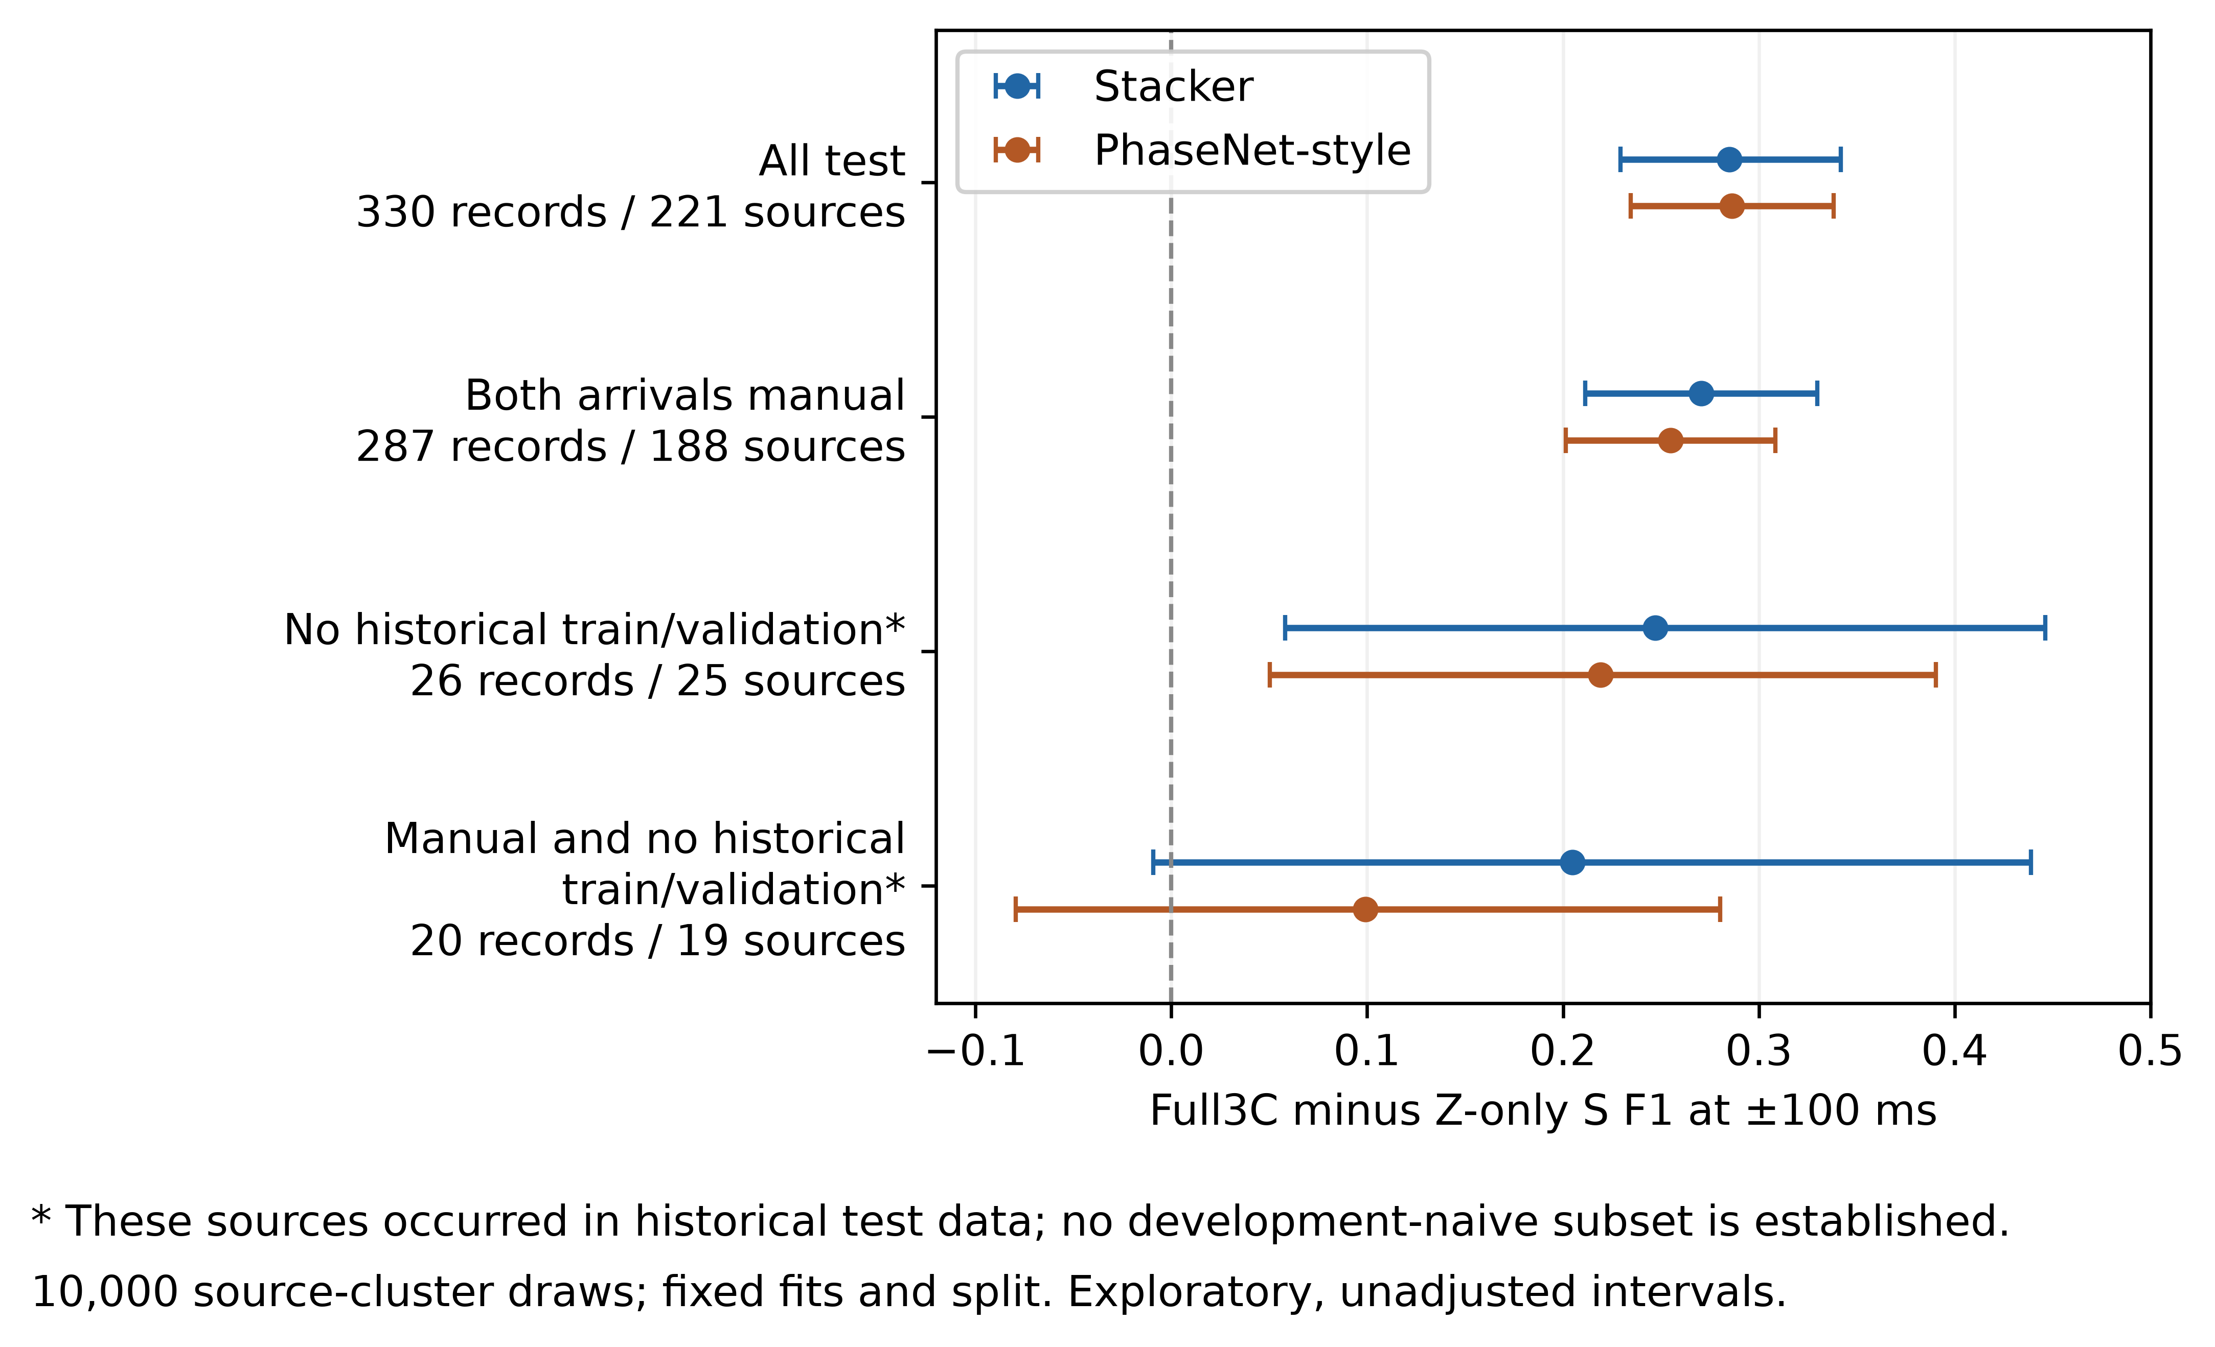
Supplementary Fig. S7. S Full3C-minus-Z-only F1 sensitivity at ±100 ms for the quality-threshold-3 slice. Columns vary peak threshold; rows vary maximum S–P window. The original configuration is outlined. Table S27 and accompanying CSVs include all three quality thresholds. No operating point is selected from these results.
