Preliminary Results
  - Ryan Waterman

Table of Contents
Model Implementation and Results 3
Robust Variable Selection Process 7
Model Comparison 8
Recommendations for Phase 3 11

Model Implementation and Results
Model implementation was completed with 3 phases of variable selection: Naïve (all predictors in data set), Initial Selection (variables selected as part of the analysis in the analytical plan), and Stepwise Selection (stepwise variable selection with a combination of forward and backward methods). Each configuration of variables was used to evaluate Logistic Regression, QDA, and KNN models with various levels of class imbalance correction.
Null models were trained for each of the respective model types listed above. The Confusion Matrices, ROC Curves, and AUC scores can be seen in Images 1 through 3, below.
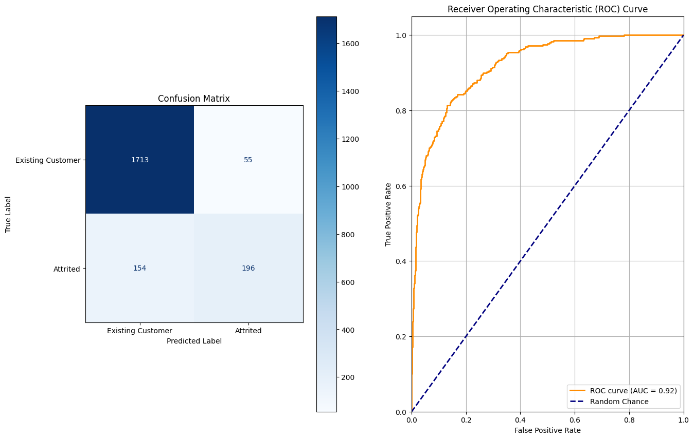
Image 1: Logistic Regression Null Model Confusion Matrix and ROC Curve
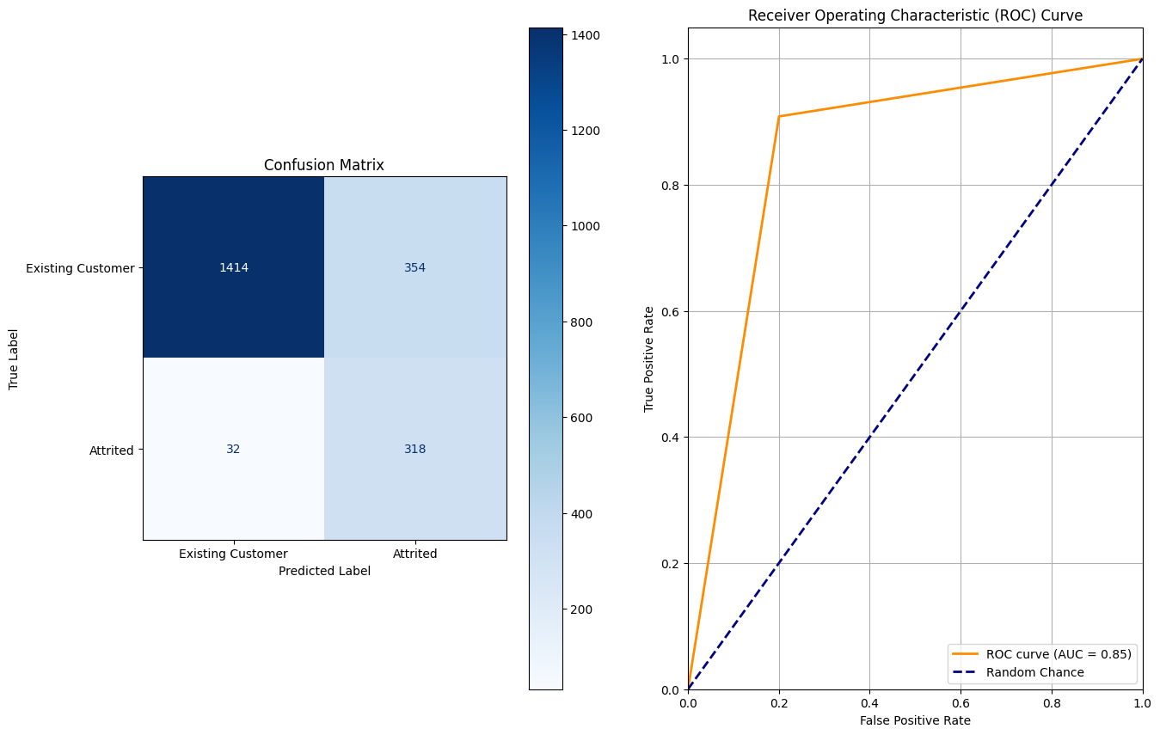
Image 2: QDA Null Model Confusion Matrix and ROC Curve
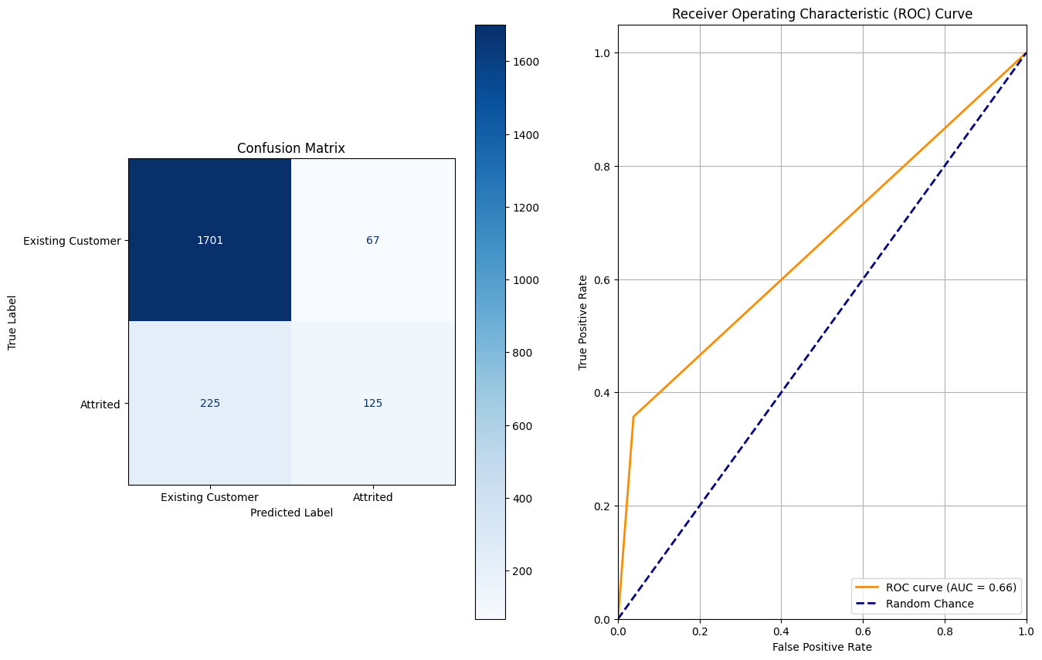
Image 3: KNN Null Model Confusion Matrix and ROC Curve
The ROC curve for the Logistic Regression model is smooth because of the continuous probability output from the model prediction. QDA and KNN models output more discrete probabilities, resulting in a sharp, jagged ROC curve.
Critical performance metrics for the Null Models are found in Table 1, below:
Model Type | Accuracy | Recall | Precision | F1-Score
Logistic Regression | 90.13% | 56% | 78.09% | 0.65
QDA | 81.78% | 90.86% | 47.32% | 0.62
KNN | 86.21% | 35.71% | 65.1% | 0.46
Table 1: Null Model Performance Metrics
By most metrics, Logistic Regression is the best performing null model, with the highest accuracy, precision, and F1-Score.
After optimizing feature selection and correcting for class imbalance, each model configuration’s performance improved. The ROC Curves and AUC Scores for the optimized models can be seen in Images 4 through 6, below.
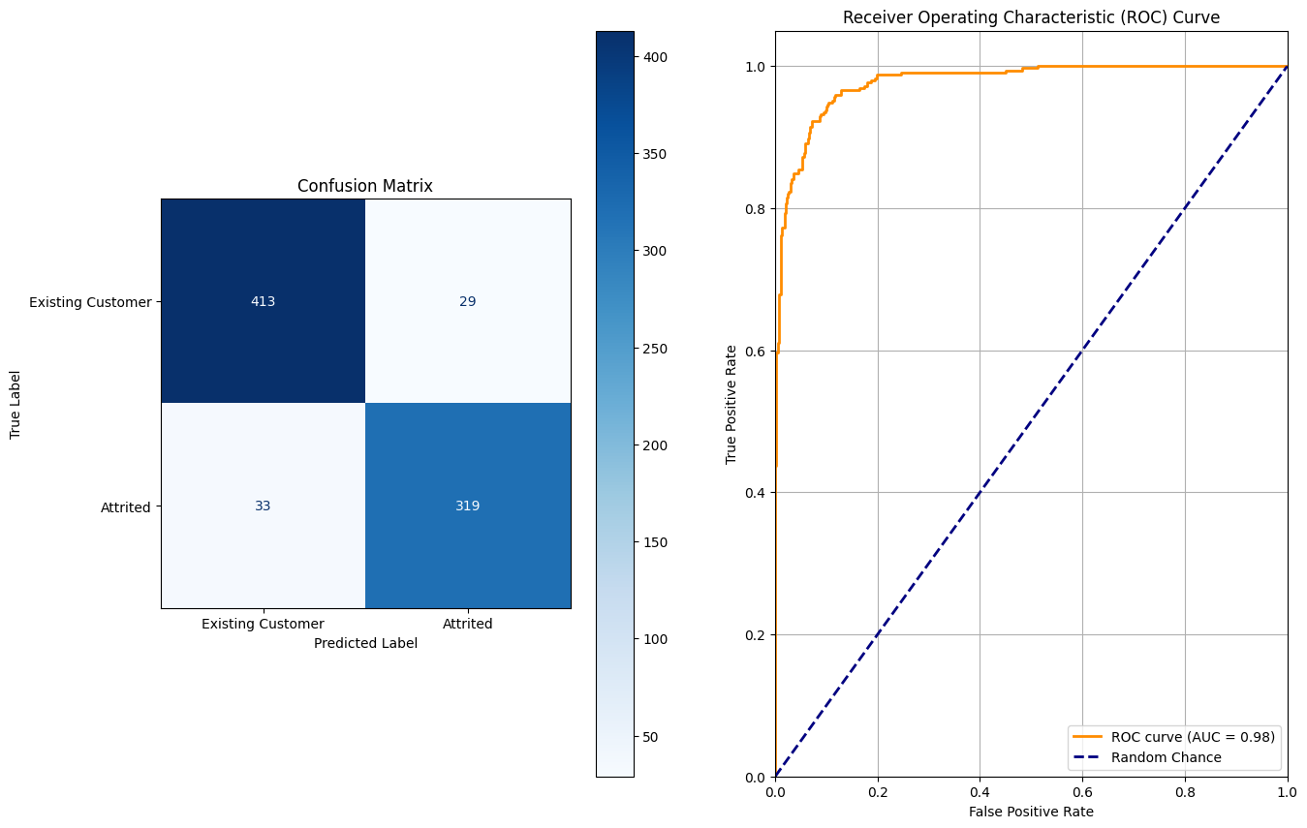
Image 4: Optimized Logistic Regression Model Confusion Matrix and ROC Curve

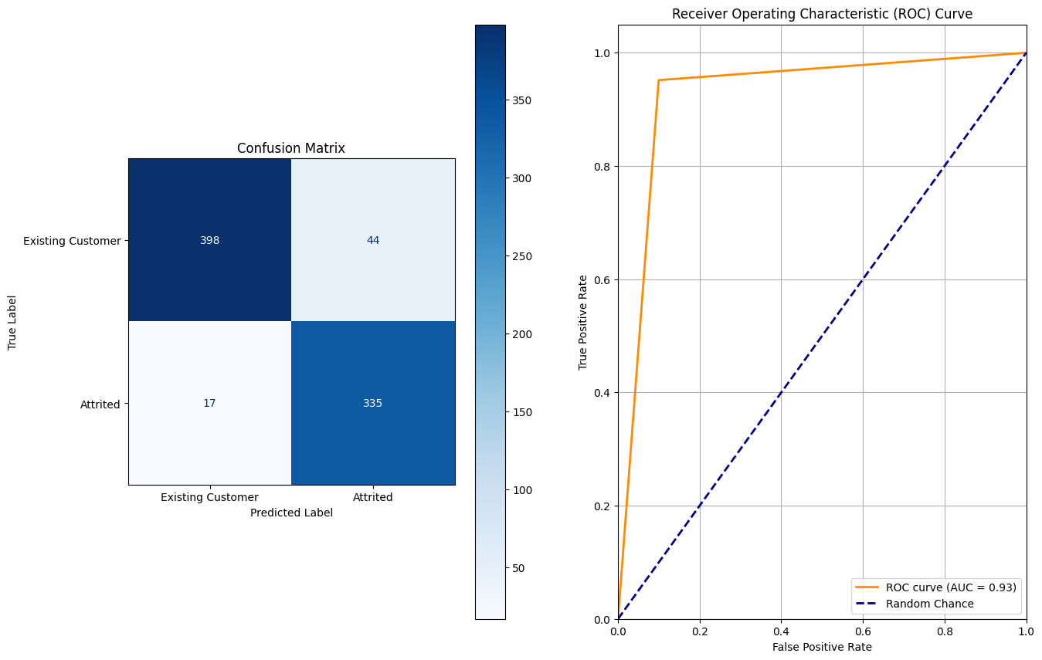
Image 5: Optimized QDA Model Confusion Matrix and ROC Curve
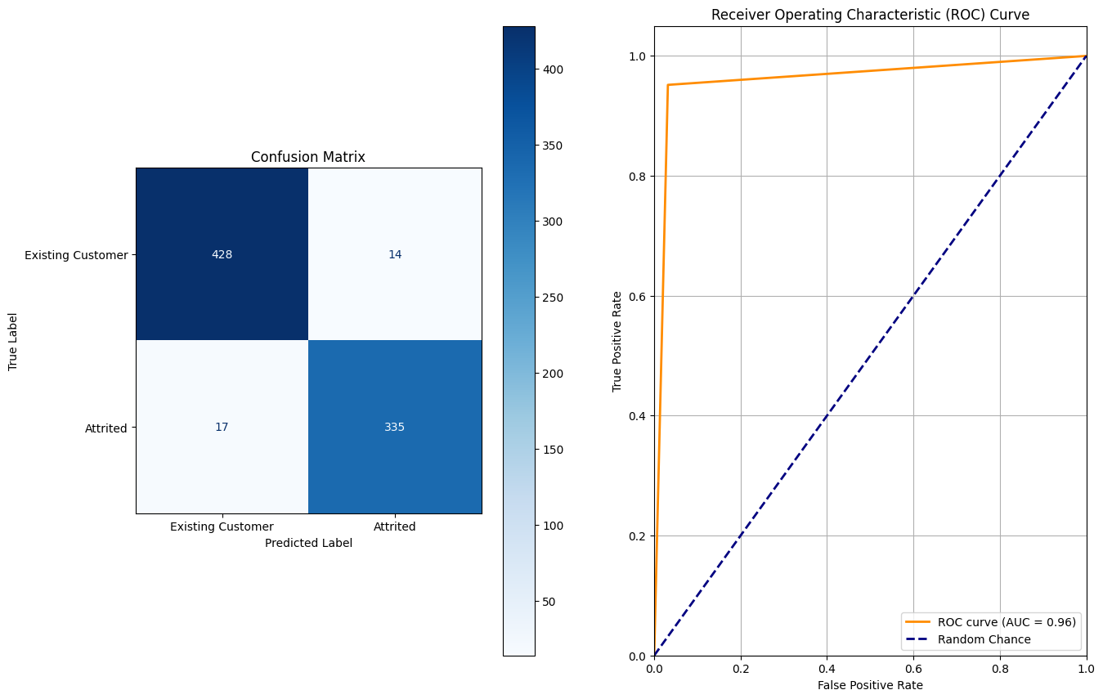
Image 6: Optimized KNN Model Confusion Matrix and ROC Curve
Critical performance metrics for the Optimized Models are found in Table 2, below:
Logistic Regression | 92.19% | 90.62% | 91.67% | 0.91
QDA | 92.32% | 95.17% | 88.39% | 0.92
KNN | 96.10% | 95.17% | 95.99% | 0.96
Table 2: Optimized Model Performance Metrics
An in-depth comparison of model performance can be found in the Model Comparison section.

Robust Variable Selection Process
The variable selection process was performed with a combination of forward and backward stepwise selection. Each subset Ordinary Least Squares model in the combinatorial predictor evaluation was scored using Mallow’s C_{p}, equation seen in Image 7, below.
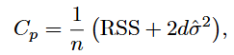
Image 7: Equation for Mallow’s C_{p}
where:
n is the number of observations,
σ² is an estimate of the variance of the error ε associated with each response measurement,
d is the number of predictors,
RSS is the Residual Sum of Squares of the model’s prediction error
Upon completion of the stepwise selection process, the critical variables were determined. Table 3, below, details the selected variables, as well as the initial variables that were selected during the analytic plan phase.
Stepwise Selected Variable | Analytic Plan Initial Variables
Balance_To_TC | Balance_To_TC
Card_Category | Card_Category
Contacts_Count_12_mon | Contacts_Count_12_mon
Credit_Limit_Per_Income | Credit_Limit_per_Income
Dependent_count | NOT SELECTED
Education_Level | Education_Level
Gender | Gender
Leveraged_Balance_Ratio | Leveraged_Balance_Ratio
Marital_Status | Marital_Status
Months_Inactive_12_mon | NOT SELECTED
Total_Amt_Chng_Q4_Q1 | Total_Amt_Chng_Q4_Q1
Total_Ct_Chng_Q4_Q1 | Total_Ct_Chng_Q4_Q1
Total_Relationship_Count | NOT SELECTED
Total_Revolving_Bal | Total_Revolving_Bal
Total_Trans_Amt | Total_Trans_Amt
Total_Trans_Ct | Total_Trans_Ct
NOT SELECTED | Avg_Utilization_Ratio
NOT SELECTED | Income_Category
NOT SELECTED | Relationship_Strength
Table 3: Stepwise Variable Selection vs Analytic Plan Variable Selection
The similarities between the two selection strategies are likely a result of the analysis completed during the Analytic Plan phase, where variables were scored based on a combination of correlation with the response variable and the outlier count. The Stepwise Variable Selection strategy dropped the following variables: Avg_Open_To_Buy, Avg_Utilization_Ratio, Credit_Limit, Customer_Age, Income_Category, Months_on_book.
As seen in the Model Comparison section, there was a performance increase across every model after feature selection and class imbalance correction. Table 4, below, highlights the improvement in performance metrics for each model from the Null model to the optimized configuration.
Model Type | Accuracy Increase | Recall Increase | Precision | F1-Score
Logistic Regression | 2.06% | 34.62% | 13.58% | 0.26
QDA | 10.54% | 4.31% | 41.07% | 0.3
KNN | 9.89% | 59.46% | 30.89% | 0.5
Table 4: Performance Metric Difference Between Null and Optimized Models
The most notable increases in performance come from the KNN and QDA models. This implies that most of the linearity in the data can be fit by the Logistic Regression model with all variables present. Alternatively, many of the localized and non-linear relationships are revealed through feature selection and class imbalance correction, leading to a dramatic increase in performance for QDA and KNN models.

Model Comparison
After training each model on the respective configurations of features, a summary table of model performance could be generated, as seen in Table 4, below. Note the percent reduction indicated in the Feature Configuration column. This describes the percentage reduction of observations in the training set to mitigate class imbalance.
Feature Configuration | Model Type | Accuracy | Recall | Precision | F1-Score
Null – No Reduction | Logistic Regression | 90.13% | 56% | 78.09% | 0.65
Null – No Reduction | QDA | 81.78% | 90.86% | 47.32% | 0.62
Null – No Reduction | KNN | 86.21% | 35.71% | 65.1% | 0.46
Null – 65% Reduction | Logistic Regression | 93.28% | 90.40% | 89.30% | 0.90
Null – 65% Reduction | QDA | 91.45% | 91.02% | 84.24% | 0.88
Null – 65% Reduction | KNN | 81.47% | 60.37% | 78.31% | 0.68
Null – 75% Reduction | Logistic Regression | 91.94% | 90.06% | 91.62% | 0.91
Null – 75% Reduction | QDA | 91.56% | 90.34% | 90.60% | 0.90
Null – 75% Reduction | KNN | 78.46% | 67.05% | 81.10% | 0.73
Initial Variable Selection – No Reduction | Logistic Regression | 87.77% | 38.29% | 75.71% | 0.51
Initial Variable Selection – No Reduction | QDA | 87.63% | 74.86% | 60.09% | 0.67
Initial Variable Selection – No Reduction | KNN | 89.99% | 60.57% | 74.13% | 0.67
Initial Variable Selection – 65% Reduction | Logistic Regression | 92.46% | 86.38% | 90.29% | 0.88
Initial Variable Selection – 65% Reduction | QDA | 90.84% | 94.12% | 81.07% | 0.87
Initial Variable Selection – 65% Reduction | KNN | 96.64% | 95.36% | 94.48% | 0.95
Initial Variable Selection – 75% Reduction | Logistic Regression | 91.56% | 88.92% | 91.79% | 0.90
Initial Variable Selection – 75% Reduction | QDA | 91.56% | 95.45% | 86.82% | 0.91
Initial Variable Selection – 75% Reduction | KNN | 96.10% | 95.17% | 95.99% | 0.96
Stepwise Selected Variables- No Reduction | Logistic Regression | 89.14% | 50.00% | 76.09% | 0.60
Stepwise Selected Variables- No Reduction | QDA | 87.58% | 76.29% | 59.73% | 0.67
Stepwise Selected Variables- No Reduction | KNN | 90.46% | 64.57% | 74.34% | 0.69
Stepwise Selected Variables- 65% Reduction | Logistic Regression | 92.97% | 88.54% | 89.94% | 0.89
Stepwise Selected Variables- 65% Reduction | QDA | 90.63% | 94.43% | 80.47% | 0.87
Stepwise Selected Variables- 65% Reduction | KNN | 96.64% | 95.05% | 94.75% | 0.95
Stepwise Selected Variables- 75% Reduction | Logistic Regression | 92.19% | 90.62% | 91.67% | 0.91
Stepwise Selected Variables- 75% Reduction | QDA | 92.32% | 95.17% | 88.39% | 0.92
Stepwise Selected Variables- 75% Reduction | KNN | 96.10% | 95.17% | 95.99% | 0.96
Table 5: Summary of Model Performance Across Feature and Training Configurations
The highest performing optimized model identified during this evaluation was KNN with a neighbor count of 7. Interestingly, this model produces the same performance metrics for both Initial Variable Selection – 75% Reduction and Stepwise Selected Variables- 75% Reduction feature configurations. The performance metrics for this model are as follows:
Accuracy | AUC | Recall | Precision | F1-Score
96.10% | 0.96 | 95.17% | 95.99% | 0.96
Table 6: Optimal KNN Performance Metrics
The KNN model likely performs the best on the reduced dataset because of non-linear relationships and localized patterns within the data. Logistic regression will attempt to make a linear approximation of the non-linear relationships, causing a drop in accuracy. QDA models can fit non-linear relationships, but they struggle with decision boundaries that are not smooth curves, as well as localized patterns. QDA outperforms Logistic regression in the optimized feature configurations, which is evidence of non-linear relationships. KNN further outperforming QDA is an indication of both non-linear relationships and localized clusters of patterns within the data.
Across the three models, KNN is the lowest interpretability, however, it produces performance gains that are greater than 4% across all metrics as compared to QDA or Logistic Regression. KNN fits the data well because it learns localized relationships between variables, not one global equation that describes the data like Logistic Regression. Given the business case, accuracy is paramount to solve the problem at hand, therefore KNN is advantageous despite being a “black box” model. In practice, this principle is common, as deep learning models fall further down the interpretability score hierarchy, but they are the flagship models for nearly every domain where artificial intelligence and machine learning are applicable.

Recommendations for Phase 3
Based on the outcome of the model evaluation phase, models with the ability to fit non-linear relationships and localized patterns are advantageous for this data set. To further improve predictive performance on the data, models such as Localized Regression, Gradient Boosted Decision Trees, or Random Forest can be explored. Given the performance of KNN during this phase of analysis, a distance weighted KNN model may provide additional performance benefits.
Additionally, features could be added by arbitrarily combining different quantitative variables with various mathematical operations, then further stepwise selection could be used to identify which combinations increase predictability. This would introduce combinations of variables with high predictive value that may not have been explored otherwise.

