Analytical Plan for ABC Corporation Customer Churn Predictive Model
  - Ryan Waterman

Table of Contents
Business Problem Statement 3
Dataset Overview and Exploratory Data Analysis 3
Feature Engineering Plan 7
Initial Variable Selection Strategy 8
Preliminary Modeling Strategy 9

Business Problem Statement
ABC Corporation, a bank that offers several credit products, is interested in accurately predicting the probability a given customer may leave their services. Long term customers are more likely to recommend products to potential customers, providing exponentially growing value. Additionally, due to the compounding effect of interest, long-term customers that bank and lend with ABC Corporation are exponentially more valuable than new customers. Attrition prediction capabilities would allow ABC Corporation to allocate resources to customer retention campaigns, such as offering discounts, promotional offers, or targeted ads to attempt to retain high attrition risk customers. The features that predict attrition are to be identified, offering ABC Corporation the opportunity to internally invest in market research and product development.

Dataset Overview and Exploratory Data Analysis
The dataset provided by ABC Corporation includes 21 variables and 10,127 observations. Of the 21 variables, 14 are quantitative, and 6 are categorical, as seen in the table, below. Note that ‘CLIENTNUM’ is not associated with a quantitative or categorical classification. This is intentional, as ‘CLIENTNUM’ is a unique identifier for each of the clients in the dataset, and this variable does not provide analytical value to the analysis.
Variable Name | Classification
Customer_Age | Quantitative
Dependent_count | Quantitative
Months_on_book | Quantitative
Total_Relationship_Count | Quantitative
Months_Inactive_12_mon | Quantitative
Contacts_Count_12_mon | Quantitative
Credit_Limit | Quantitative
Total_Revolving_Bal | Quantitative
Avg_Open_To_Buy | Quantitative
Total_Amt_Chng_Q4_Q1 | Quantitative
Total_Trans_Amt | Quantitative
Total_Trans_Ct | Quantitative
Total_Ct_Chng_Q4_Q1 | Quantitative
Avg_Utilization_Ratio | Quantitative
Attrition_Flag | Categorical
Income_Category | Categorical
Gender | Categorical
Education_Level | Categorical
Marital_Status | Categorical
Card_Category | Categorical

The categorical variables are distributed according to the histogram plots, below:
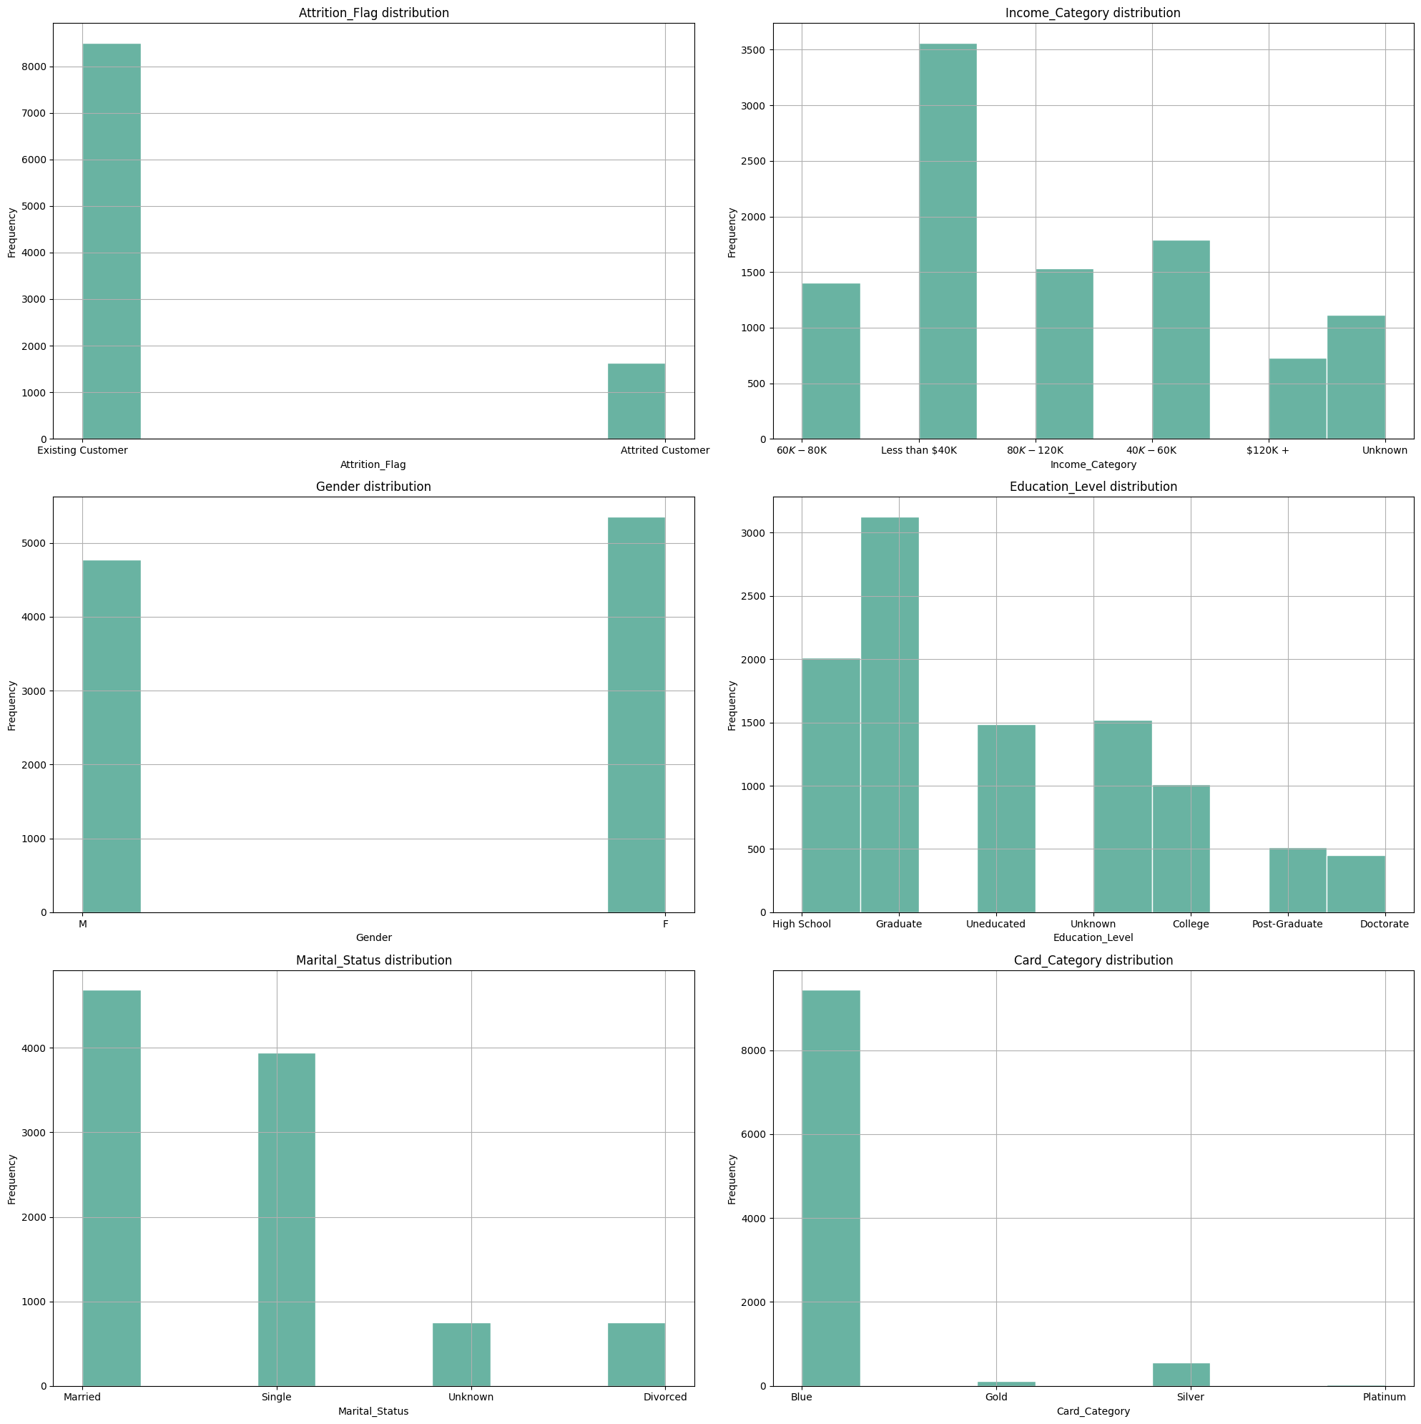
Chart 1: Histogram Plots of Categorical Variables

Of the variables that were identified as being correlated, the charts, below, indicate the most positive and the most negative correlated variables, respectively:
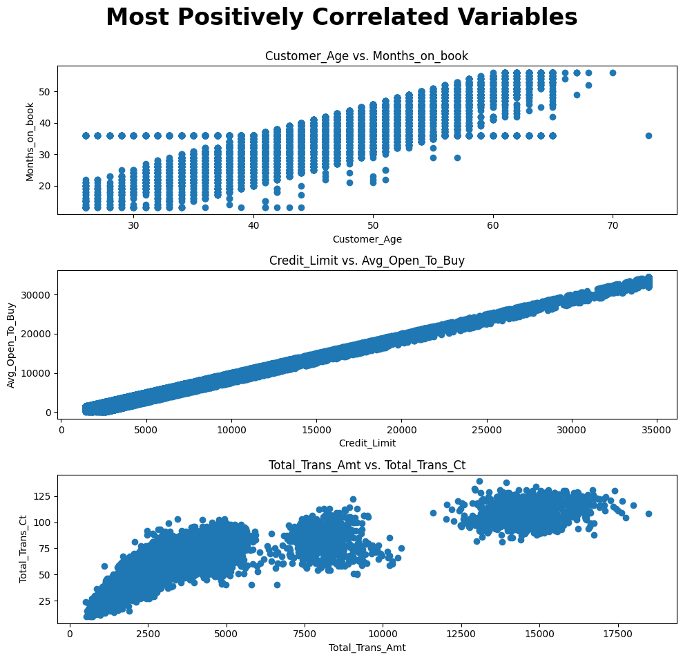
Chart 2: Most Positive Correlated Variables
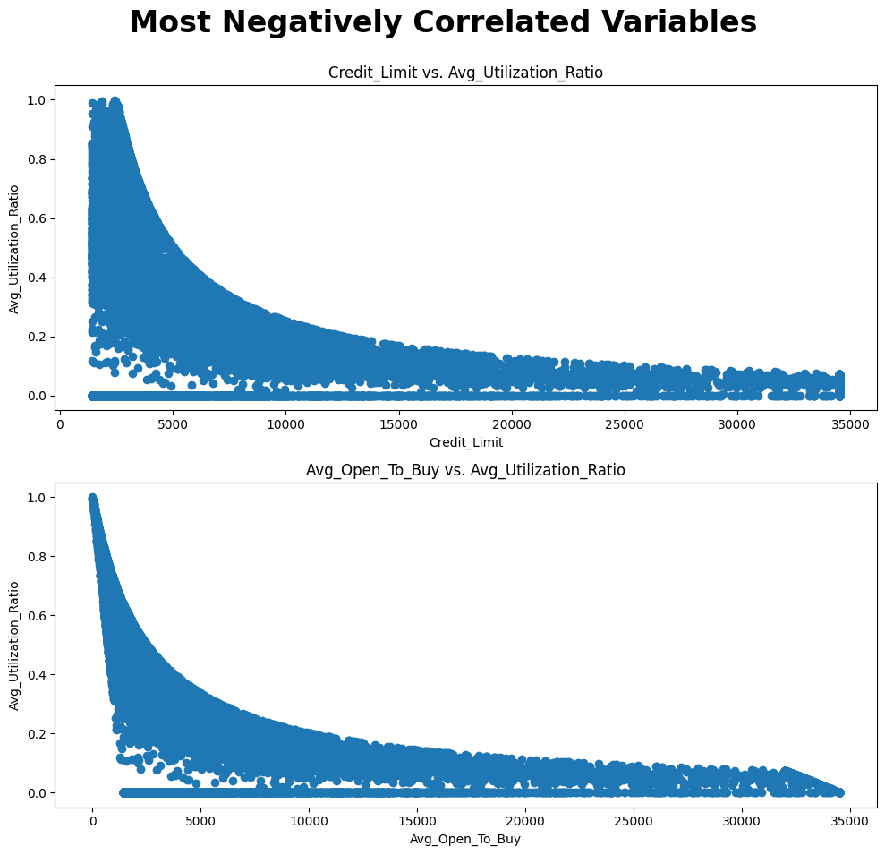
Chart 3: Most Negative Correlated Variables
Based on the preliminary analysis, the table, below, describes the relevance of each variable in predicting customer churn rate, as determined with the ‘Attrition_Flag’ variable. Relevance is scored from 0-1, with 1 being most relevant and 0 being least relevant. Correlation represents the correlation coefficient between Attrition_Flag (encoded such that Attrited Customer is 1 and Existing Customer is 0) and the variable being evaluated. Additionally, box plots were generated for the quantitative variables, grouped by Attrition_Flag, and the difference in IQR and outlier count were factored into the relevance score. Max Proportion Attrited represents the maximum proportion, by categorical variable, of customers that left the bank, compared to the number of existing customers.
Variable | Variable Type | Correlation | Max Proportion Attrited | Max Attrited Sub-Category | Relevance Score
Customer_Age | Quantitative | 0.018203 | N/A | N/A | 0.2
Dependent_count | Quantitative | 0.018991 | N/A | N/A | 0.2
Months_on_book | Quantitative | 0.013687 | N/A | N/A | 0.1
Total_Relationship_Count | Quantitative | -0.150005 | N/A | N/A | 0.4
Months_Inactive_12_mon | Quantitative | 0.152449 | N/A | N/A | 0.4
Contacts_Count_12_mon | Quantitative | 0.204491 | N/A | N/A | 0.6
Credit_Limit | Quantitative | -0.023873 | N/A | N/A | 0.3
Total_Revolving_Bal | Quantitative | -0.263053 | N/A | N/A | 0.9
Avg_Open_To_Buy | Quantitative | -0.000285 | N/A | N/A | 0.1
Total_Amt_Chng_Q4_Q1 | Quantitative | -0.131063 | N/A | N/A | 0.5
Total_Trans_Amt | Quantitative | -0.168598 | N/A | N/A | 0.6
Total_Trans_Ct | Quantitative | -0.371403 | N/A | N/A | 0.9
Total_Ct_Chng_Q4_Q1 | Quantitative | -0.290054 | N/A | N/A | 0.9
Avg_Utilization_Ratio | Quantitative | -0.178410 | N/A | N/A | 0.6
Income_Category | Categorical | N/A | 20.96% | $120k + | 0.7
Gender | Categorical | N/A | 21% | F | 0.6
Education_Level | Categorical | N/A | 26.69% | Doctorate | 0.8
Marital_Status | Categorical | N/A | 20.81% | Unknown | 0.6
Card_Category | Categorical | N/A | 33.33% | Platinum | 0.9

Feature Engineering Plan
Many of the existing features in the dataset lend themselves to transformation, which could improve model performance. There are six variables that have been identified as candidates for transformation, or as the basis for new features: Total_Revolving_Bal, Credit_Limit, Avg_Utilization_Ratio, Total_Trans_Amt, Months_on_book, and Total_Trans_Ct. Additional experimentation would be required, but Avg_Utilization_Ratio has a non-linear relationship with Credit_Limit and Avg_Open_To_Buy, therefore a log transformation may aid in the relevance and predictive impact of this variable.
The ratio between Total Revolving Balance and Total Transaction Count could be added as a new feature, which would provide information about the customer’s spending habits. A high revolving balance to transaction count ratio would imply the customer is spending large amounts with few transactions, or vice versa, which may have an impact on churn rate. This variable would be called Balance_To_TC.
Another feature that could be added is the proportion of Income Category that Credit Limit makes up. The income categories would be reduced to numerical representations, likely using a bin size adjusted mean income per income category. If customers have obtained a high credit limit relative to their income, it can be assumed they have high credit scores, for which the number of open accounts in good standing is a factor. A high number of open accounts in good standing implies the customer may be less likely to close their account. This variable would be called Credit_Limit_per_Income.
Average Utilization Ratio, Total Transaction Amount, and Credit Limit can be compounded to identify the multiple of a given customer’s average balance is being transacted annually. Average Utilization Ratio multiplied by Credit Limit would result in the average balance carried on the card, which Total Transaction Amount could be divided by. The resulting feature would be an indication of how capable the customer is of paying their balance, normalized to their credit limit. This variable would be called Leveraged_Balance_Ratio.
Lastly, the number of Months on Book can be multiplied by the Total Relationship Count (number of products held by the customer) to create a variable that represents the strength of the relationship the customer has with the bank. A higher value indicates a stronger relationship, as customers that are heavily invested in the products and services the bank provides may be less likely to stop utilizing the bank. This variable would be called Relationship_Strength.

Initial Variable Selection Strategy
The inclusion criteria for the initial modeling attempt would be the variables with relevance scores greater than 0.5 (as identified in the Dataset Overview and Exploratory Data Analysis section), as well as the new features identified in the Feature Engineering Plan. See the table, below, for the complete list of selected variables.
Variable | Variable Type
Contacts_Count_12_mon | Quantitative
Total_Revolving_Bal | Quantitative
Total_Amt_Chng_Q4_Q1 | Quantitative
Total_Trans_Amt | Quantitative
Total_Trans_Ct | Quantitative
Total_Ct_Chng_Q4_Q1 | Quantitative
Avg_Utilization_Ratio | Quantitative
Balance_To_TC | Quantitative
Credit_Limit_per_Income | Quantitative
Leveraged_Balance_Ratio | Quantitative
Relationship_Strength | Quantitative
Income_Category | Categorical
Gender | Categorical
Education_Level | Categorical
Marital_Status | Categorical
Card_Category | Categorical

The excluded variables had minimal correlation with Attrition_Flag, which is a poor metric for predictive value when considering interactions with other variables. The solution to this problem is the inclusion of the new features, many of which are derivatives of the excluded variables. The intent was to remove the variables that independently offer minimal predictive value, and to then replace them with variables that are compounded with higher relevance variables. Ideally, this will increase the signal to noise ratio across the dataset, making the model more accurate.
Class imbalance could be addressed by randomly sampling a smaller subset of the ‘Existing Customer’ observations. If the model evaluation steps detailed in the Preliminary Modeling Strategy indicate that class imbalance is an issue (i.e. high density false positives or false negatives on a particular Attrition_Flag outcome), then the ratio of ‘Existing Customer’ observations could be further reduced.

Preliminary Modeling Strategy
The algorithms that will be tested in this strategy are kNN, Logistic Regression, and QDA. Each of these models will be evaluated based on the following criteria:
- Accuracy on Novel Data (Cross Validation)
  - This will be evaluated by excluding data from the training data set. The same data will be excluded from the training data of each model to remain consistent.
- Recall
  - After the models make predictions on the test data, a confusion matrix will be generated for each model. Recall will be calculated based on the ratio of true positives to the total number of actual positives.
- Precision
  - The proportion of positive predictions that are actually positive.
- F1-score
  - The harmonic mean of precision and recall (2 * (Precision * Recall) / (Precision + Recall)).
Some of challenges that could arise during this initial modeling attempt would be none of the models making accurate predictions, including the categorical variables in the dataset, and evaluating the quality of the dataset. If the models cannot converge and make accurate predictions, there are two approaches to take. First, the hyperparameters of the model could be tuned, and second, the dataset could be modified. This leads to another challenge: evaluating dataset quality. This is something that will be addressed regardless of the model performance. The intent would be to use multiple linear regression (MLR) to evaluate the interaction between variables and get a general sense of the relationship between the predictors and Attrition_Flag. If the MLR is used as the baseline for dataset viability, then changes to the dataset could be evaluated using the same criteria to determine the impact on the kNN, Logistic Regression, and QDA models. Lastly, inclusion of the categorical variables can be achieved through encoding. If each of the categorical variables is reduced to a numerical representation, the model can incorporate the impact of the categorical variable in the higher-dimensional interactions across the dataset.

