Analytical Plan for ABC Corporation Customer Churn Predictive Model
  - Ryan Waterman

Table of Contents
Business Problem Statement 3
Dataset Overview and Exploratory Data Analysis 3
Feature Engineering Plan 6
Initial Variable Selection Strategy 6
Preliminary Modeling Strategy 6
Sources 7

Business Problem Statement
ABC Corporation would like to identify customers that have a high risk of attrition (i.e., leaving the services of ABC Corporation). The risk of attrition should be a value between 0 and 1, so it can be interpreted as the probability that the customer leaves. With this capability, ABC management can target these customers that have a high risk (i.e., probability) of attrition with additional advertisements and/or offers in an effort to prevent them from leaving. Furthermore, ABC Corporation would like to know which features of a customer are most predictive of attrition.

Dataset Overview and Exploratory Data Analysis
The dataset provided by ABC Corporation includes 21 variables and 10,127 observations. Of the 21 variables, 14 are quantitative, and 6 are categorical, as seen in the table, below. Note that ‘CLIENTNUM’ is not associated with a quantitative or categorical classification. This is intentional, as ‘CLIENTNUM’ is a unique identifier for each of the clients in the dataset, and this variable does not provide analytical value to the analysis.
Variable Name | Classification
Customer_Age | Quantitative
Dependent_count | Quantitative
Months_on_book | Quantitative
Total_Relationship_Count | Quantitative
Months_Inactive_12_mon | Quantitative
Contacts_Count_12_mon | Quantitative
Credit_Limit | Quantitative
Total_Revolving_Bal | Quantitative
Avg_Open_To_Buy | Quantitative
Total_Amt_Chng_Q4_Q1 | Quantitative
Total_Trans_Amt | Quantitative
Total_Trans_Ct | Quantitative
Total_Ct_Chng_Q4_Q1 | Quantitative
Avg_Utilization_Ratio | Quantitative
Attrition_Flag | Categorical
Income_Category | Categorical
Gender | Categorical
Education_Level | Categorical
Marital_Status | Categorical
Card_Category | Categorical

The categorical variables are distributed according to the histogram plots, below:
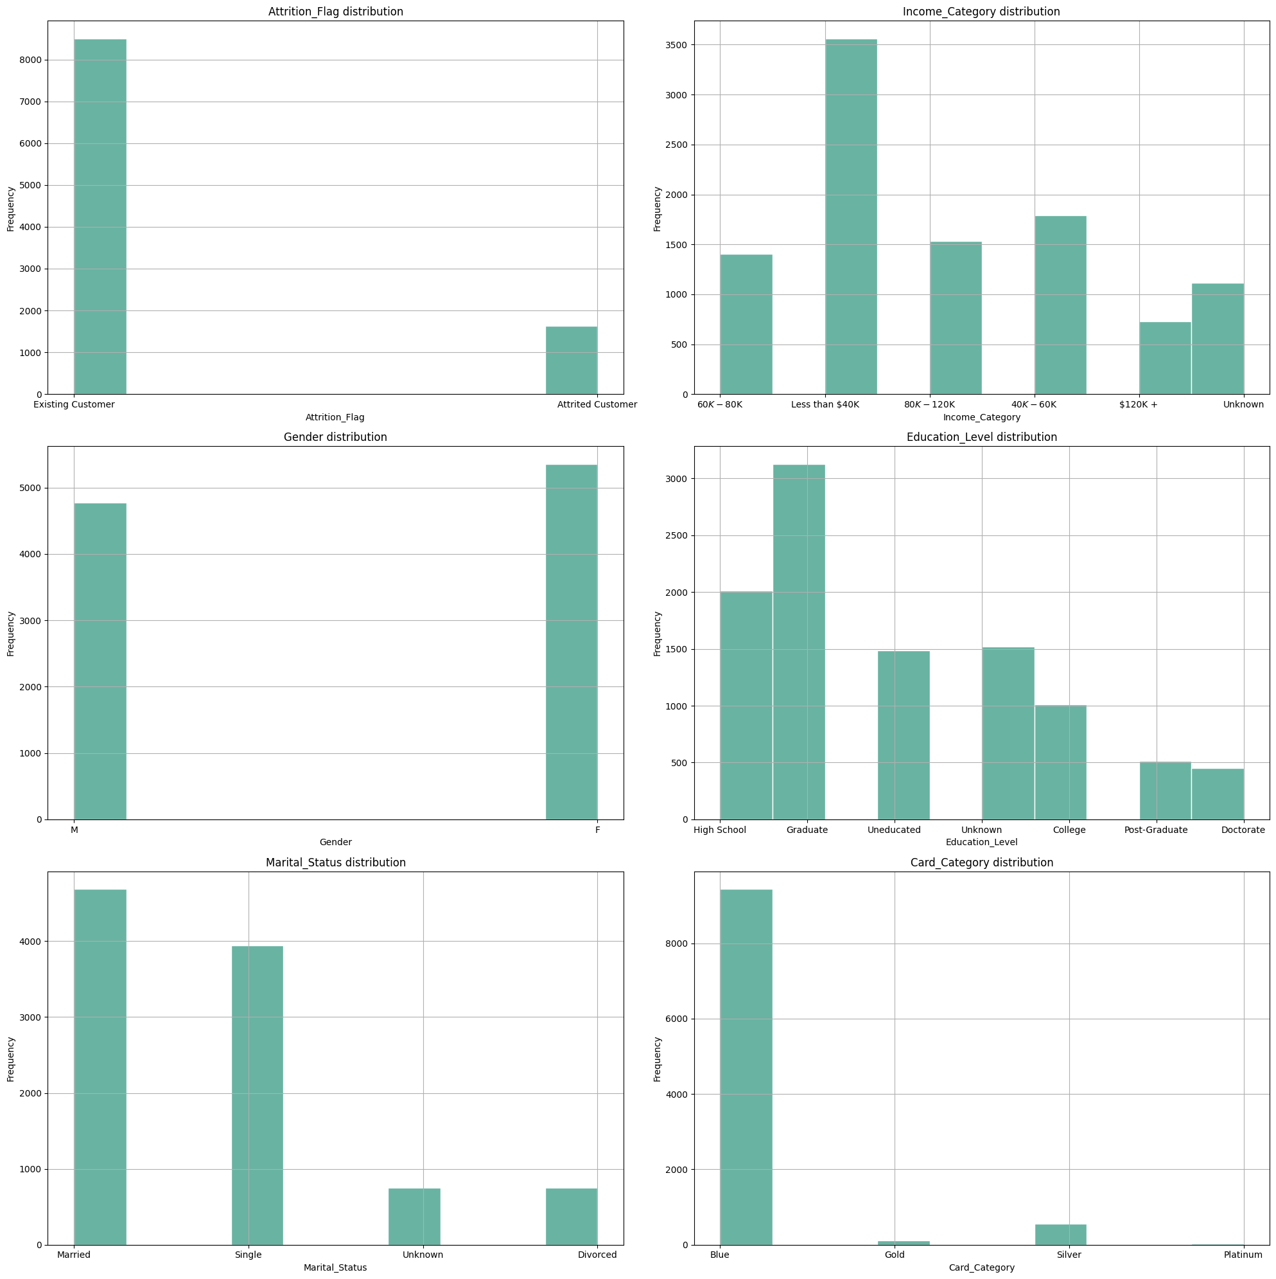
Chart 1: Histogram Plots of Categorical Variables

Of the variables that were identified as being correlated, the charts, below, indicate the most positive and the most negative correlated variables, respectively:
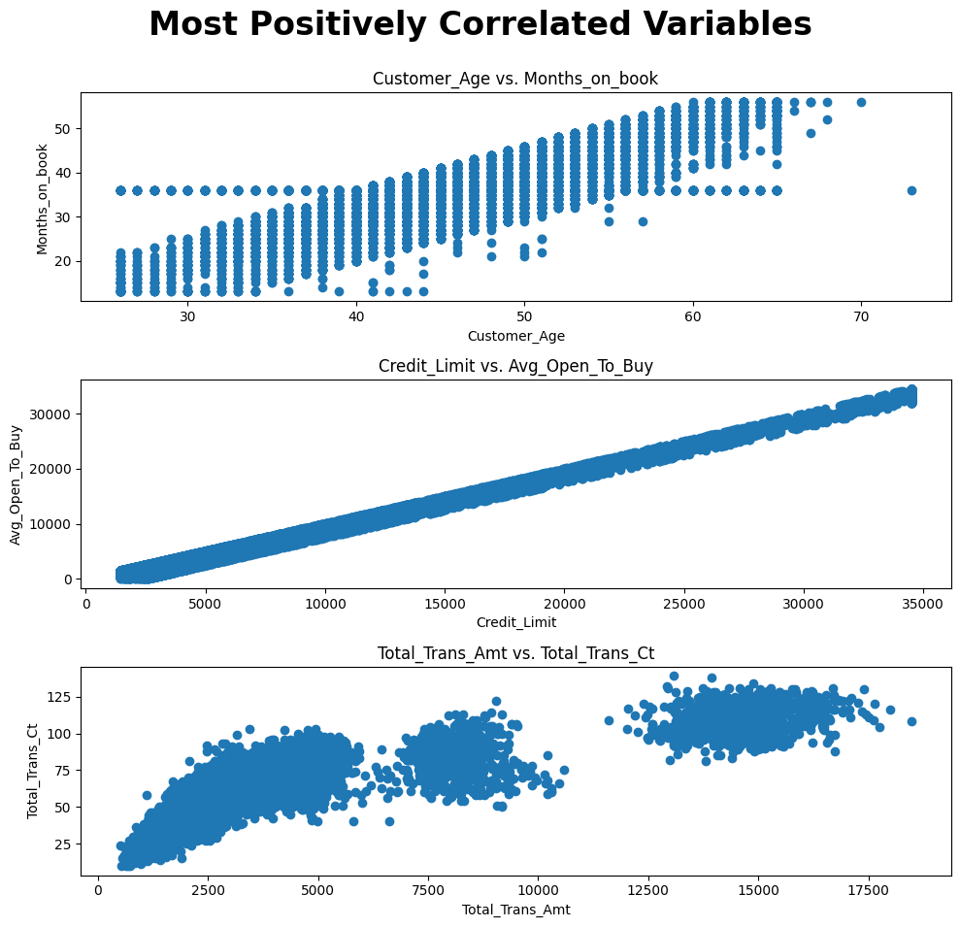
Chart 2: Most Positive Correlated Variables
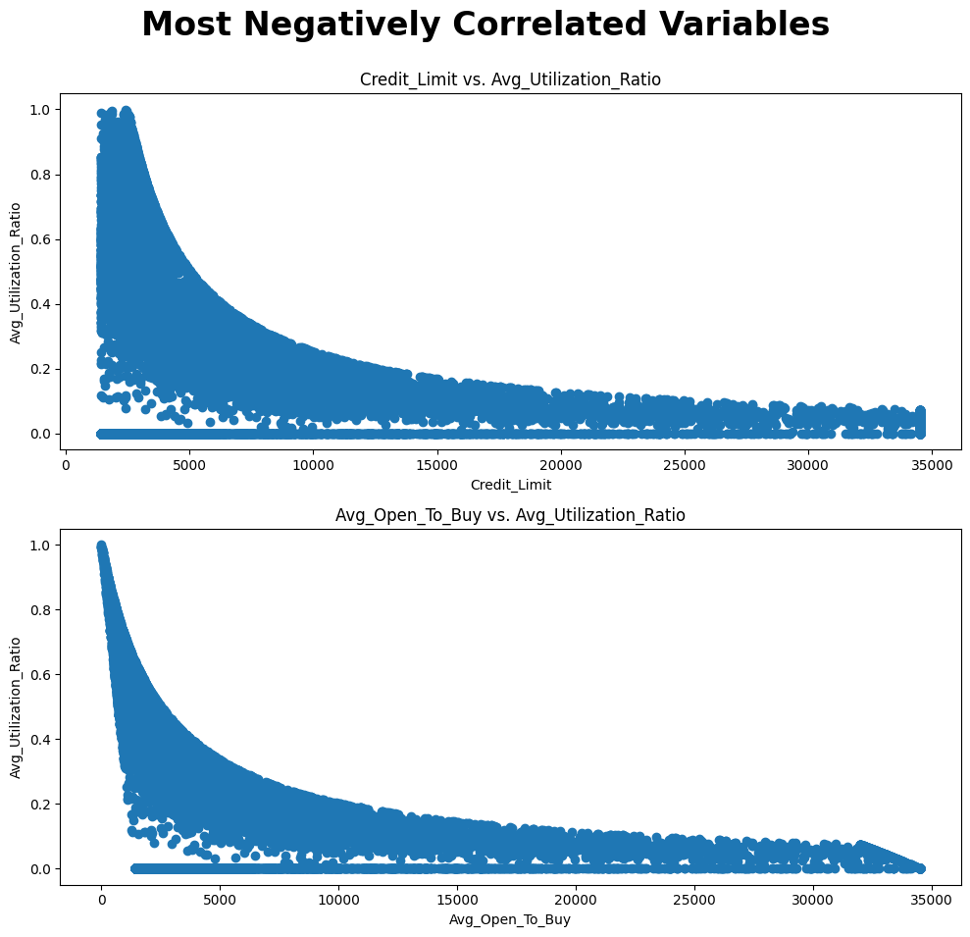
Chart 3: Most Negative Correlated Variables
Based on the preliminary analysis,

Feature Engineering Plan

Initial Variable Selection Strategy

Preliminary Modeling Strategy

Sources

