ML-Assisted Thermal Bias Prediction for High-Accuracy Accelerometers
Exploratory Data Analysis Report
Team Alpha
Ryan Waterman — Documentation Lead
Ngongha Fon — Communication Lead
GitHub Repository: https://github.com/DSE6311
Capstone Project EDA Deliverable

1. Background and Research Question
Accelerometers embedded in inertial measurement units (IMUs) are widely used in robotics, aerospace, industrial monitoring, navigation, and consumer electronics. Their measurements can change as internal components expand and contract with temperature. This temperature-dependent shift, commonly described as thermal bias or thermal drift, can reduce the accuracy of systems that depend on precise motion sensing. The practical problem is therefore not simply whether temperature is associated with accelerometer output, but whether the relationship is sufficiently stable and predictable to support software-based compensation.
The finalized proposal was revised in response to instructor feedback. The original plan attempted to construct an error variable from deviations around a nominal acceleration value. That step was removed because the published experiment collected accelerometer output while the instrument was stationary. Under the assumptions of the original study, changes in the measured X, Y, and Z outputs can therefore be treated as temperature-related bias without inventing a new target. This reframing reduces the risk of label bias and allows the project to focus on modeling and validation.
Research question: Can temperature measurements collected at multiple locations on and around a stationary tri-axial accelerometer be used to predict the accelerometer’s thermal bias along the X, Y, and Z axes?
Hypothesis and prediction: The team hypothesizes that thermal bias follows repeatable relationships with the distributed temperature measurements. We predict that a multi-output regression model will learn these relationships and predict the three-axis bias vector on unseen observations more accurately than a simple mean-based or linear baseline. Because thermal behavior may be nonlinear and sensors may be highly correlated, a nonlinear model is expected to improve particularly on the X and Y axes, where the preliminary linear model is weakest.

2. Methods

2.1 Dataset and Acquisition
The analysis uses the dataset “Temperature Characterization of a High Sensitivity Tri-Axial Accelerometer Through Multiple Thermometers” attributed in the project proposal to Iafolla et al. (2023). The data were obtained as multiple comma-separated value (CSV) files. In the notebook, each CSV file in the project data directory was read with pandas and concatenated row-wise into one DataFrame. The combined dataset contains 4,440,384 observations.
Each observation includes a timestamp, accelerometer outputs for the X, Y, and Z axes, twelve temperature measurements, and altitude. Temperature was measured at locations such as the axis sensors, sensor faces, electronics face, acquisition face, top surface, internal air, and external environment. The notebook preview shows timestamps at one-second intervals, although the full sampling schedule should be verified against the dataset documentation before the final report.
The original measurements were collected while the accelerometer was stationary. This design is advantageous because variation in the recorded acceleration can be interpreted as bias under the study’s experimental assumptions rather than intentional motion. However, the repeated time-series structure also means adjacent rows are unlikely to be independent. This affects validation: a purely random split may place nearly identical neighboring observations into both training and test sets and may overstate generalization.

2.2 EDA Preparation and Methods
EDA was intentionally conducted with minimal cleaning. The three CSV files were combined, the Date field was removed from the numerical EDA DataFrame, and missingness was assessed. No missing values were reported for the variables in the notebook. The three acceleration outputs were retained as the targets, while the temperature measurements were treated as the primary predictors. Altitude remains available as a contextual variable, but its scientific role requires further justification before modeling.
The EDA included descriptive statistics, missing-value checks, univariate target distributions, temperature boxplots, selected temperature-to-target scatterplots, a pairplot, a correlation heatmap, principal component analysis (PCA), a train/test distribution comparison, and the distribution of the three-dimensional bias magnitude. These methods were selected to evaluate scale, spread, skewness, extreme values, possible nonlinear relationships, redundancy among sensors, and whether dimensionality reduction may be useful.
A preliminary multi-output linear regression model was also trained as an exploratory baseline. Although model fitting is not the primary purpose of EDA, the baseline provides an early indication of whether a linear temperature-bias relationship is adequate and identifies axes that may benefit from nonlinear modeling.

3. Results

3.1 Data Completeness and Descriptive Statistics
The combined data contained 4,440,384 observations and no reported missing values. All variables used in the current analysis are continuous; therefore, categorical frequencies and proportions are not applicable. The acceleration targets are centered near zero, as expected for bias measurements from a stationary instrument, but their spreads and distribution shapes differ substantially by axis.
Table 1. Descriptive statistics for the three accelerometer bias targets.
Variable | N | Mean | SD | Min | Median | Max | Skew | Kurtosis
Z bias (m/s²) | 4,440,384 | 1.67×10⁻⁸ | 0.000848 | -0.003595 | 0.000125 | 0.001969 | -0.602 | 0.778
X bias (m/s²) | 4,440,384 | 3.37×10⁻⁹ | 0.000093 | -0.000349 | 0.000025 | 0.000223 | -1.806 | 4.697
Y bias (m/s²) | 4,440,384 | 4.95×10⁻⁹ | 0.000073 | -0.000178 | 0.000016 | 0.000237 | -0.422 | -0.466
The Z-axis has much greater variability than the X and Y axes. The X-axis is strongly left-skewed and has high positive kurtosis, indicating a heavier-tailed distribution and more extreme observations than a normal distribution. This difference suggests that a single aggregate performance metric could hide important axis-specific behavior.
Table 2. Descriptive statistics for temperature predictors.
Temperature (°C) | Mean | SD | Min | Median | Max | Skew | Kurtosis
T z | 20.119 | 1.083 | 17.041 | 20.189 | 25.023 | 0.346 | 1.188
T x | 20.146 | 1.088 | 17.097 | 20.201 | 25.338 | 0.451 | 1.445
T y | 20.194 | 1.087 | 17.182 | 20.243 | 25.186 | 0.475 | 1.373
Bottom x1 side | 19.964 | 1.107 | 16.883 | 20.017 | 25.294 | 0.489 | 1.581
X sensor face | 20.080 | 1.127 | 17.001 | 20.110 | 27.664 | 0.657 | 2.288
Y sensor face | 20.348 | 1.149 | 17.114 | 20.413 | 27.215 | 0.486 | 1.845
Bottom x2 side | 20.033 | 1.115 | 16.938 | 20.083 | 25.680 | 0.513 | 1.676
X electronics face | 20.153 | 1.112 | 17.075 | 20.197 | 27.193 | 0.578 | 2.044
Y ACQ face | 20.086 | 1.111 | 16.991 | 20.137 | 26.191 | 0.523 | 1.837
Top | 20.111 | 1.147 | 16.996 | 20.138 | 28.097 | 0.687 | 2.250
Inside air | 20.392 | 1.104 | 17.315 | 20.439 | 25.777 | 0.501 | 1.635
External | 20.164 | 1.128 | 16.981 | 20.229 | 31.306 | 1.042 | 7.933
Most temperature variables have means near 20°C and standard deviations close to 1.1°C, suggesting they experienced a shared thermal cycle. External temperature is the most asymmetric and heavy-tailed variable, with a maximum of 31.306°C, skewness of 1.042, and kurtosis of 7.933. Sensor-face and top measurements also have upper extremes above the main interquartile range and should be reviewed as potential experimental heating events rather than automatically removed as errors.
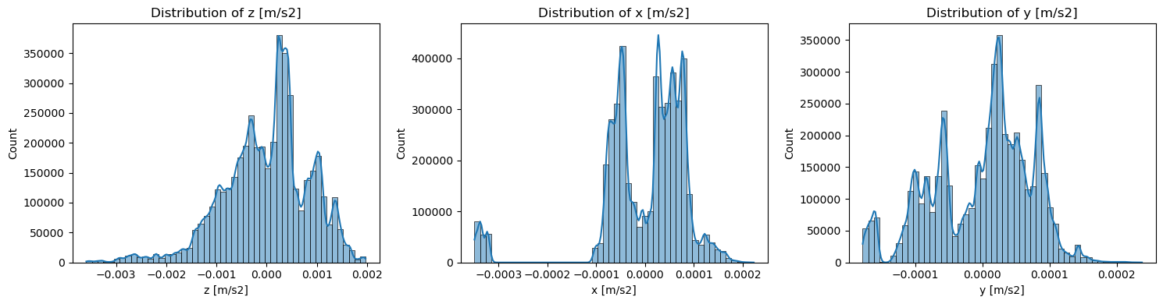
Figure 1. Distributions of the Z-, X-, and Y-axis thermal-bias targets. The plots confirm different shapes and scales across axes; X is particularly left-skewed, while Z shows the widest range.
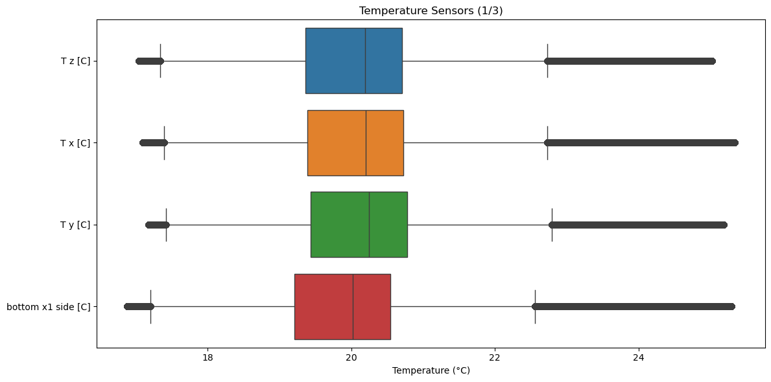
Figure 2. Boxplots for the first group of temperature sensors. The central ranges are similar, while isolated high-temperature observations indicate possible thermal peaks that should be investigated in sequence rather than deleted automatically.

3.2 Collinearity and Dimensional Structure
The correlation heatmap shows extensive collinearity among the temperature measurements. This is scientifically plausible because the sensors are mounted on the same instrument and exposed to the same thermal environment. High predictor correlation does not necessarily prevent accurate prediction, but it can make individual linear coefficients unstable and difficult to interpret.
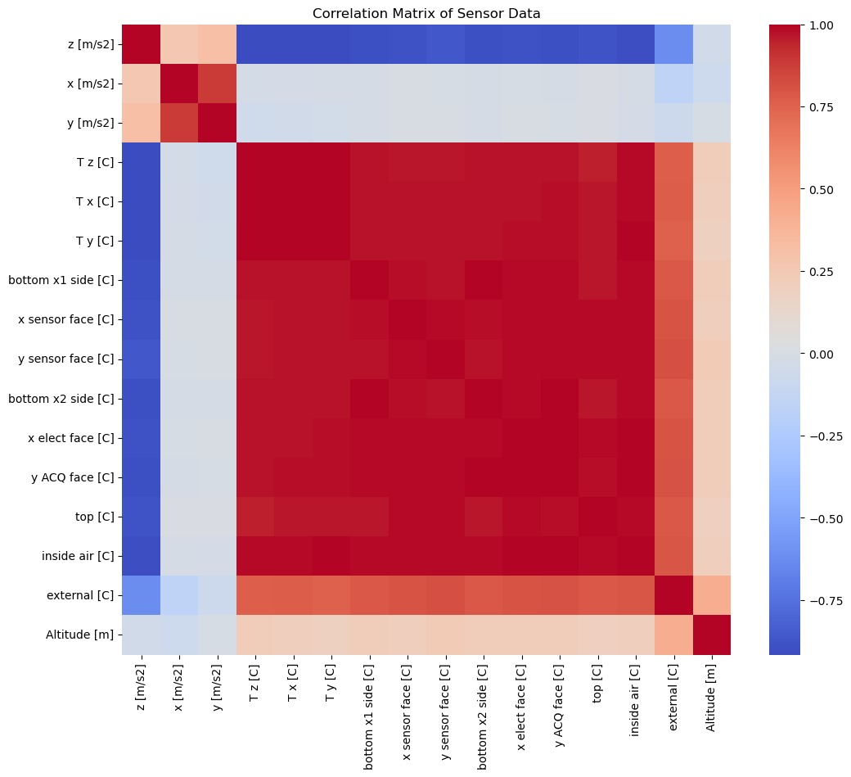
Figure 3. Correlation heatmap for accelerometer, temperature, and altitude variables. The large blocks of similar color among temperature features indicate strong shared variation and potential redundancy.
PCA was used as a complementary assessment of redundancy. The cumulative explained-variance curve rises rapidly, indicating that a relatively small number of components captures most of the variance across the temperature sensors. The exact number of components at the 95% threshold should be reported directly from the PCA summary table in the final notebook rather than inferred only from the plotted curve.
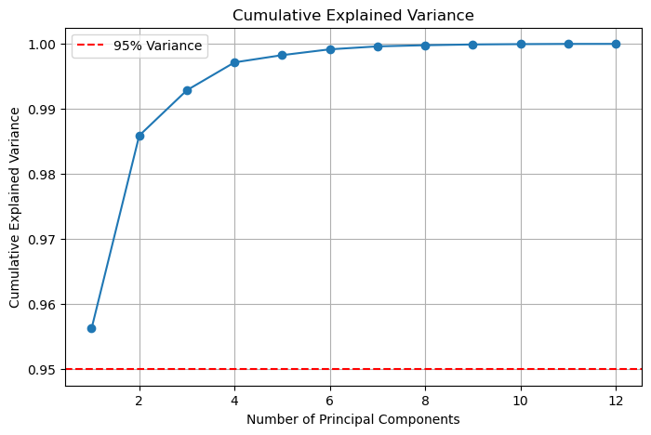
Figure 4. Cumulative explained variance from PCA of standardized temperature predictors. The rapid increase suggests that the twelve sensor measurements occupy a lower-dimensional thermal structure.

3.3 Relationships Between Temperature and Thermal Bias
Selected scatterplots show systematic associations between sensor-face temperatures and measured acceleration bias. The point clouds do not appear uniformly linear across all axes, and several trajectories overlap. This supports the plan to retain a linear model as an interpretable baseline while testing nonlinear alternatives.
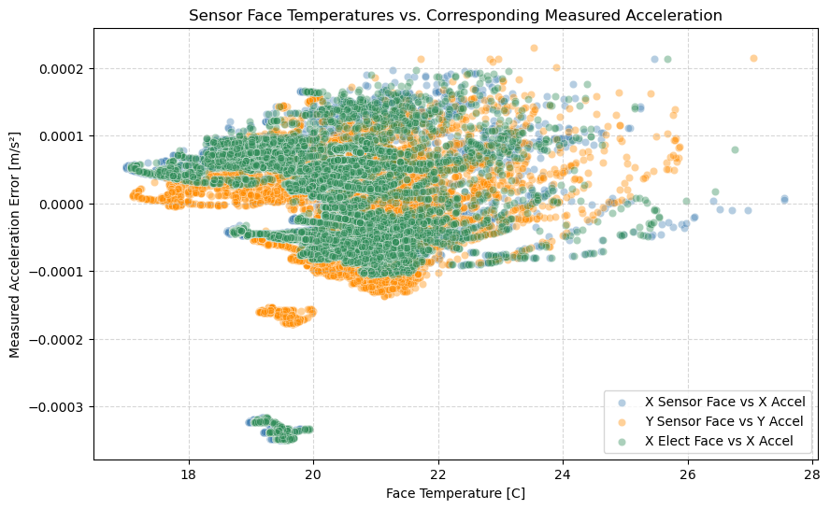
Figure 5. Selected sensor-face temperatures versus corresponding measured acceleration bias, based on a random sample of 10,000 observations. Sampling improves readability while preserving the large-scale relationship patterns.
The combined bias magnitude provides a single summary of total three-axis displacement from zero. Its distribution is concentrated at relatively small values with a longer upper tail. This measure may be useful as a secondary operational metric, but it should not replace axis-specific evaluation because the Z-axis dominates the overall magnitude due to its larger variance.
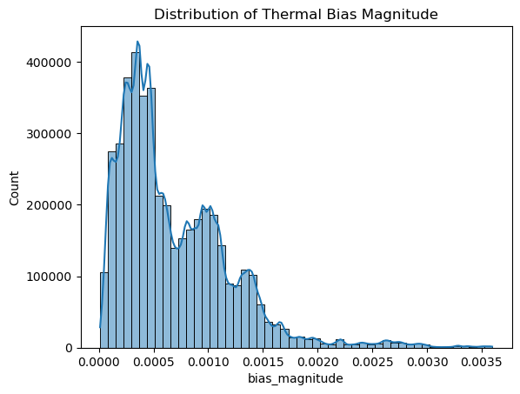
Figure 6. Distribution of the three-dimensional thermal-bias magnitude. Most observations have modest total bias, with a smaller set of larger-magnitude observations.

3.4 Exploratory Linear Baseline
The preliminary multi-output linear regression achieved an overall R² of 0.3645, RMSE of approximately 0.0002 m/s², and MAE of approximately 0.0001 m/s². Axis-specific R² values were 0.1165 for X, 0.0857 for Y, and 0.8911 for Z. The strong Z performance but weak X and Y performance indicates that the relationship is not equally linear across axes and that aggregate metrics are misleading.
Table 3. Preliminary multi-output linear regression performance.
Outcome | R² | Interpretation
Overall | 0.3645 | Moderate aggregate fit; dominated by the higher-variance Z axis
X axis | 0.1165 | Weak linear explanatory power
Y axis | 0.0857 | Weak linear explanatory power
Z axis | 0.8911 | Strong linear explanatory power
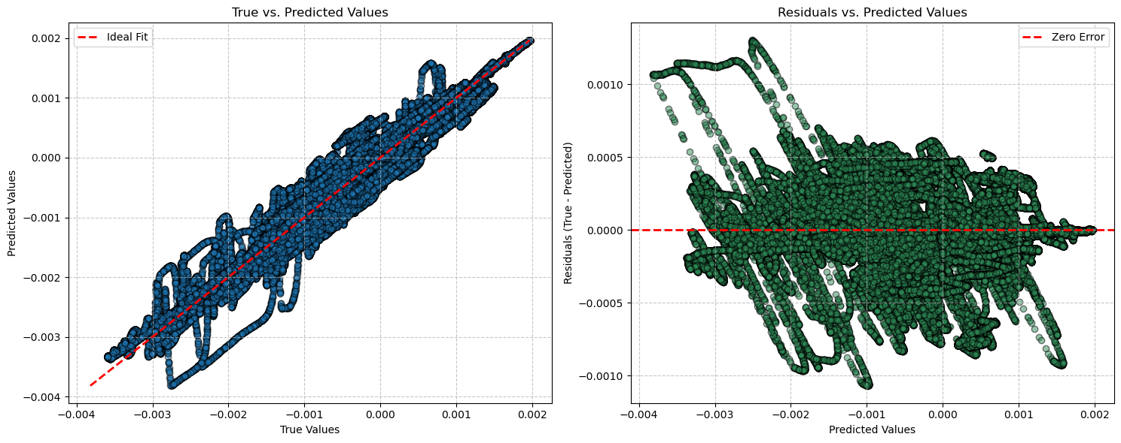
Figure 7. True-versus-predicted values and residuals for the preliminary linear baseline. Residual structure suggests that linearity and constant-error assumptions should be examined separately for each axis.

4. Discussion and Next Steps

4.1 Key Takeaways
The EDA supports the revised research question. Temperature measurements vary together and show visible associations with stationary accelerometer output, making supervised prediction feasible. At the same time, the target axes have markedly different distributions and baseline predictability. Figure 1 and Table 1 show that Z bias is much more variable than X or Y, while Table 3 shows that the linear model explains Z well but explains little of X and Y. The final analysis should therefore report metrics by axis and avoid relying only on one averaged score.
The collinearity results in Figure 3 and the PCA curve in Figure 4 indicate that many temperature sensors contain overlapping information. This does not require immediate feature removal, especially for regularized or tree-based models, but it motivates comparing three approaches: all standardized sensors, a smaller sensor subset selected by domain relevance or regularization, and PCA-derived components. Interpretability should be evaluated alongside accuracy so that the final recommendation can explain which sensor locations contribute useful information.
The observed upper-temperature extremes should not be classified as errors solely because they appear as boxplot outliers. They may represent the most informative portions of the thermal experiment. Before any removal, the team should inspect timestamps and determine whether these points form sustained heating periods, isolated instrument faults, or transitions between experimental runs.

4.2 Revised Cleaning and Preprocessing Plan
The next version of the analysis will retain the timestamp rather than permanently dropping it. Date will be parsed as a datetime field, sorted, and used to identify experimental runs, gaps, and temporal drift. Duplicate rows and duplicate timestamps will be checked. Missingness should be reassessed separately for each source CSV, since concatenation can conceal file-specific problems even when the final combined table has no missing values.
Model predictors will be standardized for linear regression, regularized regression, PCA, and neural-network models. Extreme temperatures will be flagged using distributional and time-series diagnostics but retained unless there is evidence of measurement failure. Altitude will be evaluated for scientific relevance; if it is effectively constant or acts only as a proxy for run identity, it should be excluded from the generalized thermal compensation model.
Most importantly, the random train/test split used in the exploratory notebook will be replaced with a chronological or grouped validation design. Candidate methods include blocked train/validation/test periods, leave-one-run-out validation, or walk-forward validation. These approaches will provide a more credible estimate of performance on future thermal cycles and reduce leakage from adjacent observations.
The planned model comparison will include a mean or persistence baseline, multi-output linear regression, regularized regression, at least one nonlinear machine-learning model, and a compact neural network if computational resources permit. Evaluation will include MAE, RMSE, and R² for each axis, along with vector-magnitude error. Residuals will be examined over time and temperature to identify systematic under-correction or over-correction. The primary success criterion will be meaningful improvement over the baseline on temporally separated test data rather than a generic “95% accuracy” threshold, which is not well defined for continuous regression.

Appendix A. Data Dictionary
Table A1. Current data dictionary based on the notebook.
Variable | Type | Description / Planned Role
Date | Datetime | Observation timestamp; retain for ordering, run identification, and time-aware validation.
z [m/s2] | Continuous | Stationary Z-axis accelerometer output; thermal-bias target.
x [m/s2] | Continuous | Stationary X-axis accelerometer output; thermal-bias target.
y [m/s2] | Continuous | Stationary Y-axis accelerometer output; thermal-bias target.
T z [C] | Continuous | Temperature associated with the Z-axis sensor.
T x [C] | Continuous | Temperature associated with the X-axis sensor.
T y [C] | Continuous | Temperature associated with the Y-axis sensor.
bottom x1 side [C] | Continuous | Temperature measured at bottom X1 side location.
x sensor face [C] | Continuous | Temperature measured on the X sensor face.
y sensor face [C] | Continuous | Temperature measured on the Y sensor face.
bottom x2 side [C] | Continuous | Temperature measured at bottom X2 side location.
x elect face [C] | Continuous | Temperature measured on the X electronics face.
y ACQ face [C] | Continuous | Temperature measured on the Y acquisition face.
top [C] | Continuous | Temperature measured on the top surface.
inside air [C] | Continuous | Internal air temperature.
external [C] | Continuous | Ambient external temperature.
Altitude [m] | Continuous | Altitude measurement; role in thermal-bias prediction requires justification.
error_array | Derived vector | Notebook representation combining X, Y, and Z targets into one three-output target.
bias_magnitude | Derived continuous | Euclidean magnitude of the three-axis thermal-bias vector.

Appendix B. EDA Reproducibility Notes
The notebook reads every CSV file in the configured data directory, concatenates the files, and calculates descriptive statistics with pandas. Visualizations are generated with Matplotlib and Seaborn. Scatterplots use a reproducible random sample of 10,000 observations to reduce rendering time. PCA should be rerun in a clean notebook with explicit StandardScaler and PCA initialization cells so that all variables used in the cumulative-variance plot are defined within the submitted notebook.

