ML-Assisted Thermal Bias Prediction for High-Accuracy Accelerometers
Preprocessing and Feature Engineering Report
Team Alpha
Ryan Waterman — Documentation Lead
Ngongha Fon — Communication Lead
GitHub Repository: https://github.com/DSE6311
Capstone Project Preprocessing and Feature Engineering Deliverable

1. Background and Research Question
Research question: Can temperature measurements collected at multiple locations on and around a stationary tri-axial accelerometer be used to predict the accelerometer’s thermal bias along the X, Y, and Z axes?
Hypothesis and prediction: The team hypothesizes that thermal bias follows repeatable relationships with the distributed temperature measurements. We predict that a multi-output regression model will learn these relationships and predict the three-axis bias vector on unseen observations more accurately than a simple mean-based or linear baseline. Because thermal behavior may be nonlinear and sensors may be highly correlated, a nonlinear model is expected to improve particularly on the X and Y axes, where the preliminary linear model is weakest.

2. Methods and Results
During the EDA, we proposed the next version of the analysis would retain the timestamp rather than permanently dropping it. Additionally, this timestamp would be parsed, sorted, and used to identify experimental runs, gaps, and temporal drift. Duplicate rows and duplicate timestamps would be checked. Missingness would be reassessed separately for each source CSV, since concatenation can conceal file-specific problems even when the final combined table has no missing values.
As planned, this version of the analysis retained the timestamp rather than permanently dropping it. ‘Date’ was converted to a datetime field, further converted to an int64 data type to get microseconds, then divided by 10e6 to get seconds (since epoch). From here, the entire DataFrame was sorted by Date field and used to identify experimental runs, gaps, and temporal drift. The resulting scatterplot was generated to display temperature on the Z accelerometer face over time.
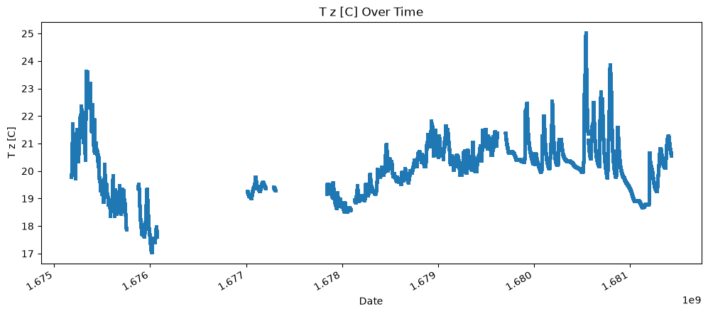
Figure 1: Visualization of T z [C] over time
This chart clearly indicates that there are significant gaps in the data across the measurement cycle. To remedy this, the longest continuous stretch of data was identified, seen below.
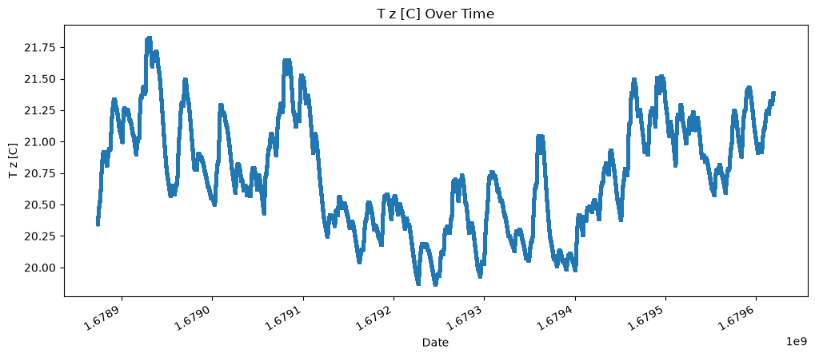
Figure 2: Visualization of longest continuous stretch of data over time

The length of this subset is 746265, which remains substantial for a machine learning effort. Duplicate rows or timestamps were not present anywhere in this subset of the data.
Due to the continuous, chronological organization of the data, the random train/test split used in the exploratory analysis was replaced with a chronological validation design. The train/test split was selected at 80:20, selecting the first 80% of the chronological data for training and the last 20% for testing. A future consideration for a deep neural network is that temporal awareness is a requirement, so a traditional neural network architecture is no longer viable. Additionally, utilizing a singular chunk of the data may blind the model to trends outside of this subset, which may require an initial training and subsequent fine-tuning approach to better generalize the model to the full breadth of the data.
The selected unsupervised feature engineering method was PCA. Prior to performing PCA, the predictors were scaled and centered using the Standard Scaler from scikit-learn. A visual of the pre and post scale and center operation is displayed, below.
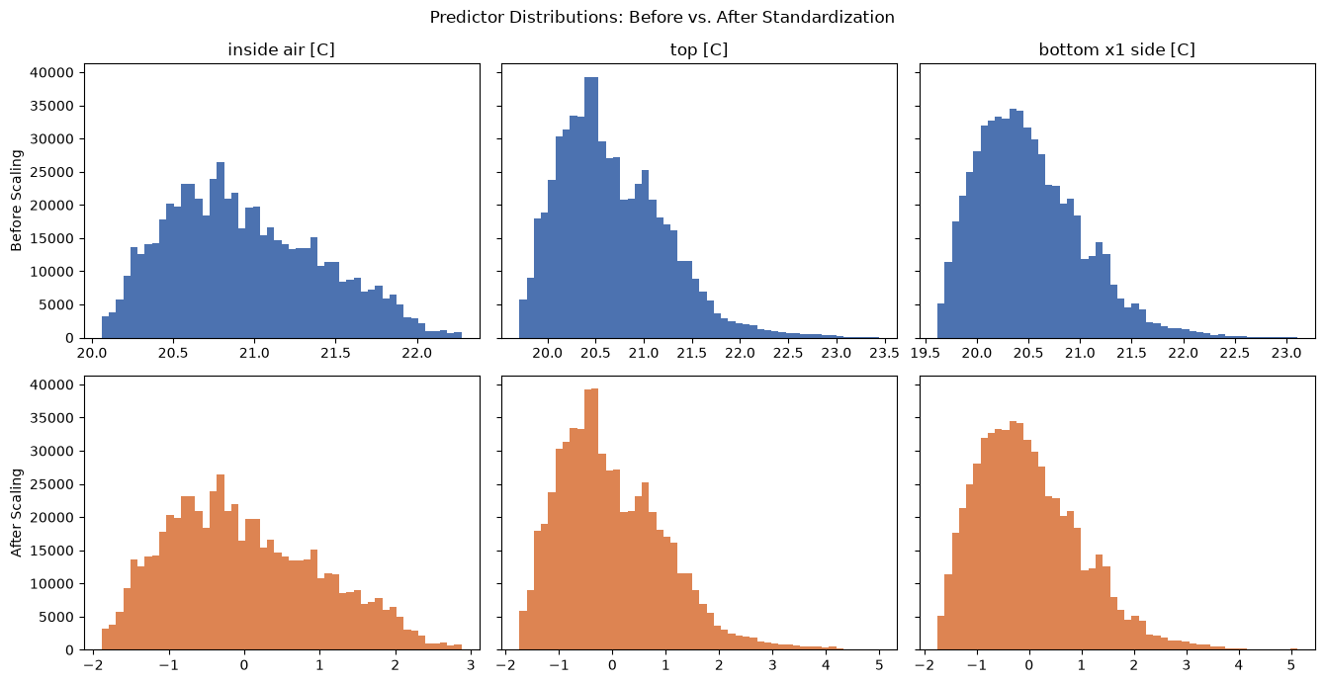
Figure 3: Scaled and centered predictor variables
The PCA demonstrated the cumulative explained-variance curve rises rapidly: the first principal component accounts for approximately 91% of the variance, approaching the 95% threshold shown in Figure 4. This concentration confirms that the twelve temperature measurements largely track a shared thermal process, although retaining individual sensors may still improve local prediction and interpretability.
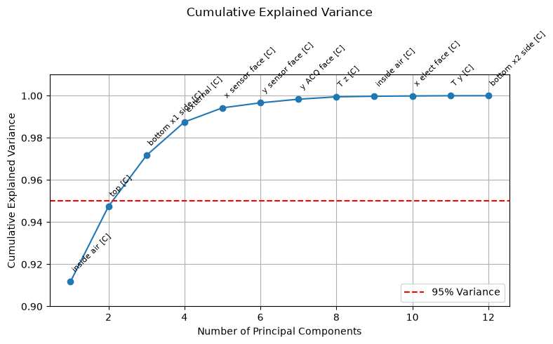
Figure 4. Cumulative explained variance from PCA of standardized temperature predictors. The first component explains approximately 91% of variance, indicating a strongly lower-dimensional thermal structure.
The planned supervised model comparison will include a mean or persistence baseline, multi-output linear regression, or regularized regression, but primarily feature a kNN model as it will be most effective at capturing the time series elements of the data. Evaluation will include MAE, RMSE, and R² for each axis, along with vector-magnitude error. Residuals will be examined over time and temperature to identify systematic under-correction or over-correction. The primary success criterion will be meaningful improvement over the baseline on temporally separated test data rather than a generic “95% accuracy” threshold, which is not well defined for continuous regression.

3. Discussion and Next Steps
The clearest takeaway from this phase is that the temporal nature of the data will need to be accounted for during modeling. Originally, we anticipated this effect to be minimal, but the discontinuous data across the full dataset proves otherwise. Predicting temporal effects can be achieved with several model architectures like 1D-CNN, RNN, LSTM, Bi-Directional LSTM, ARIMA, or even kNN if lagged values are developed. Once model testing begins, additional feature engineering may be required to derive variables that capture the rate of change in the dataset. For example, instead of leaving T z [C] as-is, the prior point could be subtracted from the current to get a rolling delta, baking in the lagged temporal effect to the variable.
The modeling plan, as previously alluded to, will include a baselining phase, followed by a regression phase, then a kNN phase, and lastly, a more complex model phase such as LSTM or ARIMA. The end goal of the project is to train a viable deep learning model that is performant, but computationally light-weight in order to be integrated into the existing micro-processor of a drone. The traditional modeling phases will serve as opportunities to understand where certain model architectures succeed and struggle with the dataset. Traditional models are far more interpretable than the proposed deep learning models, so we could quickly identify features of the data that cause catastrophic failures within the model training phase, if any.

Appendix A. Data Dictionary
Table A1. Current data dictionary based on the notebook.
Variable | Type | Description / Planned Role
Date | Discrete | Observation timestamp; retain for ordering, run identification, and time-aware validation. Converted to seconds since epoch.
z [m/s2] | Continuous | Stationary Z-axis accelerometer output; thermal-bias target.
x [m/s2] | Continuous | Stationary X-axis accelerometer output; thermal-bias target.
y [m/s2] | Continuous | Stationary Y-axis accelerometer output; thermal-bias target.
T z [C] | Continuous | Temperature associated with the Z-axis sensor.
T x [C] | Continuous | Temperature associated with the X-axis sensor.
T y [C] | Continuous | Temperature associated with the Y-axis sensor.
bottom x1 side [C] | Continuous | Temperature measured at bottom X1 side location.
x sensor face [C] | Continuous | Temperature measured on the X sensor face.
y sensor face [C] | Continuous | Temperature measured on the Y sensor face.
bottom x2 side [C] | Continuous | Temperature measured at bottom X2 side location.
x elect face [C] | Continuous | Temperature measured on the X electronics face.
y ACQ face [C] | Continuous | Temperature measured on the Y acquisition face.
top [C] | Continuous | Temperature measured on the top surface.
inside air [C] | Continuous | Internal air temperature.
external [C] | Continuous | Ambient external temperature.
Altitude [m] | Continuous | Altitude measurement; role in thermal-bias prediction requires justification.
error_array | Derived vector | Notebook representation combining X, Y, and Z targets into one three-output target.
bias_magnitude | Derived continuous | Euclidean magnitude of the three-axis thermal-bias vector.

