CAPSTONE FINAL REPORT
ML-Assisted Thermal Bias Prediction
for High-Accuracy Accelerometers
A leakage-aware evaluation of temperature-only correction models
TEAM ALPHA
Ryan Waterman — Documentation Lead
Ngongha Fon — Communication Lead
* Each author contributed equally to the design, coding & development, analysis, and writing of this project.
DSE6311 | AI for Text and Images
29 August 2026
Repository: https://github.com/DSE631

Abstract
Temperature changes can bias high-accuracy accelerometers and degrade navigation or control systems. Team Alpha evaluated whether distributed temperature measurements could predict the three-axis bias of a stationary, high-sensitivity accelerometer. The project combined 4,440,384 one-second observations, characterized the final analytical dataset, used PCA to examine sensor redundancy, and compared K-nearest-neighbor, random-forest, autoregressive, and long short-term memory (LSTM) models under time-aware validation. The temperature sensors shared a strong low-dimensional thermal pattern, but every temperature-only predictive model produced negative held-out R², meaning it generalized worse than predicting the target mean. The final chunk-tested LSTM achieved R² = -1.032 and MAE = 5.03×10⁻⁴ m/s². A one-step persistence benchmark achieved R² = 0.999965 because adjacent readings were extremely similar, but it relies on previous acceleration and therefore answers a different operational question. The current temperature-only LSTM is not suitable for correction or deployment. The project’s main contribution is a defensible evaluation framework and a clear next step: rebuild sequences strictly within recording boundaries, validate forward in time, compare axis-specific baselines, and determine whether the thermal relationship is stable across regimes before further neural-network tuning.

Contents
1. Background, stakeholder need, and research question
2. Data acquisition and analytical dataset
3. Cleaning, preprocessing, and feature engineering
4. Exploratory analysis of the final dataset
5. Algorithm selection, tuning, and validation
6. Results and post hoc diagnostics
7. Discussion, recommendations, and next steps
8. Code availability and reproducibility
References
Appendices: data dictionary, model details, and rubric traceability

1. Background, Stakeholder Need, and Research Question

1.1 Why thermal bias matters
Inertial measurement units (IMUs) translate acceleration and rotation into information used by drones, robots, navigation systems, aerospace platforms, industrial monitoring equipment, and consumer devices. Their usefulness depends on stable measurements. As temperature changes, sensor materials and packaging expand or contract, creating shifts in measured acceleration even when the instrument is not moving. In a high-precision system, that bias can accumulate navigation drift, degraded control, or repeated sensor-specific calibration work.
Published work supports the engineering relevance of this problem. Wang, Cheng, and Du (2020) describe thermal modeling and calibration for inertial navigation under complex temperature fields, while Liu et al. (2024) evaluate compensation of temperature effects in force-balanced MEMS accelerometers. These studies motivate a data-driven correction layer, but they also imply an important standard: a proposed model must transfer across thermal regimes rather than merely interpolate within one recording.
The stakeholder is an engineering or product team responsible for high-accuracy inertial sensing, including manufacturers of precision drones and other navigation-dependent platforms. Such a team needs to know whether software can reduce calibration burden without compromising safety or reliability. The practical decision is not simply whether temperature and bias correlate; it is whether a model predicts bias prospectively, on recording periods that were not used during training.

1.2 Final research question
RESEARCH QUESTION: Can temperature measurements collected at multiple locations on and around a stationary tri-axial accelerometer predict its thermal bias along the X, Y, and Z axes accurately enough to support software-based compensation on unseen recording periods?

1.3 Hypothesis and prediction
Hypothesis. Thermal bias follows repeatable relationships with distributed temperature measurements because thermal expansion and internal stress are governed by the sensor package’s geometry and thermal state.
Prediction. A multi-output nonlinear sequence model using present, lagged, and rate-of-change temperature features will produce positive held-out R² and outperform simple mean, linear, and non-sequential baselines on unseen chronological recording periods. Performance should be stable across axes and validation folds.
Decision rule. The prediction is supported only if the model beats a target-mean benchmark (R² > 0) on leakage-resistant, later-in-time or independent recording chunks and retains practically small axis-specific errors. Small absolute errors alone are insufficient because the target values are themselves very small.

2. Data Acquisition and Analytical Dataset

2.1 Source and suitability
The project uses the public dataset “Temperature Characterization of a High Sensitivity Tri-Axial Accelerometer Through Multiple Thermometers” (Iafolla et al., 2023; Mendeley Data, Version 1, DOI 10.17632/f78bmhr628.1). Three CSV files were read with pandas and concatenated row-wise into a single table containing 4,440,384 observations. Each row contains a timestamp, three acceleration measurements, twelve temperature measurements, and altitude.
The dataset is well matched to the question because the source experiment held the accelerometer stationary. Under that experimental assumption, change in the X, Y, and Z measurements can be treated as sensor bias rather than intentional motion. This avoids constructing a synthetic error label. At the same time, that assumption limits external validity: performance on a stationary laboratory sensor does not establish performance under vibration, rotation, device-to-device manufacturing variability, or field operation.
Table 1. Analytical dataset specifications.
Element | Final analytical definition | Justification
Unit of observation | One timestamped measurement, nominally one second apart within uninterrupted runs | Preserves the time-series structure required for thermal lag analysis
Targets | x [m/s2], y [m/s2], z [m/s2] combined in [x, y, z] order | Direct stationary outputs operationalize the three-axis bias vector
Primary predictors | Six direct temperature channels plus engineered thermal features | Keeps physically interpretable temperature locations and temporal context
Excluded variable | Altitude [m] | Not central to the stated temperature-compensation mechanism and dropped consistently in modeling
Final LSTM input | 53 engineered features over 40-second sequences in the chunk experiment | Represents thermal level, change, spatial gradient, and memory

2.2 Known acquisition and interpretation concerns
- Recording gaps divide the data into multiple uninterrupted chunks; sequences must not bridge those gaps.
- Rows are highly autocorrelated, so random train/test splitting would leak near-duplicate temporal information.
- All observations appear to come from one experimental sensor context; cross-device generalization is untested.
- The stationary-device assumption makes the targets useful for calibration research but does not reproduce dynamic deployment conditions.
- The notebook converts timestamps to integer values; reproducibility requires one consistent unit and explicit verification of the nominal one-second cadence.

3. Cleaning, Preprocessing, and Feature Engineering

3.1 Reproducible cleaning sequence
- Load every CSV in the project data directory and concatenate all rows.
- Parse Date as a timestamp, sort all observations chronologically, and identify a new recording chunk whenever adjacent timestamps differ by more than one nominal sampling interval.
- Remove Altitude [m] for the temperature-focused models.
- Retain x, y, and z accelerometer outputs as the multi-output response vector; do not construct a separate synthetic target.
- Within each recording chunk, reset elapsed time to zero, calculate engineered temperature features, and drop only the initial rows made incomplete by differencing or lagging.
- Create model sequences inside each chunk before concatenating sequences; fitting sequences after chunk concatenation can create artificial transitions across gaps.
- Split chronologically or by recording chunk. Fit all scalers only on the training observations of each fold, then transform validation/test observations with those fitted scalers.

3.2 Missingness, outliers, and assumptions
The EDA notebook reported no missing values in the combined source variables. Missingness introduced by first differences and lag features was handled by dropping the first 60 rows of each processed chunk, corresponding to the longest temperature lag. This is deterministic and does not impute values across recording boundaries. Temperature extremes were retained because they may represent genuine heating events; deleting them solely from boxplot position would remove the regimes the model is intended to learn.
The cleaning design assumes that within-chunk timestamps are correctly ordered, adjacent nominal intervals are comparable, sensor labels and units are consistent across CSV files, and stationary acceleration changes primarily reflect thermal bias. If any assumption is false, the target interpretation and validation results change materially.

3.3 Feature engineering and dimensionality reduction
Table 2. Final temperature-only feature set.
Feature group | Count | Definition and rationale
Direct temperatures | 6 | T x, T y, T z, x sensor face, y sensor face, and top; preserves local thermal state
First differences | 6 | One-sample dT for each direct channel; represents rate and direction of thermal change
Spatial summaries | 3 | Row-wise mean, standard deviation, and range; represents common state and uneven heating
Physical differences | 2 | x sensor face − x electronics face; y sensor face − y acquisition face; approximates local gradients
Temperature lags | 36 | Six direct channels at 1, 2, 5, 10, 30, and 60 samples; represents delayed thermal response
Total | 53 | Input features supplied at every LSTM time step

PCA was used as an unsupervised exploration and dimensionality-reduction method. After standardizing the temperature variables, the first principal component explained approximately 95.6% of their variance. This confirmed extensive redundancy and justified PCA in the KNN and random-forest pipelines. PCA was not applied to the final LSTM because the engineered channels have explicit temporal and physical interpretations, and the network was intended to learn nonlinear combinations directly.

4. Exploratory Analysis of the Final Dataset
The EDA below uses the combined analytical data after the target definition was finalized. Together, the figures establish different target scales, shared thermal structure, nonlinearity, and temporal distribution shift—the conditions that drove the choice of axis-aware metrics and time-based validation.
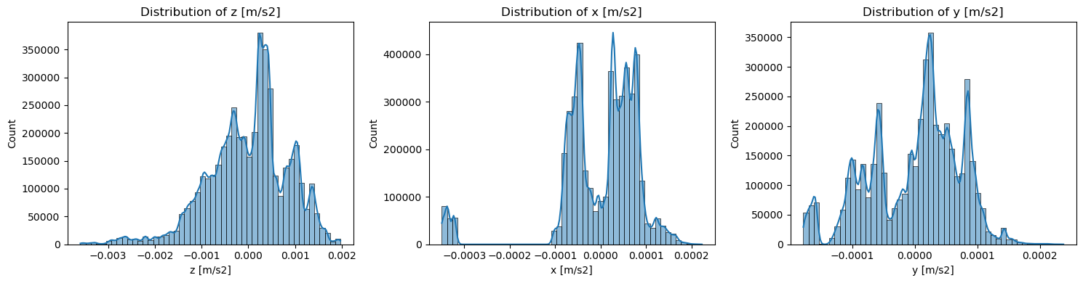
Figure 1. Distributions of X-, Y-, and Z-axis acceleration bias. The axes have materially different shapes and scales; Z varies most, while X is strongly skewed. Aggregate metrics can therefore conceal axis-specific failure.
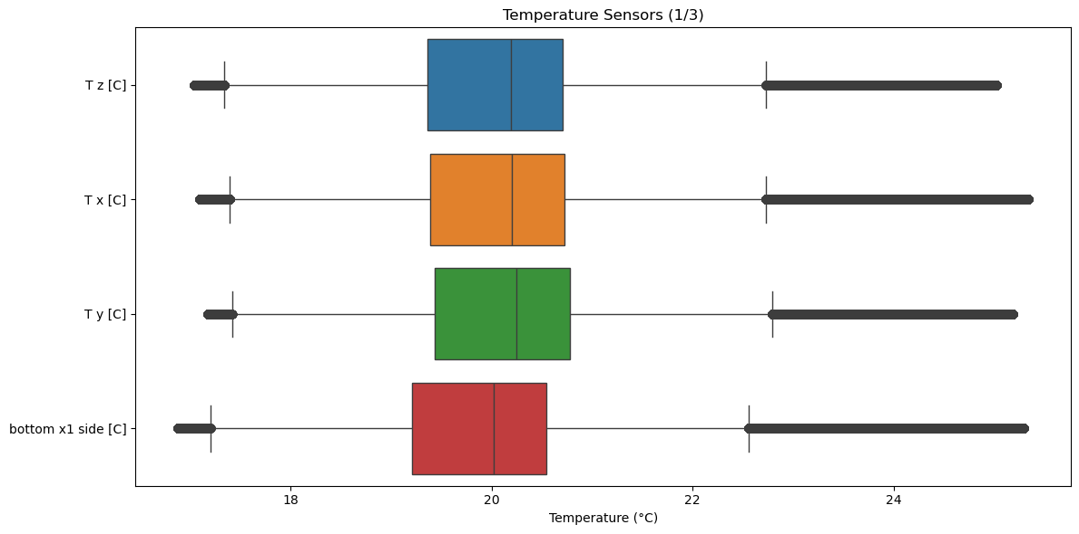
Figure 2. Temperature-sensor boxplots. Most sensors share similar central ranges, while upper extremes indicate heating regimes that should be retained and evaluated rather than automatically treated as errors.
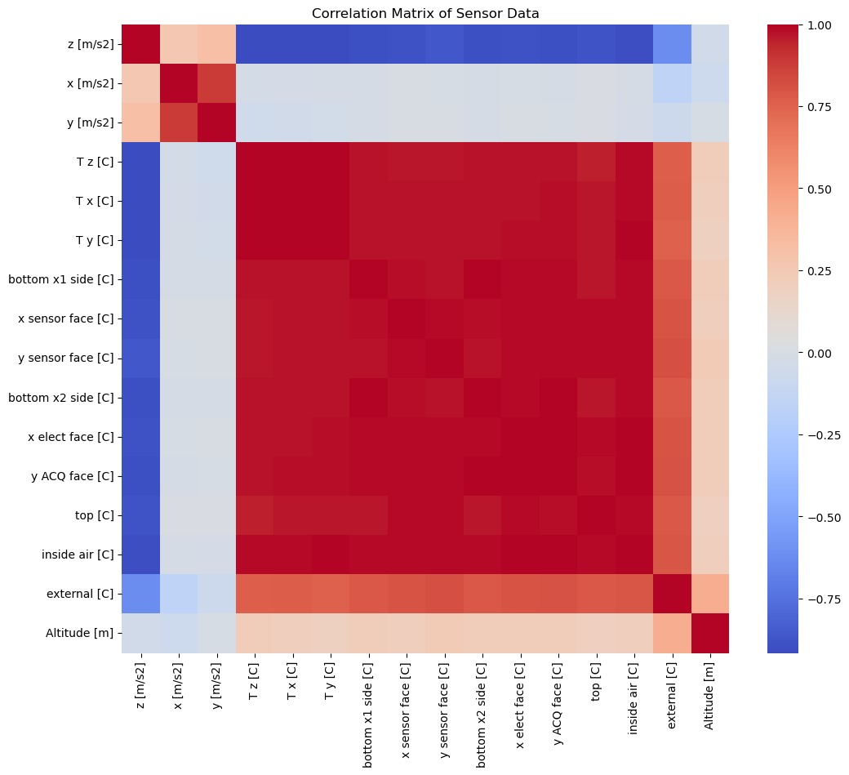
Figure 3. Correlation heatmap for the analytical variables. The large blocks of high correlation among temperature channels show a shared thermal process and substantial predictor redundancy.
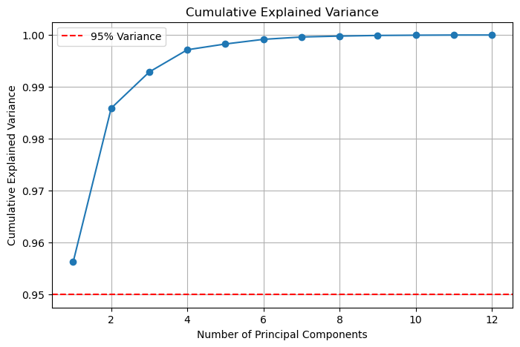
Figure 4. PCA cumulative explained variance for standardized temperature predictors. The first component explains approximately 95.6% of variance, supporting dimensionality reduction for distance- and tree-based comparison models.
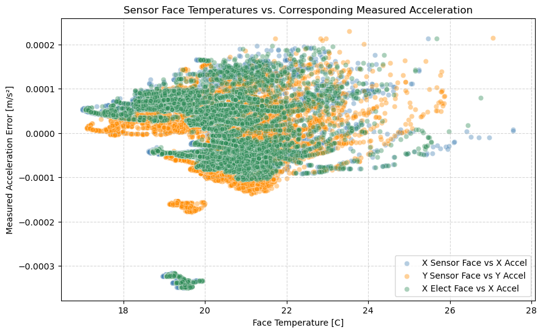
Figure 5. Selected sensor-face temperatures versus corresponding acceleration bias. Structured but overlapping trajectories suggest that a purely linear mapping may be inadequate and that time or regime affects the relationship.
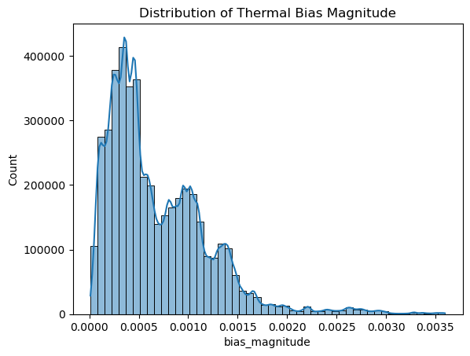
Figure 6. Three-dimensional bias magnitude. The magnitude view summarizes the combined target while retaining the need for axis-specific evaluation because direction and cancellation remain operationally important.
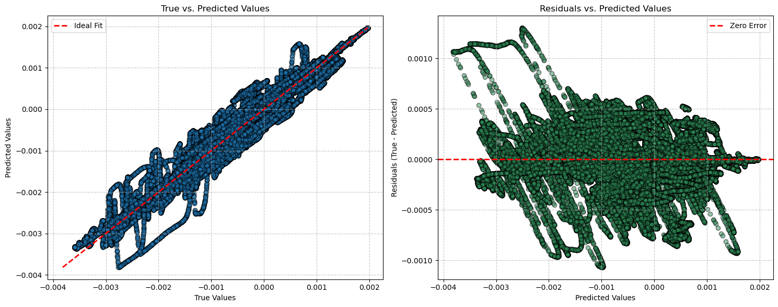
Figure 7. Chronological train/test distribution comparison. Shifts between time blocks demonstrate why random splits would be optimistic and why the final assessment must emphasize temporal transfer.

4.1 EDA implications for modeling
- Strong collinearity favors regularization, PCA, or models that do not require stable individual coefficients.
- Different target scales require target scaling during joint neural-network training and separate metrics by axis.
- Near-perfect lag-1 target correlation makes a persistence benchmark necessary, but also easy to misinterpret as evidence of temperature compensation.
- Temporal distribution shift requires walk-forward and chunk-based validation; random shuffling is inappropriate.

5. Algorithm Selection, Tuning, and Validation

5.1 Model portfolio and rationale
Table 3. Model selection and validation logic.
Model | Role | Why it was included | Key assumptions / controls
PCA | Unsupervised | Quantifies lower-dimensional thermal structure and supports compact comparison pipelines | Standardized inputs; components summarize variance, not predictive causality
Mean / persistence | Baselines | Mean defines R² = 0; one-step persistence tests how much predictability comes from target continuity | Persistence requires prior acceleration and a one-step operating scenario
KNN + PCA | Supervised | Flexible local nonlinear benchmark | Scaled distances; PCA reduces redundant dimensions; time-aware CV
Random forest + PCA | Supervised | Captures nonlinear interactions without sequence architecture | Depth/tree count tuned; chronological validation
AR random forest* | Supervised exploration | Tests whether previous acceleration explains current bias | Deployment-specific; earlier construction required leakage review
LSTM | Final exploratory temperature-only model | Represents delayed thermal response across sequences and predicts all three axes jointly | Fold-specific scaling, early stopping, dropout/L2, blocked validation

5.2 Baseline and classical supervised models
KNN and random forest were implemented with StandardScaler and PCA inside scikit-learn pipelines. TimeSeriesSplit was used during grid search to limit overfitting from chronological dependence. KNN selected 11 neighbors and 99% PCA variance; random forest selected 50 trees, maximum depth 10, and 95% PCA variance. Both produced negative cross-validation and test R², demonstrating that local similarity and nonlinear tree partitions learned from earlier periods did not transfer to the holdout.
An autoregressive random forest achieved much better metrics than the temperature-only models, but its interpretation is constrained. The earlier implementation included current acceleration in the feature list while predicting the same target, which is leakage. A clean one-step persistence model was therefore added later as the defensible autoregressive baseline. It predicts y(t) = y(t−1) within each test chunk and achieved R² = 0.999965 and MAE = 4.1×10⁻⁷ m/s² overall. This confirms extremely strong short-term continuity, not successful temperature-only calibration.

5.3 LSTM tuning and overfitting controls
The LSTM used a 64-unit recurrent layer, a 32-unit dense layer, and a three-unit linear output. Adam optimization minimized MSE on standardized targets. The tuning experiment varied sequence length from 10 to 60 samples and the number of TimeSeriesSplit folds from two to six, generating 30 configurations despite notebook labels that referred to nine. Regularization included dropout, recurrent dropout, L2 penalties in the chunk experiment, early stopping with restoration of the best validation weights, and fitting feature/target scalers separately inside each training fold.
The final chunk-based experiment retained a 40-sample sequence and three walk-forward folds. Six later recording chunks were combined for training and five earlier chunks for testing. Although the test chunks were independent, this direction is backward relative to prospective deployment. The report therefore treats the result as an exploratory external-chunk stress test, not proof of future-time performance. A corrected final protocol must train on earlier chunks and reserve later chunks for testing.

6. Results and Post Hoc Diagnostics
Table 4. Comparative performance. Negative R² means worse than the target-mean benchmark. *Interpret cautiously because of prior leakage concerns.
Model / evaluation | CV R² | Test R² | Test MAE (m/s²) | Interpretation
Persistence baseline | — | 0.999965 | 4.1×10⁻⁷ | Strong one-step continuity; uses prior target
AR random forest + PCA* | −0.5343 | −0.5361 | 2.5865×10⁻⁵ | Better, but earlier feature construction requires leakage caution
Final chunk LSTM | −8.5756 | −1.0315 | 5.0288×10⁻⁴ | Below mean benchmark on every evaluation
KNN + PCA | −3.1941 | −28.1517 | 1.35×10⁻⁴ | Poor temporal transfer
Random forest + PCA | −3.8097 | −19.6667 | 1.05×10⁻⁴ | Poor temporal transfer
Chronological LSTM | — | −14.4014 | 1.6214×10⁻⁴ | Sequence model did not fix regime shift
Separate-head LSTM | — | −7.8461 | 1.7774×10⁻⁴ | Axis heads improved R² but remained inadequate
Attention LSTM | — | −12.2849 | 1.8020×10⁻⁴ | Added complexity without generalization

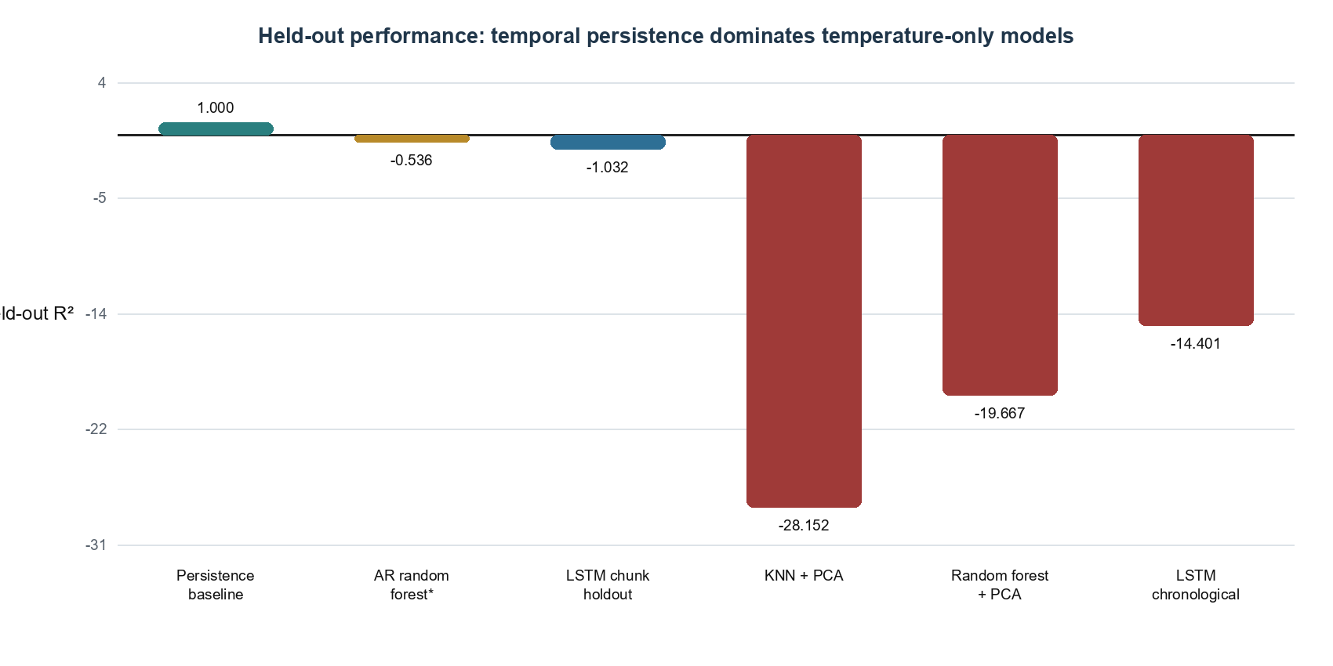
Figure 8. Held-out R² comparison. The persistence baseline is the only model above zero, but it uses the previous acceleration measurement and therefore does not demonstrate temperature-only correction.

6.1 Final temperature-only model
The chunk-based LSTM produced fold R² values of −12.544, −4.022, and −9.160 (mean −8.576). On the combined held-out chunks, R² was −1.032, MAE was 5.03×10⁻⁴ m/s², and MSE was 9.25×10⁻⁷ (m/s²)². Every R² is negative. The model therefore explains less unseen variance than predicting the relevant mean and held-out MAE is about 2.6 times the cross-validation average. This is evidence of regime mismatch and weak transfer.
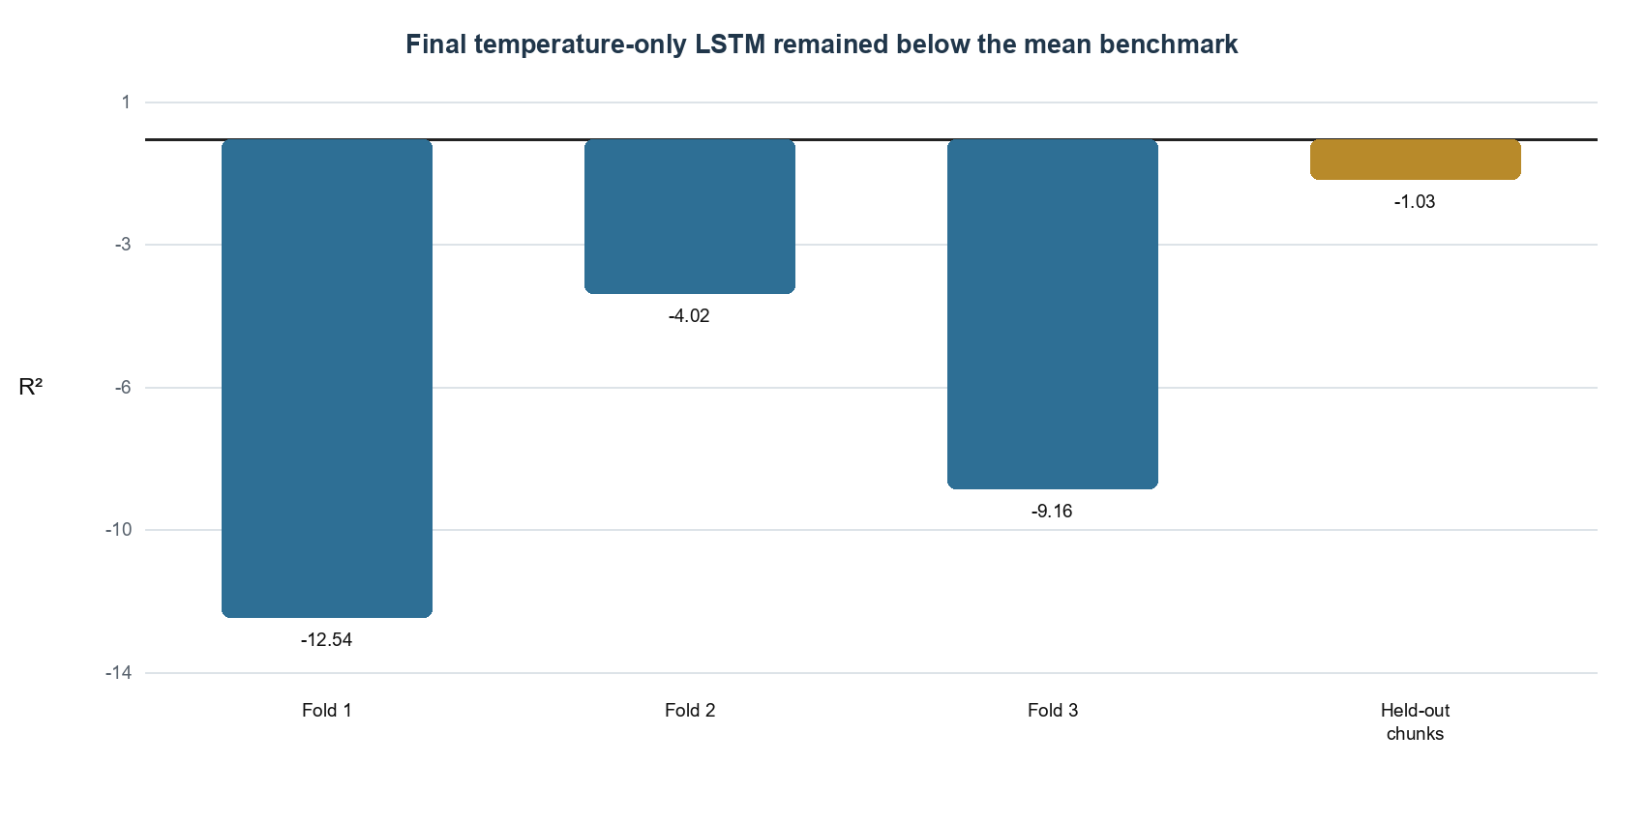
Figure 9. Final LSTM R² across chunk validation folds and held-out chunks. Performance remains below the zero benchmark in every case, so the final model cannot be defended as operationally adequate.

6.2 Post hoc axis-level analysis
Signed mean percentage error on held-out chunks was +22.60% for X, −64.69% for Y, and +78.04% for Z. Their simple average was +11.98%, but this aggregate is misleading: positive and negative axis biases cancel. Percentage error is also unstable when true bias is near zero. For decision-making, axis-specific R², MAE, RMSE, median absolute error, residual plots, and performance by recording chunk should replace the overall signed percentage summary.
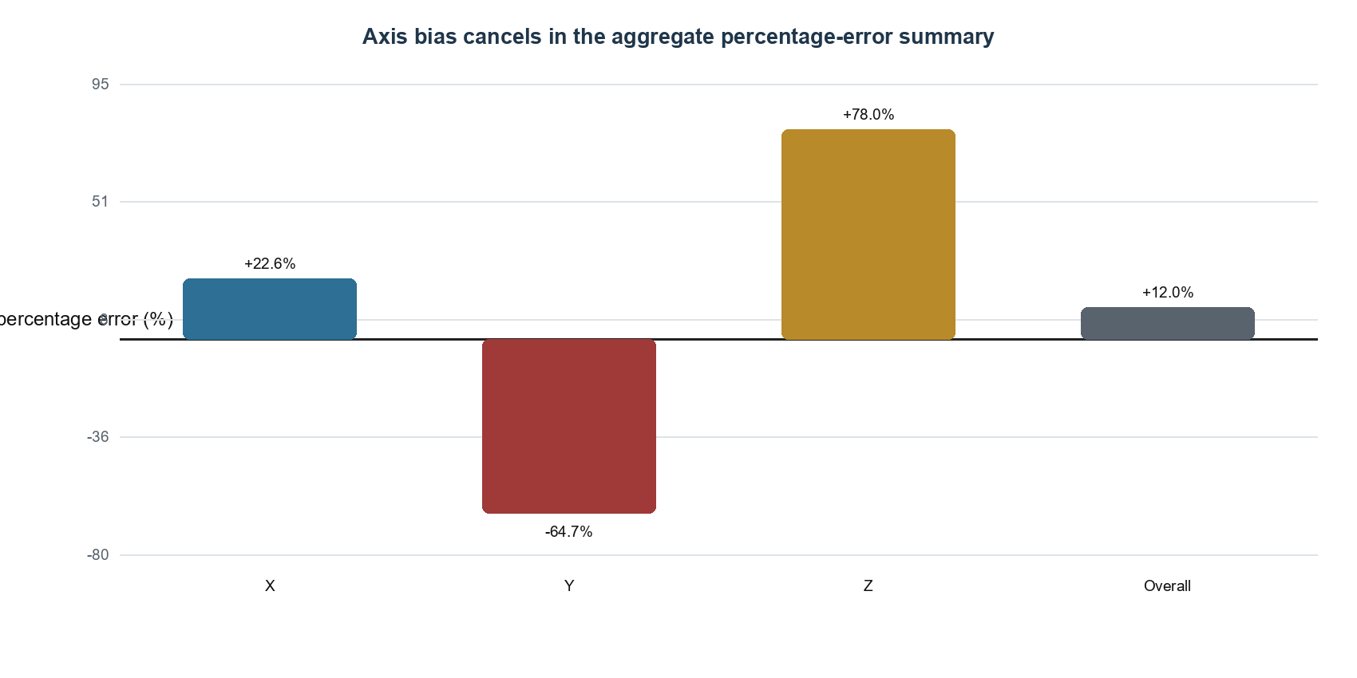
Figure 10. Signed axis-level percentage error. The apparently moderate +11.98% overall value hides large and directionally opposed errors, illustrating why aggregate percentage error is not an acceptable primary metric.

6.3 Assumption checks and remaining diagnostics
Table 5. Validity assessment and required corrections.
Concern | Evidence | Consequence / next test
Temporal leakage | Fold scalers were training-only, but sequences were sometimes created after chunk concatenation | Create sequences inside each chunk, then concatenate completed windows
Validation direction | Held-out chunks precede the training chunks | Reverse the design: earlier training, later untouched test
Residual dependence | Target lag-1 correlations ≈ 0.99996–0.99999 | Report residual ACF and Ljung–Box tests by axis
Regime stability | Negative and variable fold R² | Report metrics and residual-versus-time plots for every chunk
Loss dominance | Z has greater variance than X/Y | Scale targets in-fold and report axis-weighted and axis-specific metrics
Selection bias | Some code retained the best single fold | Select configurations by mean fold score, then refit once

7. Discussion, Recommendations, and Next Steps

7.1 Conclusions and key takeaways
The analysis supports the scientific premise that the sensor assembly has a coherent thermal structure: temperature channels are highly correlated, PCA identifies a dominant thermal component, and temperature–bias plots show systematic patterns. It does not support the project’s prediction that the current temperature-only models generalize well enough to correct three-axis bias on unseen recording periods. The final LSTM failed the pre-specified decision rule because held-out R² was negative.
The persistence result clarifies the central modeling challenge. Bias is extremely predictable one second ahead if the previous acceleration reading is available, but that short-horizon predictability can overwhelm the weaker question of whether temperature explains transferable drift. Future work must define the deployment scenario explicitly: (1) temperature-only calibration when acceleration history is unavailable or unsafe to use; (2) online filtering with prior acceleration; or (3) a hybrid model that separates slow thermal drift from rapid physical motion.
Relative to prior studies of thermal calibration (Wang et al., 2020; Liu et al., 2024), this project contributes a cautionary empirical result: regularization and neural-network complexity do not compensate for incorrect temporal validation or unstable regimes. The most valuable deliverable is therefore the evaluation discipline needed before any calibration claim is made.

7.2 Recommendations to the engineering stakeholder
- Do not use the current LSTM to correct live accelerometer output; it's held-out performance is below the mean benchmark.
- Choose and document the operating scenario before the next model cycle. If prior acceleration is available, compare a clean persistence or state-space filter; if not, retain a strict temperature-only track.
- Rebuild all sequences within recording boundaries and test prospectively: train on earlier chunks, tune on middle chunks, and lock the latest chunk as the final test.
- Report axis-specific R², MAE, RMSE, median absolute error, residual autocorrelation, and error by temperature regime. Treat near-zero percentage metrics as secondary.
- Start the next iteration with ridge/elastic-net and gradient-boosted-tree baselines before expanding the LSTM search. Complexity should earn its place by stable fold-average improvement.
- Acquire or identify multi-device and dynamic-motion data before claiming generalized deployment. Stationary single-context results are calibration evidence, not field validation.

7.3 Proposed next analytical cycle
Table 6. Recommended continuation plan.
Priority | Action | Acceptance criterion
1 | Correct chunk-local sequences and forward-time split | No window crosses a gap; latest chunk remains untouched
2 | Establish mean, persistence, ridge, and boosted-tree baselines | Complete axis-level metrics for every fold and test chunk
3 | Diagnose residuals and regime shift | Residual ACF, Ljung–Box, residual-vs-time/temperature plots
4 | Tune LSTM only after baseline stability | Positive mean fold R² and improvement on all or most axes
5 | Validate transfer | Positive R² on later-time and, ideally, separate-device data

7.4 Limitations, bias, and simplifying assumptions
This work is limited by a single published experimental context, stationary operation, substantial temporal dependence, uneven recording-chunk sizes, and possible changes in the temperature–bias relationship across regimes. The project assumes that acceleration variation under stationary conditions is predominantly thermal bias, yet other effects—sensor aging, supply variation, mechanical relaxation, pressure, vibration, data-acquisition drift, or unrecorded experimental interventions—may confound that interpretation. Dropping altitude simplifies the analysis but could remove a proxy for pressure or experimental state. Selecting only six direct temperature channels may omit useful environmental signals, while extensive engineered lags increase redundancy and computation. Earlier experiments also contained scaling and autoregressive leakage risks, and some notebook labels did not match the number of configurations executed. Finally, the backward chunk holdout is independent but not deployment-direction validation. These caveats prevent causal or production claims even where individual plots show association.

8. Code Availability and Reproducibility
Project code is organized in the DSE6311 repository materials and includes notebooks for EDA, preprocessing/feature engineering, baseline models, and hyperparameter tuning. The supplied repository reference is https://github.com/DSE6311.
Table 7. Reproducibility checklist.
Component | Recorded / required information
Primary language | Python
Core packages | pandas, NumPy, scikit-learn, TensorFlow/Keras, Matplotlib, Seaborn
Notebooks | project_eda.ipynb; preprocessing_and_fe.ipynb; baseline_models_2.ipynb; hyperparameter_tuning_3.ipynb
Data source | Iafolla et al. (2023), Mendeley Data V1, DOI 10.17632/f78bmhr628.1
Split rule | Chronological or recording-chunk based; no random shuffle
Randomness | Record Python/NumPy/TensorFlow seeds before final rerun; current notebooks do not consistently document them
Environment | Export exact package versions and hardware/CUDA information before publication
Final artifact | Commit this report’s PDF and the executed notebooks with preserved outputs

References
Iafolla, L., Santoli, F., Carluccio, R., Chiappini, S., Fiorenza, E., Lefevre, C., Lucente, M., Pignatelli, A., & Chiappini, M. (2023). Temperature characterization of an high sensitivity tri-axial accelerometer through multiple thermometers (Version 1) [Data set]. Mendeley Data. https://doi.org/10.17632/f78bmhr628.1
Liu, D., Li, F., Zhao, G., Gao, L., Cai, B., Wu, X., Peng, M., Wu, W., & Tu, L. (2024). Compensation of temperature effects in force-balanced microelectromechanical system accelerometers. Measurement, 237, 115126. https://doi.org/10.1016/j.measurement.2024.115126
Wang, Z., Cheng, X., & Du, J. (2020). Thermal modeling and calibration method in complex temperature field for single-axis rotational inertial navigation system. Sensors, 20(2), 384. https://doi.org/10.3390/s20020384

Appendix A. Data Dictionary
Table A1. Source and engineered variable dictionary.
Variable | Role | Definition
Date | Timestamp | Observation time; converted to elapsed time within chunk
x [m/s2] | Target | X-axis stationary acceleration measurement / bias, m/s²
y [m/s2] | Target | Y-axis stationary acceleration measurement / bias, m/s²
z [m/s2] | Target | Z-axis stationary acceleration measurement / bias, m/s²
T x [C] | Predictor | Internal X-axis element temperature, °C
T y [C] | Predictor | Internal Y-axis element temperature, °C
T z [C] | Predictor | Internal Z-axis element temperature, °C
bottom x1 side [C] | Candidate | Bottom package temperature, sensor 1, °C
bottom x2 side [C] | Candidate | Bottom package temperature, sensor 2, °C
x sensor face [C] | Predictor | X sensor-face temperature, °C
y sensor face [C] | Predictor | Y sensor-face temperature, °C
x elect face [C] | Derived source | X electronics-face temperature, °C
y ACQ face [C] | Derived source | Y acquisition-face temperature, °C
top [C] | Predictor | Top package temperature, °C
inside air [C] | Candidate | Internal ambient temperature, °C
external [C] | Candidate | External ambient temperature, °C
Altitude [m] | Excluded | Barometric altitude; removed in temperature-focused models
error_array | Derived target | Three-element response ordered [x, y, z]
*_dT | Engineered | One-sample first difference of a direct temperature
temp_mean/std/range | Engineered | Cross-sensor spatial summaries at each time
x_sensor_diff | Engineered | x sensor face − x electronics face
y_sensor_diff | Engineered | y sensor face − y acquisition face
*_lag_1/2/5/10/30/60 | Engineered | Prior direct temperature value at stated sample lag

Appendix B. Detailed LSTM Specification
Table B1. Reproducible LSTM configuration.
Component | Value / range | Reason
Direct input | 53 engineered thermal features | Represents level, change, gradient, and delayed state
Sequence length | 10–60 samples tuned; 40 selected in chunk experiment | Tests thermal-memory duration
Architecture | 64 LSTM units → 32 dense units → 3 linear outputs | Joint nonlinear sequence regression
Regularization | Dropout 0.30; recurrent dropout 0.20; L2 = 1×10⁻⁴ in final chunk experiment | Limits co-adaptation and overfit
Training | Adam; MSE; batch 256; up to 10 epochs; patience 3 | Standard regression optimization with early stopping
Scaling | MinMaxScaler for X; StandardScaler for y, fitted inside each fold | Prevents scale dominance and validation leakage
Validation | TimeSeriesSplit and recording-chunk walk-forward | Preserves temporal ordering
Selection correction needed | Choose mean fold score, then refit once | Avoids best-fold selection bias

Appendix C. Rubric Traceability
Table C1. Assignment coverage map.
Rubric requirement | Location in this report
Accessible opening synthesis | Abstract and decision callout
Background with at least two citations | Section 1.1 and References
Question, hypothesis, prediction | Sections 1.2–1.3
Acquisition, dimensions, target | Section 2 and Table 1
Reproducible cleaning | Section 3.1
At least five final-dataset graphs/tables | Figures 1–7 and Tables 1–2
Preprocessing and feature engineering | Sections 3.2–3.3 and Table 2
Unsupervised, baseline, and two supervised algorithms | Sections 3.3 and 5; Table 3
Cross-validation and comparative metrics | Sections 5–6; Tables 4–5
Final model and post hoc analysis | Sections 6.1–6.3; Figures 8–10
Discussion, field context, recommendations, limitations | Section 7
Code availability and reproducibility | Section 8
Works cited and data dictionary | References and Appendix A

