Bryant Pong

ECSE-4750

12/3/14

**Robotic Arm Simulator User Manual**

**Supported Platforms:** This simulator has been tested on Windows 7 64-bit and Ubuntu Linux 14.04 64-bit using the Google Chrome browser.

I will be demoing a two link robotic arm in this manual.

**1.** Open up the file “simulator.html” in your browser. You should see the following window:

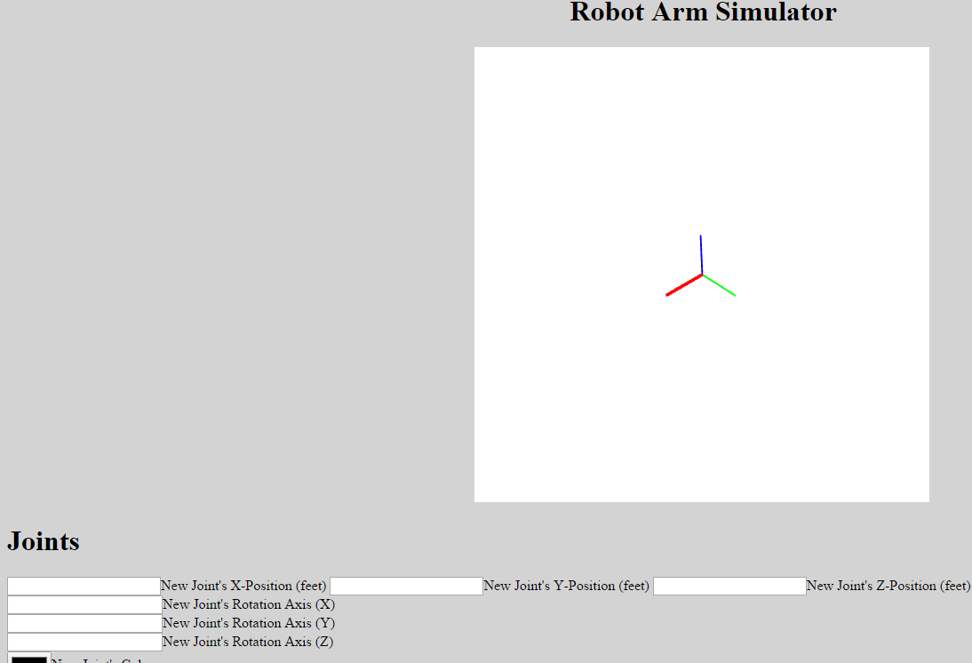

The center window with the 3 axes is the canvas in which your robotic arm will be displayed. The **current viewing angle** is from Cartesian Location **(0.1, 0.1, 0.1)**. The **red** axis denotes the **Positive X-Direction**, the **green** axis denotes the **Positive Y-Direction**, and the **blue** axis denotes the **Positive Z-Direction**. The **canvas view** is from **-10 to +10 feet** in **all directions**.

2. If you scroll down, you will find the form to input all your joint parameters:

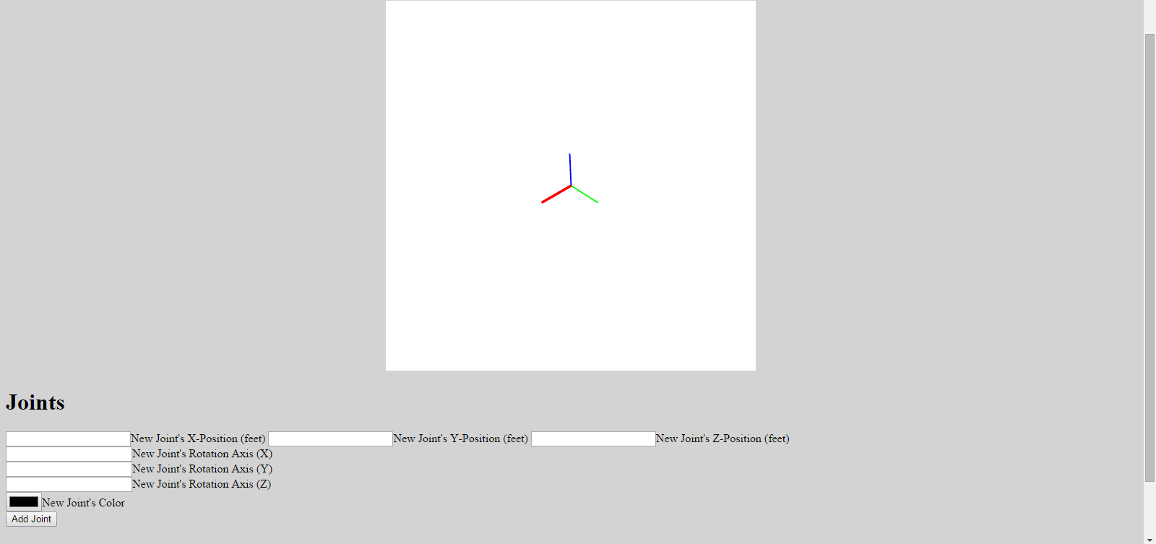

In this form, you will enter the new joint’s Cartesian X, Y, and Z positions **in feet** as well as the joint’s rotation axis. The rotation axis should **normalized**. You can also set the joint color by clicking the **colored rectangle** marked “New Joint’s Color”. Once you are done, click “Add Joint”. A **slider** element should appear to the right of the “Add Joint” button for **each joint** **created**. This slider allows each joint to be rotated from **-360 to +360** **degrees**. When entering a new joint, be sure to change only either the X, Y, or Z position and not all of them at the same time; otherwise, the links will not be properly rendered.

If you scroll down further, you will see the **Forward Kinematics** section. As you create joints, this section will be populated with each joint’s current Cartesian Location as well as the current joint angle. Please refer to the example shown below for more details on the kinematics section.

**Example Robot Arm**

As an example, let’s create a 2-link robot arm. The first joint will be at (0, 0, 0), the second joint will be at (3, 0, 0), and the end effector will be at (5, 0, 0).

To create the first joint, fill the form like so:

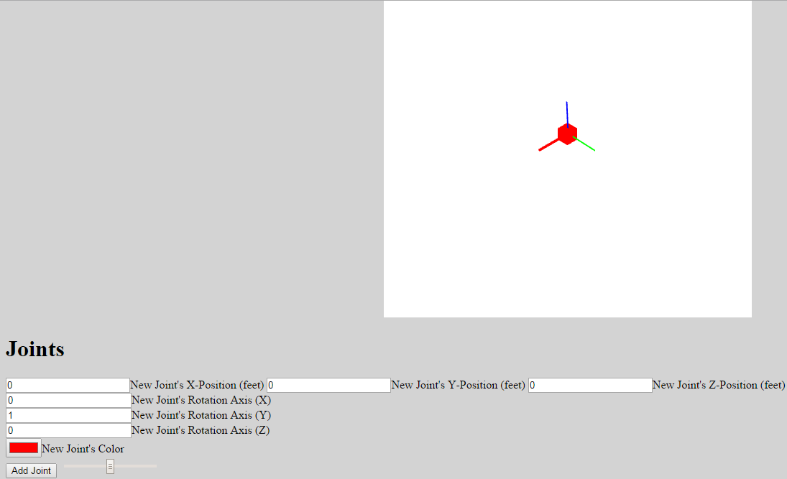

Notice that the first joint (denoted by a red cube) is set at the origin.

Next, let’s create the second joint at (3, 0, 0):

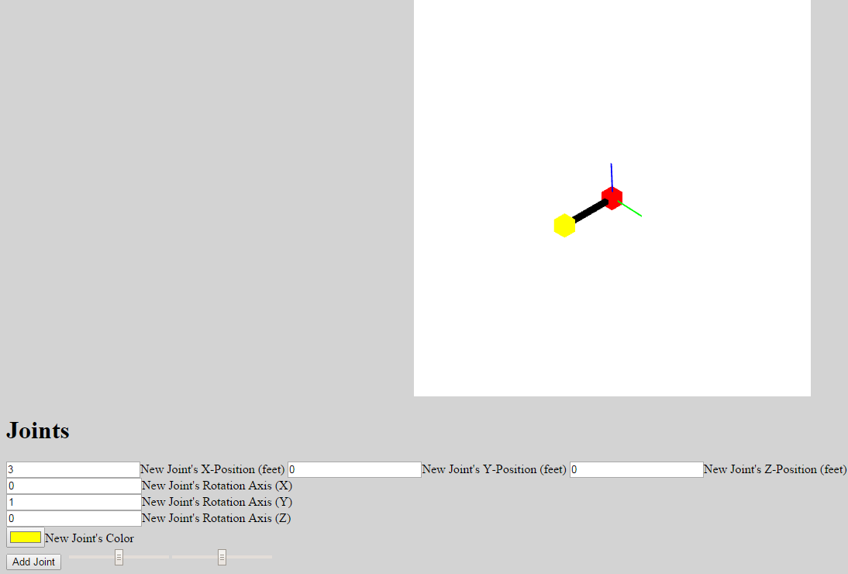

Finally, let’s create the end effector joint at (5, 0, 0):

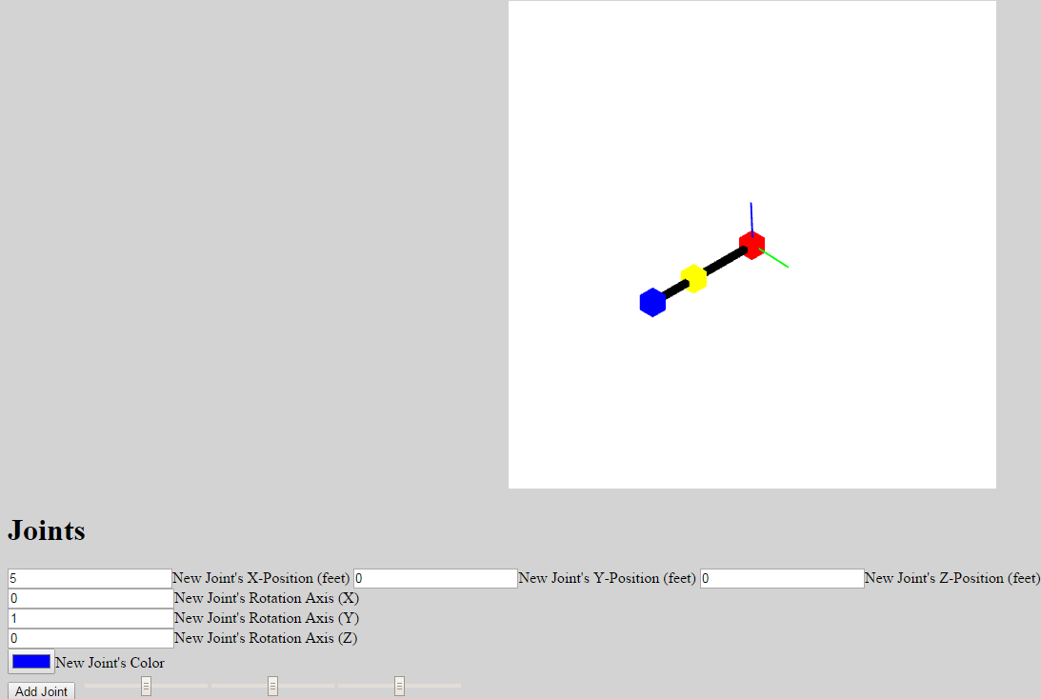

We now have our two-link robotic arm. To control each of the joints, notice the **three slider elements** that have been created to the right of the “Add Joint” button. The **first** slider corresponds to the **red** joint, the **second** corresponds to the **yellow** joint, and the **third** corresponds with the **blue** joint. Below is a screenshot of the first joint rotated to +88 degrees along the Y-Axis:

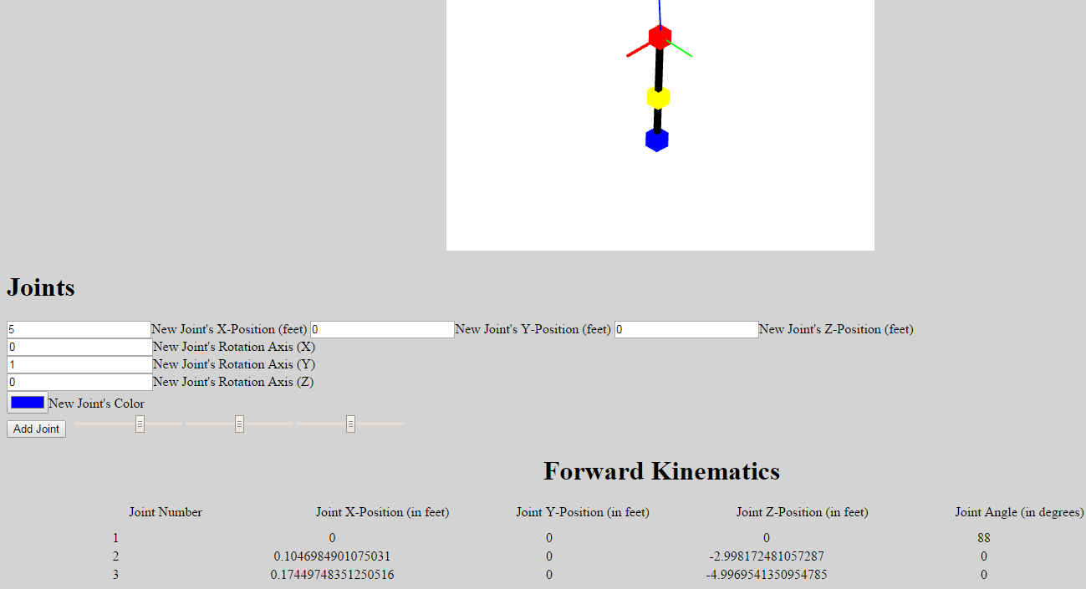

This screenshot also shows the **forward kinematics** section of the simulator. In this table, the current Cartesian Location of each joint and its joint angle are displayed. As you can see, we have indeed rotated the first joint 88 degrees. This rotation preserves the position of the first joint. Notice that the locations of the second and third joints have changed. Indeed, since the second joint was originally located at (3, 0, 0) and the third joint was originally at (5, 0, 0), it makes sense that the second joint is now at close to (0, 0, -3) feet down and the third joint is close to (0, 0, -5) feet.