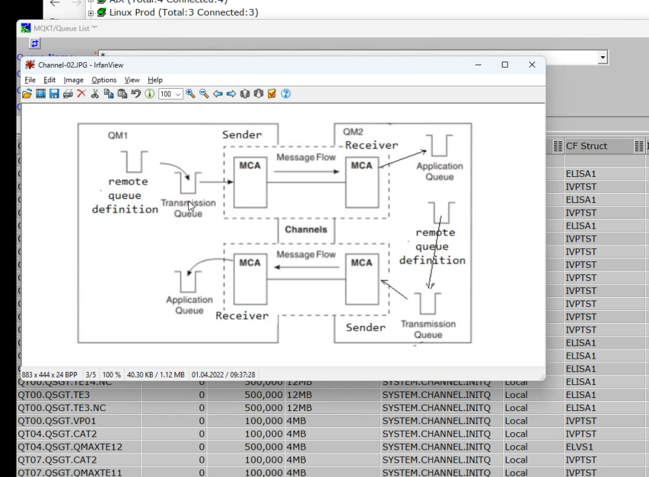

MQ
MQ = Servers
QL = Local Queues
QR = Remote Queues
QT = Transmission Queues
QA = Aliases Queues (points to a local queue )

XX.MTZ = (Mainframe test Zentrale)

QMAXTE11
QREMOTE -> Transmission -> Sender Channel -> Queuemanager -> Local Queue
QR00.ATD.RAMON.TEST -> QT00.TE11.TE12 -> CH00.TE11.TE12 -> QMAXTE12 -> QL00.ATD.RAMON12

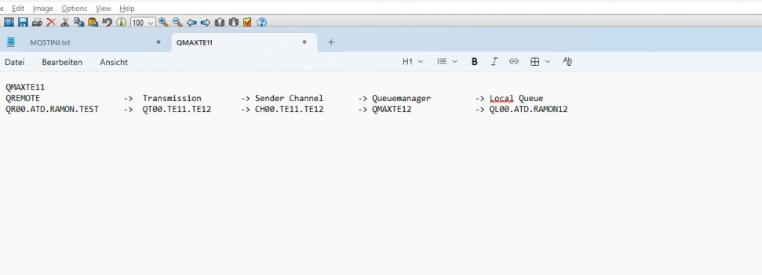

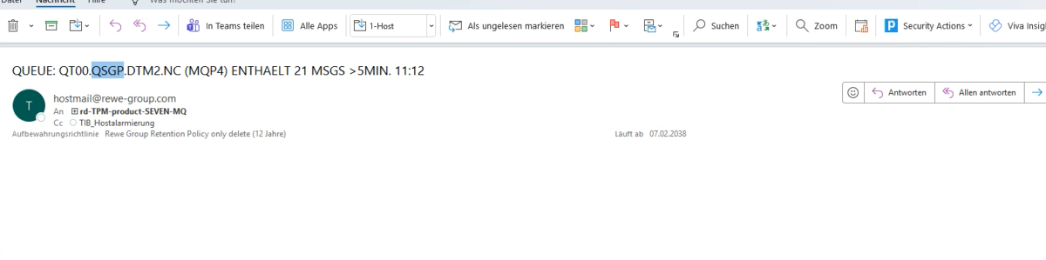

Exercises:
QT00.TE11.TE12

QMAXTE12
QL00.ATD.RAMON12

Brachthaeuser, Feli
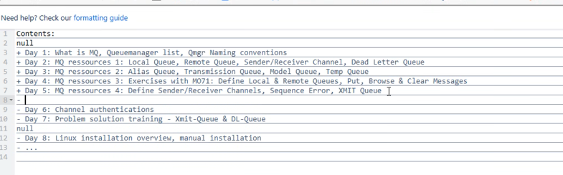

Day 6: MQ ressources 5: Client channels, Channel authentications, optimization plan, security
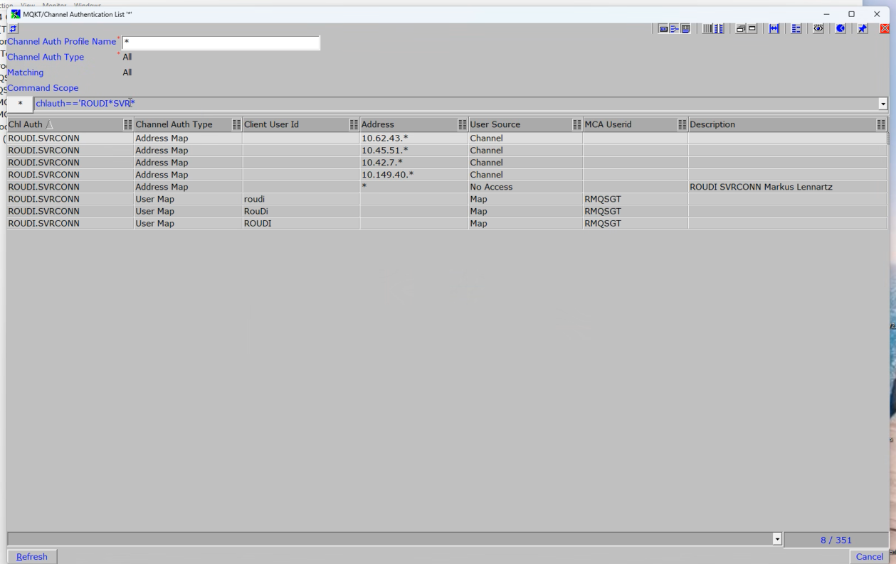
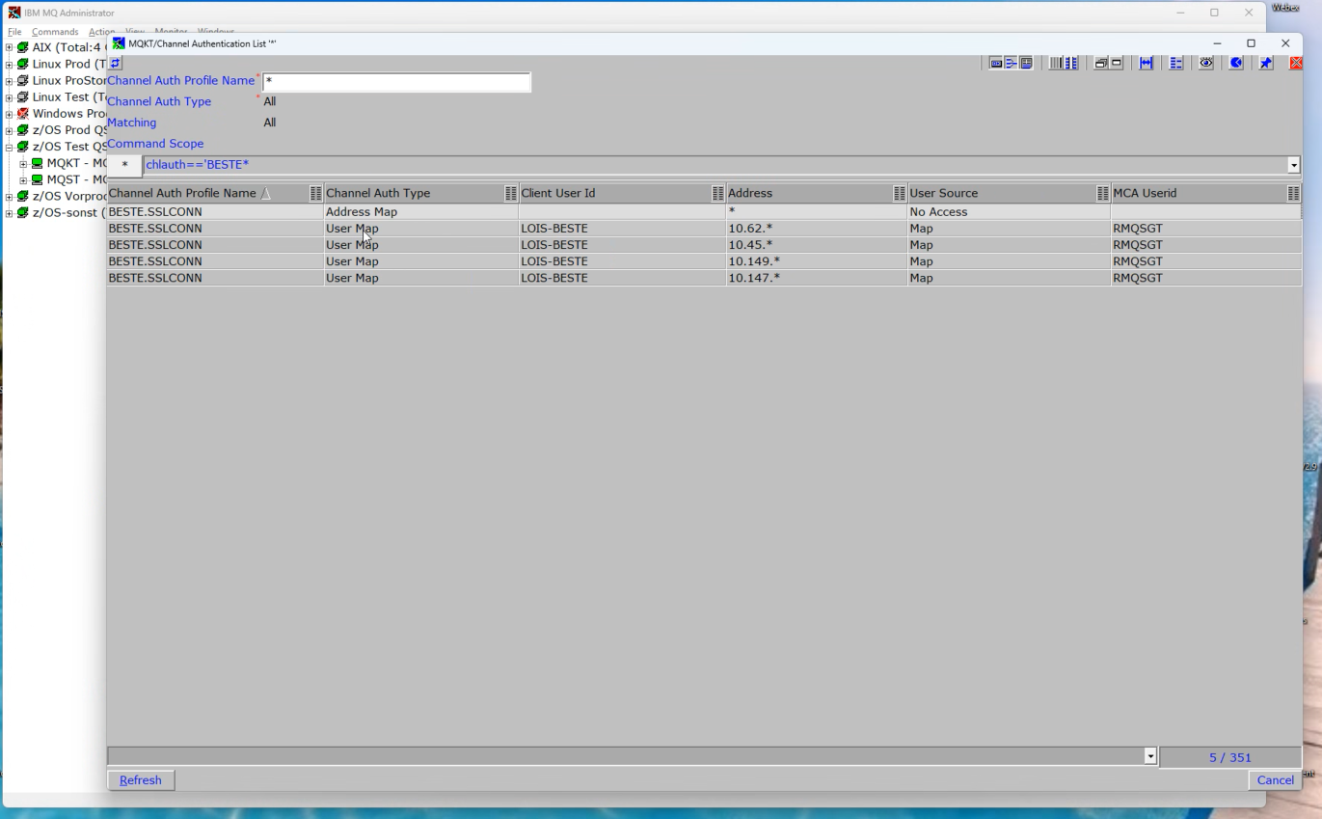
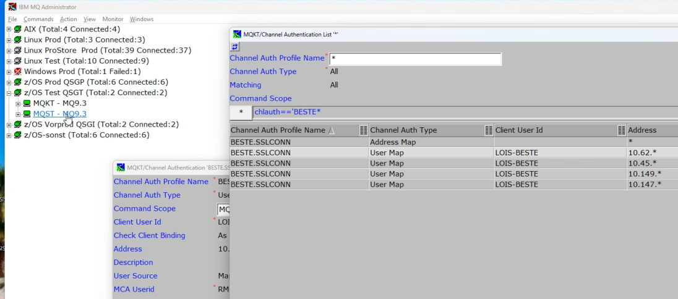
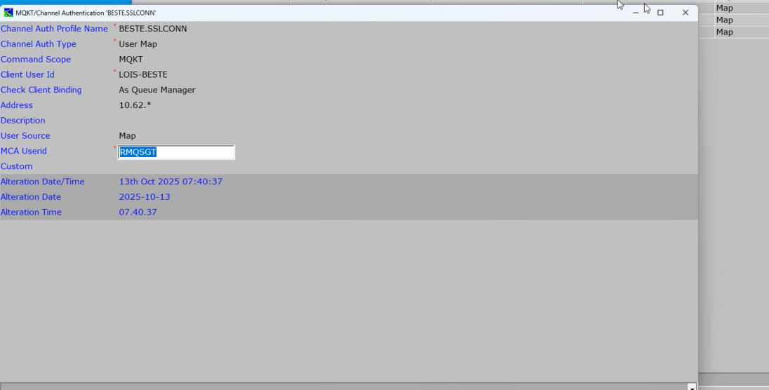
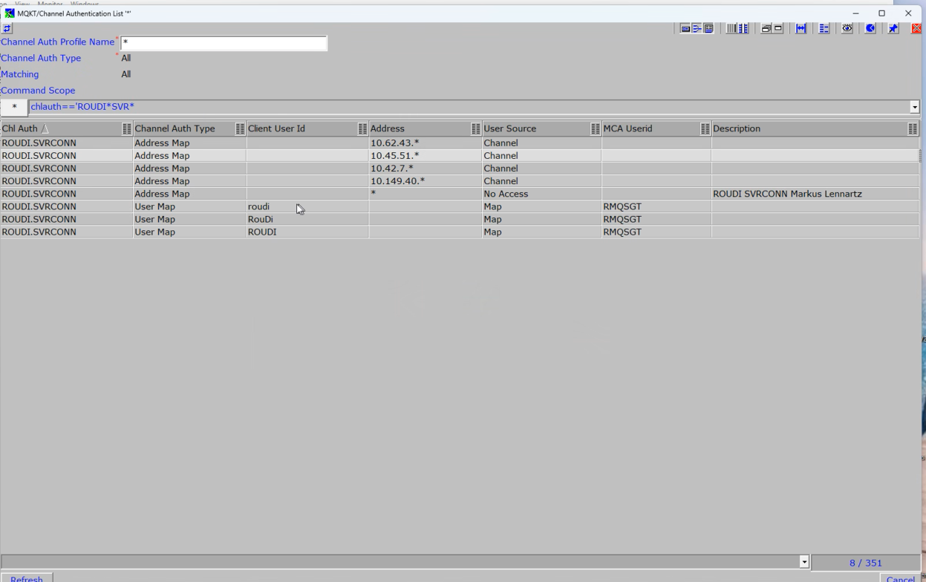
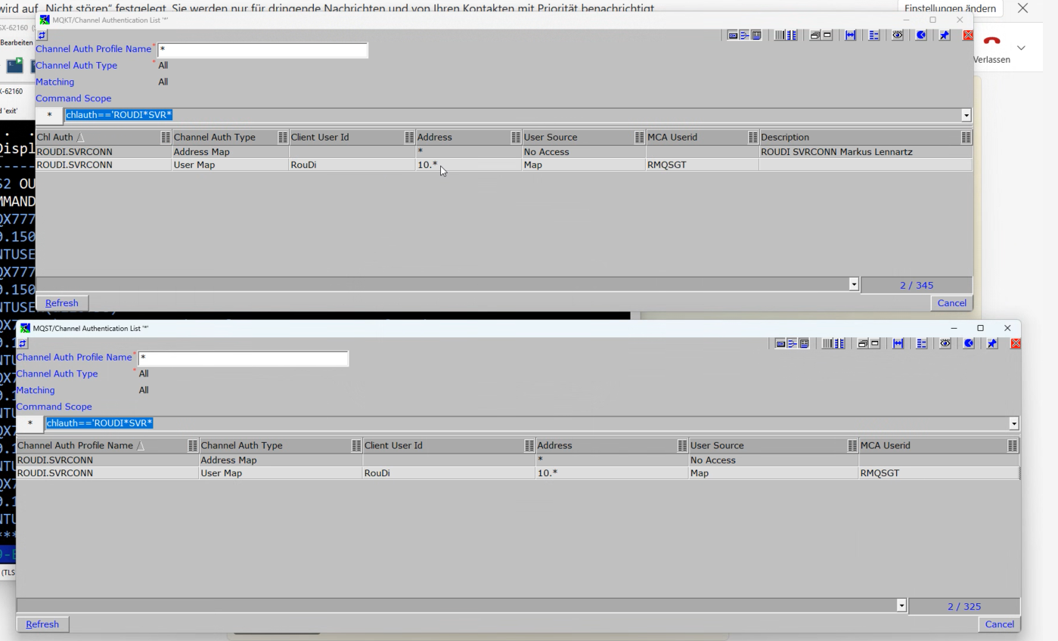
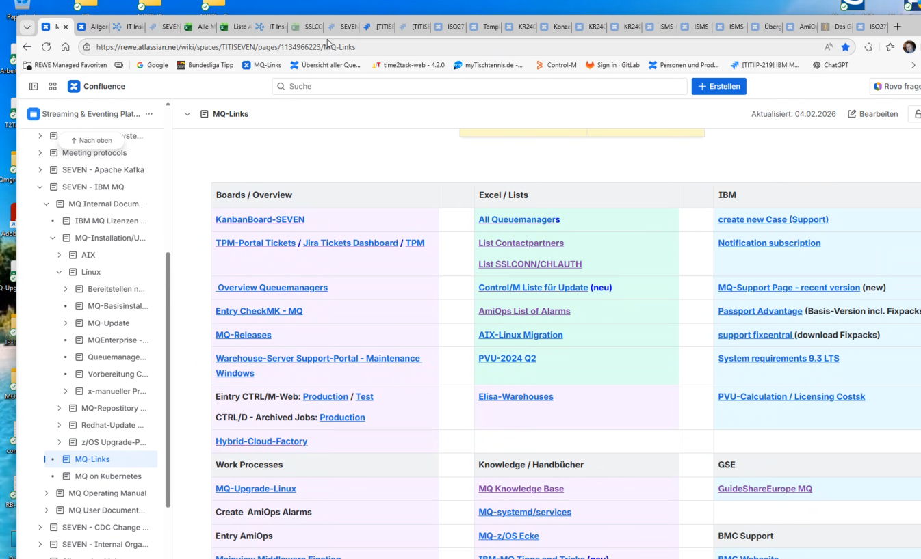
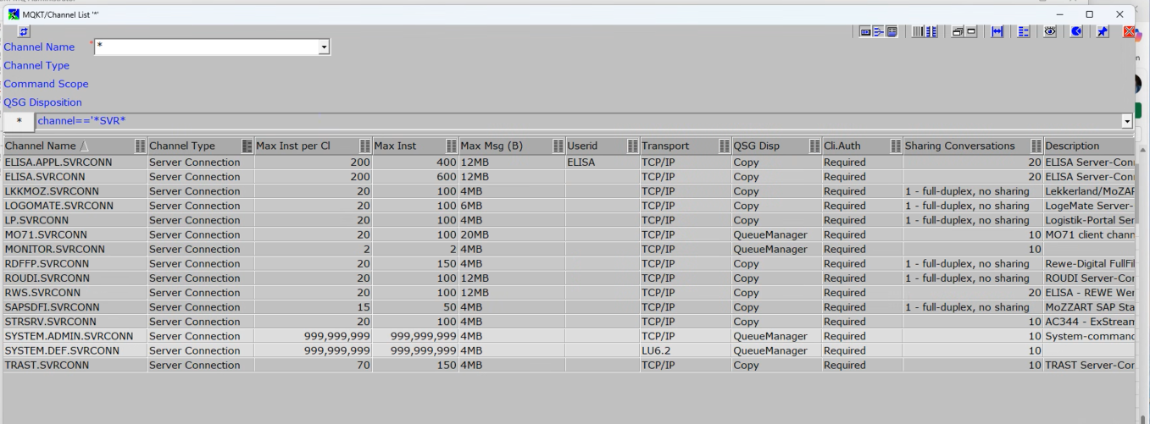chlauth==’

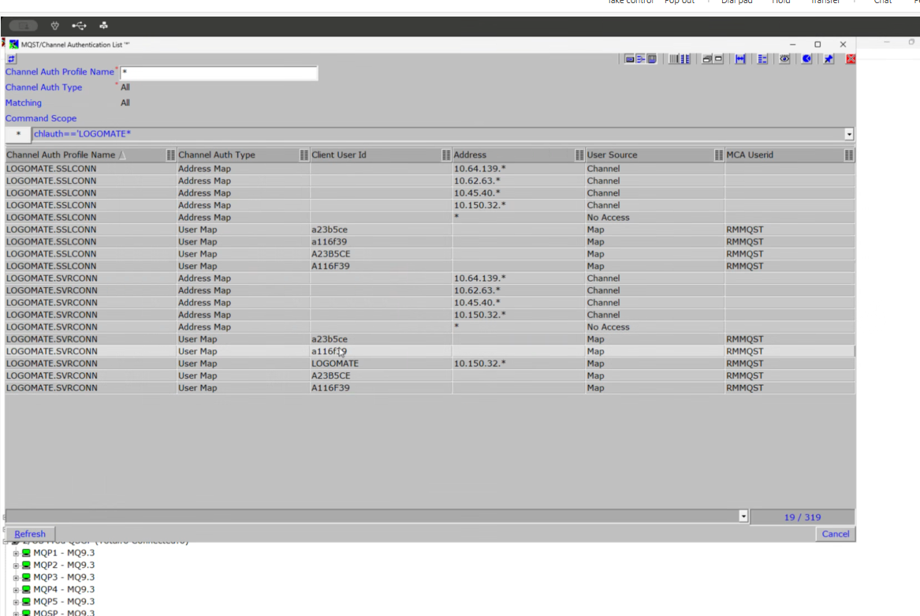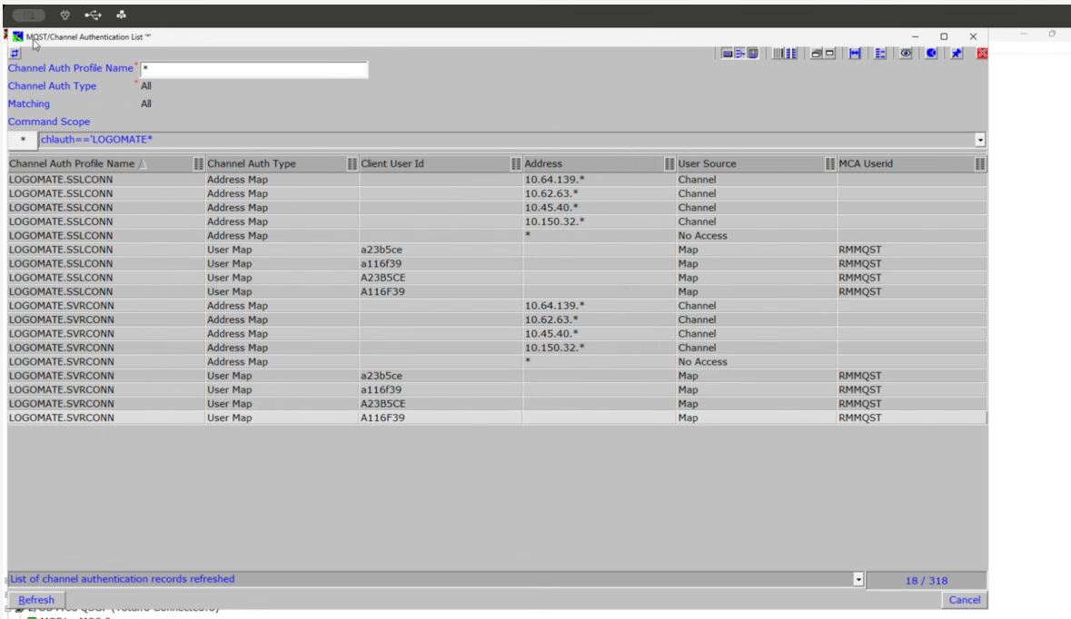

Task 2.24 to create these entries to the “LOGOMATE” ACL
