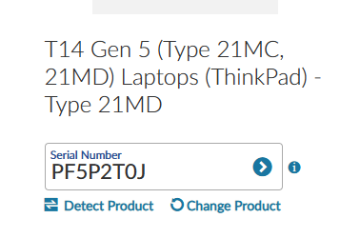
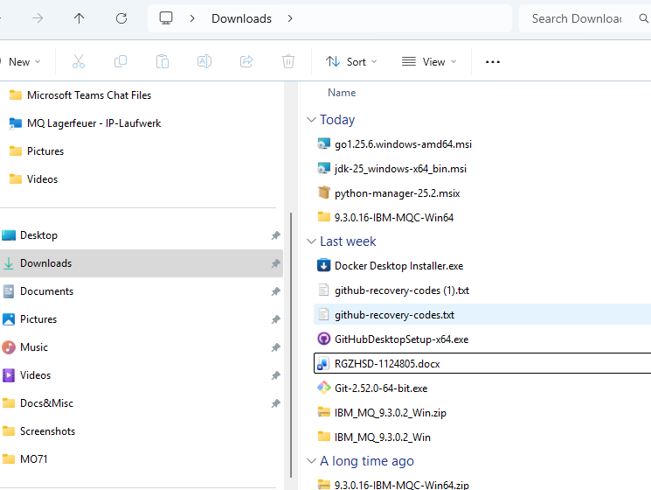

WSL

Install WSL | Microsoft Learn
Basic commands for WSL | Microsoft Learn
Set up the Visual Studio Code WSL extension - Training | Microsoft Learn

For future consideration | What distro is the best to learn RedHat enterprise on, without using RedHat enterprise? : r/linuxquestions

Windows PowerShell
Copyright (C) Microsoft Corporation. All rights reserved.

Install the latest PowerShell for new features and improvements! https://aka.ms/PSWindows

PS C:\Windows\system32> wsl.exe –install

List of commands for wsl
- wsl : This command will start a new WSL session.
- wsl -l : This command will list all of the installed WSL distributions.
- wsl -d <distribution name> : This command will start a new WSL session using the specified distribution.
- wsl --shutdown : This command will shut down all running WSL sessions.

After reboot
PS C:\Windows\system32>wsl.exe --install Ubuntu

Ubuntu Java installation
#sudo apt install default-jre
Use the default as it will be more flexible afterwards using the symbolic links
a233c1f@PF5P2T0J:/mnt/c/kafka_2.13-4.1.1$ ls -alF /usr/lib/jvm
total 16
drwxr-xr-x 3 root root 4096 Feb 3 15:53 ./
drwxr-xr-x 58 root root 4096 Feb 3 15:53 ../
-rw-r--r-- 1 root root 1840 Jan 23 00:46 .java-1.21.0-openjdk-amd64.jinfo
lrwxrwxrwx 1 root root 25 Oct 5 2023 default-java -> java-1.21.0-openjdk-amd64/
lrwxrwxrwx 1 root root 21 Jan 23 00:46 java-1.21.0-openjdk-amd64 -> java-21-openjdk-amd64/
drwxr-xr-x 7 root root 4096 Feb 3 15:53 java-21-openjdk-amd64/

.bash.profile or in /etc/environment.d/90java.conf
JAVA_HOME="/usr/lib/jvm/default-java"

a233c1f@PF5P2T0J:~$ docker run -d --name broker apache/kafka:latest
Command 'docker' not found, but can be installed with:
sudo apt install docker.io # version 28.2.2-0ubuntu1~24.04.1, or
#sudo apt install podman-docker # version 4.9.3+ds1-1ubuntu0.2

In the WSL env

Installing GO

Install Go binary manually

#cd /usr/local
#sudo wget https://go.dev/dl/go1.26.0.linux-amd64.tar.gz
#sudo tar -xvzf go1.26.0.linux-amd64.tar.gz

Update environment and path

https://code.dev.rewe.cloud/ip/caas/modules/go/kafka-self-service

export PATH="/usr/local/go/bin:$PATH"
GOPATH=/home/a233c1f/go
export GOPATH
PATH=$PATH:$GOPATH/bin
export PATH

Team seven go dev. Environment
Integration Platform / CAAS / modules / go / kafka-self-service · GitLab

Before mockery –all
#cd into the local repository
#go mod tidy

