# Coffee Shop Sales Analysis Project

Candidate Name: Rahul Das

Email: rd019041@gmail.com

Duration: Feb 2025 – Jul 2025

College: Hooghly Engineering & Technology College

Tools Used: MySQL, Excel, Power BI

## Problem Statement

The objective of this project is to extract meaningful business insights from a coffee shop’s sales data using SQL and Power BI. This includes data cleaning, KPI computation, performance breakdowns by product, store, and time, and visual storytelling through dashboards.

## Project Phases

- Data Walkthrough & Cleaning  
- MySQL Table Creation & Import  
- Date & Time Formatting  
- SQL Query Writing for KPIs  
- Power BI Visualization & DAX

## KPI Metrics Explained

### 1. Total Sales

Total revenue is calculated as unit_price × transaction_qty. Used to monitor monthly revenue and growth.

SQL Example:  
SELECT SUM(unit_price * transaction_qty) FROM coffee_shop_sales;

### 2. Total Orders

Orders are counted via transaction IDs to understand customer volume.

### 3. Total Quantity Sold

Total number of items sold gives insights into product demand and inventory planning.

## Chart-Based Visual Analysis

### Calendar Heat Map

A calendar view of sales per day. Darker cells represent higher sales. Useful for identifying peak days, trends, and anomalies.

### Weekday vs Weekend

Sales patterns compared across weekdays and weekends. Useful to identify customer behavior and plan staffing.

### Sales by Store Location

Breaks down performance by physical location. Useful for location-specific marketing and investment.

## Product & Time-Based Analysis

### Sales by Product Category

Identifies which product categories contribute the most to total sales. Useful for product bundling strategies.

### Top 10 Products by Sales

Highlights highest selling items. Supports inventory optimization and promotions.

### Sales by Hour and Day

Reveals peak sales hours by each day. Useful for workforce scheduling and operational efficiency.

## Power BI and DAX Integration

### MoM Growth & Difference (Orders)

Dynamic KPI that calculates difference and growth in orders between current and previous months. DAX used to display directional trend with symbols and formatted text.

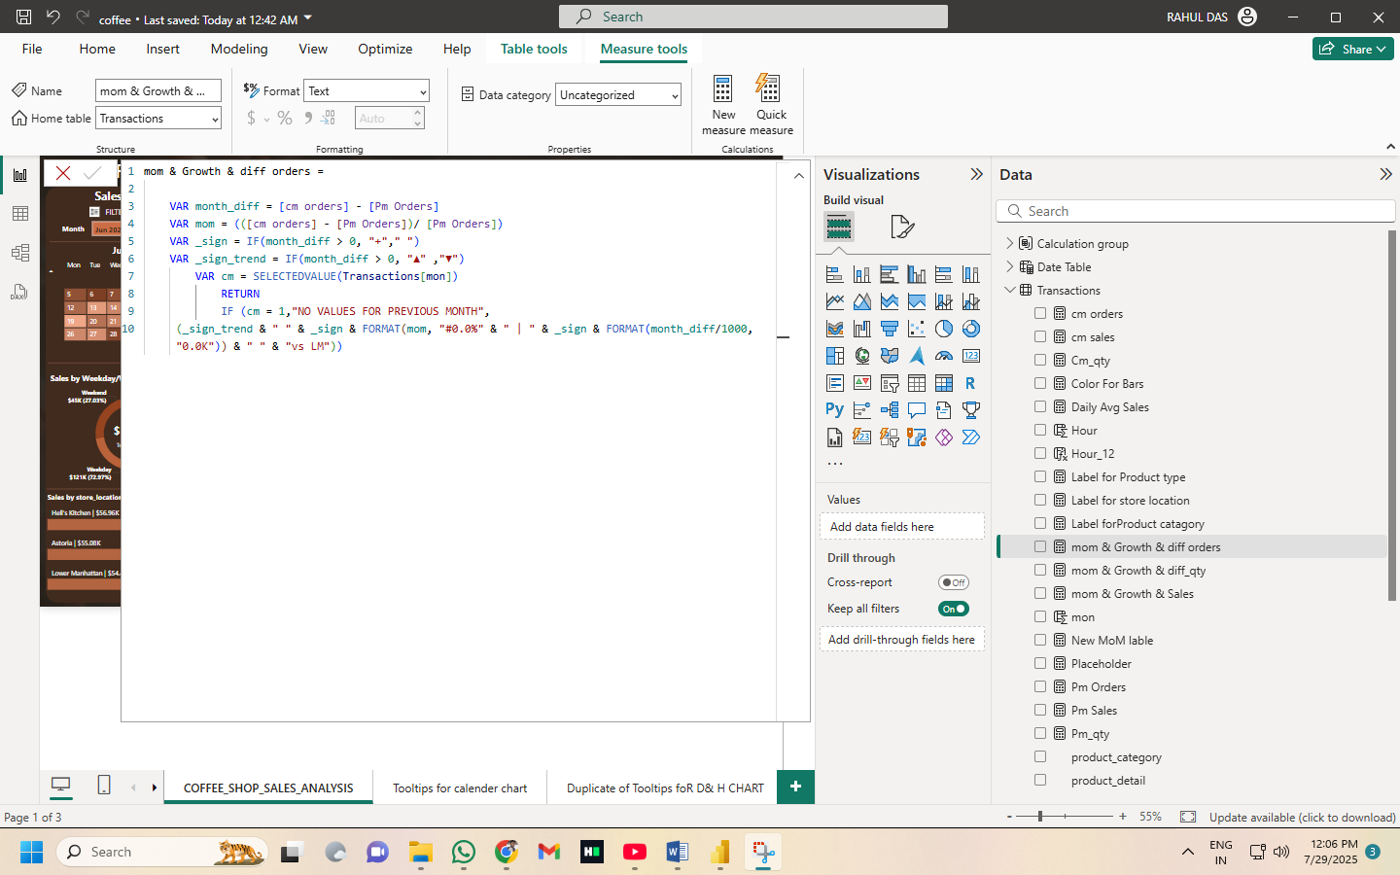

### Product Category Tooltip Label

Combines product category and total sales in tooltips using DAX. Enhances user interactivity and comprehension.

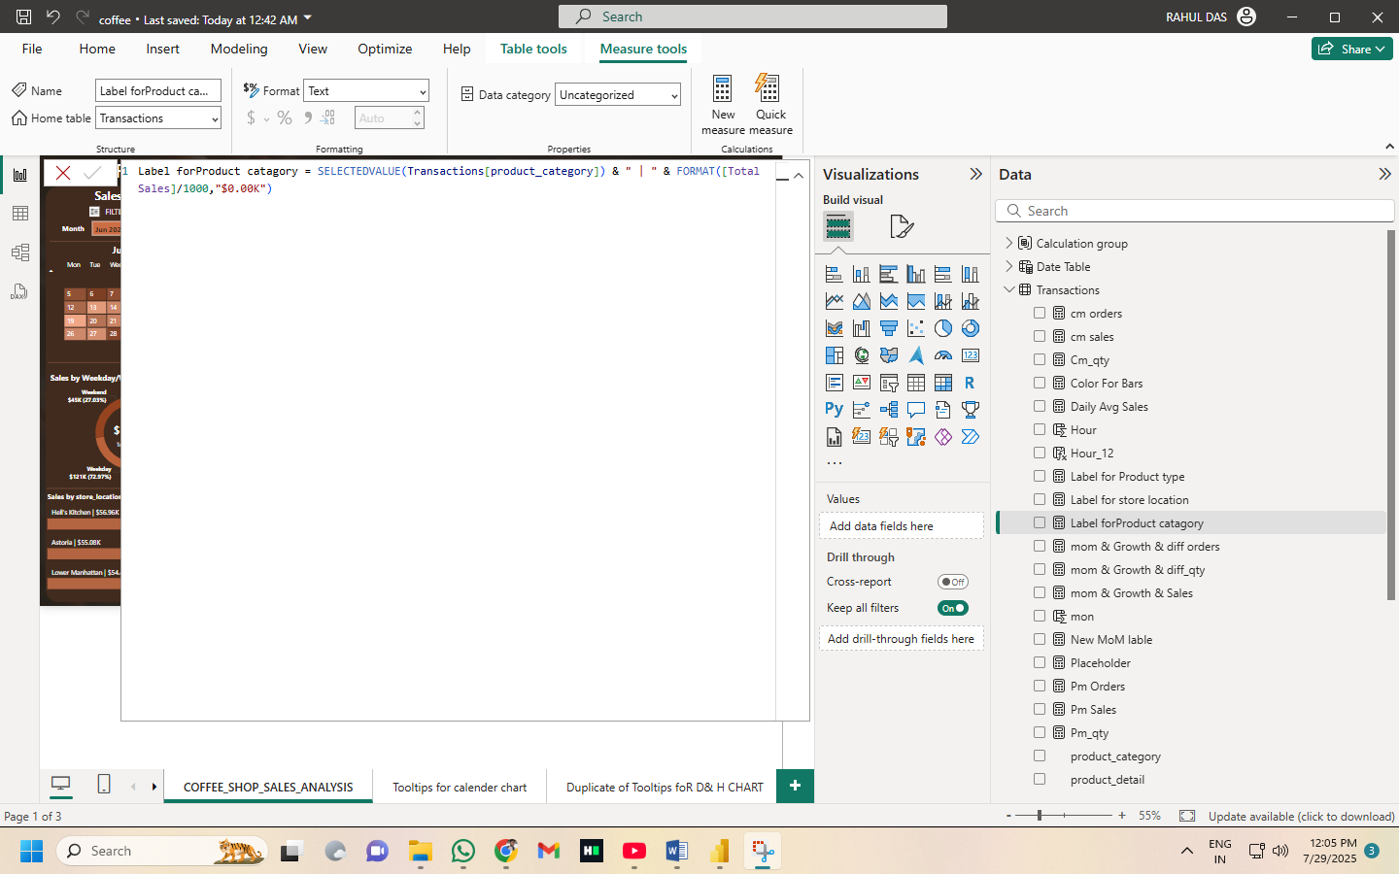

## SQL & Analytical Skills Demonstrated

- STR_TO_DATE, ROUND, SUM, COUNT, AVG, LAG  
- MONTH, DAY, HOUR, DAYOFWEEK  
- GROUP BY, ORDER BY, CASE, JOINS  
- Subqueries and Window Functions  
- Data Cleaning and Column Transformations

## Business Insights & Takeaways

- Identified 20–30% more sales on weekends.  
- Morning hours (8–11 AM) saw highest sales concentration.  
- Top 3 products made up over 40% of sales.  
- Store-specific insights aided location-level optimization.

## Conclusion

This project showcases end-to-end data analysis using SQL and Power BI, from cleaning raw datasets to deriving actionable insights. It reflects core capabilities in database querying, DAX scripting, and dashboard storytelling, useful for real-world business intelligence roles.