Demo-Report-RStudio

Thang Pham

5/21/2020

# Comparison of Document Counts and Comment Counts Across 3 Courses

## Data

The data was extracted from a sample database of student users. In total, there are 64 documents and 350 comments authored by all students, with an average document:comment ratio of 5.47.

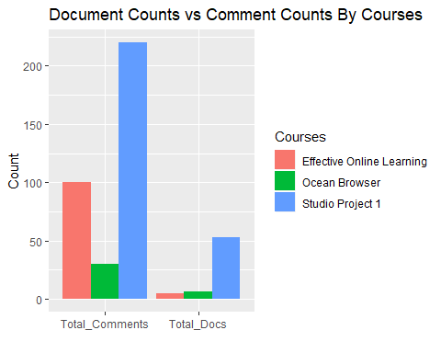

While it is not surprising that there are more comments than documents, effective online learning seems to generate by far the highest level of productivity, with a comment/doc ratio of 20, about 4 times higher than the other two courses.

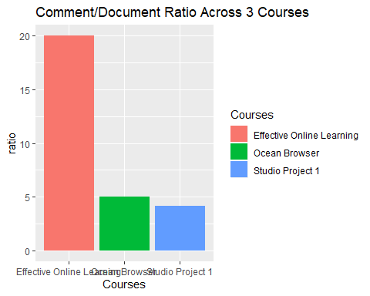

## Implications

The two charts and above analyses suggest that there is room to improve the interactivity of the 2 courses Ocean Browser and Studio Project 1.

Further research should be carried out to investigate what makes Effectie Online Learning so engaging.