 1DV508 - Project Course in Computer Science

                   Analysis and Requirements

Project description:

The goal of the project it to create a timeline management application. It should contain an edit mode, and a display mode for viewing, adding, deleting, and modifying timelines containing “events” that have a time and may or may not have a duration.

Project Members(7):

Hägg Robin (Project manager)

Dirnfeld Ruth

Charo John Elie

Madou Idris

Lee Su In

Meng Chaoran

Huang Tianyi

Github repository: <https://github.com/rd222dv/Project>

Use-case diagram:

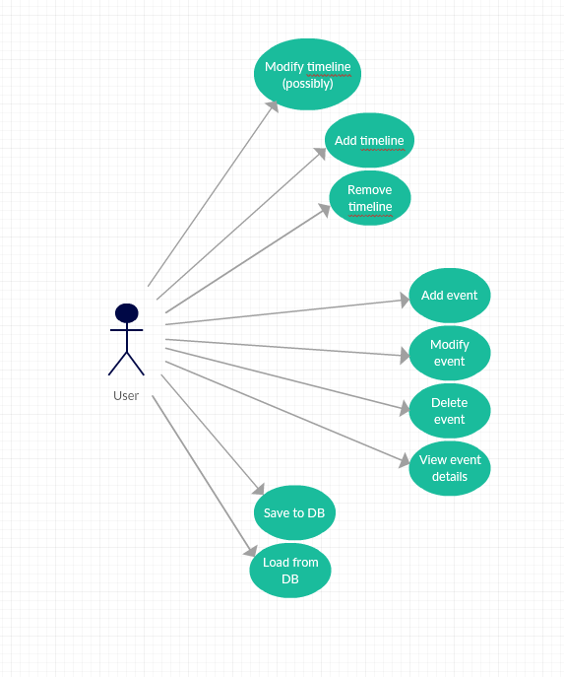

Use-case specifications:

Use Case: **Modify timeline** (possibly)

Actors: User

Description: The User has installed the timeline app, chooses to modify the timeline and saves it afterwards

Preconditions: has the timeline app

Main flow:

- clicks on the “modify timeline” button

- User modifies what he wants

- clicks save

- modified timeline is shown

Postcondition: The timeline was successfully modified

Exceptions: validate range, end cannot be before start

Use Case: **Add timeline**

Actors: User

Description: The User has installed the timeline app, chooses to add a timeline and saves it afterwards

Preconditions: has the timeline app

Main flow:

- clicks on the “new timeline” button

- User enters details in displayed fields

- clicks save

- modified timeline is shown

Postcondition: The timeline was successfully added and displayed

Exceptions: validate range, end cannot be before start

Use Case: **Remove timeline**

Actors: User

Description: The User has installed the timeline app and chooses to remove the timeline

Preconditions: has the timeline app

Main flow:

- clicks on the “remove timeline” button

- Are you sure you want to delete this timeline + Yes or No options pop up

- confirm to delete

- timeline is deleted

Postcondition: The timeline was successfully deleted

Exceptions: none

Use Case: **Add event**

Actors: User

Description: The User has installed the timeline app and chooses to add an event to the timeline

Preconditions: has the timeline app

Main flow:

- clicks on the “new event” button

- User enters details in displayed fields (title / text / duration)

- clicks save

- modified timeline is shown

Postcondition: The timeline was successfully modified and the event added

Exceptions: validate range, end cannot be before start

Use Case: **Modify event**

Actors: User

Description: The User has installed the timeline app and chooses to modify an event in the timeline

Preconditions: has the timeline app and created an event

Main flow:

- clicks on the “modify event” button

- User modifies details in displayed fields (modify title / text / duration)

- clicks save

- modified timeline is shown

Postcondition: The event was successfully modified in the timeline

Exceptions: validate range, end cannot be before start

Use Case: **Delete event**

Actors: User

Description: The User has installed the timeline app and chooses to delete an event from the timeline

Preconditions: has the timeline app and created an event

Main flow:

- clicks on the “delete event” button

- Are you sure you want to delete this event + Yes or No options pop up

- clicks delete

- the event was deleted

Postcondition: The event was successfully deleted from the timeline

Exceptions: none

Use Case: **View event details**

Actors: User

Description: The User has installed the timeline app and chooses to view the event details

Preconditions: has the timeline app and created an event

Main flow:

- clicks on the event

- details are displayed (title / text / duration)

Postcondition: The event was successfully displayed

Exceptions: none

Use Case: **Save to file**

Actors: User

Description: saving info to the file

Precondition: App is open

Main flow:

- press save

- select where to save

- click ok

Postcondition: The file has been written

Exceptions: none

Use Case: **Load from file**

Actors: User

Description: loading info from the file

Precondition: App is open

Main flow:

- press load (verify that you really want to load if there has been changes in the timeline already open)

- select where to load from

- click ok

Postcondition: timelines and events have been loaded from file and are displayed in the app

Exceptions: none

Requirements

Edit Mode - Timelines

|  |  |
| --- | --- |
| ID |  |
| A1 | Add a new timeline with start and end time |
| D1 | Delete a complete timeline |
| M1 | Modify a timeline (might bring problems with start/end time and events that are outside the new range of the timeline, requirement might be dropped) |

Edit Mode - Events

|  |  |
| --- | --- |
| ID |  |
| A2 | Add event to timeline (with title, description and time) |
| A2.1 | Add non-duration event to timeline |
| A2.2 | Add event with duration to timeline |
| D2 | Delete event on a timeline |
| M2 | Modify title, description, time for any event |

Display Mode

|  |  |
| --- | --- |
| ID |  |
| V1 | All timelines shown simultaneously including events |
| V2 | Event titles should be visible |
| V3 | Duration events should take up space corresponding to their duration on the timeline |
| V4 | Clicking on an event should bring up a pop-up with all details |
| V5 | The user shall be able to scroll horizontally and/or vertically if all timelines cannot fit in the display window. |

General

|  |  |
| --- | --- |
| ID |  |
| G1 | Save and load timelines |
| G2 | Data persistence through SQL db or a simple file (CSV or similar) |