 1DV508 - Project Course in Computer Science

                   Analysis and Requirements

Project description:

The goal of the project is to create a timeline management application. It should contain an edit mode, and a display mode for viewing, adding, deleting, and modifying timelines containing “events” that have a time and may or may not have a duration.

Project Members(7):

Hägg Robin (Project manager)

Dirnfeld Ruth

Charo John Elie

Madou Idris

Lee Su In

Meng Chaoran

Huang Tianyi

Github repository: <https://github.com/rd222dv/Project>

Use-case diagram:

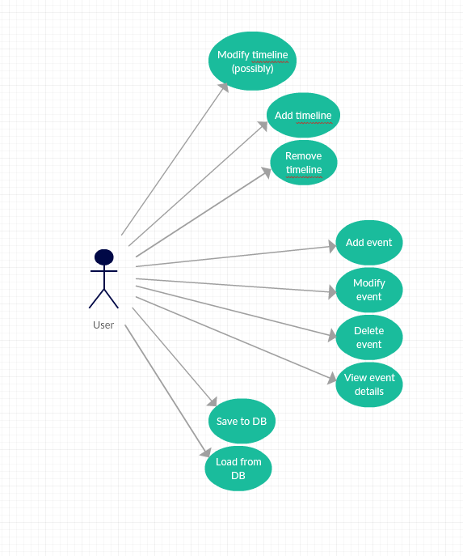

Use-case specifications:

|  |  |
| --- | --- |
| **Title** | **Add timeline** |
| **Actors** | User. |
| **Description** | The User has installed the timeline app, chooses to add a timeline and saves it afterwards. |
| **Preconditions** | Has the timeline app. |
| **Main flow** | 1. Clicks on the “new timeline” button. 2. User enters details in displayed fields (name, start time, end time). 3. Clicks save. 4. Timeline is added and shown in the app. |
| **Alternative flow** | 1. If the user clicks cancel instead of saving:  * The operation (adding a timeline) is canceled, and the default screen is shown without being changed.  1. The use case ends unsuccessfully. |
| **Postcondition** | The timeline was successfully added and displayed. |
| **Exceptions** | Validate range, end cannot be before start. |

Use Case 1.1

Use Case 1.2

|  |  |
| --- | --- |
| **Title** | **Modify timeline** |
| **Actors** | User. |
| **Description** | The User has installed the timeline app, chooses to modify the timeline and saves it afterwards. |
| **Precondition** | Has the timeline application. |
| **Main flow** | 1. Clicks on the “modify timeline” button. 2. User modifies what they want. 3. Clicks save. 4. Modified timeline is shown. |
| **Alternative flow** | 1. If the user clicks cancel instead of saving:  * The operation (modifying a timeline) is canceled, and the default screen is shown without being changed.  1. The use case ends unsuccessfully. |
| **Postcondition** | The timeline was successfully modified. |
| **Exceptions** | Validate range, end cannot be before start. |

Use Case 1.3

|  |  |
| --- | --- |
| **Title** | **Delete timeline** |
| **Actors** | User. |
| **Description** | The User has installed the timeline app and chooses to remove the timeline. |
| **Preconditions** | Has the timeline app. |
| **Main flow** | 1. Clicks on the “remove timeline” button. 2. Are you sure you want to delete this timeline + Yes or No options pop up. 3. Confirm to delete. 4. Timeline is deleted. |
| **Alternative flow** | 1. If the user clicks cancel instead of deleting:  * The operation (removing a timeline) is canceled, and the default screen is shown without being changed.  1. The use case ends unsuccessfully. |
| **Postcondition** | The timeline was successfully deleted. |
| **Exceptions** | None. |

Use Case 2.1

|  |  |
| --- | --- |
| **Title** | **Add event** |
| **Actors** | User. |
| **Description** | The User has installed the timeline app and chooses to add an event to the timeline. |
| **Preconditions** | Has the timeline app. |
| **Main flow** | 1. Opens a timeline. 2. Clicks on the “new event” button. 3. User enters details in displayed fields (title / text / duration). 4. Clicks save. 5. Modified timeline is shown. |
| **Alternative flow** | 1. If the user clicks cancel instead of saving:  * The operation (adding event) is canceled, and the event is not added to the Timeline. |
| **Postcondition** | The timeline was successfully modified and the event added. |
| **Exceptions** | Validate range, end cannot be before start. |

Use Case 2.2

|  |  |
| --- | --- |
| **Title** | **Modify event** |
| **Actors** | User. |
| **Description** | The User has installed the timeline app and chooses to modify an event in the timeline. |
| **Preconditions** | It has the timeline app and created an event. |
| **Main flow** | 1. Clicks on the “modify event” button. 2. User modifies details in displayed fields (modify title / text / duration). 3. Clicks save. 4. Modified timeline is shown. |
| **Alternative flow** | 1. If the user clicks cancel instead of modifying:  * The operation (modify event) is canceled, and the event is not modified. |
| **Postcondition** | The event was successfully modified in the timeline. |
| **Exceptions** | Validate range, end cannot be before. |

Use Case 2.3

|  |  |
| --- | --- |
| **Title** | **Delete event** |
| **Actors** | User. |
| **Description** | The User has installed the timeline app and chooses to delete an event from the timeline. |
| **Preconditions** | It has the timeline app and created an event. |
| **Main flow** | 1. Clicks on the “delete event” button. 2. Are you sure you want to delete this event + Yes or No options pop up. 3. Clicks delete. 4. The event was deleted. |
| **Alternative flow** | 1. If the user clicks cancel instead of deleting:  * The operation (removing an event) is canceled, and the timeline is shown without being changed.  1. The use case ends unsuccessfully. |
| **Postcondition** | The event was successfully deleted from the timeline. |
| **Exceptions** | None. |

Use Case 3

|  |  |
| --- | --- |
| **Title** | **View event details** |
| **Actors** | User. |
| **Description** | The User has installed the timeline app and chooses to view the event details. |
| **Preconditions** | It has the timeline app and created an event. |
| **Main flow** | 1. Clicks on the event. 2. Details are displayed (title/ text / duration). |
| **Alternative flow** | 1. Empty event selected:  * The use case ends unsuccessfully.  1. No event selected:  * timeline stays displayed. * the use case ends unsuccessfully. |
| **Postcondition** | The event was successfully displayed. |
| **Exceptions** | None. |

|  |  |
| --- | --- |
| **Title** | **Save to file** |
| **Actors** | User. |
| **Description** | saving info to the file |
| **Preconditions** | App is open |
| **Main flow** | 1. Press save. 2. Select where to save. 3. Click ok. |
| **Postcondition** | The file has been written. |
| **Exceptions** | None. |

Use Case 4.1

|  |  |
| --- | --- |
| **Title** | **Load from file** |
| **Actors** | User. |
| **Description** | loading info from the file. |
| **Preconditions** | App is open. |
| **Main flow** | 1. Press load (verify that you really want to load if there has been changes in the timeline already open). 2. Select where to load from. 3. Click ok. |
| **Postcondition** | Timelines and events have been loaded from file and are displayed in the app. |
| **Exceptions** | None. |

Use Case 4.2

Requirements

Edit Mode - Timelines

|  |  |
| --- | --- |
| **ID** |  |
| **A1** | Add a new timeline with start and end time |
| **D1** | Delete a complete timeline |
| **M1** | Modify a timeline (might bring problems with start/end time and events that are outside the new range of the timeline, requirement might be dropped) |

Edit Mode - Events

|  |  |
| --- | --- |
| **ID** |  |
| **A2** | Add event to timeline (with title, description and time) |
| **A2.1** | Add non-duration event to timeline |
| **A2.2** | Add event with duration to timeline |
| **D2** | Delete event on a timeline |
| **M2** | Modify title, description, time for any event |

Display Mode

|  |  |
| --- | --- |
| **ID** |  |
| **V1** | All timelines shown simultaneously including events |
| **V2** | Event titles should be visible |
| **V3** | Duration events should take up space corresponding to their duration on the timeline |
| **V4** | Clicking on an event should bring up a pop-up with all details |
| **V5** | The user shall be able to scroll horizontally and/or vertically if all timelines cannot fit in the display window. |

General

|  |  |
| --- | --- |
| **ID** |  |
| **G1** | Save and load timelines |
| **G2** | Data persistence through SQL db or a simple file (CSV or similar) |