[testcase1@gmail.com](mailto:testcase1@gmail.com) all below on Bank AA tab:

In report2 page first steps and upper data is also done please check that also.

Bugs:

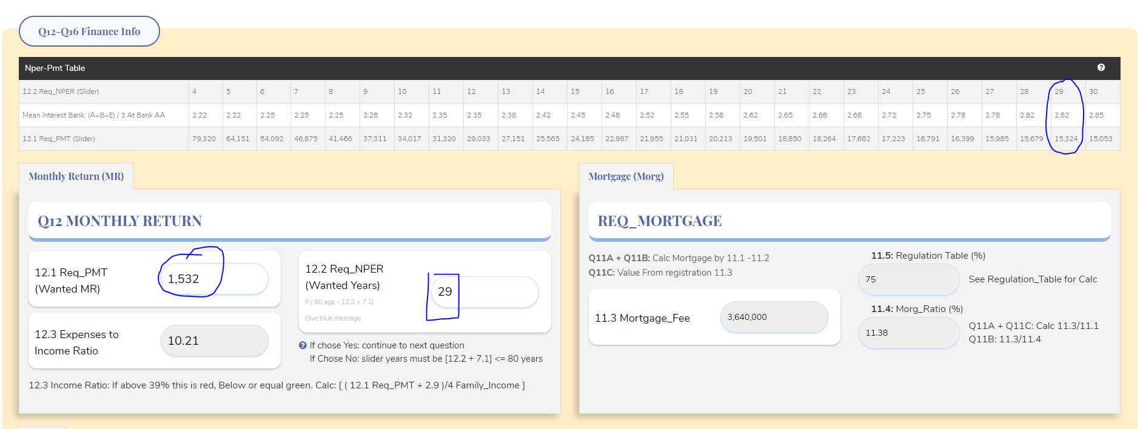

1. Pmt value on slider not correct. Should be based on pmt-nper table as seen above. Please fix asap. DONE

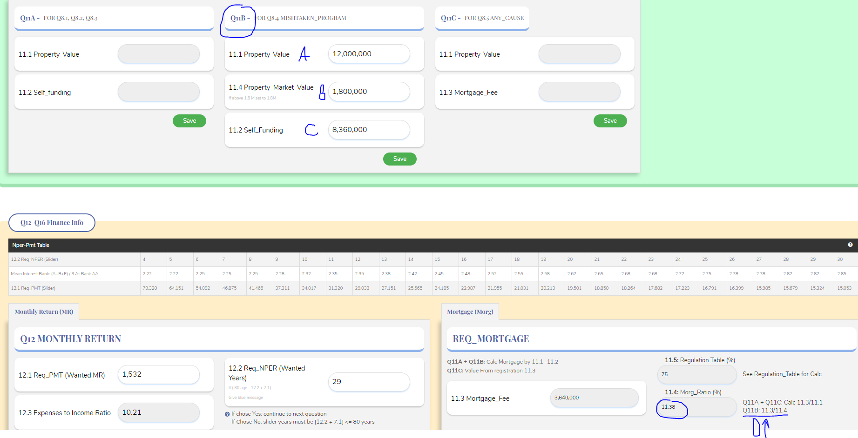

1. For Q11B you need the following validation when enter values this values are not correct you entered – added this validations.

Must check (don't allow other values):

B >= A

C <= A

Must added this validation on registration process. DONE

1. The 11.4 Morg_Ratio is not correct also:

As you see it should be for Q11B: 11.3/11.4

so 3.640M / 1.8M = 202.22% in this case not 11.38% please fix.DONE

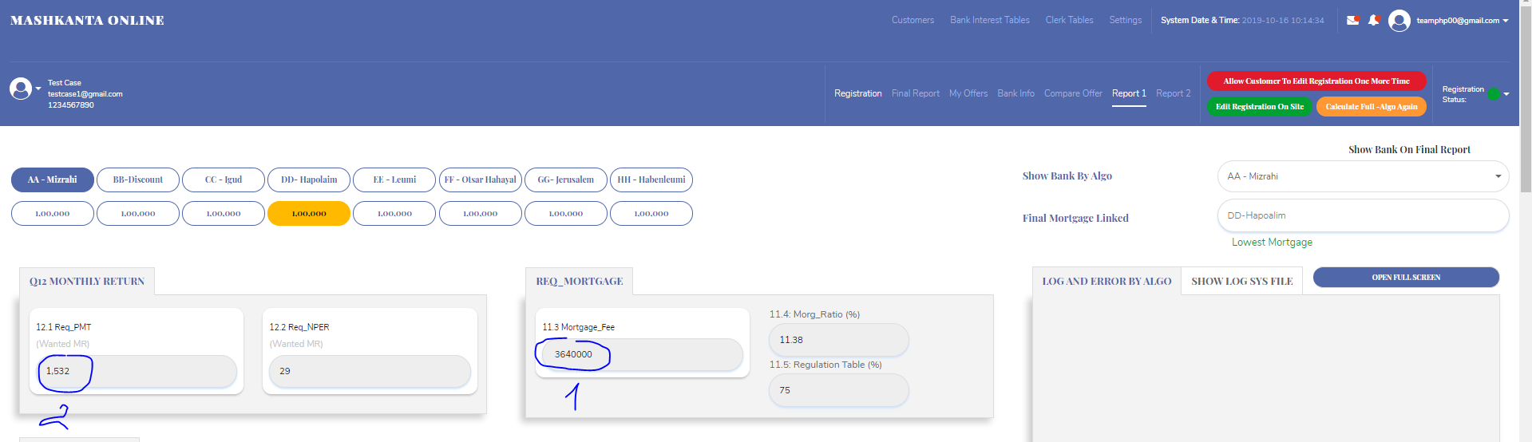

1. Comma issue after 3 zeros need ,DONE
2. Fix pmt to be correct.DONE

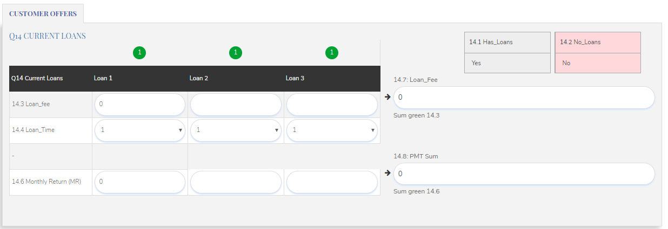

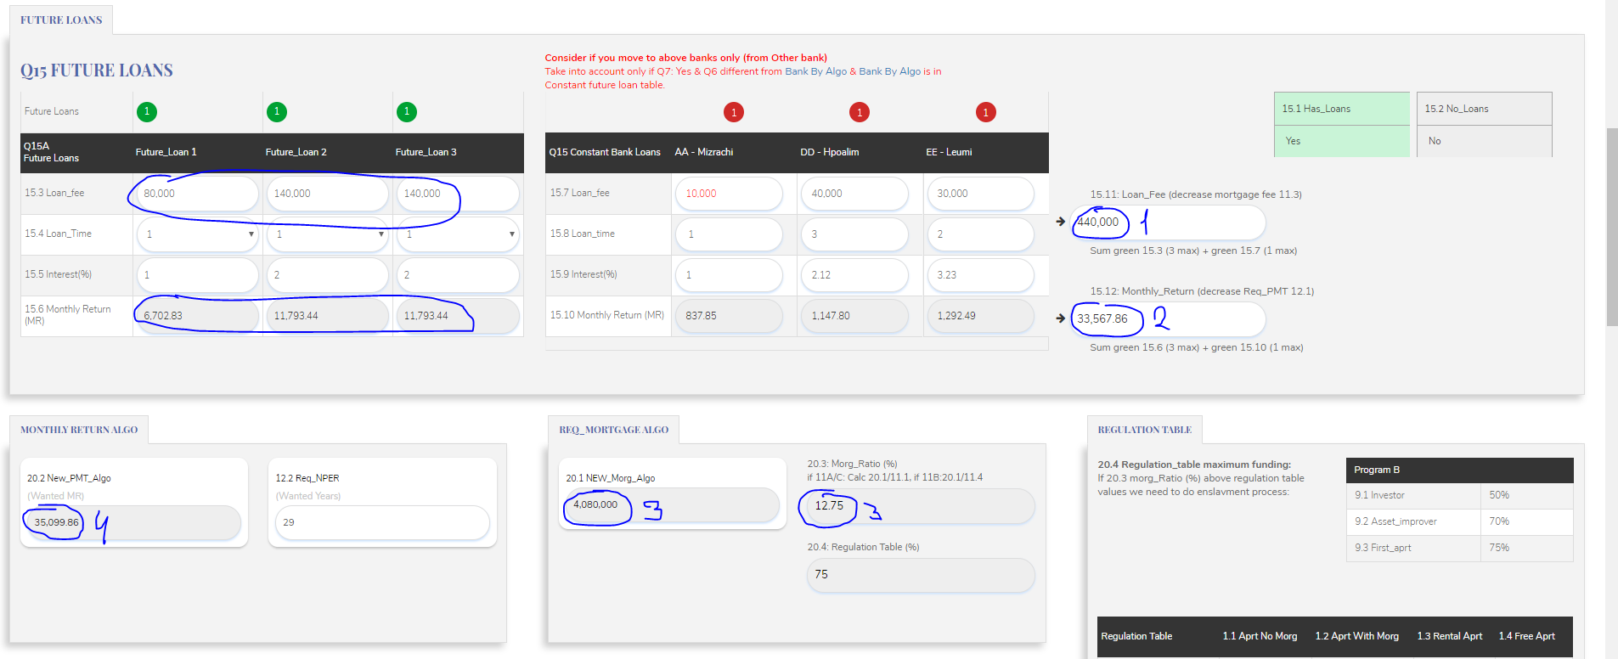

1+2 you need to sum with negative value on Q15 please added negative sign on Q15 on 15.11 + 15.12 values.

1. Value is not correct the sum of green lights is -360k not -440k need to fix**DONE**
2. Value is not correct the sum of green lights is -30,288 not -33,567 need to fix**DONE**
3. The 20.1 new_morg_algo should be calculated by

3.64M – 360k = 3.28M please fix to this value to be calculated with the negative value above on Q15**DONE**

**Also update the 20.3 Morg_ratio correctly:DONE**

For 11a + 11c you calc: 20.1/11.1

For 11b you calc: 20.1/11.4

The morg value should be lowered not up.

1. Also fix this value:

If you did slider correct above you should get 12.1 pmt: 15,324 then to decrease 15.2 value:DONE

15,324 - 30,288 = 100

**>>> Please set 20.2 value not to be below 100 value this is the minimum if you reach number below it.DONE**

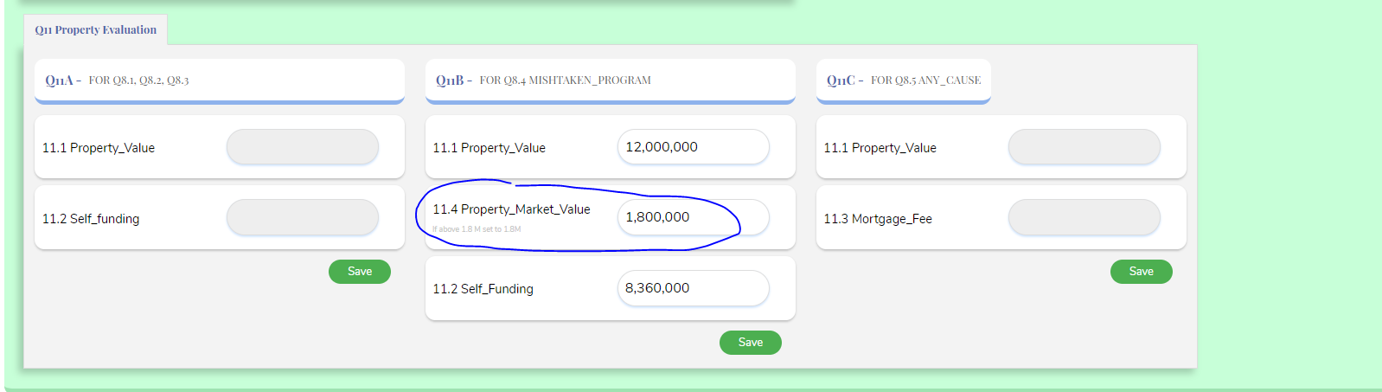

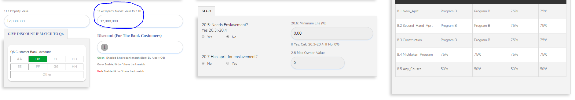

**Please fix 11.4 value to be the same like on registration 11.4 should be the same now it's not correct. On registration it's correct.DONE**

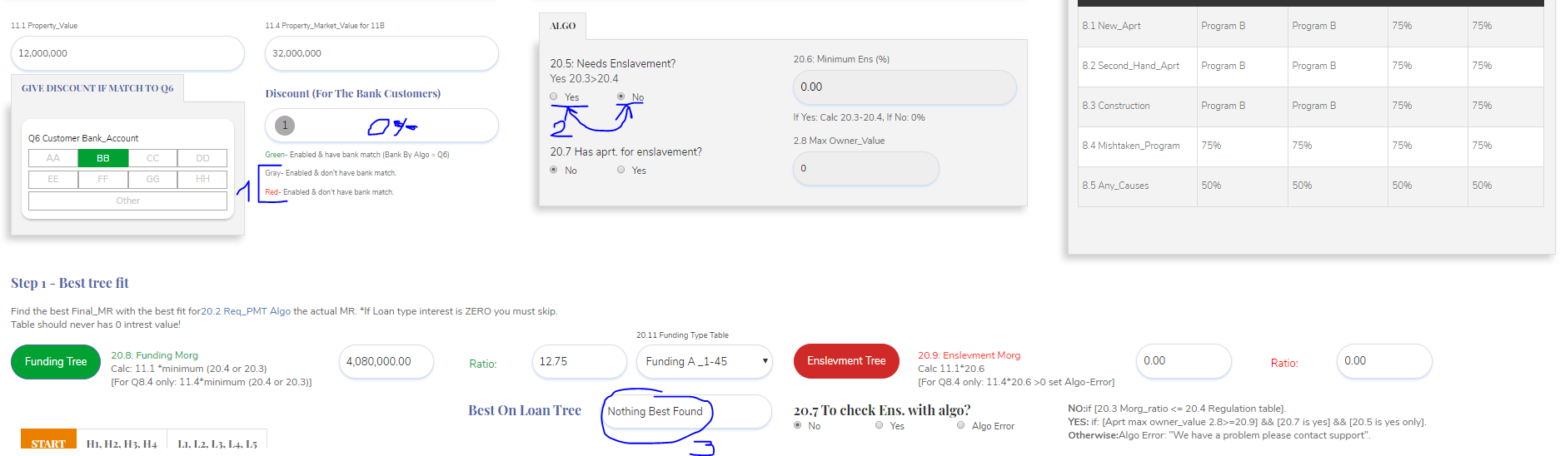

1. **If the light is grey (don’t have match on bank tab to Q6) or red discount on bank interest table not enabled on the current bank tab we are in – show 0% discount as we don’t give discount.**

**Only when green show discount number from bank interest table.**

1. **Switch place yes on the right. DONE**
2. **If nothing best found you should show always if you go to L5 tree or H4 tree here as you go over all tables and the last table values with last table years that was checked will be used for the next step. You need to always have result also you didn’t found fit it is ok we need to continue so the best table that found in case you go over all tree tables is:**

**H4 – Nothing Best FoundDONE**

**L5 – Nothing Best FoundDONE**

**This are the 2 options if you didn’t found fit please fix and show the last table on correct tree.DONE**

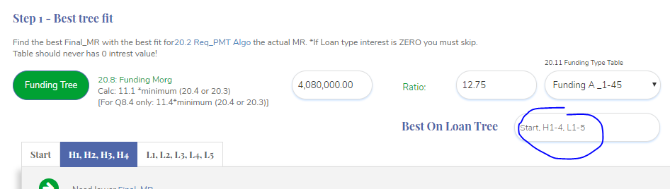

**When I push on the blue tab not the value that was here is changed this is not good we should see the result always.**

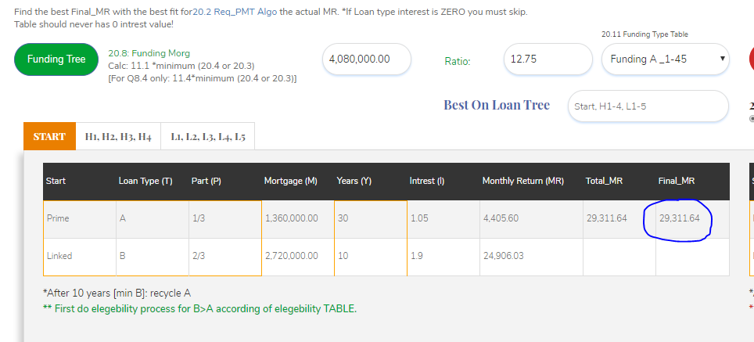

As you see our Final_MR is LOWER than 20.2 New_PMT_Algo: 86 on START.

So according to algo in this case you need to go to L1-L5 tree as we are lower and we want to increase our Final_MR and that what L tree does.

And you should find the fit right away when Final_MR is higher than 20.2 New_PMT_Algo:**DONE**

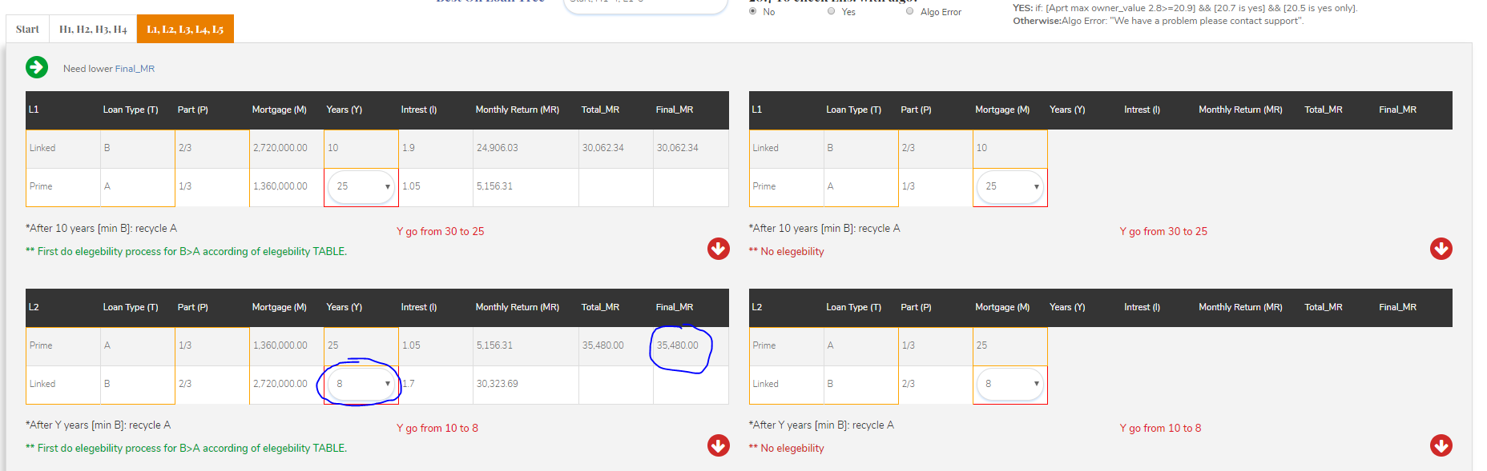

Bug - As you see you have fit (reach higher on L tree, on H tree you stop when you reach lower than 20.2 value, the opposite way). You didn’t find any fit as marked above and this is not good you should find this fit on L2 tree.**DONE**

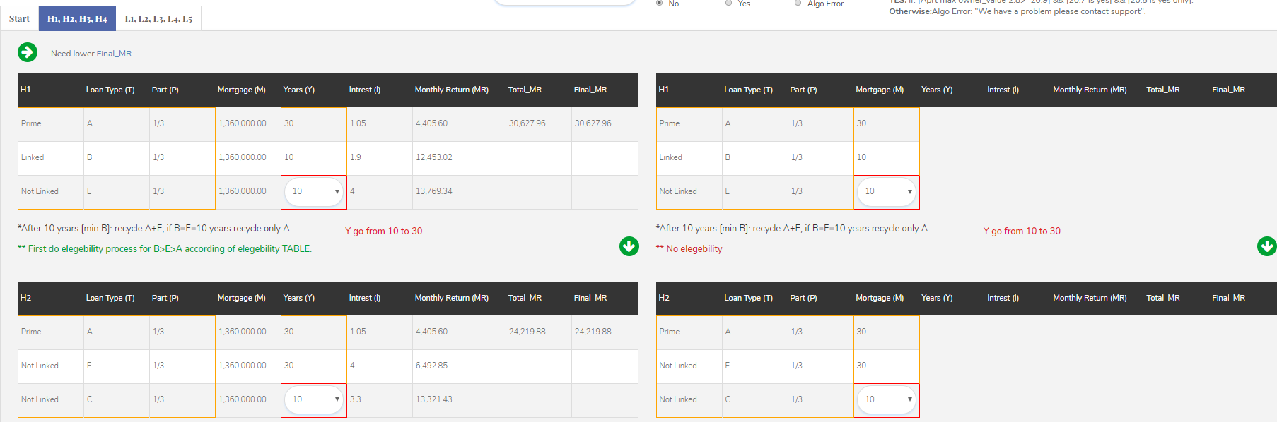

Bug – if you go to L tree according to START table you should not calculate values on the H tree as we are working with one of the trees only at each time you need to show only on L tree values in this case as our Final_MR on START table was lower.**DONE**

Please don’t waste time and don’t calculate the H tree its confusing just when its needed.

No I moved to Bank BB tab:

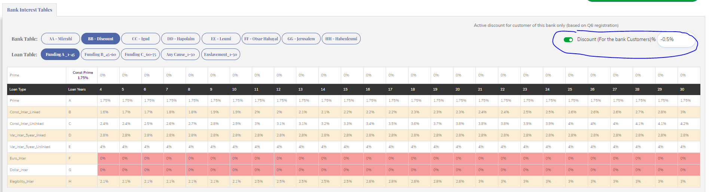

As you see we have discount enabled on bank BB tab on bank interest table.**DONE**

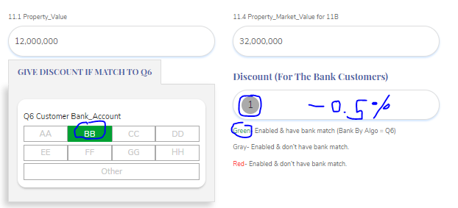

You also chose on Q6 that you are in bank BB by registration.**DONE**

So according to algo you need to give on bank tab BB only discount of -0.5% according to algo but you don’t give nothing.**DONE**

Bug - Please fix to show discount where it's needed to show and work.

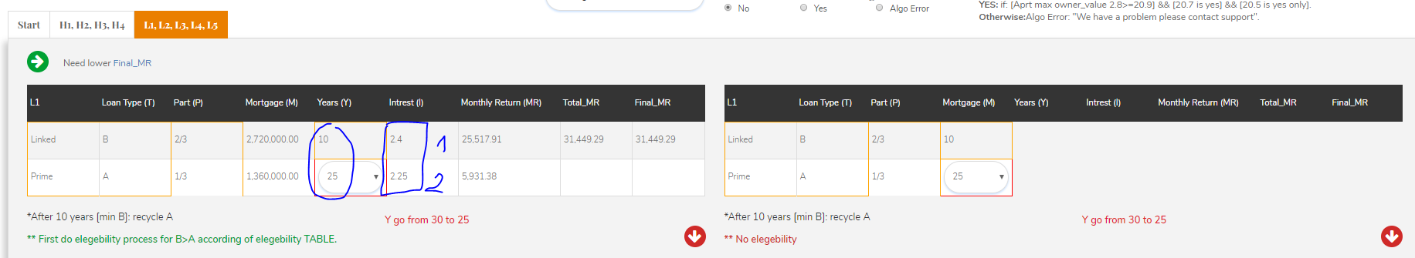

On bank BB tab the interest is not correct as per bank interest tables:**DONE**

1. As seen on the upper image: bank BB, funding_A, B, year 10: 1.9% and with discount that needed to be implemented here the value I should see 1.4% please fix DONE
2. As seen on the upper image: bank BB, funding_A, A, year 25: 1.75% and with discount that needed to be implemented here the value I should see 1.25% please fix to be correct and with discount. [DONE](http://49.249.236.30:3355/admin/report2/28)
3. **Fix all tables to take the correct interest from finding table as we talked about it.DONE**

**Once all above fix send me again the test case:**

[testcase1@gmail.com](mailto:testcase1@gmail.com)

Waiting for update!

**Query –**

1. When I go to report1 it calculate the current tab all over again this is good?
2. When I change tab it calculate all over again this is good also?
3. When we do final report it should be saved in data base with the BEST bank results and show directly to user right away. No waiting time. how you will do that? You need to calculate all 8 banks report1+report2 fully one time and save the best bank results no waiting time at all the frontend report should be according to best bank and show right away – is that clear.
4. When the full algo calculations will take place? Can you do the calculations in the background after registration and show frontend report when done?

Please explain what you develop.