**CHEME 7770 – Problem Set 1**

**Robert Dunleavy**

**1a) Modifying RNAP to account for the closed complex**

We assumed that changing the W_gene1_RNAP parameter to 1.0 effectively turns on transcription of gene 1. This assumes that all available RNAP is present in the open complex. However, RNAP can exists in equilibrium between the closed and open complex,

R + P <--> RP_closed <--> RP _open

Where R = Free RNAP and P= promoter concentration

The expression that [RP_open]=[RNAP_total]*(1-exp(-t/t_obs)) can be used to account for the time dependence for RNAP to equilibrate to the open position.

Changes were made to the Kinetics.jl file so that

rnapII_concentration = rnapII_concentration*(1-exp(-k_obs*(t-10)))

where k_obs was estimated to be 0.36 [1/hr] according to Figure 2.

**1b) Comparison of Constant versus Non-constant RNAP**

Having RNAP be a function of time (accounting for the closed complex shifts the amount of protein produced to the right, as less RNAP is immediately available for transcription.

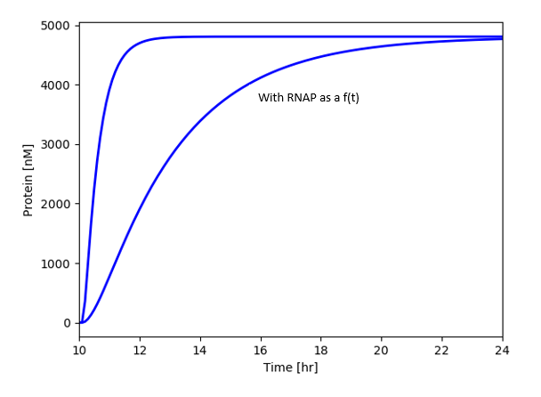

**1c) Effect of Gene Length**

Gene read length drastically affects the amount of protein produced, shorter genes are transcribed much quicker. However, in practice a 10 bp gene (perhaps 2 amino acids) would not be transcribed.

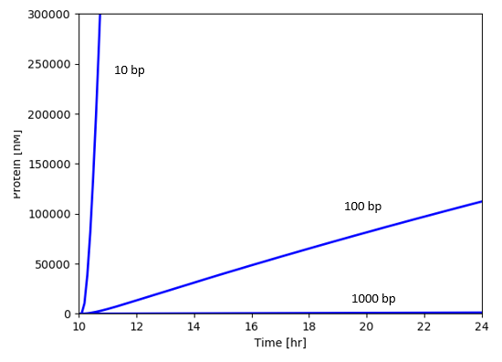

**Problem 1 – Code Specifics**

The Three Gene Example was modified to plot only Protein 1.

The figure in 1b) was created by running Washout.jl and commenting line 39 in the Kinetics.jl file that has RNAP as a function of time.

The figure in 1c) was prepared by manually changing the length of gene 1 in data dictionary.jl.

It would be better to produce 1b) and 1c) in a for loop instead of preparing the figures manually.

**2a) Average Scaled Sensitivity Array**

To get an estimate of the parameters involved an average scaled sensitivity array was calculated

|  |  |  |
| --- | --- | --- |
|  | Parameter Number | Parameter Name |
| Protein 3 | 5 | n_gene_3_gene_1 |
|  | 6 | K_gene_3_gene_1 |
|  | 7 | n_gene_3_gene_2 |
|  | 8 | K_gene_3_gene_2 |
|  | 14 | W_gene_3_gene_1 |
|  | 15 | W_gene_3_gene_2 |
|  | 16 | rnapII_concentration |
|  | 17 | ribosome_concentration |
|  | 21 | kcat_translation |
|  | 23 | saturation_constant_transcription |
|  | 24 | saturation_constant_transcription |
| Protein 2 | 1 | n_gene_2_gene_1 |
|  | 2 | K_gene_2_gene_1 |
|  | 3 | n_gene_2_gene_3 |
|  | 4 | K_gene_2_gene_3 |
|  | 11 | W_gene_2_gene_1 |
|  | 12 | W_gene_2_gene_3 |
|  | 16 | rnapII_concentration |
|  | 17 | ribosome_concentration |
|  | 21 | kcat_translation |
|  | 23 | saturation_constant_transcription |
|  | 24 | saturation_constant_translation |
| Protein 1 | 9 | W_gene_1_RNAP |
|  | 16 | rnapII_concentration |
|  | 17 | ribosome_concentration |
|  | 19 | degradation_constant_protein |
|  | 20 | kcat_transcription |
|  | 21 | kcat_translation |
|  | 22 | maximum_specific_growth_rate |
|  | 23 | saturation_constant_transcription |
|  | 24 | saturation_constant_translation |

As expected, the control parameters (W, n, and K) affect their target. Global parameters (roughly 16 through 24) affect most proteins present.

(States are on the y-axis, from Protein 3,2,1 then mRNA 3,2,1 then gene 3,2,1)

(Parameters are on the x-axis, from parameter 1 (far left) to parameter 24 (far right))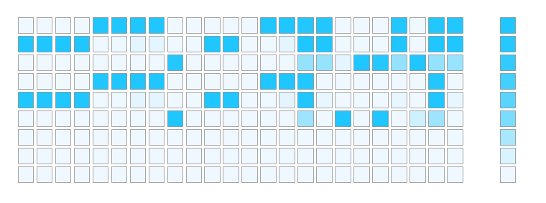

**2a) SVD Analysis**

SVD was performed using the julia command (U,S,V) = svd(SA,thin=false)

From looking at V, the global parameters (rnapII_concentration, ribosome_concentration) control the steady state abundance of the three proteins.

I wasn’t sure how to interpret the dynamic sensitivity analysis, but I would guess that saturation_constant_transcription and saturation_constant_translation control the dynamics of protein induction.

**2b) Identifiable Parameters**

Changing sampling frequency from time_skip=1 to time_skip=100 did not influence the number of measurable parameters, there is probably an error in the code someplace.

Using the function estimate_identifiable_parameters(SA,0.01) on the full sensitivity array allows 5 parameters to be estimated (12, 16, 17, 18, 22)

When the sensitivity array only included Protein 3 and mRNA1, only 2 parameters could be estimated (17, 18).

**Problem 2 - Code Specifics**

The AdjDriver.jl script was modified to call an adjoint_washout_simulation.jl which is identical to the Washout.jl script expect it calls SolveAdjBalances instead of just SolveBalances.

The AdjDriver script takes about an hour to run and it solves for the states and sensitivity coefficients while changing 24 parameters.

The time data for each parameter is saved to a file in Problem_2/src/sensitivity2. The file Sensitivity.jl calculates the average sensitivity array, plots this array using PlotSensitivity.jl, performs SVD on the time averaged sensitivity array (which outputs U, S, and V), and estimates the number of indefinable parameters.

**3a) Strategy for Model Discrimination**

Generate Three Models for the Experimental Data

|  |  |
| --- | --- |
| Model 1 | Inducer induces Gene 1  Gene 1 activates Gene 2  Gene 2 inhibits Gene 3  Gene 1 inhibits Gene 3 |
| Model 2 | Inducer induces Gene 1  Gene 1 activates Gene 2  Gene 2 inhibits Gene 3 |
| Model 3 | Inducer induces Gene 1  Gene 1 activates Gene 2  Gene 2 inhibits Gene 3  Gene 3 inhibits Gene 2 |

1. Use JuGRN to generate model code for each Hypothesis
2. Create an Error function (Error.jl) that given a vector of model parameters
   1. Runs Washout.jl and returns the average value for P1, P2, and P3
   2. Calculates the error between the average values and the data given for Figure 2.
3. Create a function (Final.jl) that minimizes Error.jl by changing 13 parameters that appear in data dictionary. Using the NLopt package, a minimum for the Error can be found.

**3b) Results**

In general, the minimization function Final.jl, while able to be run, does not minimize Error.jl completely. It would be better to perform a detailed sensitivity analysis to only change parameters that affect P1, P2, and P3 the most.

Perhaps specifying relative tolerances or allowing the minimization to continue for a longer time would help.

In summary, Model 3 appears to fit the shape of the experimental the best.

**Model 1**

Neglecting the magnitude of the proteins produced, there is a small change in P3 when P1 falls.

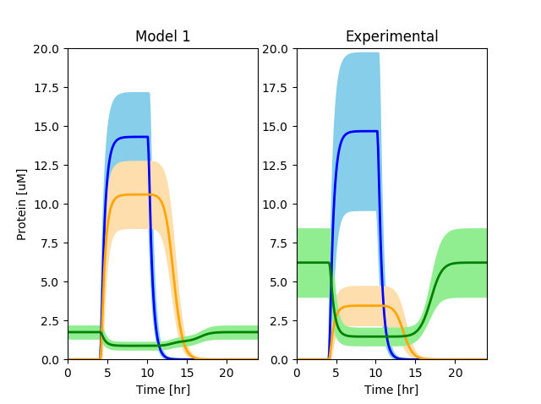

|  |  |  |
| --- | --- | --- |
| Parameter | Initial | Final |
| n_gene_2_gene_1 | 1 | 0.933755 |
| K_gene_2_gene_1 | 120 | 122.847 |
| n_gene_3_gene_2 | 1 | 0.983646 |
| K_gene_3_gene_2 | 120 | 120.401 |
| n_gene_3_gene_1 | 1 | 0.989281 |
| K_gene_3_gene_1 | 120 | 122.189 |
| W_gene_1_RNAP | 0 | 0.002175 |
| W_gene_2_RNAP | 0 | 0.017389 |
| W_gene_2_gene_1 | 0.5 | 0.497263 |
| W_gene_3_RNAP | 1 | 0.975153 |
| W_gene_3_gene_2 | 1 | 0.971979 |
| W_gene_3_gene_1 | 1 | 0.964657 |
| rnapII_concentration | 10964 | 5307.75 |
| ribosome_concentration | 1.20E+06 | 5.69E+05 |
| Error | 25156 | 4643 |

**Model 2**

Neglecting the magnitude of the proteins produced, this appears to best match the experimental values.

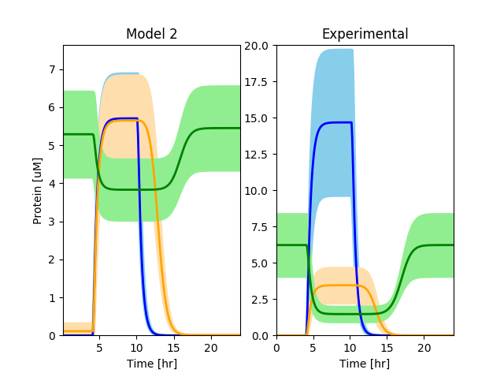

|  |  |  |
| --- | --- | --- |
|  | Initial | Final |
| n_gene_2_gene_1 | 1 | 0.352577 |
| K_gene_2_gene_1 | 120 | 91.9121 |
| n_gene_3_gene_2 | 1 | 0.566859 |
| K_gene_3_gene_2 | 120 | 109.7 |
| W_gene_1_RNAP | 0 | 0.086042 |
| W_gene_2_RNAP | 0 | 0.276489 |
| W_gene_2_gene_1 | 0.1 | 0.231164 |
| W_gene_3_RNAP | 1 | 0.286561 |
| W_gene_3_gene_2 | 1 | 0.58469 |
| rnapII_concentration | 10964 | 55755.6 |
| ribosome_concentration | 1.20E+06 | 6.19E+06 |
| Error | 8355 | 4839 |

**Model 3**

Neglecting the magnitude of the proteins produced, this appears to best match the experimental values.

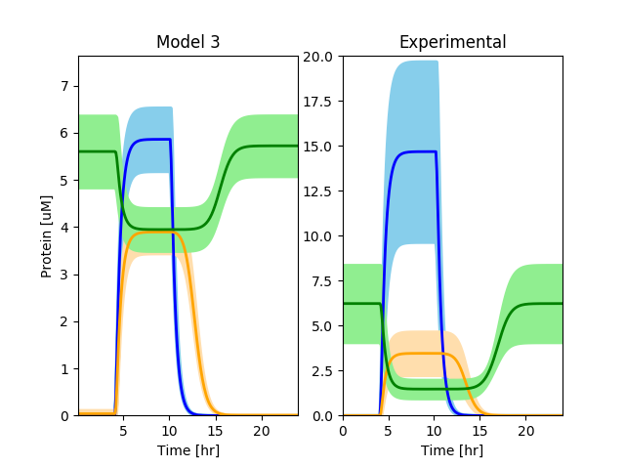

|  |  |  |
| --- | --- | --- |
| Parameter | Initial | Final |
| n_gene_2_gene_1 | 1 | 1.93506 |
| K_gene_2_gene_1 | 120 | 183.209 |
| n_gene_2_gene_3 | 1 | 1.94307 |
| K_gene_2_gene_3 | 120 | 183.621 |
| n_gene_3_gene_2 | 1 | 2.21159 |
| K_gene_3_gene_2 | 120 | 169.313 |
| W_gene_1_RNAP | 0 | 0.316946 |
| W_gene_2_RNAP | 0 | 0.311712 |
| W_gene_2_gene_1 | 1 | 0.692489 |
| W_gene_2_gene_3 | 1 | 0.683372 |
| W_gene_3_RNAP | 1 | 0.682877 |
| W_gene_3_gene_2 | 1 | 0.682443 |
| rnapII_concentration | 10964 | 62491.1 |
| ribosome_concentration | 1.20E+06 | 6.19E+06 |
| Error | 8360 | 4498 |

**Problem 3 - Code Specifics**

Each model is listed under Problem_3/Model_#/src

For each model, under the source folder, run Final.jl to creates the figures produced, return final parameters and the initial/final error. Depending on the constraint for maximum time provided, each Final.jl make take up to 5 minutes to run.

Decrease t in maxtime!(opt, t) to have the minimization run in shorter time.