Problem Set 2

Robert Dunleavy

a) The model for the flux analysis and dynamic figures was taken from the CHEME-7770-EColi-Core-Network repository. This included 142 reactions using 92 metabolites. This is also the same model posted previously on Slack in VFF (Varner Flat File, Network.net) format. This model is unbalanced on H and O.

b) The sample code under CHEME7770-Ecoli-Core-Network-Example was modified to include a maximize_formate_data_dictionary function and a maximize_ethanol_data_dictionary.

Each data dictionary maximized a certain reaction corresponding to the production of M_metabolite_b, with the exception of ATP. The bounds for each M_metabolite_b were changed accordingly in each case.

This can be run by running Part-b/src/Solve.jl and uncommenting the data_dictionary’s or return Flux/return Atoms. The check balances function was written by Rachel LeCover.

For most cases (3/4), the model is not balanced on hydrogen or oxygen. This is most likely from reactions 48 through 51 which are not balanced on either H or O.

# 48 M_h_e --> M_h2o_b

# 49 M_h2o_b --> M_h_e

# 50 M_h2o_e --> M_h_b

# 51 M_h_b --> M_h2o_e

**Maximize Acetate Production**

Flux profile shows a maximization of Reaction 35

"6,R_ACKr_reverse::M_actp_c+M_adp_c --> M_ac_c+M_atp_c,0.9999999999999993"

"12,R_ACt2r_reverse::M_ac_c+M_h_c --> M_ac_e+M_h_e,0.9999999999999993"

"20,R_ATPM::M_atp_c+M_h2o_c --> M_adp_c+M_h_c+M_pi_c,4.499999999999999"

"22,R_ATPS4r::M_adp_c+4.0*M_h_e+M_pi_c --> M_atp_c+M_h2o_c+3.0*M_h_c,2.4999999999999996"

"26,R_CO2t_reverse::M_co2_c --> M_co2_e,1.0"

"28,R_CYTBD::2.0*M_h_c+0.5*M_o2_c+M_q8h2_c --> M_h2o_c+2.0*M_h_e+M_q8_c,1.9999999999999993"

"31,R_ENO::M_2pg_c --> M_h2o_c+M_pep_c,0.9999999999999994"

"35,R_EX_ac_e::M_ac_e --> M_ac_b,0.9999999999999993"

"38,R_EX_co2_e::M_co2_e --> M_co2_b,1.0"

"48,R_EX_h_e::M_h_e --> M_h2o_b,1.0"

"50,R_EX_h2o_e::M_h2o_e --> M_h_b,0.999999999999999"

"57,R_EX_o2_e_reverse::M_o2_b --> M_o2_e,0.9999999999999997"

"74,R_GAPD::M_g3p_c+M_nad_c+M_pi_c --> M_13dpg_c+M_h_c+M_nadh_c,0.9999999999999994"

"87,R_H2Ot_reverse::M_h2o_c --> M_h2o_e,0.999999999999999"

"99,R_NADH16::4.0*M_h_c+M_nadh_c+M_q8_c --> 3.0*M_h_e+M_nad_c+M_q8h2_c,1.9999999999999993"

"103,R_O2t::M_o2_e --> M_o2_c,0.9999999999999997"

"105,R_PDH::M_coa_c+M_nad_c+M_pyr_c --> M_accoa_c+M_co2_c+M_nadh_c,1.0"

Atom Matrix shows an unbalanced Hydrogen

[-4.44089e-16 Carbon

1.0 Hydrogen

-2.77556e-16 Nitrogen

-6.66134e-16 Oxygen

-4.64714e-16 Phosphorous

0.0] Sulfur

**Maximize Formate production**

Flux profile shows a maximization of Reaction 41

"20,R_ATPM::M_atp_c+M_h2o_c --> M_adp_c+M_h_c+M_pi_c,1.6250000000000087"

"22,R_ATPS4r::M_adp_c+4.0*M_h_e+M_pi_c --> M_atp_c+M_h2o_c+3.0*M_h_c,1.8750000000000007"

"28,R_CYTBD::2.0*M_h_c+0.5*M_o2_c+M_q8h2_c --> M_h2o_c+2.0*M_h_e+M_q8_c,2.0"

"41,R_EX_for_e::M_for_e --> M_for_b,1.0"

"48,R_EX_h_e::M_h_e --> M_h2o_b,1.0"

"57,R_EX_o2_e_reverse::M_o2_b --> M_o2_e,1.0"

"66,R_FORti::M_for_c --> M_for_e,1.0"

"97,R_ME1::M_mal_L_c+M_nad_c --> M_co2_c+M_nadh_c+M_pyr_c,0.9999999999999993"

"99,R_NADH16::4.0*M_h_c+M_nadh_c+M_q8_c --> 3.0*M_h_e+M_nad_c+M_q8h2_c,1.5000000000000002"

"103,R_O2t::M_o2_e --> M_o2_c,1.0"

"107,R_PFL::M_coa_c+M_pyr_c --> M_accoa_c+M_for_c,1.0"

Atom Matrix shows three unbalanced Hydrogens and one Oxygen

[6.66134e-15 Carbon

1.5 Hydrogen

1.76858e-15 Nitrogen

0.5 Oxygen

8.50664e-16 Phosphorous

0.0] Sulfur

**Maximize Ethanol Production**

Flux profile shows a maximization of Reaction 40

"2,R_ACALD_reverse::M_accoa_c+M_h_c+M_nadh_c --> M_acald_c+M_coa_c+M_nad_c,1.0"

"19,R_ALCD2x_reverse::M_acald_c+M_h_c+M_nadh_c --> M_etoh_c+M_nad_c,1.0"

"20,R_ATPM::M_atp_c+M_h2o_c --> M_adp_c+M_h_c+M_pi_c,1.2500000000000009"

"26,R_CO2t_reverse::M_co2_c --> M_co2_e,1.0"

"31,R_ENO::M_2pg_c --> M_h2o_c+M_pep_c,0.9999999999999999"

"34,R_ETOHt2r_reverse::M_etoh_c+M_h_c --> M_etoh_e+M_h_e,1.0"

"38,R_EX_co2_e::M_co2_e --> M_co2_b,1.0"

"40,R_EX_etoh_e::M_etoh_e --> M_etoh_b,1.0"

"74,R_GAPD::M_g3p_c+M_nad_c+M_pi_c --> M_13dpg_c+M_h_c+M_nadh_c,0.9999999999999998"

"105,R_PDH::M_coa_c+M_nad_c+M_pyr_c --> M_accoa_c+M_co2_c+M_nadh_c,0.9999999999999999"

"111,R_PGK_reverse::M_13dpg_c+M_adp_c --> M_3pg_c+M_atp_c,0.9999999999999998"

"114,R_PGM_reverse::M_3pg_c --> M_2pg_c,0.9999999999999999"

All atoms are balanced

[4.44089e-16 Carbon

1.77636e-15 Hydrogen

1.22392e-16 Nitrogen

4.44089e-16 Oxygen

9.22907e-17 Phosphorous

1.59389e-17] Sulfur

**Maximize ATP formation**

Flux profile shows a maximization of Reaction 20

"20,R_ATPM::M_atp_c+M_h2o_c --> M_adp_c+M_h_c+M_pi_c,2.916666666666667"

"22,R_ATPS4r::M_adp_c+4.0*M_h_e+M_pi_c --> M_atp_c+M_h2o_c+3.0*M_h_c,2.25"

"26,R_CO2t_reverse::M_co2_c --> M_co2_e,1.0"

"28,R_CYTBD::2.0*M_h_c+0.5*M_o2_c+M_q8h2_c --> M_h2o_c+2.0*M_h_e+M_q8_c,2.0"

"38,R_EX_co2_e::M_co2_e --> M_co2_b,1.0"

"50,R_EX_h2o_e::M_h2o_e --> M_h_b,1.0"

"57,R_EX_o2_e_reverse::M_o2_b --> M_o2_e,1.0"

"87,R_H2Ot_reverse::M_h2o_c --> M_h2o_e,1.0"

"99,R_NADH16::4.0*M_h_c+M_nadh_c+M_q8_c --> 3.0*M_h_e+M_nad_c+M_q8h2_c,1.6666666666666667"

"103,R_O2t::M_o2_e --> M_o2_c,1.0"

Atom Matrix shows an unbalanced Hydrogen and Oxygen

[ 0.0 Carbon

-1.0 Hydrogen

0.0 Nitrogen

-1.0 Oxygen

-1.78429e-17 Phosphorous

4.93038e-32] Sulfur

**c) Reproduce Figure 7 from Varma and Palsson, 1994.**

The Dyanmic_Fig7.jl file was modified to plot X, glucose, and acetate versus time. In order to have acetate be produced, the lower bound of m_O2_b was set to -1.50. The paper reports a maximum oxygen uptake rate of 15 mmol/hr/(gm-dry-weight). I am not sure why acetate could not be produced at higher oxygen uptake rates.

Also, the data produced using Dyanmic_Fig7.jl do not exactly match the experimental values determined in Figure 7. It would be best to modify the bounds of the unbounded species to have more agreement with the experimental values.

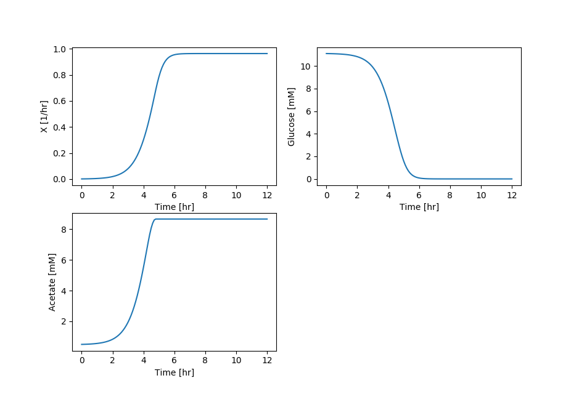

**d) Reproduce Figure 11 from Varma and Palsson, 1994.**

The Dynamic_Fig7.jl file was modified to account for ethanol and formate production (Dynamic_Fig11.jl).

A similar trend is seen compared to the paper, however it is not exact, especially in cellmass.

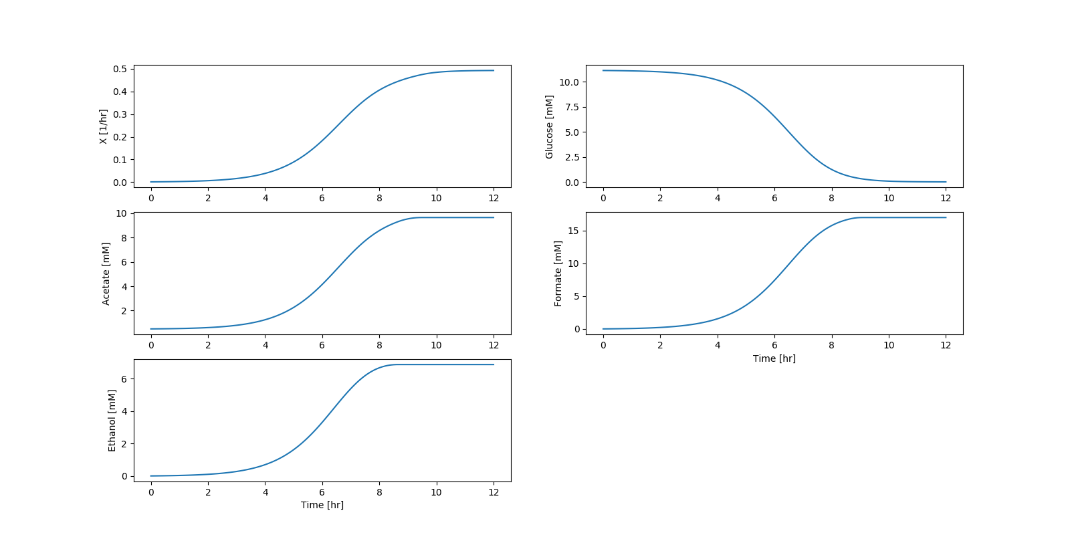

**e) Explain the trends between Figures 7 and 11**

As this E. Coli stream is naturally aerobic, a higher growth rate and higher glucose uptake rate is seen with the aerobic (Figure 7) versus the anaerobic case (Figure 11). If one were to look at the flux distribution, one would see a shift to flux that are rarely present in aerobic conditions (succinate production).