Project Wafa — Architecture Design Document
A Customer Retention Intelligence Platform for Falcon Bank UAE
MAIB AI 115 · NLP and Models · Final Group Project — Deliverable 1 · July 2026
Rakshanda Dhote

1. Design philosophy
The platform follows the course’s spine: learned models for fuzzy language, transparent rules where money and trust are decided, and a human in the loop where stakes are high. Text and behaviour are fused because either alone misleads: a customer can look healthy on paper while telling us they are leaving (our smoke tests surfaced exactly this case — behaviour score 0.8%, message: “I have already resigned and am moving back home”). We chose a multilingual-native pipeline with no translation step: Hindi arrives romanized (“mera card decline ho gaya”), which breaks off-the-shelf hi→en translators and language detectors; training directly on the four languages side-steps that failure mode and handles code-switched text for free.

2. End-to-end flow
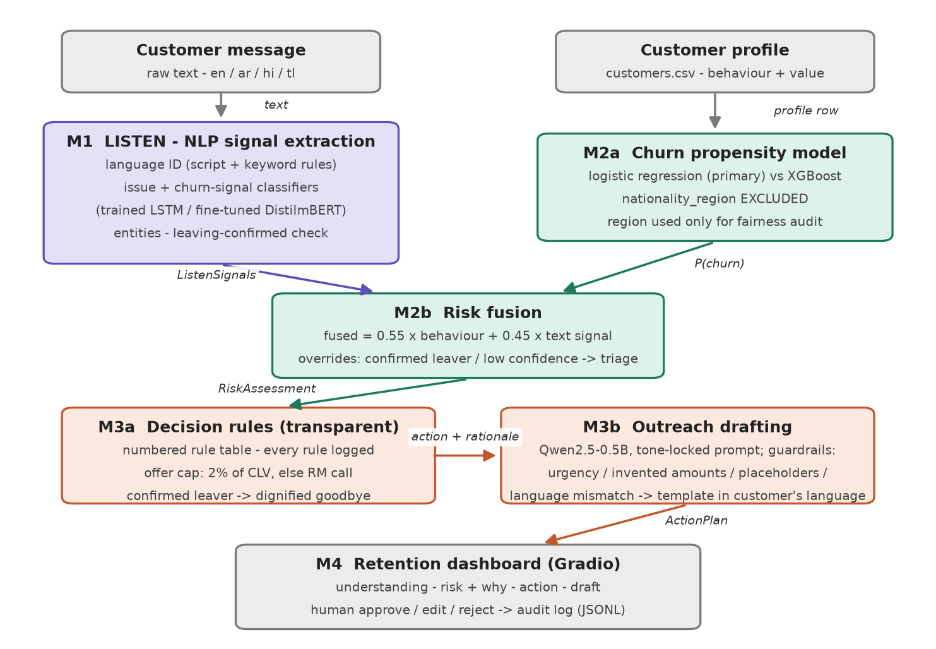

3. Modules
Module | Key files
M1 Listen — language ID, LSTM classifiers, entities | wafa/m1_listen.py; training/train_lstm_classifier.py
M1b Fine-tuned transformer + model bake-off | training/finetune_distilmbert_colab.py; training/evaluate_models.py
M2 Understand — churn model, fusion, fairness audit | wafa/m2_understand.py; training/train_churn_model.py
M3 Act — decision rules, LLM drafting, guardrails | wafa/m3_act.py; training/check_outreach_quality.py
M4 Dashboard + audit log | app.py; wafa/audit.py
Data & evaluation — generator extension, unseen-template tests | data/generate_wafa_data.py; training/make_unseen_testset.py
Six modules cover the pipeline end to end: the heavy modules (M1, M2, M3) carry the language, fusion, and action logic; the flow diagram is kept clean for readability.

4. Interface contracts
Every arrow in the flow diagram carries exactly one of the dictionaries below (defined with mock factories in wafa/contracts.py). Each module is developed and tested against these mocks, so no member is ever blocked by another’s unfinished code.

M1 → M2: ListenSignals
Field | Type / values | Meaning
message_id / customer_id | str | message ref; customer_id joins to profile
text | str | the raw message
language | en | ar | hi | tl | detected language + language_confidence (0–1)
issue_type | 7-class str | issue class + issue_confidence (0–1)
churn_signal | High | Medium | Low | text churn intent + churn_signal_confidence
leaving_confirmed | bool | explicit relocation statement detected
entities | dict | amounts_aed, dates, destinations, products
classifier | lstm | finetuned | heuristic | which model produced the prediction

M2 → M3: RiskAssessment
Field | Type / values | Meaning
behaviour_score | float 0–1 | churn probability from the tabular model
text_score | float 0–1 | churn signal mapped High=0.9 / Med=0.55 / Low=0.15
fused_risk / risk_band | float / str | 0.55·behaviour + 0.45·text; Critical≥.75, High≥.55, Med≥.35
reasons | list[str] | plain-English drivers, most important first
needs_human_triage | bool | true when classifier confidence < 0.5
segment / clv_estimate_aed | str / float | customer value context; CLV caps offer spend
profile_found | bool | false → neutral behaviour prior, text carries the call

M3 → M4: ActionPlan
Field | Type / values | Meaning
action / action_label | str | action code + human-readable name
rationale | list[str] | every fired rule, line by line (auditable)
offer_value_aed | float | 0 when no monetary offer; offer_within_budget flag
draft_message | str | outreach text awaiting human review
draft_language / draft_source | str | language of draft; llm or template
guardrail_flags | list[str] | non-empty when the LLM draft violated a check
prompt_used | str | null | the exact LLM prompt (shown in dashboard, ethics)

5. Model selection and justification
Task | Choice | Why (quality · size · languages · hardware)
Issue + churn-signal classifier (trained #1) | Bidirectional LSTM, Keras, from scratch | Multilingual-native incl. romanized Hindi; the exact architecture family built in the course; <2 MB, trains in ~1 min on CPU
Issue + churn-signal classifier (trained #2) | DistilmBERT fine-tune | 104 languages incl. Arabic and Tagalog; ~2 min on free Colab T4 (also CPU-feasible); bake-off vs the LSTM decides which serves the app
Language identification | Rule-based (script range + keyword scoring) | Romanized Hindi defeats off-the-shelf detectors; rules are transparent and testable; fasttext-lid is the upgrade path
Entity extraction | Regex + gazetteers | Transparent and reliable at 252-message scale; spaCy NER optional for English
Churn propensity | Logistic regression (primary), XGBoost benchmarked | Coefficients give the per-customer ‘why’ shown on the dashboard; nationality_region excluded by design (fairness)
Outreach generation | Qwen2.5-0.5B-Instruct | Brief’s own guidance: best small-model Arabic; runs on laptop CPU; tone-locked prompt + guardrails; curated-template fallback means the demo never depends on it
Two models are trained by the team (LSTM from scratch, DistilmBERT fine-tuned), exceeding the one-trained-model minimum. The bake-off (training/evaluate_models.py) compares both against a zero-shot Qwen classifier on the same held-out split and on an unseen-template test set, because the provided messages are template-generated and random-split scores are upper bounds. Results and per-language quality go in the business report, honestly, whichever model wins.

6. Feasibility budget — proof it runs free
Component | Size | Runs on | Time | Fallback
BiLSTM classifier | < 2 MB | laptop CPU | train ~1 min; infer < 0.1 s | keyword heuristic (built in)
DistilmBERT fine-tune | ~540 MB | train: free Colab T4; infer: laptop CPU | train ~2 min (T4); infer ~0.2 s | LSTM remains the serving model
Churn model (sklearn) | < 1 MB | laptop CPU | train in seconds | —
Qwen2.5-0.5B-Instruct | ~1 GB cached | laptop CPU | 30–60 s per draft | curated templates (WAFA_USE_LLM=0)
Gradio dashboard | — | laptop, localhost | instant | screen-recording backup
Total disk footprint ≈ 2 GB, total cost AED 0. No paid API is required at any point; every component has a fallback that keeps the live demo running offline once models are cached.

7. Risks and fallbacks
- Live-demo failure (wifi, re-download, timeout): all models pre-cached locally; WAFA_USE_LLM=0 gives an instant template-only mode; a 2-minute screen recording is the break-glass backup.
- Template leakage: near-perfect random-split metrics are reported as upper bounds; the honest evaluation runs on generator-extended unseen phrasings.
- LLM hallucination and language failure: guardrails catch urgency language, invented amounts, unfilled placeholders and drafts in the wrong language (all observed in testing — see models/outreach_language_check*.json) and fall back to curated templates in the customer's language; no draft reaches a customer without human approval.
- Fairness: nationality_region is never a model feature; it is used solely to audit that predicted risk does not skew by region (audit passing; see models/churn_eval.json).
- Draft quality at 0.5B: acceptable but plain; if demo hardware allows, Qwen2.5-1.5B is a drop-in upgrade — the bake-off template covers this comparison.

