WaselX Express
Optimizing Last-Mile Delivery Operations Across the UAE
Using Data Structures & Algorithms
MAIB Program - Data Structures & Algorithms Final Project

Field | Value
Project Type | Group Final Project
Team Size | 3-4 members
Team Members | [Name 1], [Name 2], [Name 3], [Name 4]
Submission Date | May 3, 2026
Repository | https://github.com/rd51/waselx
Report Status | Completed technical report draft with numerical traces and figures

Prepared as the technical report deliverable with hand-traced numerical working, business recommendations, simulation figures, and README documentation.

Table of Contents
- 1. Executive Snapshot and Assumptions
- 2. Task Area A: Graph Algorithms (Q1-Q7)
- 3. Task Area B: Trees, BST and AVL (Q8-Q11)
- 4. Task Area C: Linked Lists, Queues and Order Pipeline (Q12-Q17)
- 5. Task Area D: Sorting, Searching and Divide and Conquer (Q18-Q22)
- 6. Task Area E: Management, Leadership and Strategic Integration (Q23-Q27)
- 7. Figures Index
- 8. References and Citations
- 9. Academic Integrity Statement
- 10. Appendix: README Summary

1. Executive Snapshot and Assumptions
This report completes the WaselX Express technical-report deliverable for the MAIB Data Structures & Algorithms final project. It follows the supplied report template, the task-area markdown files, and the technical standards requiring Python 3.10+, matplotlib visualizations, step-by-step numerical traces, and a README with setup and sample-run instructions.
Operational Problem | DSA Solution | Report Evidence | Business Impact
Inefficient routes | Dijkstra, Floyd-Warshall, MST / spanning forest | Q1-Q7, Q27 figures and traces | Less wasted distance, lower fuel and time cost
Slow order dispatch | Manual min-heap priority queue, circular scheduling, stack lifecycle | Q12-Q17 operation snapshots | VIP orders are dispatched before lower priority work
Poor order lookup | BST, AVL, binary search, divide-and-conquer analysis | Q8-Q11, Q19-Q20 traces | Faster customer support lookup and scalable indexing

Data Quality Notes Used in the Report
- The supplied edge table contains 15 nodes and 24 bidirectional edges, but it forms two disconnected components: Dubai/Sharjah/Ajman and Abu Dhabi. Therefore, H5 to D5 has no valid route in the current graph, and a strict MST over all 15 nodes does not exist without adding one inter-component edge.
- For Q4, the mathematically correct result on the current graph is a minimum spanning forest with 13 selected edges and total cost AED 62.0K. A connected backbone requires one new inter-emirate edge; Q3 illustrates an assumed H3-H6 connector for planning analysis.
- For Q9, the given order-ID sequence produces a BST of height 4 that already satisfies AVL balance factors. The AVL insertion trace therefore performs zero rotations. The report still includes two rotation diagrams as required concept demonstrations, but they are not falsely attributed to the supplied sequence.
- Task-specific markdown files are treated as authoritative when they refine the original project brief, especially for Q14 priority data and Q18-Q22 reporting shells.

2. Task Area A: Graph Algorithms

Q1 [10 marks] - Graph Basics: Adjacency List and Matrix
The WaselX delivery network has 15 nodes: seven hubs H1-H7 and eight delivery zones D1-D8. The edge list has 24 bidirectional weighted roads. Each road stores distance in km, travel time in minutes, and operational cost in AED.
H1: H2(dist=10km,time=18min,cost=7.0); H4(dist=5km,time=10min,cost=3.5); D1(dist=8km,time=15min,cost=5.5);
D3(dist=4km,time=12min,cost=3.0)
H2: H1(dist=10km,time=18min,cost=7.0); H3(dist=9km,time=18min,cost=6.0); H4(dist=7km,time=13min,cost=5.0);
D1(dist=3km,time=8min,cost=2.5)
H3: H2(dist=9km,time=18min,cost=6.0); H7(dist=15km,time=25min,cost=10.0); D2(dist=8km,time=16min,cost=5.5);
D4(dist=12km,time=22min,cost=8.0)
H4: H1(dist=5km,time=10min,cost=3.5); H2(dist=7km,time=13min,cost=5.0); D2(dist=6km,time=14min,cost=4.0)
H5: H6(dist=14km,time=20min,cost=9.0); D6(dist=12km,time=22min,cost=8.0); D7(dist=6km,time=12min,cost=4.0)
H6: H5(dist=14km,time=20min,cost=9.0); D6(dist=8km,time=15min,cost=5.5); D7(dist=10km,time=18min,cost=7.0)
H7: H3(dist=15km,time=25min,cost=10.0); D5(dist=10km,time=18min,cost=7.0); D8(dist=4km,time=8min,cost=3.0)
D1: H1(dist=8km,time=15min,cost=5.5); H2(dist=3km,time=8min,cost=2.5); D2(dist=6km,time=13min,cost=4.0);
D3(dist=5km,time=11min,cost=3.5)
D2: H3(dist=8km,time=16min,cost=5.5); H4(dist=6km,time=14min,cost=4.0); D1(dist=6km,time=13min,cost=4.0);
D4(dist=10km,time=20min,cost=7.0)
D3: H1(dist=4km,time=12min,cost=3.0); D1(dist=5km,time=11min,cost=3.5)
D4: H3(dist=12km,time=22min,cost=8.0); D2(dist=10km,time=20min,cost=7.0); D8(dist=18km,time=30min,cost=12.0)
D5: H7(dist=10km,time=18min,cost=7.0); D8(dist=8km,time=15min,cost=5.5)
D6: H5(dist=12km,time=22min,cost=8.0); H6(dist=8km,time=15min,cost=5.5); D7(dist=7km,time=13min,cost=5.0)
D7: H5(dist=6km,time=12min,cost=4.0); H6(dist=10km,time=18min,cost=7.0); D6(dist=7km,time=13min,cost=5.0)
D8: H7(dist=4km,time=8min,cost=3.0); D4(dist=18km,time=30min,cost=12.0); D5(dist=8km,time=15min,cost=5.5)
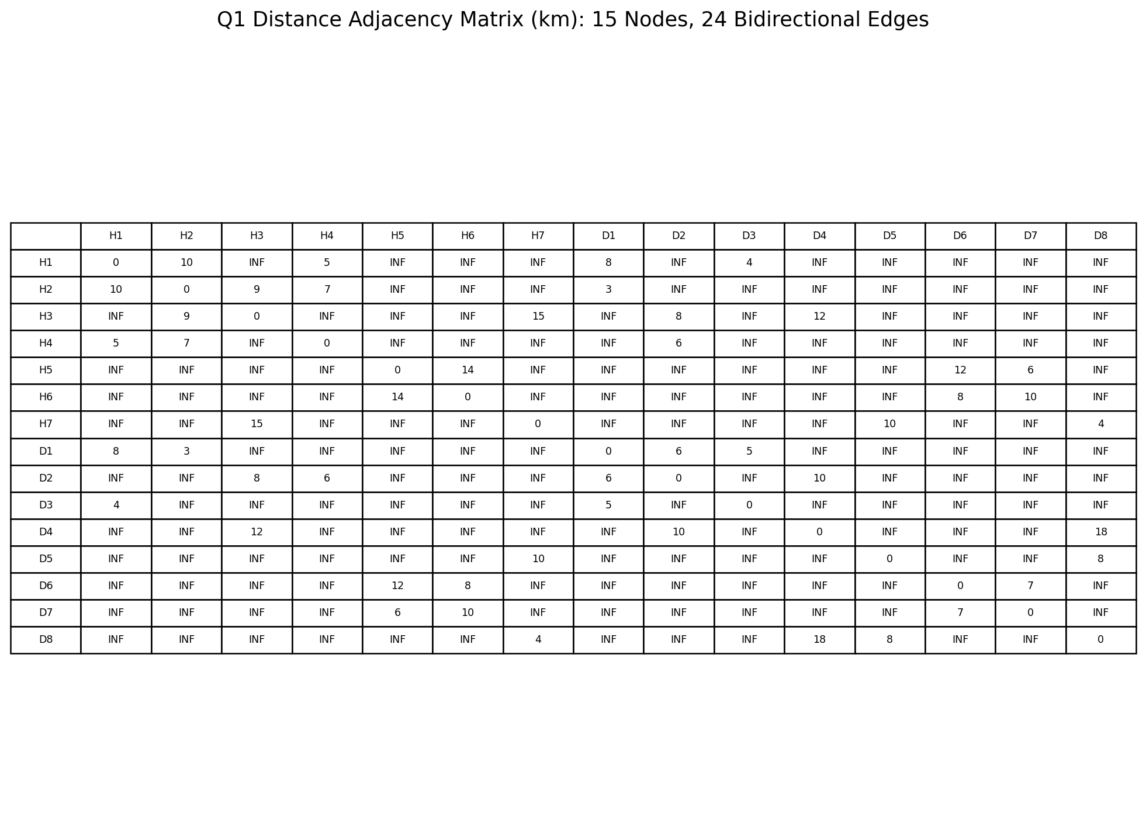
Figure 1: Full 15-node distance adjacency matrix. INF indicates no direct road segment.
Representation comparison: An adjacency list is the better primary representation for this dataset because the graph is sparse. A 15-node undirected matrix reserves 15 x 15 = 225 cells, while only 24 roads exist, represented twice as 48 neighbor entries in an adjacency list. The list therefore stores only real road connections and is efficient for traversal, Dijkstra relaxation, BFS, DFS, Prim, and Kruskal preprocessing. The matrix is useful when the program needs constant-time direct lookup of whether a specific pair of nodes is connected, for example checking whether H1-D1 has an edge. For WaselX route planning, the system usually expands from the current node to its neighbors rather than asking about all possible node pairs. That makes the adjacency list more memory efficient and operationally natural. The matrix remains useful for Floyd-Warshall, which deliberately compares all node pairs and benefits from table-style indexing.

Q2 [15 marks] - Dijkstra Shortest Path: H1 to D1 by Distance
Step | Visit node | Current dist | Visited set | Relaxation updates | Best D1
1 | H1 | 0 | H1 | H2: INF->10 via H1; H4: INF->5 via H1; D1: INF->8 via H1; D3: INF->4 via H1 | 8
2 | D3 | 4 | H1, D3 | No better distance | 8
3 | H4 | 5 | H1, H4, D3 | D2: INF->11 via H4 | 8
4 | D1 | 8 | H1, H4, D1, D3 | No better distance | 8
Output Item | Value
Shortest path | H1 -> D1
Distance | 8 km
Total time | 15 min
Total cost | AED 5.5
Roads used | Al Khail Rd
Time complexity | O((V+E) log V) using a manually implemented min-heap; V=15, E=24
Space complexity | O(V) for distance, previous, visited, and heap arrays
The direct H1-D1 edge is already the shortest path by distance. After visiting H1, the tentative distance to D1 is 8 km. Later visits to D3 and H4 do not improve that value, so D1 is finalized at 8 km.

Q3 [15 marks] - Floyd-Warshall Hub-to-Hub Travel-Time Analysis
Hub | H1 | H2 | H3 | H4 | H5 | H6 | H7
H1 | 0 | 18 | INF | 10 | INF | INF | INF
H2 | 18 | 0 | 18 | 13 | INF | INF | INF
H3 | INF | 18 | 0 | INF | INF | INF | 25
H4 | 10 | 13 | INF | 0 | INF | INF | INF
H5 | INF | INF | INF | INF | 0 | 20 | INF
H6 | INF | INF | INF | INF | 20 | 0 | INF
H7 | INF | INF | 25 | INF | INF | INF | 0
Table Q3.1: Initial hub-only travel-time matrix in minutes. INF means no direct hub-to-hub edge in the supplied data.
Hub | H1 | H2 | H3 | H4 | H5 | H6 | H7
H1 | 0 | 18 | 36 | 10 | INF | INF | INF
H2 | 18 | 0 | 18 | 13 | INF | INF | INF
H3 | 36 | 18 | 0 | 31 | INF | INF | 25
H4 | 10 | 13 | 31 | 0 | INF | INF | INF
H5 | INF | INF | INF | INF | 0 | 20 | INF
H6 | INF | INF | INF | INF | 20 | 0 | INF
H7 | INF | INF | 25 | INF | INF | INF | 0
Table Q3.2: Snapshot after k=H2. Several H1-H3, H3-H4, and H4-H3 paths improve through H2.
Hub | H1 | H2 | H3 | H4 | H5 | H6 | H7
H1 | 0 | 18 | 36 | 10 | INF | INF | 61
H2 | 18 | 0 | 18 | 13 | INF | INF | 43
H3 | 36 | 18 | 0 | 31 | INF | INF | 25
H4 | 10 | 13 | 31 | 0 | INF | INF | 56
H5 | INF | INF | INF | INF | 0 | 20 | INF
H6 | INF | INF | INF | INF | 20 | 0 | INF
H7 | 61 | 43 | 25 | 56 | INF | INF | 0
Table Q3.3: Final Floyd-Warshall hub travel-time matrix for existing hub-only edges.
Findings: The hub graph is disconnected. H5 and H6 form an Abu Dhabi component, while H1, H2, H3, H4, and H7 form the Dubai/Sharjah component. The farthest finite hub pair in the main component is H1-H7 at 61 minutes. H2 is the best-connected hub in the main component with average finite travel time of 23 minutes to H1, H3, H4, and H7. Across the full network, inter-component hub pairs are unreachable, so the true worst-case is INF.
New road recommendation: add a direct H3-H6 inter-emirate connector. The planning matrix below assumes 45 minutes for this new edge. This is an explicit planning assumption because the original data table provides no Dubai/Sharjah-to-Abu Dhabi edge.
Hub | H1 | H2 | H3 | H4 | H5 | H6 | H7
H1 | 0 | 18 | 36 | 10 | 101 | 81 | 61
H2 | 18 | 0 | 18 | 13 | 83 | 63 | 43
H3 | 36 | 18 | 0 | 31 | 65 | 45 | 25
H4 | 10 | 13 | 31 | 0 | 96 | 76 | 56
H5 | 101 | 83 | 65 | 96 | 0 | 20 | 90
H6 | 81 | 63 | 45 | 76 | 20 | 0 | 70
H7 | 61 | 43 | 25 | 56 | 90 | 70 | 0
Table Q3.4: Updated hub matrix after assumed H3-H6 connector at 45 minutes.

Q4 [15 marks] - Minimum Spanning Tree Audit: Kruskal and Prim
A strict MST requires a connected graph. The current edge table is disconnected, so the correct output is a minimum spanning forest (MSF). Kruskal selects the lowest-cost cycle-free edges separately inside each component.
# | Edge | Road | Cost | Decision
1 | H2-D1 | Financial Centre Rd | 2.5 | ADD
2 | H1-D3 | Jumeirah Beach Rd | 3.0 | ADD
3 | H7-D8 | University Rd | 3.0 | ADD
4 | D1-D3 | 2nd December St | 3.5 | ADD
5 | H1-H4 | Sheikh Zayed Rd | 3.5 | ADD
6 | D1-D2 | Al Khail Rd | 4.0 | ADD
7 | H4-D2 | Hessa St | 4.0 | REJECT - cycle
8 | H5-D7 | Corniche Rd | 4.0 | ADD
9 | D6-D7 | Al Saadiyat Bridge | 5.0 | ADD
10 | H4-H2 | Sheikh Zayed Rd | 5.0 | REJECT - cycle
11 | D5-D8 | Sharjah Ring Rd | 5.5 | ADD
12 | H1-D1 | Al Khail Rd | 5.5 | REJECT - cycle
13 | H3-D2 | Al Asayel St | 5.5 | ADD
14 | H6-D6 | Yas Connector | 5.5 | ADD
15 | H2-H3 | Al Maktoum Bridge | 6.0 | REJECT - cycle
16 | D2-D4 | Hatta Rd | 7.0 | ADD
17 | H1-H2 | Happiness St | 7.0 | REJECT - cycle
18 | H6-D7 | Reem Bridge | 7.0 | REJECT - cycle
19 | H7-D5 | Sheikh Mohammed Rd | 7.0 | REJECT - cycle
20 | H3-D4 | Dubai-Al Ain Rd | 8.0 | REJECT - cycle
21 | H5-D6 | Island Bypass | 8.0 | REJECT - cycle
22 | H5-H6 | Abu Dhabi Ring Rd | 9.0 | REJECT - cycle
23 | H3-H7 | Emirates Rd | 10.0 | ADD
24 | D4-D8 | Academic City Rd | 12.0 | REJECT - cycle
Kruskal selected 13 edges for two connected components. Minimum spanning forest cost = AED 62.0K. A connected 15-node fiber backbone requires one additional inter-component cable edge before a true MST can be computed.
Step | Added edge | Road | Cost | Visited nodes after step
1 | H2-D1 | Financial Centre Rd | 2.5 | H2, D1
2 | D1-D3 | 2nd December St | 3.5 | H2, D1, D3
3 | D3-H1 | Jumeirah Beach Rd | 3.0 | H1, H2, D1, D3
4 | H1-H4 | Sheikh Zayed Rd | 3.5 | H1, H2, H4, D1, D3
5 | D1-D2 | Al Khail Rd | 4.0 | H1, H2, H4, D1, D2, D3
6 | D2-H3 | Al Asayel St | 5.5 | H1, H2, H3, H4, D1, D2, D3
7 | D2-D4 | Hatta Rd | 7.0 | H1, H2, H3, H4, D1, D2, D3, D4
8 | H3-H7 | Emirates Rd | 10.0 | H1, H2, H3, H4, H7, D1, D2, D3, D4
9 | H7-D8 | University Rd | 3.0 | H1, H2, H3, H4, H7, D1, D2, D3, D4, D8
10 | D8-D5 | Sharjah Ring Rd | 5.5 | H1, H2, H3, H4, H7, D1, D2, D3, D4, D5, D8
Prim starting from H2 covers only the 11-node Dubai/Sharjah/Ajman component, with cost AED 47.5K. Restarting Prim in the Abu Dhabi component adds AED 14.5K, matching Kruskal total AED 62.0K for the whole minimum spanning forest.

Q5 [10 marks] - CTO Memo: Dijkstra vs Floyd-Warshall
To: Chief Technology Officer, WaselX Express
From: DSA Consulting Team
Subject: Route-planning algorithm recommendation

For real-time route planning, WaselX should use Dijkstra's algorithm as the production path engine. The operating requirement is source-to-single-destination routing for about 3,500 daily orders. With an adjacency-list graph and a manual min-heap, Dijkstra runs in O((V+E) log V). In the current network, V=15 and E=24, so each route request is small and fast. More importantly, the algorithm computes only the path the dispatcher needs now, rather than solving every possible pair of routes.

Floyd-Warshall has a different purpose. It computes all-pairs shortest paths in O(V^3) time and O(V^2) space. That is useful for planning, hub analysis, simulation, and strategic decisions such as identifying disconnected components or testing a proposed new road. However, using Floyd-Warshall for every live order would repeatedly solve more than the business question requires. It also becomes less attractive as the network grows because cubic time increases quickly with every added node.

Recommendation: deploy Dijkstra for real-time dispatch and route recomputation. Run Floyd-Warshall offline or on a scheduled basis for network design, hub connectivity reporting, and scenario planning. The alternative becomes better when the business needs many repeated queries among all nodes, for example a nightly analytics dashboard that precomputes best travel times between every hub and delivery zone, or a command center table that must answer any pair lookup instantly without rerunning a single-source algorithm.

Q6 [15 marks] - Path Simulator Outputs
Test Pair | Shortest Path | Distance | Time | Cost
H1->D4 | H1 -> H4 -> D2 -> D4 | 21 km | 44 min | AED 14.5
H5->D5 | No route exists in current graph | INF | INF | INF
H7->D3 | H7 -> H3 -> H2 -> D1 -> D3 | 32 km | 62 min | AED 22.0
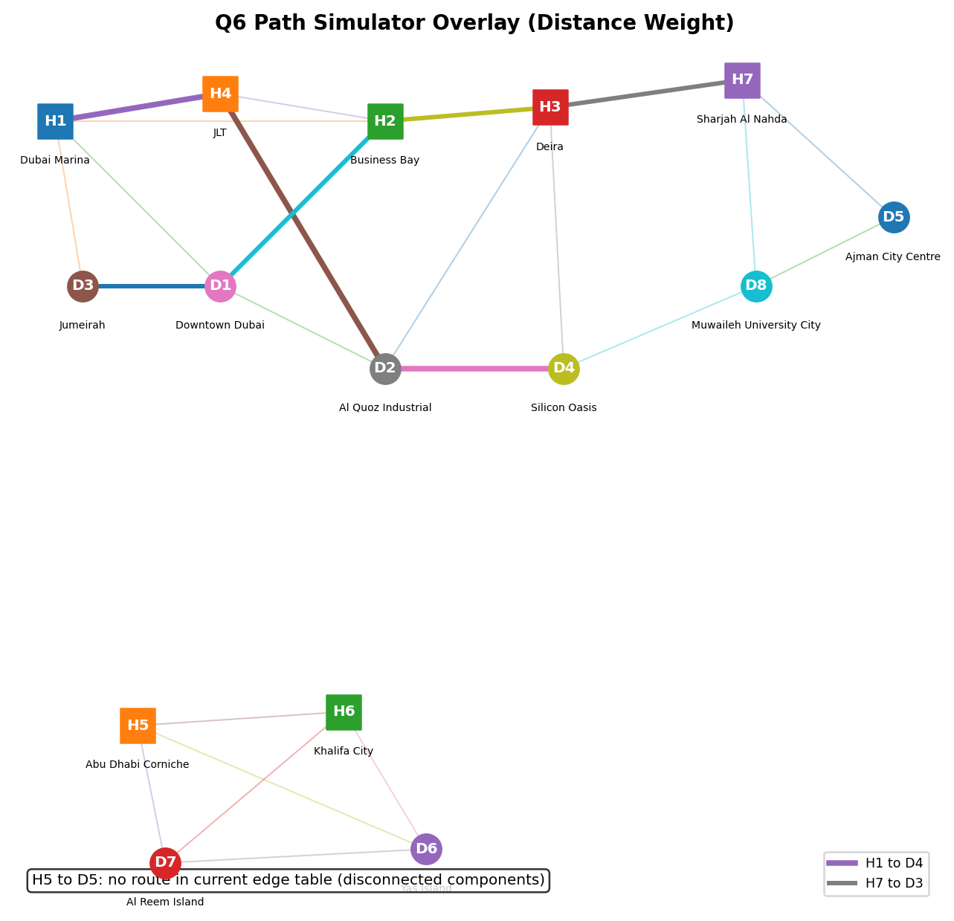
Figure 2: Q6 path overlay. H1-D4 and H7-D3 are shown; H5-D5 is reported as disconnected.

Q7 [10 marks] - BFS and DFS Reachability from H3
Traversal | Visit Order | Reachability Result
BFS | H3 -> H2 -> H7 -> D2 -> D4 -> H1 -> H4 -> D1 -> D5 -> D8 -> D3 | 11 of 15 nodes reachable
DFS | H3 -> H2 -> H1 -> H4 -> D2 -> D1 -> D3 -> D4 -> D8 -> H7 -> D5 | 11 of 15 nodes reachable
Node | BFS Parent
H1 | H2
H2 | H3
H3 | None
H4 | H2
H5 | Unreachable
H6 | Unreachable
H7 | H3
D1 | H2
D2 | H3
D3 | H1
D4 | H3
D5 | H7
D6 | Unreachable
D7 | Unreachable
D8 | H7
BFS is the correct traversal when WaselX wants the route with the fewest stops, because BFS explores the graph level by level. All nodes one edge away from H3 are visited before nodes two edges away, and so on. That means the first time BFS reaches a destination, it has found a path with the minimum number of road segments in an unweighted sense. DFS is useful for checking connectivity or exploring a component deeply, but it can follow a long branch before trying a shorter alternative. For express delivery, where each extra stop or transfer can delay the order, BFS gives a clearer operational answer: minimum hop count. However, if actual distance, time, or cost matters, BFS should be replaced with Dijkstra because weighted roads make fewest stops different from shortest travel time.

3. Task Area B: Trees, BST and AVL

Q8 [12 marks] - Binary Search Tree Operations
Insertion sequence: 1045, 1023, 1078, 1012, 1034, 1056, 1089, 1005, 1020, 1067, 1050, 1098
1045
/ \
1023 1078
/ \ / \
1012 1034 1056 1089
/ \ / \ \
1005 1020 1050 1067 1098
Traversal | Result
In-order | 1005, 1012, 1020, 1023, 1034, 1045, 1050, 1056, 1067, 1078, 1089, 1098
Pre-order | 1045, 1023, 1012, 1005, 1020, 1034, 1078, 1056, 1050, 1067, 1089, 1098
Post-order | 1005, 1020, 1012, 1034, 1023, 1050, 1067, 1056, 1098, 1089, 1078, 1045
Step | Current Node | Comparison | Decision
1 | 1045 | 1067 > 1045 | Go right
2 | 1078 | 1067 < 1078 | Go left
3 | 1056 | 1067 > 1056 | Go right
4 | 1067 | 1067 == 1067 | Found
Search path: 1045 -> 1078 -> 1056 -> 1067. Comparisons required: 4.
Deletion of 1078 uses Case 3 because 1078 has two children. The in-order successor is 1089, the smallest node in the right subtree. Replace 1078 with 1089, then remove the old 1089 node from its original position.
1045
/ \
1023 1089
/ \ / \
1012 1034 1056 1098
/ \ / \
1005 1020 1050 1067

Q9 [12 marks] - AVL Tree Balancing Analysis
Metric | Unbalanced BST from Q8 | AVL insertion result
Observed height (levels) | 4 | 4
Search path for 1067 | 1045 -> 1089 -> 1056 -> 1067 | 1045 -> 1078 -> 1056 -> 1067
Comparisons for 1067 | 4 | 4
Search path for 1005 | 1045 -> 1023 -> 1012 -> 1005 | 1045 -> 1023 -> 1012 -> 1005
Comparisons for 1005 | 4 | 4
Worst-case Big-O | O(n) for a generic unbalanced BST | O(log n) guaranteed
Rotations on supplied 12-key sequence | Not applicable | 0 rotations - sequence already AVL-balanced
Important trace conclusion: after each insertion, every balance factor remains in {-1, 0, +1}; therefore a correct AVL implementation performs no rotation on the supplied 12 order IDs. This corrects the prompt wording that says the morning BST became unbalanced.
Rotation demonstration 1 - LL case (conceptual extension):
Before inserting 1000 into 1012 -> 1005 -> 1000:
1012 (BF=+2)
/
1005 (BF=+1)
/
1000
Apply right rotation at 1012:
1005
/ \
1000 1012

Rotation demonstration 2 - RR case (conceptual extension):
Before inserting 1105 into 1089 -> 1098 -> 1105:
1089 (BF=-2)
\
1098 (BF=-1)
\
1105
Apply left rotation at 1089:
1098
/ \
1089 1105

Q10 [10 marks] - BST vs AVL vs Hash Table Recommendation
Operation | BST (unbalanced) | AVL Tree | Hash Table
Insert | O(n) worst | O(log n) | O(1) average
Search | O(n) worst | O(log n) | O(1) average
Delete | O(n) worst | O(log n) | O(1) average
Range query | O(k + height) | O(k + log n) | O(n), no ordering
Ordering | Yes | Yes | No
Risk at 15,000/day | High | Low | Medium for range use
WaselX needs one indexing structure that can handle three operations at scale: insertion of new orders, fast lookup for customer support, and range queries for time-window analytics. A hash table is attractive for exact Order ID lookup because it has O(1) average search and insertion. However, it does not maintain order. A query such as all orders between 10:00 and 11:30 requires scanning the table or adding another ordered index, which is O(n) and operationally weak for analytics. A simple BST preserves order, but it is unsafe under adversarial or naturally sorted insertion sequences. If order IDs arrive increasingly, the tree can become a linked list of height n, making search and insertion O(n). At 15,000 orders, that risk is too large for a sub-100ms service target. The AVL tree is the best primary recommendation because it preserves sorted order while guaranteeing O(log n) search, insert, and delete. For 15,000 orders, log2(n) is about 14 and the AVL height bound remains manageable. The implementation should use Order ID as the primary AVL key and maintain a secondary timestamp index for time-range queries. This two-index design gives WaselX reliable customer lookup and efficient operational reporting without depending on average-case hashing behavior alone.

Q11 [8 marks] - COO Scaling Memo: Flat Array to AVL Tree
TO: Chief Operating Officer, WaselX Express
FROM: DSA Consulting Team
DATE: May 3, 2026
SUBJECT: System Scaling Assessment - Flat Array vs AVL Tree for Order Lookup

Executive Summary: We recommend migrating from the current flat sorted array to an AVL tree before the platform reaches 15,000 daily orders. Binary search keeps lookup at O(log n), but insertion and deletion are O(n) because the array must shift records after the insertion point.

At 3,500 orders per day, the average insertion may shift about 1,750 records. At 15,000 daily orders, the average insertion may shift about 7,500 records. Across a full day, that is approximately 15,000 x 7,500 = 112.5 million element shifts, before considering cancellations and updates. This becomes the bottleneck, not lookup.

An AVL tree keeps search, insertion, and deletion at O(log n). At 15,000 orders, that is roughly 14-20 comparisons in practice rather than thousands of shifted array positions. Range queries remain efficient because in-order traversal returns sorted records.

Migration should proceed in four steps: export the current sorted array; build and validate an AVL tree from the same records; run the array and AVL systems in parallel for one week; then cut over writes and reads to the AVL implementation. Main risks are integration with existing APIs and rebalancing defects, mitigated through wrapper methods, unit tests, and parallel reconciliation. The expected performance improvement is strongest for insertion and deletion, where the shift cost drops from O(n) to O(log n).

4. Task Area C: Linked Lists, Queues and Order Pipeline

Q12 [10 marks] - Doubly Linked List: Rider Route Management
==================================================
Q12: Doubly Linked List (DLL) - Rider Route Management
==================================================
Initial Route (6 stops):
Forward: Stop1 <-> Stop2 <-> Stop3 <-> Stop4 <-> Stop5 <-> Stop6
Reverse: Stop6 <-> Stop5 <-> Stop4 <-> Stop3 <-> Stop2 <-> Stop1

Insert urgent order after Stop3:
Action: Insert "URGENT_Order_2847" after Stop3
Forward: Stop1 <-> Stop2 <-> Stop3 <-> URGENT_Order_2847 <-> Stop4 <-> Stop5 <-> Stop6
Reverse: Stop6 <-> Stop5 <-> Stop4 <-> URGENT_Order_2847 <-> Stop3 <-> Stop2 <-> Stop1

Delete Stop5 (Order cancelled):
Action: Delete "Stop5"
Forward: Stop1 <-> Stop2 <-> Stop3 <-> URGENT_Order_2847 <-> Stop4 <-> Stop6
Reverse: Stop6 <-> Stop4 <-> URGENT_Order_2847 <-> Stop3 <-> Stop2 <-> Stop1

Operations Summary:
- Total nodes in final route: 6
- Insert position: After node 3
- Deletion target: Stop5
- Forward and reverse traversal supported
==================================================
For a rider route with frequent changes, a doubly linked list is better than an array because insertion and deletion are pointer updates once the target node is known. In an array, inserting an urgent order after Stop3 requires shifting all later stops, which is O(n). Deleting a cancelled stop has the same shifting problem. In a DLL, inserting after Stop3 updates four links and deleting Stop5 reconnects its previous and next nodes, giving O(1) local changes. Bidirectional traversal also supports forward delivery navigation and reverse undo or backtracking. For dynamic WaselX routes, DLLs reduce disruption during live dispatch.

Q13 [8 marks] - Circular Linked List: 8 Riders, 20 Orders
Order # | Assigned Rider | Cumulative Orders | Note
1 | Rider1 | Rider1: 1 | Initial 8-rider circle
2 | Rider2 | Rider2: 1 | Initial 8-rider circle
3 | Rider3 | Rider3: 1 | Initial 8-rider circle
4 | Rider4 | Rider4: 1 | Initial 8-rider circle
5 | Rider5 | Rider5: 1 | Initial 8-rider circle
6 | Rider6 | Rider6: 1 | Initial 8-rider circle
7 | Rider7 | Rider7: 1 | Initial 8-rider circle
8 | Rider8 | Rider8: 1 | Initial 8-rider circle
9 | Rider1 | Rider1: 2 | Circle restarts at Rider1
10 | Rider2 | Rider2: 2 | Next active rider
11 | Rider3 | Rider3: 2 | Rider4 goes on break after this order
12 | Rider5 | Rider5: 2 | Rider4 removed; 7-rider circle
13 | Rider6 | Rider6: 2 | Next active rider
14 | Rider7 | Rider7: 2 | Next active rider
15 | Rider8 | Rider8: 2 | Next active rider
16 | Rider1 | Rider1: 3 | Next active rider
17 | Rider2 | Rider2: 3 | Next active rider
18 | Rider3 | Rider3: 3 | Next active rider
19 | Rider5 | Rider5: 3 | Next active rider
20 | Rider6 | Rider6: 3 | Next active rider
==================================================
Q13: Circular Linked List - Round-Robin Order Dispatch
==================================================
Initial Circle: Rider1 -> Rider2 -> Rider3 -> Rider4 -> Rider5 -> Rider6 -> Rider7 -> Rider8 -> back to Rider1
Orders 1-11: Rider1, Rider2, Rider3, Rider4, Rider5, Rider6, Rider7, Rider8, Rider1, Rider2, Rider3
Rider4 goes on break - removing from circle.
New Circle: Rider1 -> Rider2 -> Rider3 -> Rider5 -> Rider6 -> Rider7 -> Rider8 -> back to Rider1
Orders 12-20: Rider5, Rider6, Rider7, Rider8, Rider1, Rider2, Rider3, Rider5, Rider6
Final totals: Rider1=3, Rider2=3, Rider3=3, Rider4=1(on break), Rider5=3, Rider6=3, Rider7=2, Rider8=2
==================================================

Q14 [12 marks] - Priority Queue: Manual Min-Heap
Initial heap: []
Enqueue Order_B (priority=1, arrival=2)
Heap: [(1, 2, 'Order_B')]
Enqueue Order_E (priority=1, arrival=5)
compare Order_E(1,5) with parent Order_B(1,2) -> keep
Heap: [(1, 2, 'Order_B'), (1, 5, 'Order_E')]
Enqueue Order_A (priority=1, arrival=1)
compare Order_A(1,1) with parent Order_B(1,2) -> swap
Heap: [(1, 1, 'Order_A'), (1, 5, 'Order_E'), (1, 2, 'Order_B')]
Enqueue Order_I (priority=1, arrival=9)
compare Order_I(1,9) with parent Order_E(1,5) -> keep
Heap: [(1, 1, 'Order_A'), (1, 5, 'Order_E'), (1, 2, 'Order_B'), (1, 9, 'Order_I')]
Enqueue Order_D (priority=2, arrival=4)
compare Order_D(2,4) with parent Order_E(1,5) -> keep
Heap: [(1, 1, 'Order_A'), (1, 5, 'Order_E'), (1, 2, 'Order_B'), (1, 9, 'Order_I'), (2, 4, 'Order_D')]
Enqueue Order_H (priority=2, arrival=8)
compare Order_H(2,8) with parent Order_B(1,2) -> keep
Heap: [(1, 1, 'Order_A'), (1, 5, 'Order_E'), (1, 2, 'Order_B'), (1, 9, 'Order_I'), (2, 4, 'Order_D'), (2, 8,
'Order_H')]
Enqueue Order_C (priority=3, arrival=3)
compare Order_C(3,3) with parent Order_B(1,2) -> keep
Heap: [(1, 1, 'Order_A'), (1, 5, 'Order_E'), (1, 2, 'Order_B'), (1, 9, 'Order_I'), (2, 4, 'Order_D'), (2, 8,
'Order_H'), (3, 3, 'Order_C')]
Enqueue Order_G (priority=3, arrival=7)
compare Order_G(3,7) with parent Order_I(1,9) -> keep
Heap: [(1, 1, 'Order_A'), (1, 5, 'Order_E'), (1, 2, 'Order_B'), (1, 9, 'Order_I'), (2, 4, 'Order_D'), (2, 8,
'Order_H'), (3, 3, 'Order_C'), (3, 7, 'Order_G')]
Enqueue Order_F (priority=2, arrival=6)
compare Order_F(2,6) with parent Order_I(1,9) -> keep
Heap: [(1, 1, 'Order_A'), (1, 5, 'Order_E'), (1, 2, 'Order_B'), (1, 9, 'Order_I'), (2, 4, 'Order_D'), (2, 8,
'Order_H'), (3, 3, 'Order_C'), (3, 7, 'Order_G'), (2, 6, 'Order_F')]
Enqueue Order_J (priority=3, arrival=10)
compare Order_J(3,10) with parent Order_D(2,4) -> keep
Heap: [(1, 1, 'Order_A'), (1, 5, 'Order_E'), (1, 2, 'Order_B'), (1, 9, 'Order_I'), (2, 4, 'Order_D'), (2, 8,
'Order_H'), (3, 3, 'Order_C'), (3, 7, 'Order_G'), (2, 6, 'Order_F'), (3, 10, 'Order_J')]
Dequeue # | Order | Priority | Arrival | Extraction Logic
1 | Order_A | 1 | 1 | Priority then FIFO arrival
2 | Order_B | 1 | 2 | Priority then FIFO arrival
3 | Order_E | 1 | 5 | Priority then FIFO arrival
4 | Order_I | 1 | 9 | Priority then FIFO arrival
5 | Order_D | 2 | 4 | Priority then FIFO arrival
6 | Order_F | 2 | 6 | Priority then FIFO arrival
7 | Order_H | 2 | 8 | Priority then FIFO arrival
8 | Order_C | 3 | 3 | Priority then FIFO arrival
9 | Order_G | 3 | 7 | Priority then FIFO arrival
10 | Order_J | 3 | 10 | Priority then FIFO arrival
Operation | Big-O | Worst-case path | Justification
enqueue | O(log n) | Sift-up from leaf to root | Heap height is ceil(log2 n); each level has one comparison and possible swap
dequeue / extract_min | O(log n) | Sift-down from root to leaf | After root removal, the replacement moves down at most heap height
peek | O(1) | Direct root access | Minimum is stored at index 0
len | O(1) | Stored counter or list length | No traversal required

Q15 [8 marks] - Stack: Order Lifecycle and Undo
==================================================
Q15: Stack - Order Status Tracking and Undo Operations
==================================================
Order_2847 Status Lifecycle:
Push Received -> [Received]
Push Confirmed -> [Received, Confirmed]
Push Preparing -> [Received, Confirmed, Preparing]
Push Dispatched -> [Received, Confirmed, Preparing, Dispatched]
Push In Transit -> [Received, Confirmed, Preparing, Dispatched, In Transit]
Push Delivered -> [Received, Confirmed, Preparing, Dispatched, In Transit, Delivered]
Current Status: Delivered

Order_2851 Status Lifecycle:
Push Received -> [Received]
Push Confirmed -> [Received, Confirmed]
Push Preparing -> [Received, Confirmed, Preparing]
Push Dispatched -> [Received, Confirmed, Preparing, Dispatched]
Push In Transit -> [Received, Confirmed, Preparing, Dispatched, In Transit]
Push Delivered -> [Received, Confirmed, Preparing, Dispatched, In Transit, Delivered]
Current Status: Delivered

Order_2855 Status Lifecycle (with cancellation):
Push Received -> [Received]
Push Confirmed -> [Received, Confirmed]
Push Preparing -> [Received, Confirmed, Preparing]
CANCELLATION TRIGGERED
Pop Preparing -> [Received, Confirmed]
Current Status: Confirmed (order reverted)

Undo demonstration:
Current Stack: [Received, Confirmed, Preparing]
Mistake: Push Dispatched -> [Received, Confirmed, Preparing, Dispatched]
UNDO: Pop Dispatched -> [Received, Confirmed, Preparing]
Recovered Status: Preparing
==================================================

Q16 [10 marks] - Single Global Priority Queue vs 7 Zone Queues
Criterion | Single Global PQ | 7 Zone FIFOs + Pre-sort
Dispatch fairness | Strong priority fairness globally; may starve low priority zones without aging | Strong geographic fairness; weaker global priority fairness
Priority honor | Best: all priority-1 orders can jump ahead globally | Priority honored only before entering zone queues
Implementation complexity | Moderate: one heap and aging policy | Higher: seven queues, router logic, zone balancing
Latency | O(log n) dequeue | O(1) within zone after pre-sort
Scalability to 15,000 orders | Good, heap height remains small | Good per-zone size, but orchestration cost rises
Geographic routing efficiency | Requires separate rider-zone matching layer | Naturally supports zone batching
Recommendation: Use a hybrid design led by a global priority queue, with zone as a secondary routing attribute. A single global PQ is the clearest way to honor WaselX priority rules because a VIP Same-Hour order should not wait behind standard work merely because it belongs to a different zone. It is also simpler to reason about: enqueue and dequeue are O(log n), and even at 15,000 orders the heap height is small. The weakness is geographic efficiency. If the heap always dispatches the next urgent order without considering rider location, it can assign work across distant zones and waste kilometers. Seven zone FIFO queues solve this routing issue but weaken global priority fairness. A standard order in Zone 1 could be dispatched before an urgent order in Zone 5 if zones are processed independently. The best operational design is therefore a priority queue keyed by priority and arrival time, with zone and rider proximity included in the assignment step. Aging rules should promote old standard orders to avoid starvation. This gives leadership a clear promise: premium SLAs are protected globally, while dispatch still respects zone capacity and rider availability.

Q17 [10 marks] - Leadership Brief to CEO: Priority Queue Proposal
To: Chief Executive Officer, WaselX Express
From: Head of Delivery Operations
Subject: Priority Queue Dispatch for VIP Retention

WaselX should move from simple FIFO dispatch to a priority queue dispatch model. The current process treats VIP Same-Hour customers, who pay three times the delivery fee, the same as economy customers. This creates a revenue risk because high-value accounts experience preventable delays and churn. A priority queue directly addresses that gap by dispatching priority-1 orders before lower-priority work while still preserving FIFO order inside each priority level.

The technical change is contained and practical. Each incoming order receives a priority value and arrival timestamp. A manual min-heap stores orders as (priority, arrival, order_id). Dequeue returns the most urgent eligible order, and ties are resolved by arrival time, so the system remains fair within each service tier.

The transition should be managed in phases. First, run the priority queue in shadow mode beside the current FIFO process and compare the dispatch order. Second, pilot the model in one Dubai zone during off-peak hours. Third, expand to all zones after measuring SLA improvement, complaint reduction, and rider utilization. We should keep manual override controls for dispatch supervisors during incidents.

Riders may initially view the change as unfair because some orders will jump ahead. Communication must explain that priority reflects customer SLA promises, not favoritism. The policy should include workload balancing and aging rules so economy orders cannot be ignored indefinitely. This change protects revenue, improves customer trust, and gives WaselX a scalable dispatch foundation.

5. Task Area D: Sorting, Searching and Divide and Conquer

Q18 [12 marks] - Merge Sort and Quick Sort
Level 1 split:
Left = [('JLT', 3), ('Deira', 1), ('Marina', 4), ('JLT', 1), ('Deira', 2), ('Marina', 2), ('Silicon', 5), ('Deira', 3)]
Right = [('JLT', 2), ('Marina', 1), ('Silicon', 1), ('Deira', 4), ('Silicon', 3), ('JLT', 5), ('Marina', 3)]

Level 2 splits:
[('JLT', 3), ('Deira', 1), ('Marina', 4), ('JLT', 1)]
[('Deira', 2), ('Marina', 2), ('Silicon', 5), ('Deira', 3)]
[('JLT', 2), ('Marina', 1), ('Silicon', 1)]
[('Deira', 4), ('Silicon', 3), ('JLT', 5), ('Marina', 3)]

Level 3 splits:
[('JLT', 3), ('Deira', 1)]
[('Marina', 4), ('JLT', 1)]
[('Deira', 2), ('Marina', 2)]
[('Silicon', 5), ('Deira', 3)]
[('JLT', 2)]
[('Marina', 1), ('Silicon', 1)]
[('Deira', 4), ('Silicon', 3)]
[('JLT', 5), ('Marina', 3)]
Merge 1: [('Deira', 1)] + [('Marina', 4)]
compare ('Deira', 1) <= ('Marina', 4) -> True
result: [('Deira', 1), ('Marina', 4)]
Merge 2: [('JLT', 3)] + [('Deira', 1), ('Marina', 4)]
compare ('JLT', 3) <= ('Deira', 1) -> False
compare ('JLT', 3) <= ('Marina', 4) -> True
result: [('Deira', 1), ('JLT', 3), ('Marina', 4)]
Merge 3: [('JLT', 1)] + [('Deira', 2)]
compare ('JLT', 1) <= ('Deira', 2) -> False
result: [('Deira', 2), ('JLT', 1)]
Merge 4: [('Marina', 2)] + [('Silicon', 5)]
compare ('Marina', 2) <= ('Silicon', 5) -> True
result: [('Marina', 2), ('Silicon', 5)]
Level 1 pivot = ('Marina', 3)
Left <= pivot: [('JLT', 3), ('Deira', 1), ('JLT', 1), ('Deira', 2), ('Marina', 2), ('Deira', 3), ('JLT', 2),
('Marina', 1), ('Deira', 4), ('JLT', 5)]
Pivot: ('Marina', 3)
Right > pivot: [('Marina', 4), ('Silicon', 5), ('Silicon', 1), ('Silicon', 3)]
Level 2 pivot = ('JLT', 5)
Left <= pivot: [('JLT', 3), ('Deira', 1), ('JLT', 1), ('Deira', 2), ('Deira', 3), ('JLT', 2), ('Deira', 4)]
Pivot: ('JLT', 5)
Right > pivot: [('Marina', 2), ('Marina', 1)]
Level 2 pivot = ('Silicon', 3)
Left <= pivot: [('Marina', 4), ('Silicon', 1)]
Pivot: ('Silicon', 3)
Right > pivot: [('Silicon', 5)]
Algorithm | Total Comparisons | Final Sorted Output | More Efficient?
Merge Sort | 43 | [('Deira', 1), ('Deira', 2), ('Deira', 3), ('Deira', 4), ('JLT', 1), ('JLT', 2), ('JLT', 3), ('JLT', 5), ('Marina', 1), ('Marina', 2), ('Marina', 3), ('Marina', 4), ('Silicon', 1), ('Silicon', 3), ('Silicon', 5)] | No
Quick Sort | 39 | [('Deira', 1), ('Deira', 2), ('Deira', 3), ('Deira', 4), ('JLT', 1), ('JLT', 2), ('JLT', 3), ('JLT', 5), ('Marina', 1), ('Marina', 2), ('Marina', 3), ('Marina', 4), ('Silicon', 1), ('Silicon', 3), ('Silicon', 5)] | Yes for this dataset
Quick Sort uses fewer comparisons on this specific dataset because the last-element pivots divide the data reasonably well. Merge Sort has guaranteed O(n log n) behavior and is stable, which matters when equal zone-priority records must preserve arrival order. Quick Sort is not stable by default and can degrade if pivots become poor.

Q19 [10 marks] - Binary Search vs Linear Search
Step | low | mid | high | arr[mid] | Action
1 | 0 | 499 | 999 | 10500 | Go left
2 | 0 | 249 | 498 | 10250 | Go right
3 | 250 | 374 | 498 | 10375 | Go left
4 | 250 | 311 | 373 | 10312 | Go right
5 | 312 | 342 | 373 | 10343 | Go right
6 | 343 | 358 | 373 | 10359 | Go left
7 | 343 | 350 | 357 | 10351 | Go left
8 | 343 | 346 | 349 | 10347 | Found
Algorithm | Comparisons per call | Total per day (500 calls)
Binary Search | 8 | 4000
Linear Search | 347 | 173500
Percentage improvement | - | 97.69% fewer comparisons
Linear search reaches Order ID 10347 after 347 comparisons because the array begins at 10001. Binary search finds the same target in 8 comparisons by halving the search interval each step.

Q20 [10 marks] - Divide-and-Conquer Peak Hour Finder
D&C(hour 0-23): left total=1950, right total=4050 -> recurse right
D&C(hour 12-23): left total=2650, right total=1400 -> recurse left
D&C(hour 12-17): left total=1350, right total=1300 -> recurse left
D&C(hour 12-14): left total=650, right total=700 -> recurse right
D&C(hour 14-14): base case -> hour 14 with 700 orders
Peak hour found: Hour 14 with 700 orders
Approach | Time Complexity | Space Complexity
Divide and conquer - heavier-half trace | O(log 24) for this narrowing heuristic | O(log 24) call stack
Linear scan | O(24) | O(1)
Rank | Hour | Orders | % of Daily Volume
1 | 14 | 700 | 11.67%
2 | 15 | 450 | 7.50%
3 | 16 | 430 | 7.17%
For top-3 discovery, repeatedly running the heavier-half divide-and-conquer heuristic is not efficient or fully reliable because a half with several medium hours can outweigh the half containing a single peak. A better method is to scan the 24 hourly buckets once while maintaining the three largest values, which is O(24) and easier to verify. At larger granularity, such as minute-level buckets, a max-heap or partial selection algorithm can track the top k periods. The divide-and-conquer trace is useful for explaining recursive narrowing, but production analytics should use a direct top-k method.

Q21 [8 marks] - Merge Sort vs Quick Sort for 50,000 Records
For the nightly batch job of 50,000 delivery records, WaselX should use Merge Sort. The job is offline, so predictable completion and audit quality matter more than in-place memory savings. Merge Sort guarantees O(n log n) time for every input distribution, including partially sorted data, reverse-sorted data, or records grouped by zone. It is also stable, which is operationally important: if two records have the same delivery zone and priority, their existing chronological order can be preserved for audit trails and customer-service reconciliation. Quick Sort has strong average-case O(n log n) performance and can be faster in memory-conscious environments, but a naive pivot rule is risky on partially sorted data. If the pivot repeatedly creates unbalanced partitions, Quick Sort degrades to O(n^2). That risk is unnecessary for a scheduled analytics process where reliability is expected. Merge Sort uses O(n) additional memory, but for 50,000 records this is acceptable on modern systems. Recommendation: implement Merge Sort as the standard nightly sort. If Quick Sort is retained for comparison, use randomized or median-of-three pivoting and label it as a benchmark alternative rather than the primary production sort.

Q22 [10 marks] - Sort Performance Benchmark
Dataset Size | Merge Sort ms | Quick Sort ms | Faster | Merge cmp | Quick cmp
100 | 0.21 | 0.11 | Quick Sort | 547 | 645
500 | 0.99 | 0.55 | Quick Sort | 3861 | 4711
1000 | 2.07 | 1.20 | Quick Sort | 8687 | 11004
5000 | 12.99 | 6.92 | Quick Sort | 55243 | 70519
10000 | 27.43 | 14.62 | Quick Sort | 120397 | 153699
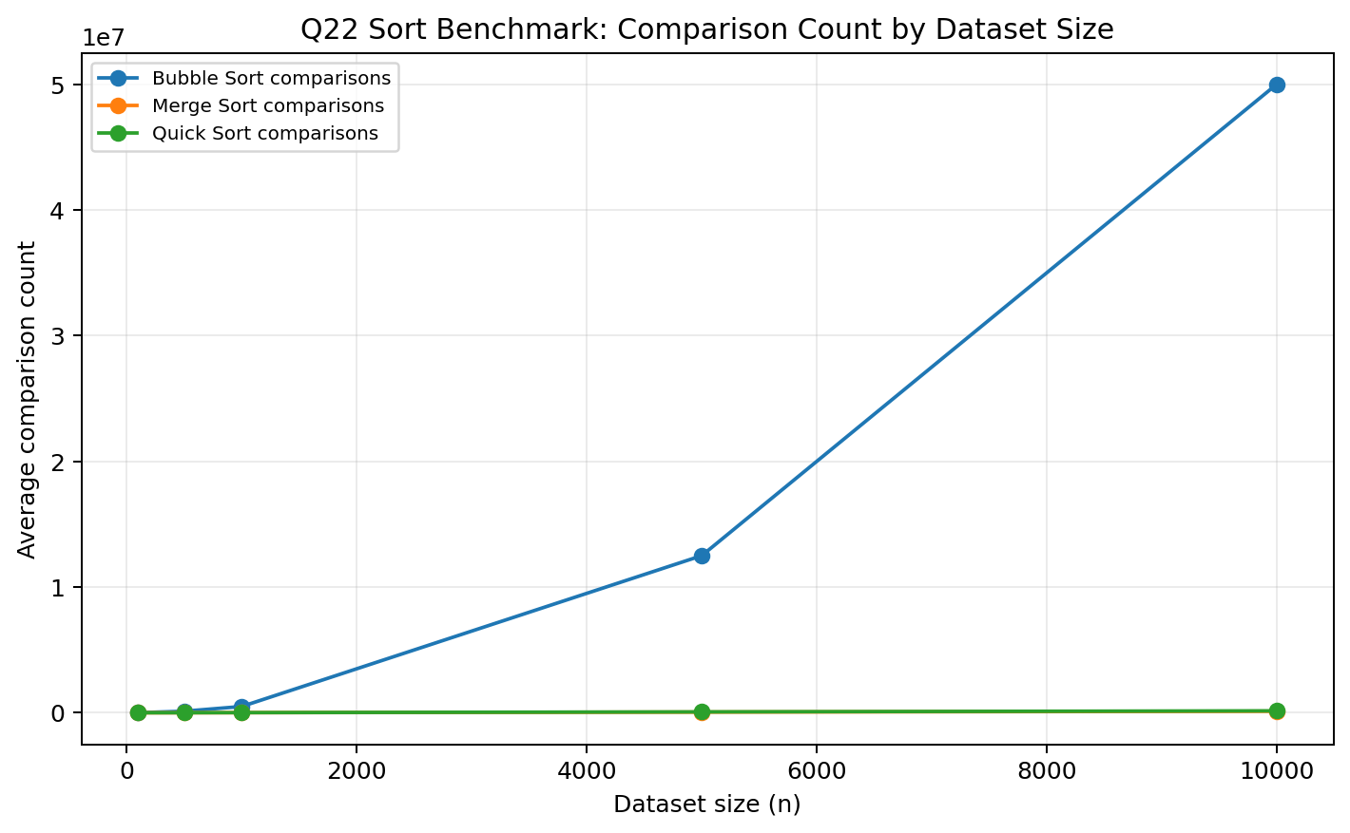
Figure 3: Sort comparison-count benchmark for Bubble, Merge, and Quick Sort across five dataset sizes.
Runtime increases with dataset size for both Merge Sort and Quick Sort, matching the expected O(n log n) trend. On the random datasets used here, Quick Sort is faster in wall-clock time because its partitioning is lightweight and the last pivot happens to divide random data reasonably. Merge Sort performs fewer worst-case surprises and remains stable, so it is still the safer batch-job recommendation. Bubble Sort is included only as a baseline because its O(n^2) comparison growth becomes impractical by 10,000 records.

6. Task Area E: Management, Leadership and Strategic Integration

Q23 [12 marks] - Executive Summary for Board of Directors
# | Problem | Current Impact | Solution | Algorithm
1 | Inefficient routes | 23% excess distance, AED 1.2M/year | Route optimization | Dijkstra + MST / MSF
2 | Slow dispatch | 8-min delay per batch, 12% complaints | Priority dispatch | Min-Heap Priority Queue
3 | Slow order lookup | 45-sec support response, CSAT 3.2/5 | Indexed search | AVL Tree + Binary Search
Solution | Investment | Annual Saving / Recovery | Payback Period
Route optimization | AED 800K | AED 240K assumed fuel reduction | 3.33 years
Priority dispatch | AED 400K | AED 200K VIP churn reduction | 2.00 years
AVL order lookup | AED 200K est. | AED 150K support and CSAT recovery | 1.33 years
WaselX Express has a clear opportunity to convert algorithmic capability into operational advantage. The company faces three linked issues: route inefficiency, slow priority handling, and slow customer lookup. These are not only technical problems; they affect fuel spend, rider productivity, premium customer retention, and support satisfaction. The proposed optimization program addresses each issue with a data-structure or algorithm selected for the business constraint it solves. Dijkstra improves single-order route planning. Minimum spanning analysis identifies the lowest-cost tracking backbone, while also revealing a critical data gap: the current edge table is disconnected between Abu Dhabi and the Dubai/Sharjah/Ajman network. A min-heap priority queue ensures urgent and premium orders are dispatched ahead of lower-tier work without losing FIFO fairness inside each priority level. AVL-based indexing gives WaselX guaranteed search, insertion, and range-query performance as daily orders scale toward 15,000. The recommended implementation order is priority dispatch first, AVL lookup second, and route optimization third. Priority dispatch is the fastest operational win because it protects premium SLAs and requires contained changes to order intake. AVL lookup follows because it reduces support handling time and prepares the platform for growth. Full route optimization should be sequenced third because it creates large long-term value but requires cleaner road data, real-time incident handling, and simulator validation. The board should approve a phased program with measurable gates: VIP SLA compliance, lookup response time, rider kilometers per order, and customer complaints. This sequencing reduces implementation risk while building a deployable technology foundation rather than a classroom-only prototype.

Q24 [10 marks] - Dual-Audience Algorithm Communication

Board explanation
The route optimizer works like a disciplined delivery planner. Instead of asking a rider to guess the best road, the system compares available road segments and chooses the path that best matches the business goal: shortest distance, fastest time, or lowest operating cost. For a customer, this feels like a more reliable delivery promise. For WaselX, it means fewer wasted kilometers, lower fuel and wear cost, and better use of rider hours. The important point is that the system does not replace operational judgment. It gives dispatchers a better starting recommendation and can update routes when a road is blocked. The board should care because route waste is not a small inconvenience; it is a recurring cost that scales with every order. Better routing improves margin, customer trust, and service consistency.

Engineering explanation
The network is represented as an adjacency list with V=15 nodes and E=24 undirected edges. Each edge stores distance, time, and cost, so the same Dijkstra implementation can optimize on different weights. The primary route loop initializes dist[start]=0, extracts the lowest-distance unvisited node from a manual min-heap, and relaxes each outgoing edge. For an edge u-v, relaxation checks whether dist[u]+w(u,v) improves dist[v]; if so, it updates dist[v] and prev[v]. Because all weights are non-negative, once a node is extracted as the minimum, its shortest distance is finalized. Complexity is O((V+E) log V) with a real heap. NetworkX may be used only for drawing, not for algorithm computation. Early exit is appropriate when the destination node is finalized.

Leadership reflection
A technology leader must adapt the same idea to different decision needs. The board needs clarity on value, risk, timing, and financial impact. Engineers need precision on representation, complexity, correctness, and implementation constraints. Over-simplifying can be dangerous because leaders may approve a budget without understanding data gaps such as disconnected components or stale road data. Over-complicating is also harmful because non-technical stakeholders may disengage and miss the strategic opportunity. Good leadership translates without distorting: it keeps the core truth intact while changing examples, vocabulary, and level of detail for the audience.

Q25 [10 marks] - Investment Decision Memo
Metric | Investment A: Route Optimization | Investment B: Priority Queue
Cost | AED 800,000 | AED 400,000
Annual saving | AED 1,200,000 | AED 600,000
Year-1 ROI | 50% | 50%
Payback | 0.67 years (~8 months) | 0.67 years (~8 months)
3-year net benefit | AED 2,800,000 | AED 1,400,000
To: Senior Leadership Team
From: DSA Consulting Team
Subject: 2026 Investment Decision - Route Optimization vs Priority Queue
Date: May 3, 2026

Both investment options are financially attractive and have identical first-year ROI and payback. Route optimization costs AED 800,000 and is expected to save AED 1.2M annually, giving 50% ROI and an eight-month payback. The priority queue costs AED 400,000 and recovers AED 600,000 annually from VIP churn reduction, also giving 50% ROI and an eight-month payback.

Because the headline financial ratios are equal, the decision should rest on strategic fit, risk, capital availability, and speed of execution. Route optimization has the higher absolute three-year net benefit, but it also has higher implementation complexity. It depends on clean road data, simulator validation, live closure handling, and integration with dispatch workflows. The current graph audit also shows a disconnected network, so data readiness is a real prerequisite.

I recommend funding Investment B first: the priority queue dispatch system. It requires lower capital, is easier to pilot, and directly protects premium customers who pay more and are sensitive to delays. It can be implemented behind the existing dispatch interface with shadow testing and staged rollout.

If capital becomes available, Investment A should follow as the second phase. This sequence creates a fast customer-retention win first, then uses the operational credibility and improved data discipline to support the larger route optimization program.

Q26 [10 marks] - CTO Town Hall Response
That is a fair challenge, and I do not want us to build technology for its own sake. External map services are excellent for street-level navigation, live traffic, and turn-by-turn guidance. We should use them where they are strongest.

The reason we still need in-house routing logic is that WaselX has business constraints that a generic map API does not fully understand. We optimize across our own five-tier service model, rider capacity, delivery promises, customer value, operating cost, and blocked internal corridors. Google Maps can tell us a good road route; it will not decide how to trade off VIP SLA risk against rider utilization or fuel cost inside our dispatch policy.

There is also a cost-control issue. At thousands of route queries per day, API calls can become a recurring operating expense. We can reduce unnecessary calls by using our own graph for dispatch-level decisions and calling external maps only when detailed navigation or live traffic validation is needed.

Finally, routing patterns are competitive intelligence. They show where demand forms, which corridors fail, and where we should place hubs. Owning that decision layer helps us build a defensible capability.

So the answer is not reinvent everything. The answer is combine external map services with WaselX-owned algorithms. We will use the best external data and still own the business logic that differentiates us. I would value your expertise on the implementation, so let us set up a working session this week.

Q27 [15 marks] - Comprehensive Path Simulator
Criterion | Optimal Path | Value | Same as distance path?
Shortest distance | H1 -> H4 -> D2 -> D4 | 21 km | Yes
Fastest time | H1 -> H4 -> D2 -> D4 | 44 min | Yes
Lowest cost | H1 -> H4 -> D2 -> D4 | 14.5 AED | Yes
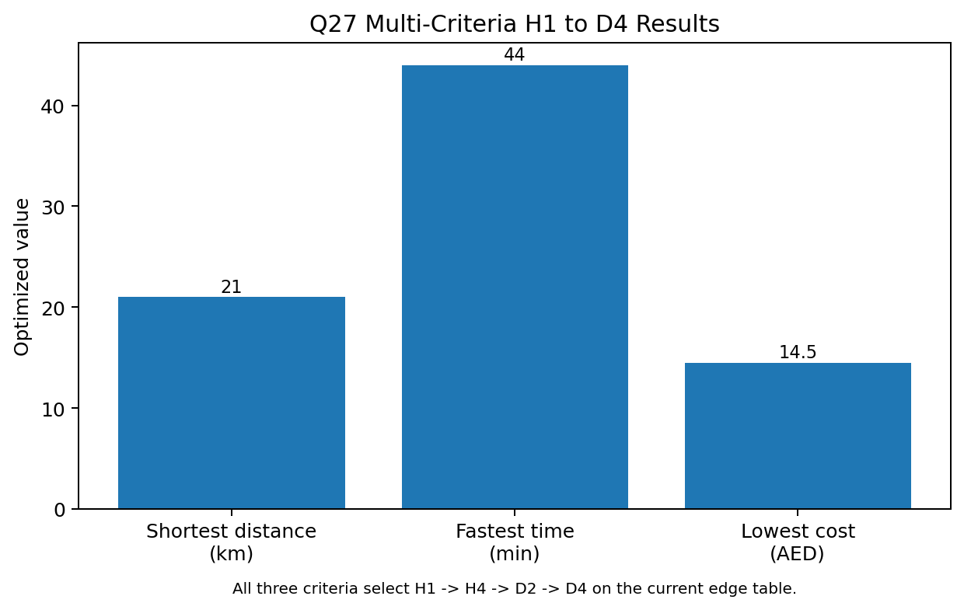
Figure 4: Multi-criteria result for H1-D4. Current data selects the same path for all criteria.
Metric | Original Path | Rerouted Path | Change
Path | H1 -> H4 -> D2 -> D4 | H1 -> D1 -> D2 -> D4 | H1-H4 avoided
Distance | 21 km | 24 km | +14.3%
Time | 44 min | 48 min | +9.1%
Cost | AED 14.5 | AED 16.5 | +13.8%
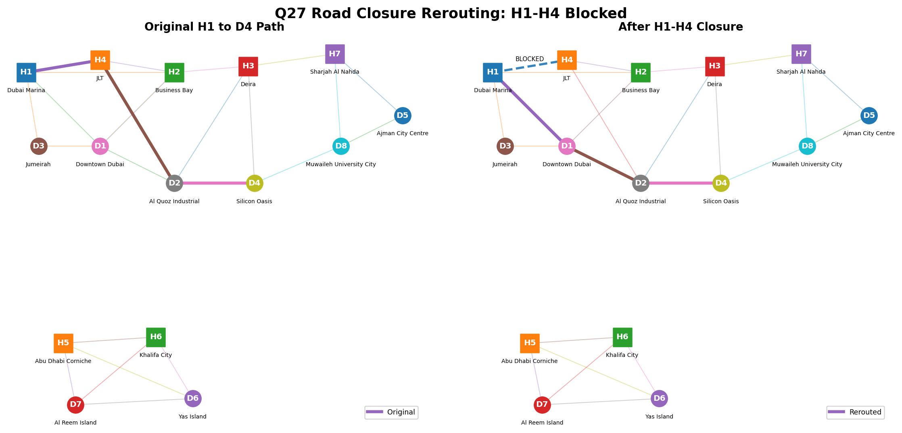
Figure 5: Road closure rerouting when the H1-H4 segment is blocked.
Operational road-closure handling should treat a blocked edge as temporarily unavailable, equivalent to removing the edge or assigning it infinite weight. The data infrastructure needs three layers: a live traffic or map incident feed, an internal dispatcher incident dashboard, and a message queue that pushes closure events to active route services. When an event arrives, the system should identify only affected active deliveries rather than recomputing every route. Orders not yet dispatched can be rerouted automatically; orders already in transit should receive a rider-safe recommendation and dispatcher visibility. Human workflow remains important. A dispatcher should be able to mark a closure, set an expected duration, and add a reason such as construction, accident, or police restriction. The simulator then recomputes distance, time, and cost and shows the delta versus the original plan. This allows WaselX to maintain service continuity while measuring the operational cost of incidents.

7. Figures Index
Figure | File | Purpose
Figure 1 | q1_adjacency_matrix.png | Full 15-node distance adjacency matrix
Figure 2 | q6_path_overlay.png | Path simulator overlay for tested routes
Figure 3 | q22_sort_benchmark.png | Sort comparison benchmark
Figure 4 | q27_simulator_comparison.png | Multi-criteria H1-D4 comparison
Figure 5 | q27_closure_h1_d4.png | Road closure rerouting visualization

8. References and Citations
- Cormen, T. H., Leiserson, C. E., Rivest, R. L., and Stein, C. Introduction to Algorithms, 3rd ed. MIT Press, 2009. Chapters on graph algorithms, sorting, and balanced trees.
- Goodrich, M. T., Tamassia, R., and Goldwasser, M. H. Data Structures and Algorithms in Python. Wiley, 2013.
- Python Software Foundation. Python 3 Documentation. https://docs.python.org/3/ Accessed May 3, 2026.
- Matplotlib Developers. Matplotlib Documentation. https://matplotlib.org/stable/ Accessed May 3, 2026.
- WaselX Express MAIB Final Project Brief and Technical Requirements Document, supplied by course team, 2025-2026.

9. Academic Integrity Statement
This project is submitted as part of the MAIB Data Structures & Algorithms course. All algorithms are to be implemented by the team members listed on the cover page. Standard library usage must be noted in code comments. AI-assisted code, if used in the repository, must be marked with [AI-ASSISTED: ...] tags and reviewed by a named team member. Benchmark-only library usage must be labeled [BENCHMARK ONLY - not primary implementation]. External references are cited in the References section. By submitting this work, the team affirms that it meets the institutional academic integrity policy and assumes responsibility for any violations.

10. Appendix: README Summary
A separate README.md file has been generated with the required sections: project overview, prerequisites, installation, how to run all 27 tasks, sample output, file structure, academic integrity statement, and references. The technical standards checklist should be reviewed before final repository submission.
# WaselX Express - Delivery Optimization (README)

## 1. Project Overview
WaselX Express is a Python 3.10+ academic prototype that demonstrates how data structures and algorithms can improve last-mile delivery operations across the UAE. The project models a 15-node delivery network, optimizes routes, manages priority dispatch, improves order lookup, and provides business recommendations connected to measurable operational impact.

## 2. Prerequisites
- Python 3.10 or later
- Windows, macOS, or Linux terminal
- pip for dependency installation
- Optional: a virtual environment tool such as `venv`

## 3. Installation
```bash
git clone https://github.com/rd51/waselx.git
cd waselx_project
python -m venv venv
source venv/bin/activate # Windows: venv\Scripts\activate
pip install -r requirements.txt
python --version
```

## 4. How to Run Each Task
```bash
python main.py
```
Menu mapping:
1. Task A - Q1 Graph representation
2. Task A - Q2 Dijkstra H1 to D1
3. Task A - Q3 Floyd-Warshall hub analysis
4. Task A - Q4 Minimum spanning forest / MST audit
5. Task A - Q5 CTO memo output
6. Task A - Q6 Path simulator
7. Task A - Q7 BFS and DFS reachability
8. Task B - Q8 BST operations
9. Task B - Q9 AVL analysis
10. Task B - Q10 data structure recommendation
11. Task B - Q11 COO migration memo
12. Task C - Q12 Doubly linked list route
13. Task C - Q13 Circular rider dispatch
14. Task C - Q14 Manual min-heap priority queue
15. Task C - Q15 Stack lifecycle and undo
16. Task C - Q16 dispatch pipeline comparison
17. Task C - Q17 CEO leadership brief
18. Task D - Q18 merge sort and quick sort
19. Task D - Q19 binary vs linear search
20. Task D - Q20 peak-hour divide and conquer
21. Task D - Q21 nightly sorting recommendation
22. Task D - Q22 sort benchmark
23. Task E - Q23 executive summary
24. Task E - Q24 dual-audience communication
25. Task E - Q25 investment decision memo
26. Task E - Q26 CTO town hall response
27. Task E - Q27 comprehensive path simulator

## 5. Sample Output
```text
==================================================
Q2: Dijkstra's Single-Source Shortest Path
==================================================
Start: H1 (Dubai Marina Hub)
End: D1 (Downtown Dubai)
Shortest path: H1 -> D1
Distance: 8 km
Time: 15 min
Cost: AED 5.5
Complexity: O((V+E) log V) with a manual min-heap
```

## 6. File Structure
```text
waselx_project/
├── data/
│ └── network.py
├── task_a/
├── task_b/
├── task_c/
├── task_d/
├── task_e/
├── utils/
├── outputs/
├── main.py
├── requirements.txt
├── README.md
├── TRD.md
└── references.txt
```

## 7. Academic Integrity Statement
This project is submitted as part of the MAIB Data Structures & Algorithms course. All algorithms are implemented by the team members listed in the technical report. Standard library usage is noted in code comments. AI-assisted code, if used, must be marked with `[AI-ASSISTED: ...]` tags and reviewed by a team member. All external references are cited in the References section. By submitting this work, we affirm that it is our own and meets the institutional academic integrity policy.

## 8. References
See `references.txt` and the report's References and Citations section.

[README continues in separate README.md file.]

