**Initial load**

Data di customer_staging

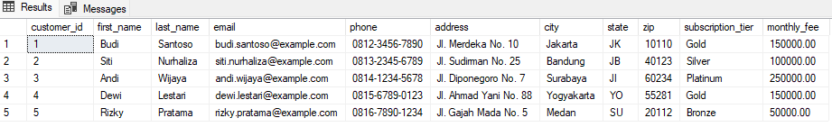

Hasil load dim_customer

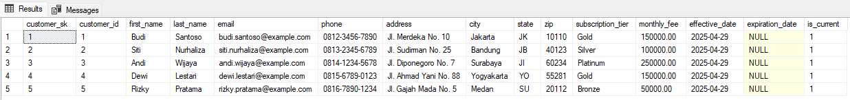

**Perubahan data di customer_staging**

Update

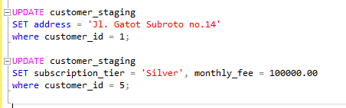

Insert

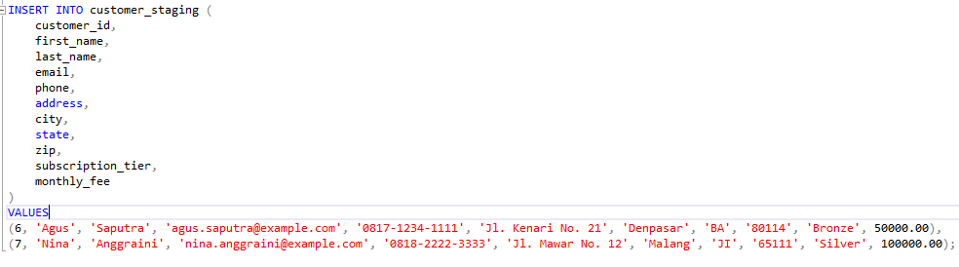

Data di customer_staging

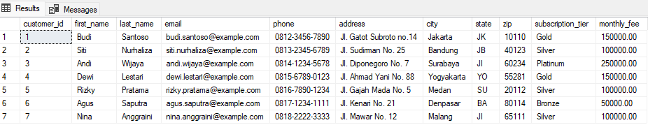

Hasil load dim_customer

step 1 : update expiration_date dan is_current saat ada perubahan data

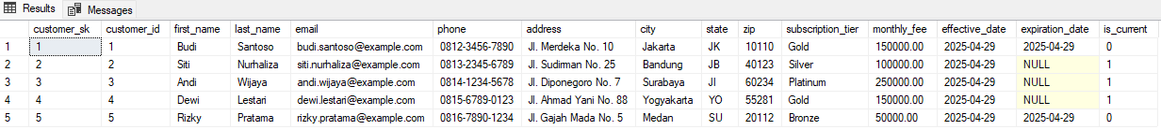

Step 2 : insert data baru dan terupdate

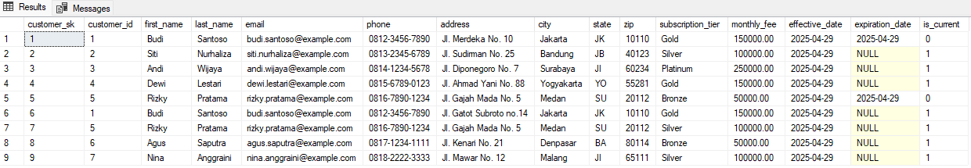

**Update beberapa kolom**



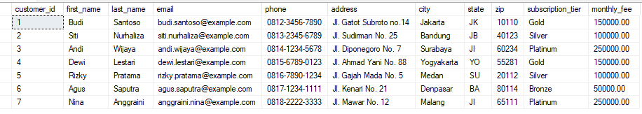

Hasil load dim_customer

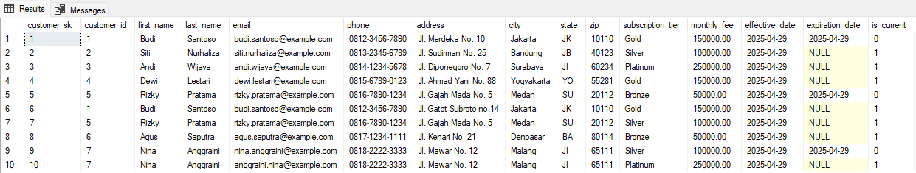

**Data staging terhapus (subscription expired)**



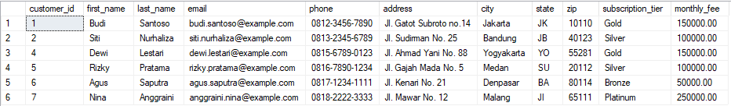

Hasil load dim_customer

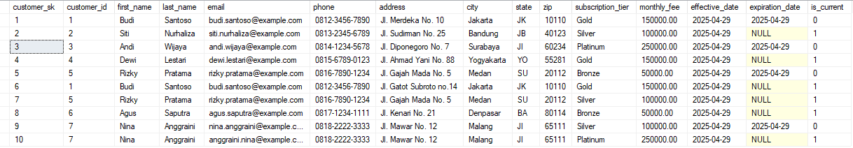

**Error handling Data Duplikat**

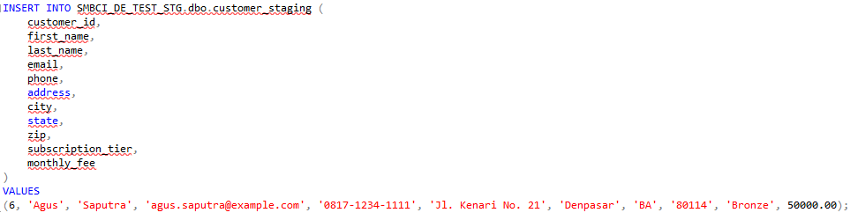

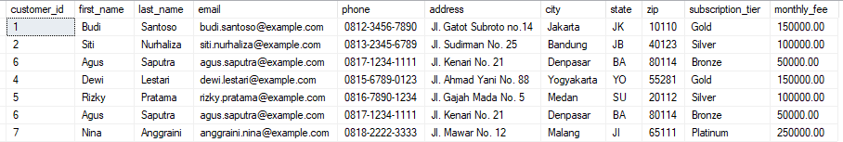

Hasil Error

