SEO Master System v7.4
Team Operations Manual
Search Policy, Ranking-Risk Prevention, Humanization, and Recovery Governance
Release: 7.4-search-policy-ranking-risk | Validated: August 6, 2026
This manual is operational guidance. It does not promise rankings or replace legal, medical, financial, security, or regulatory review.

1. What Changed in v7.4
- Added Module 10 as a mandatory search-policy and ranking-risk governance layer.
- Expanded coverage beyond content quality to links, structured data, technical eligibility, migrations, security, site reputation abuse, affiliate thinness, UGC spam, and recovery.
- Integrated automatic routing across Full/Lite and Flat/Modular editions.
- Kept Module 09 direct-audit-first: detector reports remain optional and non-authoritative.
- Added a mandatory pre-PASS compliance matrix and explicit NOT TESTED publication controls.
- Added cross-engine controls for Google, Bing Webmaster Tools, IndexNow, and AI-search visibility.

2. Project Installation

Layer 1 - Project Instructions
Paste PROJECT_INSTRUCTION_FULL_FLAT_v7.4.md once into the ChatGPT Project Instructions field. It is 4,197 characters, below the 8,000-character limit.

Layer 2 - Project Sources
Upload once | Do not mix
Controller, canonical context, Modules 01-10, START_HERE, README, triggered references | Full and Lite controllers
One Flat package for manual ChatGPT use | Flat and Modular duplicates
One Modular package for repositories/agents | Legacy v6/v7.1/v7.3 controller copies

Layer 3 - Task Chat
Attach current client evidence only: drafts, URLs, approved claims, brand rules, crawl data, Search Console exports, analytics, backlinks, implementation evidence, or optional detector reports.

3. Automatic Module Routing
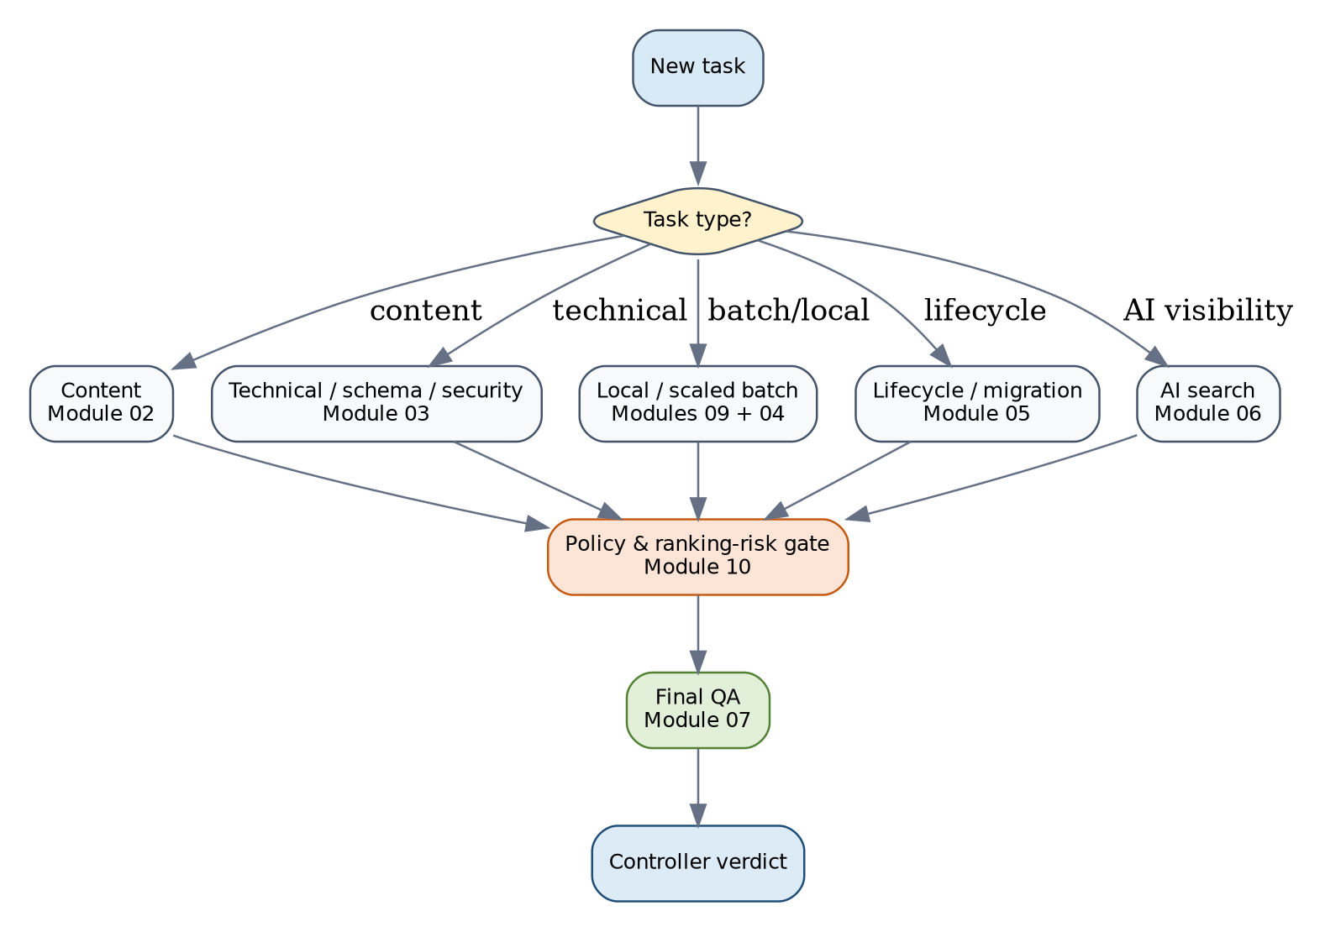
Task | Automatic route
New article | Controller -> Context -> Module 01 if needed -> Module 02 -> Module 10 -> Module 08 if relevant -> Module 07
Related content batch | Controller -> Context -> Module 01 -> Module 02 -> Module 09 Mode B -> Module 04 -> Module 10 -> Module 07
Technical/schema/security | Controller -> Context -> Module 03 -> Module 10 -> Module 07
Migration or recovery | Controller -> Context -> Module 05 -> Module 03 -> Module 10 -> Module 07
AI-search visibility | Controller -> Context -> Module 06 -> Module 10 when policy/eligibility applies -> Module 07

4. Module 09: Automatic Humanization and Batch Audit
Mode | When it activates | Team requirement
A | One content asset | Attach the asset and task. No detector required.
B | Three or more related drafts, or a meaningful shared-template batch | Attach all related pages in one task. The system compares them against one another.
C | External detector report supplied | Provide tool, date/version when known, exact tested scope, and result.
Combined | Direct audit plus supplied detector evidence | The direct audit controls the editorial decision; detector authorship remains NOT TESTED.

The team does not need to type “Run Module 09 Mode B” when the batch trigger is clear.

5. Module 10: Automatic Policy and Ranking-Risk Gate
Module 10 activates automatically for publication/indexation, scaled/local pages, links, affiliate or review content, third-party hosted sections, structured data, migrations, redirects, expired domains, ranking drops, security issues, manual actions, recovery, and policy-compliance work.
Control family | Examples
Spam policies | Cloaking, doorway, scaled-content abuse, site reputation abuse, scraping, keyword stuffing, link spam, sneaky redirects, thin affiliation, UGC spam, policy circumvention
People-first quality | Audience, task completion, original value, Who/How/Why, trust, YMYL, freshness integrity, review methodology
Technical eligibility | Crawl, index, canonical, robots, status, rendering, mobile parity, sitemaps, hreflang, security, Core Web Vitals
Structured data | Visible-content match, accurate properties, feature rules, testing, no fabricated ratings or entities
Cross-engine | Google Search Console, Bing Webmaster Tools, IndexNow, AI-search citation readiness
Recovery | Root-cause correction, owners, deployment evidence, monitoring, retests, no outcome guarantees

6. Standard Task Requests
Scenario | Ready-to-copy request
Single article | Review this article for publication. Select the route, preserve approved facts, mark gaps, run policy checks, and return QA verdict.
Related batch | Review this batch for publication. Run cross-page similarity, local/scaled review, policy governance, and final QA.
Technical audit | Audit crawl, render, Search Console, index eligibility, canonicals, robots, redirects, schema, security, and page experience. Mark untested items.
Ranking decline | Separate tracking, demand, technical, migration, content, policy, link, and SERP causes. Do not call it a penalty without evidence.

7. Ranking-Drop and Penalty Triage
A manual action or security action can be directly verified. An algorithmic cause is normally INFERRED unless stronger evidence exists. Timing correlation with an update is not proof of causation.

8. Evidence and Approval Requirements
Evidence | Owner
URLs, intended indexation, page purpose, audience | Project Owner / SEO Lead
Approved services, locations, claims, credentials, prices, limitations | Client / Project Owner
Authors, expert reviewers, sources, first-party proof | Content Lead
Crawl, render, status, canonical, robots, sitemap, schema tests | Developer / Technical SEO
Search Console manual actions, security, indexing, performance | SEO Lead
Backlinks, sponsorships, guest posts, affiliate relationships | SEO Lead / Legal
Medical/legal/financial approval where applicable | Qualified Reviewer

9. Publication Blockers
- An active critical policy or security risk remains.
- A material applicable category is NOT TESTED without an explicit block or condition.
- Fabricated evidence, identity, experience, review, location, or claim is present.
- A batch lacks distinct page purpose and information gain.
- Structured data does not match visible content.
- High-impact technical indexation state is unknown.
- YMYL review or essential qualifiers are missing.
- Owners, implementation evidence, and retests are undefined.

10. Team Roles
Role | Responsibility
Project Owner | Business purpose, scope, evidence access, approvals, publication decision
SEO Lead | Routing review, search evidence, risk register, monitoring
Content Lead | Accuracy, originality, authorship, sources, revisions
Developer | Technical implementation and test evidence
Qualified Reviewer | Regulated claims and limitations
QA Reviewer | Independent Module 07 and Module 10 gate verification

11. Final Run Checklist
☐ One edition and one controller only
☐ Project instruction installed once
☐ Modules 01-10 available
☐ Current client evidence attached
☐ Route stated before execution
☐ Evidence states applied
☐ Module 09 run when triggered
☐ Module 10 run when triggered
☐ Technical claims tested, not assumed
☐ No ranking/recovery guarantees
☐ Module 07 complete
☐ Controller verdict supported

12. Package Files for the Team
- PROJECT_INSTRUCTION_FULL_FLAT_v7.4.md - paste once into ChatGPT Project Instructions.
- TEAM_OPERATIONS_MANUAL_v7.4.md - source manual for repositories and internal editing.
- TEAM_OPERATIONS_MANUAL_v7.4.docx / PDF - distribution and training copies.
- MODULE_10_SEARCH_POLICY_AND_RANKING_RISK_GOVERNANCE.md - active Flat module.
- modules/10_SEARCH_POLICY_AND_RANKING_RISK_GOVERNANCE.md - active Modular module.
- OFFICIAL_POLICY_SOURCE_REGISTER_v7.4.md - official-source baseline and maintenance trigger.
- PACKAGE_VALIDATION_v7.4.json - machine-readable release evidence; do not use as a routine execution source.

