Creating an Azure DevOps Account
- Be sure to log out of all Browsers.
- Navigate to https://azure.microsoft.com/en-us/free/students/ and Push Start Free. Be sure to log in with your school account.
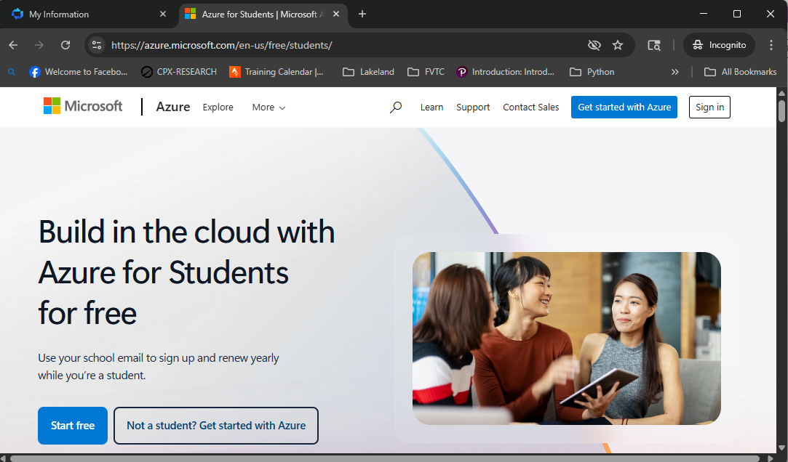

- Click on Azure for Students.
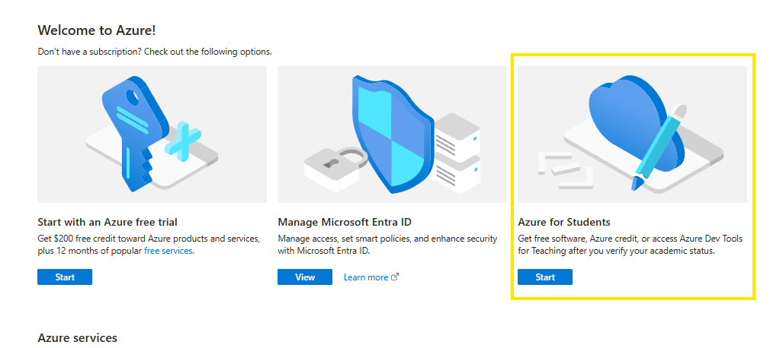

Then put in your profile information and hit Verify Academic Status. 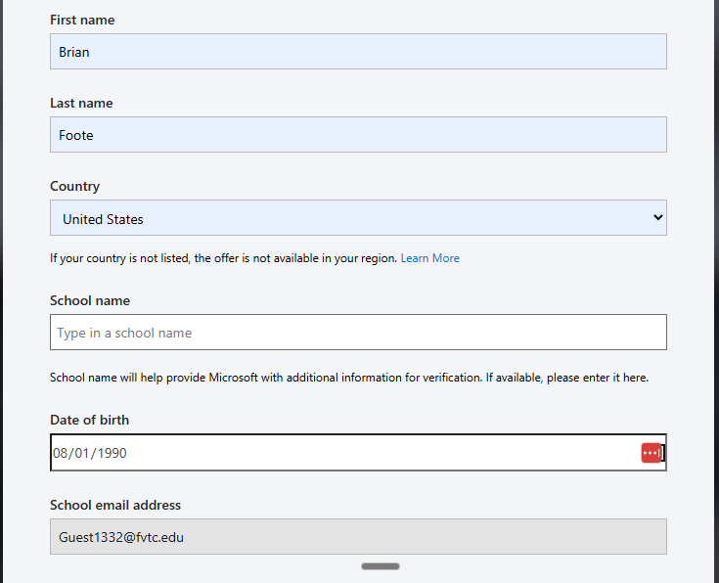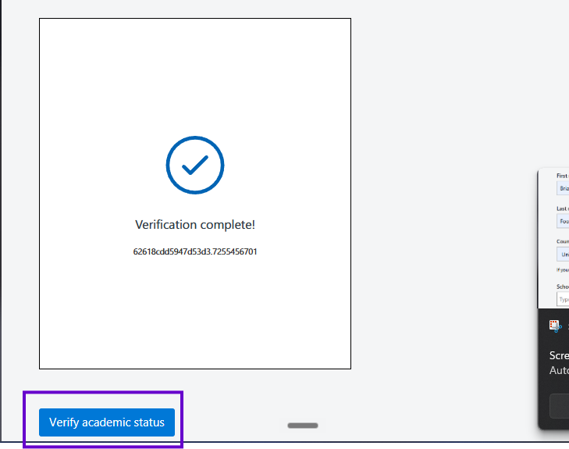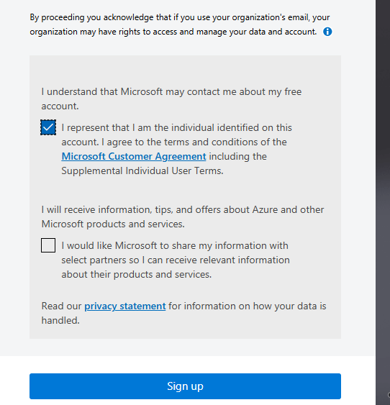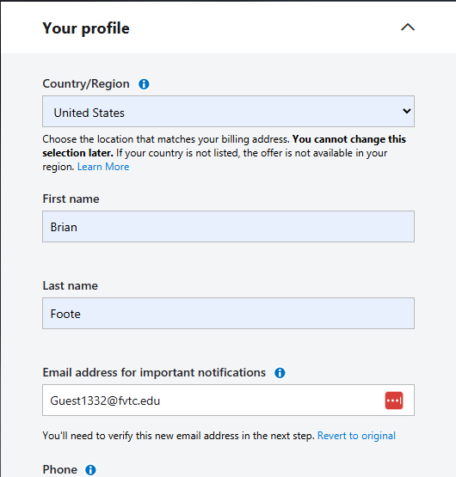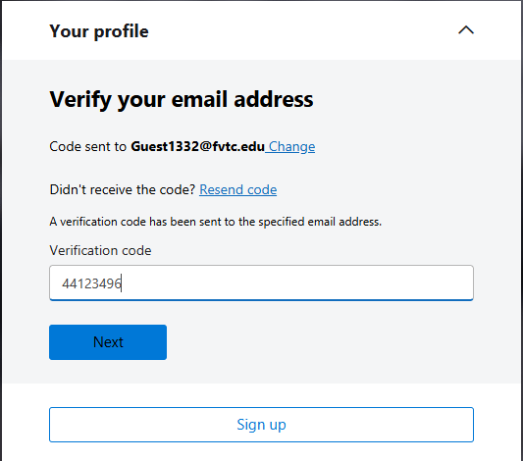
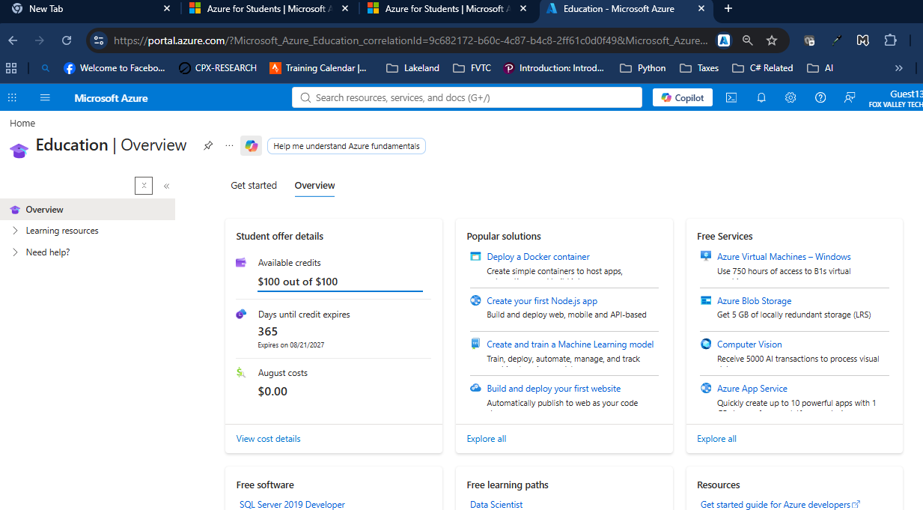

- Once the Azure subscription is created, you can then create the DevOps organization at https://aex.dev.azure.com 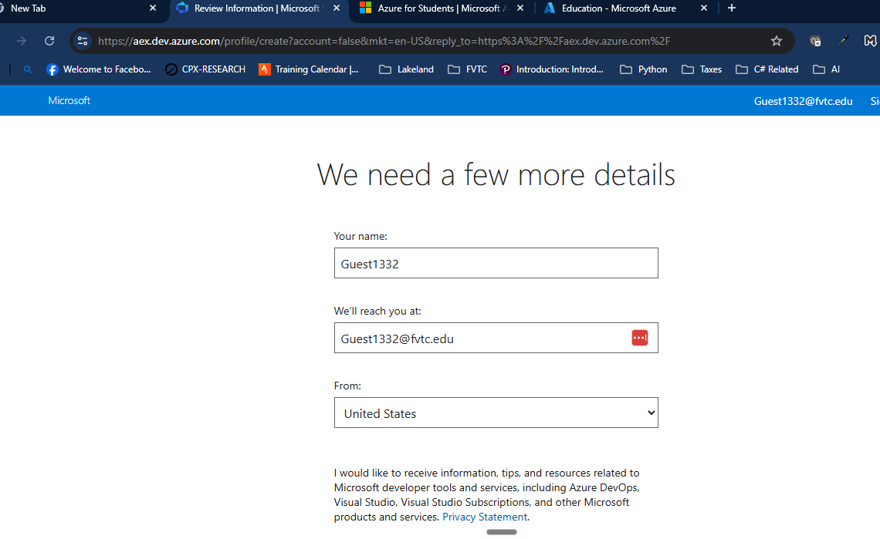
- Add more contact information if need be.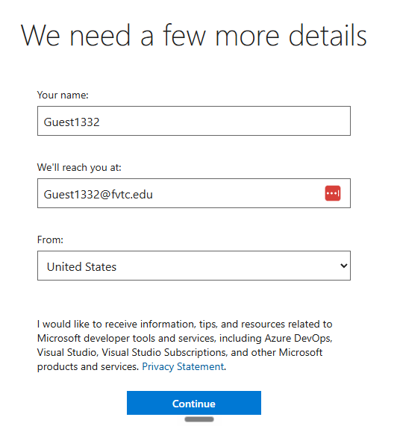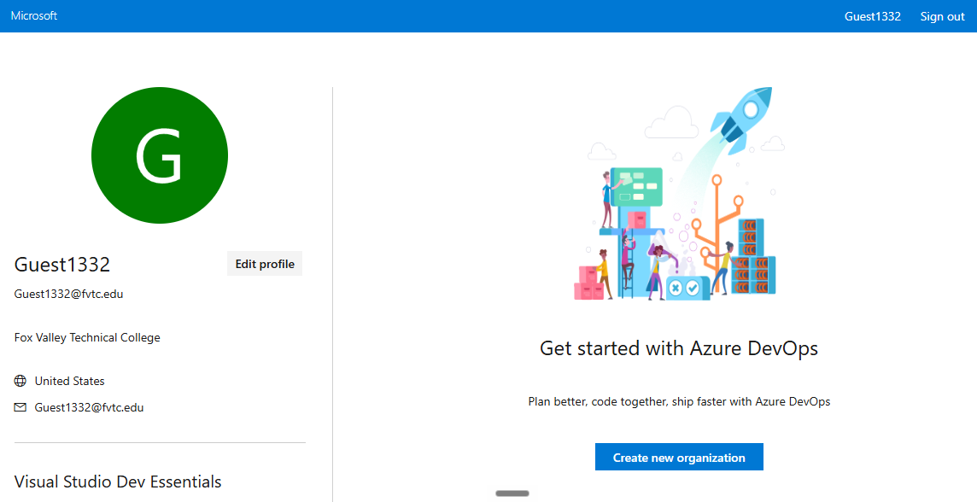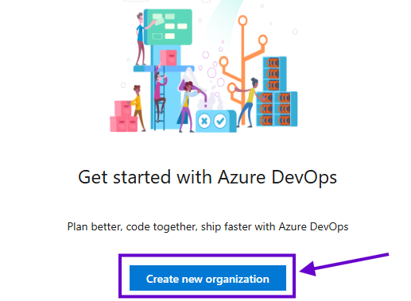

- Then you can continue with the organization creation process.
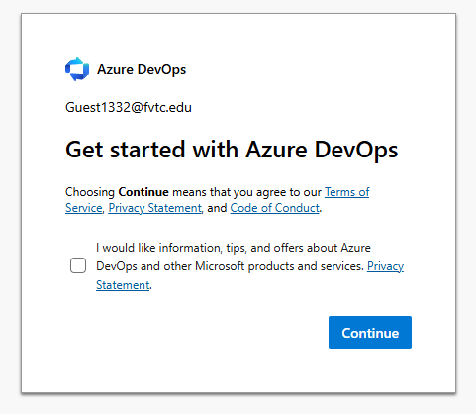

- You can leave the default values. The newly created subscription should automatically be selected now.
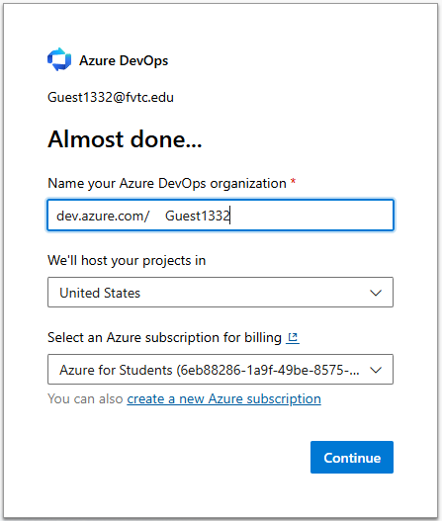
- Then you be in DevOps and be sure to create a project. 