# 



Immersion Day

S3 Hands-On Lab

Getting Started with Simple Storage Service

# Amazon S3 Overview

Amazon Simple Storage Service (S3) provides a simple web services interface that can be used to store and retrieve any amount of data, at any time, from anywhere on the web. This lab is designed to demonstrate how to interact with S3 to store, view, move and delete objects.

This lab will walk you through the following:

* Creating a bucket in S3
* Adding an object to the S3 bucket
* View the object in S3
* Move the object in S3
* Enable bucket versioning
* Delete the object and the bucket in S3

# Create a Bucket in S3

Every object in Amazon S3 is stored in a bucket. Before you can store data in Amazon S3 you must create a bucket.

***Note:*** *You are not charged for creating a bucket; you are only charged for storing objects in the bucket and for transferring objects in and out of the bucket.*

1. Sign into the AWS Management Console and open the Amazon S3 console at <https://console.aws.amazon.com/s3>.
2. Click **Create Bucket**. The **Create a Bucket** dialog box appears.

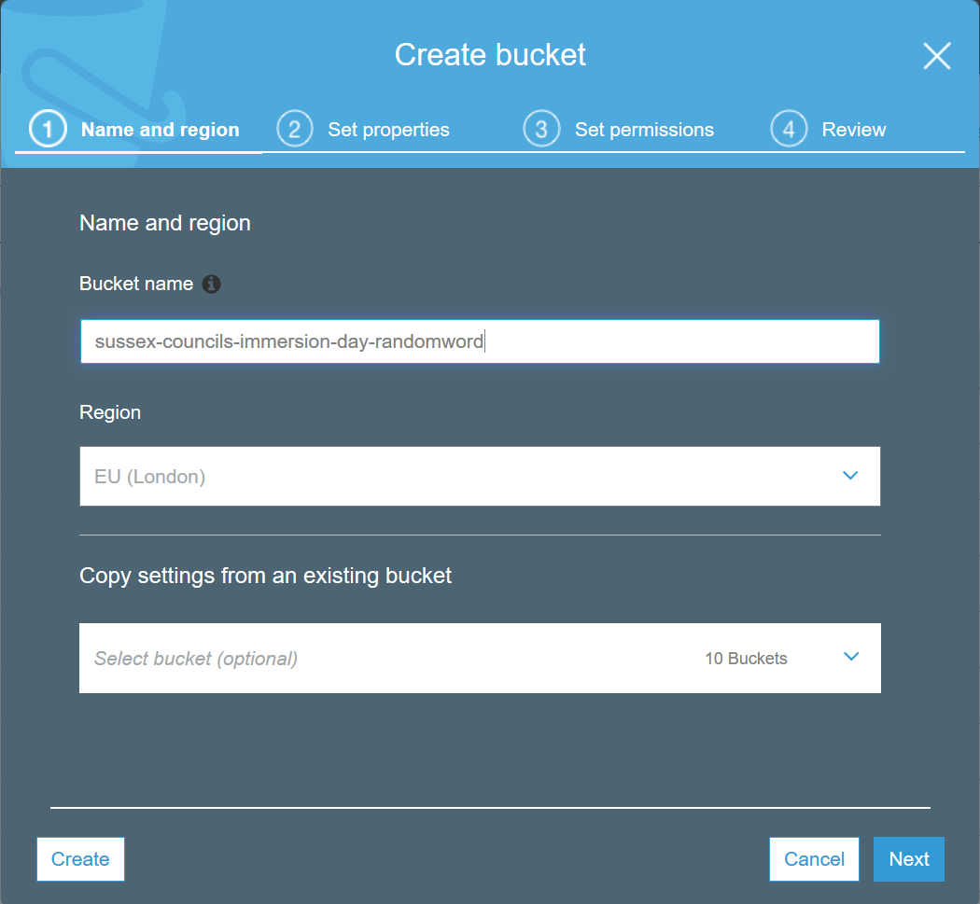

1. Enter a bucket name in the **Bucket Name** field. The bucket name you choose must be unique across all existing bucket names in Amazon S3. One way to do that is to prefix your bucket names with your organisation's name.

Bucket names must comply with the following requirements.

Bucket names:

* Can contain lowercase letters, numbers, periods (.) and dashes (-)
* Must start with a number or letter
* Must be between 3 and 255 characters long
* Must not be formatted as an IP address (e.g., 265.255.5.4)

***Note:*** *There might be additional restrictions on bucket names based on the region your bucket is in or how you intend to access the object. Once you create a bucket, you cannot change its name. In addition, the bucket name is visible in the URL that points to the objects stored in the bucket. Make sure the bucket name you choose is appropriate.*

1. In the **Region** drop-down list box, select a region. Click **Next**.
2. Under **Tags**, in the **Key** box, type **Purpose**, and in the **Value** box, enter **Immersion Day**.
3. Have a good look at the other options, but leave them as default for this lab. Click **Next** twice.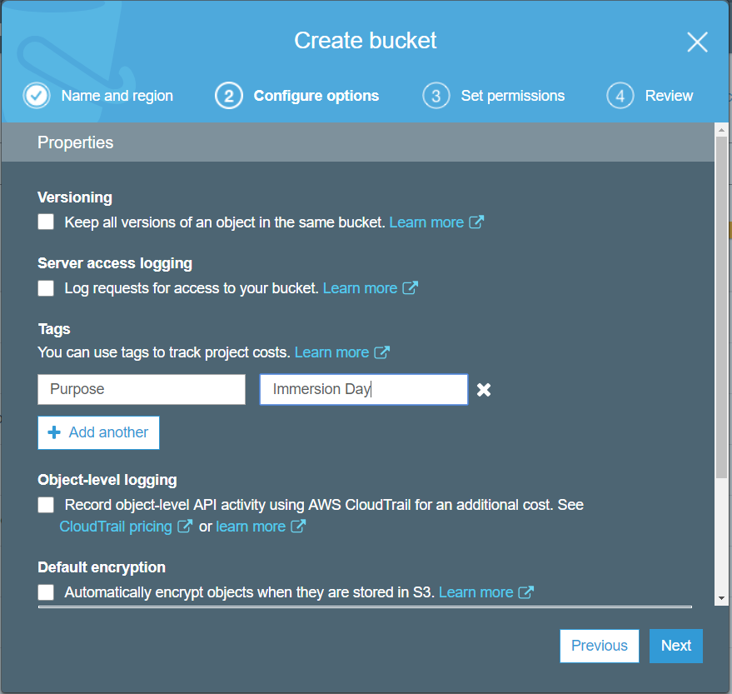
4. Finally, review your settings and click **Create bucket**. When Amazon S3 successfully creates your bucket, the console displays your empty bucket in the **Buckets** panel.

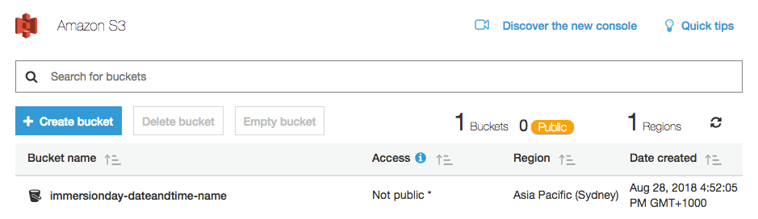

**Well done - you've created your first bucket in Amazon S3!**

# Add an Object to a Bucket

Now that you've created a bucket, you're ready to add an object to it. An object can be any kind of file: a text file, a photo, a video and so forth. When you add a file to Amazon S3, you have the option of including metadata with the file and setting permissions to control access to the file.

1. In the Amazon S3 console, click the on the name of the bucket to which you want to upload an object (not the bucket icon itself, though), and then click **Upload** in the **Objects** tab. The **Upload** dialogue opens (its appearance may differ slightly between different browsers).
2. Click **Add Files** to select a file to upload. A file selection dialog box opens.
3. Select a small file to upload and click **Open**. The **Upload** dialogue shows the files and folders you've selected to upload.
4. Click **Upload**. You can watch the progress of the upload at the bottom of the screen. This appears as soon as the upload begins.

**Good work - you've added a file to your bucket!**

# View an Object

Now that you've added an object to a bucket, you can open and view it in a browser.

1. In the Amazon S3 console, click the on the name of the object you want to open.

***Note****: By default, your Amazon S3 buckets and objects are private. To view an object using a URL, for example, https://s3.amazonaws.com/Bucket/Object the object must be publicly readable. Otherwise, you will need to create signed URL that includes a signature with authentication information. You can optionally save the object locally.*

1. Click on the **Permissions** tab. In the **Manage public permissions** section, click the radio button next to **Everyone**. In the Everyone dialogue, under the **Object access** section, tick the **Read** box, and then click **Save.**

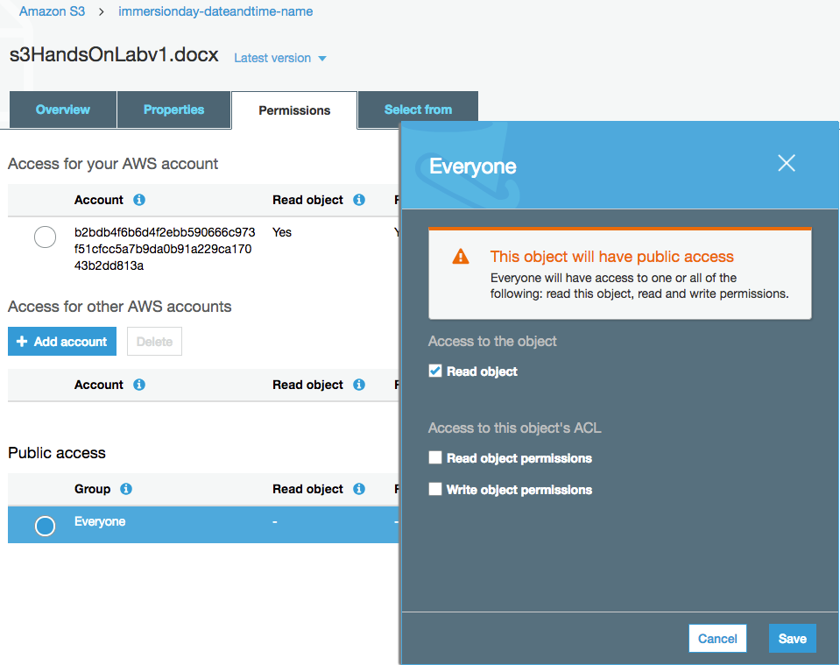

1. Click on the **Overview** tab, and then click on the link to your object at the bottom of the screen to view the file using your browser.

**Good job - you've retrieved your object from S3 via the web!**

# Move an Object

Now that you've added an object to a bucket and viewed it, you might like to move the object to a different bucket or folder.

1. In the Amazon S3 console, create a new bucket (reference earlier section for details).
2. Select the first bucket you created and view the list of objects.
3. Select the object(s) you want to move by clicking the selection box to their left. You can ignore the info box that opens when you select an object.
4. Once you’ve selected your files, click on the **More** button, and then click **Cut**.
5. Navigate to the target bucket (and folder, if applicable) to which you want to move the object, click the **More** button and then click **Paste**. At the **Cut and paste** review dialogue, confirm the action by clicking **Paste**.

***Note****: When you move an object across buckets the previously set object permissions will persist by default.*

**Congratulations - you have now moved an object between buckets.**

# Enable Bucket Versioning

If you want to add new version of the object to the same bucket but want to retain the old version, you can turn on bucket versioning.

1. In the S3 Console, click on the link representing the bucket you created, and then select the **Properties** tab.

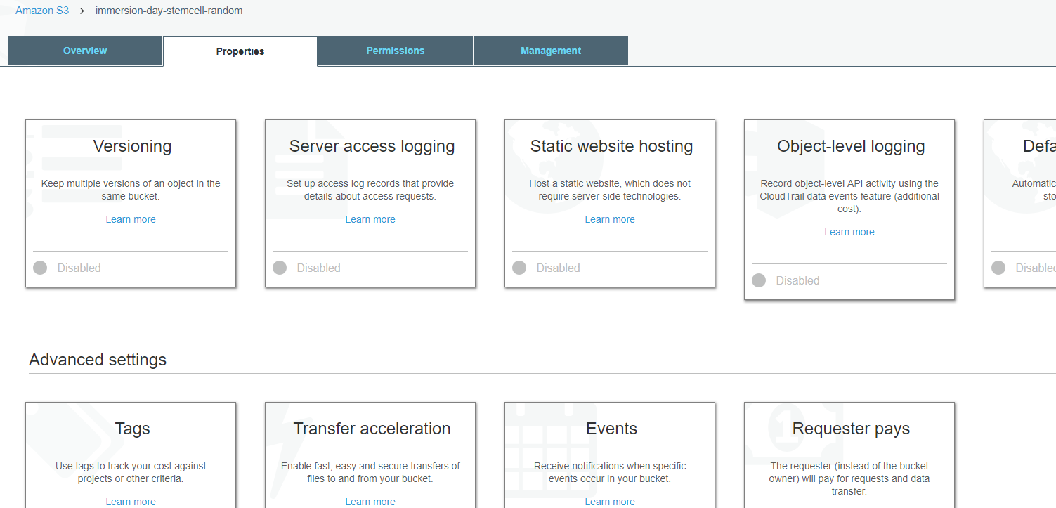

1. Click on the **Versioning** tile, select the **Enable versioning** radio button, and then click **Save**.
2. Choose an object that you are able to edit on your computer, and upload it using the steps from the **Add an Object to a Bucket** section above.
3. Now open the original file on your computer and edit it, saving the updated version under the **same file name**.
4. Upload this updated file to the S3 bucket in the same way as before.
5. Now click on the object’s link in the S3 bucket and click on the words **Latest version** (to the right of the object’s name).

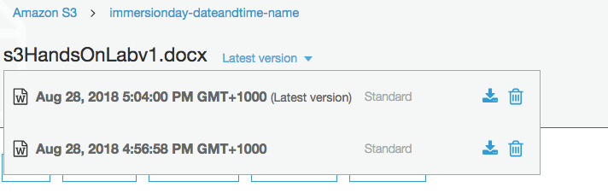

This shows the different versions of the object in the bucket. You can click on the **download** icon and view the different versions of the object.

# Delete an Object and Bucket

You’ve added an object to a bucket, viewed it, and moved it. Now, you can delete it and the bucket it's in.

If you no longer need to store the objects you uploaded and moved while going through this guide, you should delete them so you do not incur further charges on those objects.

1. In the Amazon S3 console, click on the link representing the bucket containing the object(s) you want to delete. Then select the object(s).
2. Click the **More** button, followed by **Delete**. To confirm the action in the **Delete objects** dialogue, click **Delete**.
3. Navigate back to the S3 console and select the bucket icon of the bucket you want to delete (not the link to its right), and at the top of the page, click **Delete bucket**. Confirm the deletion by typing its name verbatim at the **Delete bucket** prompt.

**Well done, your bucket is now deleted!**

# Conclusion

In this lab you have learned the basic operations to manage the lifecycle of an S3 object. First, you created a bucket, which is the logical container of objects. Then by uploading, viewing, moving an object, and enabling versioning, you learned the basic operations of the object itself. Finally, you learned how to delete both an object and a bucket.

You should continue exploring more features of S3!

* *Did you know you can host a website entirely on S3?*
* *Did you know you can define automated lifecycle policies?*
* *How about fine-grained access control with Bucket Policy?*