Miscellaneous topics

Calibration of models:

We will find the probability values of the test point, that belongs to each class or the other.
Calibration returns the actual probability of the test point

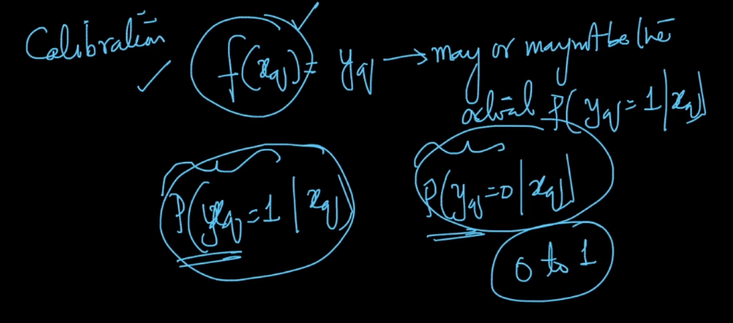
Why do we need Calibration ?
To interpret the probability values of the test data point that belongs to the Class.

Calibration Plots:
Step -1: Construct the data set:
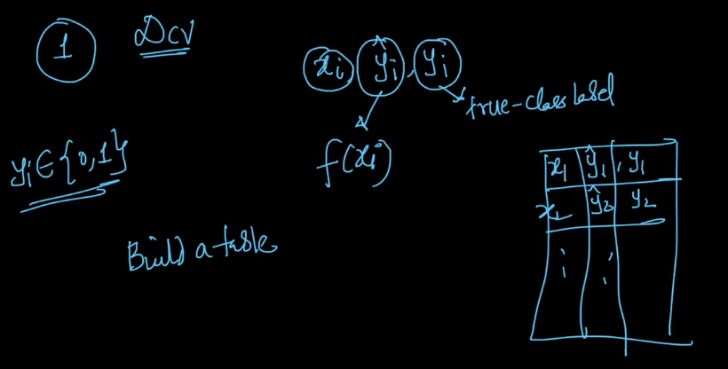
Step -2:
Sort this table in increasing order of Yi^.

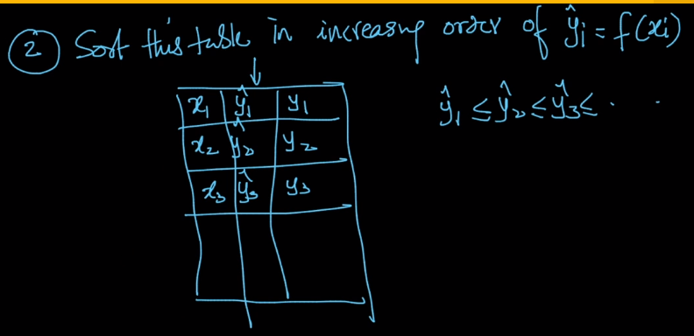
Step – 3:
Break the table into chunks of size ‘m’. In each Chunk we will compute the avg(yi^) and avg(yi).
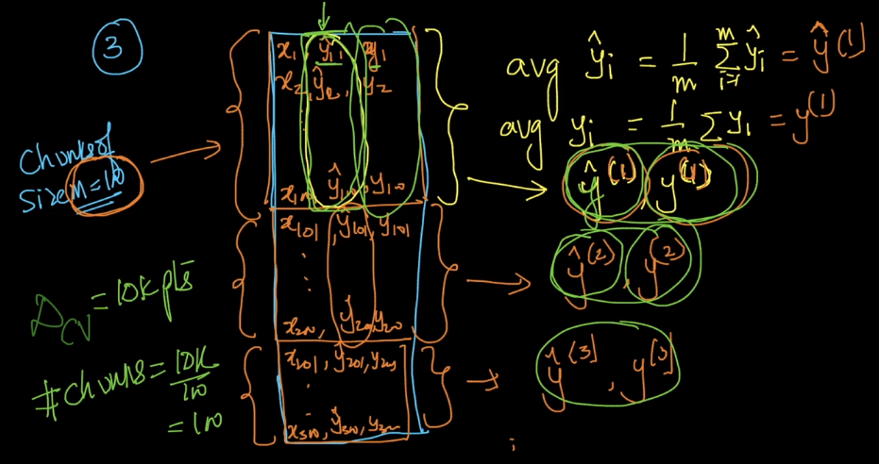

Now, the data for calibration.

Calibration Plots:
In case of 100% correct classification, there will be a 45 degree line between the Yi and Yi^’s.

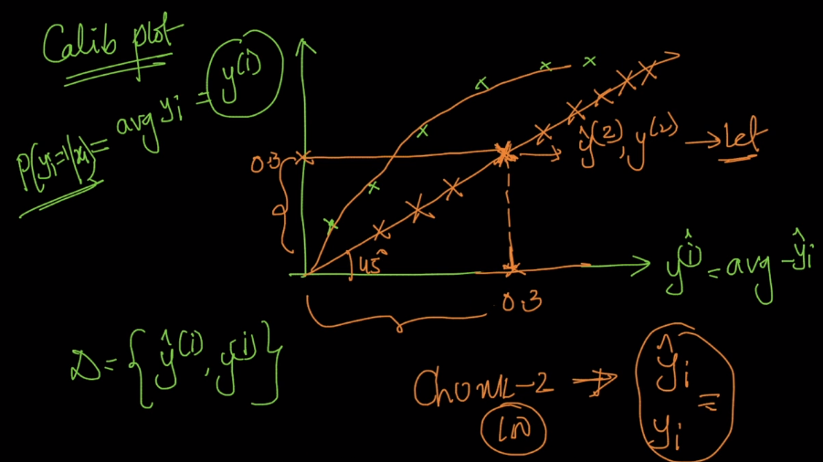
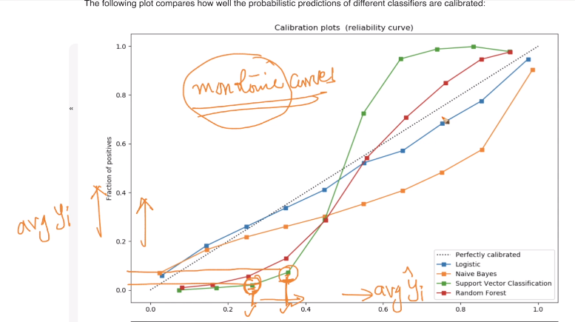

Platt’s calibration and scaling: Works only when the line is sigmoidial shape.

So we use Isotonic Calibration to solve this problem.

