Case Project 1

library(tidyverse)  
library(tidymodels)  
library(GGally)  
library(MASS)  
library(esquisse)  
library(ggcorrplot)  
library(gridExtra)

am = read_csv("ames_student.csv")

str(am)  
summary(am)

am = am %>% mutate_if(is.character,as_factor)  
str(am)  
summary(am)

ggplot(am) +  
 aes(x = Above_Median, y = Year_Built) +  
 geom_boxplot(fill = "#EF562D") +  
 labs(x = "Above Median (Yes/No)",   
 y = "Year built", title = "Year House was Built") +  
 theme_minimal()

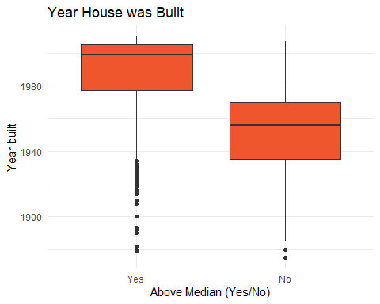

ggplot(am) +  
 aes(x = MS_Zoning, fill = Above_Median) +  
 geom_bar(position = "dodge") +  
 scale_fill_hue(direction = 1) +  
 theme_minimal()

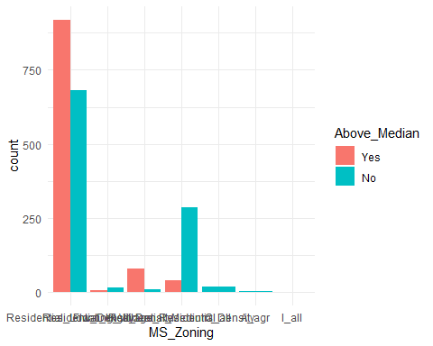

ggplot(am) +  
 aes(x = Above_Median) +  
 geom_bar(position = "dodge", fill = "#112446") +  
 labs(title = "Neighorhood") +  
 theme_minimal() +  
 facet_wrap(vars(Neighborhood))

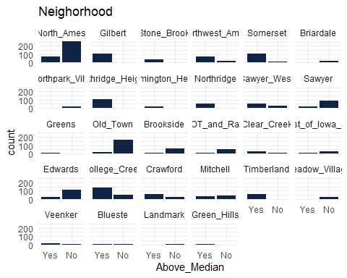

ggplot(am) +  
 aes(x = Above_Median) +  
 geom_bar(fill = "#112446") +  
 labs(title = "Housing Style") +  
 theme_minimal() +  
 facet_wrap(vars(House_Style))

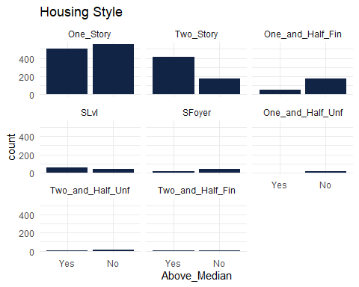

ggplot(am) +  
 aes(x = Above_Median, group = Year_Built) +  
 geom_bar(position = "dodge", fill = "#112446") +  
 labs(title = "Year built") +  
 theme_minimal()

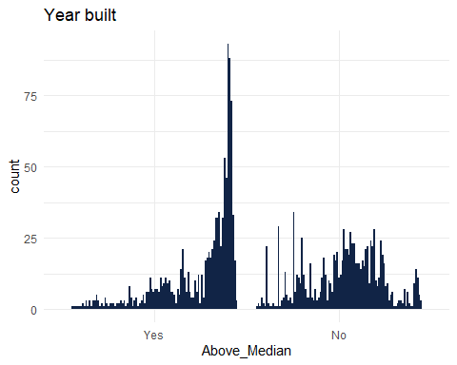

ggplot(am) +  
 aes(x = Above_Median, fill = Exterior_1st) +  
 geom_bar(position = "dodge") +  
 scale_fill_hue(direction = 1) +  
 labs(title = "Exterior Siding") +  
 theme_minimal()

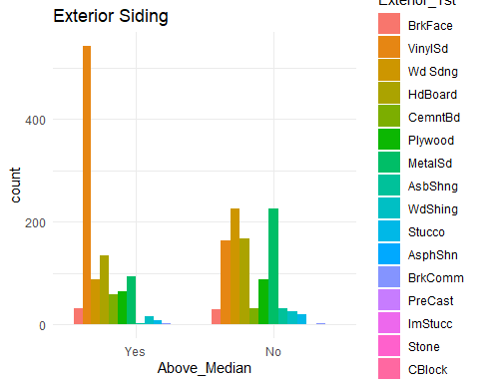

ggplot(am) +  
 aes(x = Above_Median, y = Mas_Vnr_Area) +  
 geom_boxplot(fill = "#112446") +  
 labs(title = "Mas_Vnr_Area") +  
 theme_minimal()

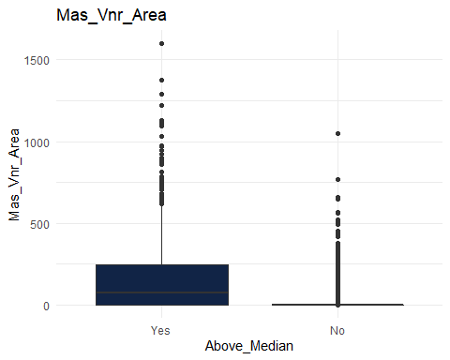

##esquisser()

ggpairs(am, columns = c(81,2:3,19:20,26,34))

## `stat_bin()` using `bins = 30`. Pick better value with `binwidth`.  
## `stat_bin()` using `bins = 30`. Pick better value with `binwidth`.  
## `stat_bin()` using `bins = 30`. Pick better value with `binwidth`.  
## `stat_bin()` using `bins = 30`. Pick better value with `binwidth`.  
## `stat_bin()` using `bins = 30`. Pick better value with `binwidth`.  
## `stat_bin()` using `bins = 30`. Pick better value with `binwidth`.  
## `stat_bin()` using `bins = 30`. Pick better value with `binwidth`.  
## `stat_bin()` using `bins = 30`. Pick better value with `binwidth`.  
## `stat_bin()` using `bins = 30`. Pick better value with `binwidth`.  
## `stat_bin()` using `bins = 30`. Pick better value with `binwidth`.

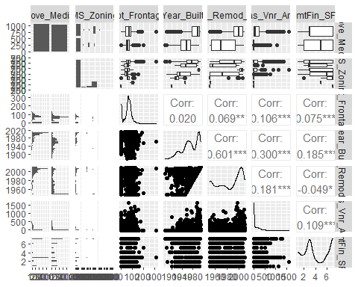

ggpairs(am, columns = c(81,36:38,43:45))

## `stat_bin()` using `bins = 30`. Pick better value with `binwidth`.  
## `stat_bin()` using `bins = 30`. Pick better value with `binwidth`.  
## `stat_bin()` using `bins = 30`. Pick better value with `binwidth`.  
## `stat_bin()` using `bins = 30`. Pick better value with `binwidth`.  
## `stat_bin()` using `bins = 30`. Pick better value with `binwidth`.  
## `stat_bin()` using `bins = 30`. Pick better value with `binwidth`.

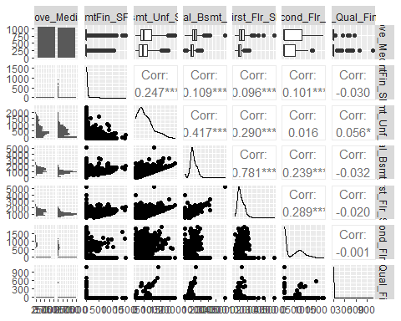

ggpairs(am, columns = c(81,46:52))

## `stat_bin()` using `bins = 30`. Pick better value with `binwidth`.  
## `stat_bin()` using `bins = 30`. Pick better value with `binwidth`.  
## `stat_bin()` using `bins = 30`. Pick better value with `binwidth`.  
## `stat_bin()` using `bins = 30`. Pick better value with `binwidth`.  
## `stat_bin()` using `bins = 30`. Pick better value with `binwidth`.  
## `stat_bin()` using `bins = 30`. Pick better value with `binwidth`.  
## `stat_bin()` using `bins = 30`. Pick better value with `binwidth`.

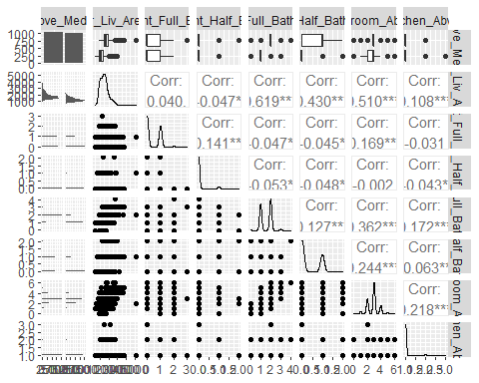

ggpairs(am, columns = c(81,54,56,60:61,65:67))

## `stat_bin()` using `bins = 30`. Pick better value with `binwidth`.  
## `stat_bin()` using `bins = 30`. Pick better value with `binwidth`.  
## `stat_bin()` using `bins = 30`. Pick better value with `binwidth`.  
## `stat_bin()` using `bins = 30`. Pick better value with `binwidth`.  
## `stat_bin()` using `bins = 30`. Pick better value with `binwidth`.  
## `stat_bin()` using `bins = 30`. Pick better value with `binwidth`.  
## `stat_bin()` using `bins = 30`. Pick better value with `binwidth`.

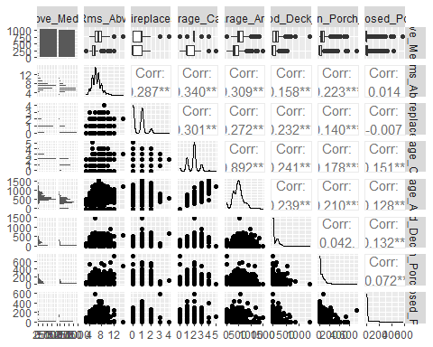

ggpairs(am, columns = c(81,67:70, 74:76, 79:80))

## `stat_bin()` using `bins = 30`. Pick better value with `binwidth`.  
## `stat_bin()` using `bins = 30`. Pick better value with `binwidth`.  
## `stat_bin()` using `bins = 30`. Pick better value with `binwidth`.  
## `stat_bin()` using `bins = 30`. Pick better value with `binwidth`.  
## `stat_bin()` using `bins = 30`. Pick better value with `binwidth`.  
## `stat_bin()` using `bins = 30`. Pick better value with `binwidth`.  
## `stat_bin()` using `bins = 30`. Pick better value with `binwidth`.  
## `stat_bin()` using `bins = 30`. Pick better value with `binwidth`.  
## `stat_bin()` using `bins = 30`. Pick better value with `binwidth`.

