UOM Data Science – Module 22 Home Sales
Responses to questions

Robert Bentz

Q&A for module 22:

What is the average price for a four-bedroom house sold for each year?

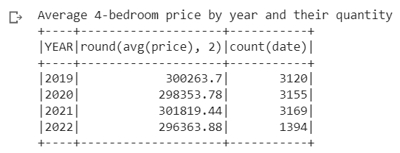

What is the average price of a home for each year it was built that has three bedrooms and three bathrooms?

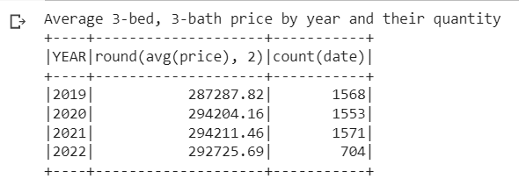

What is the average price of a home for each year that has three bedrooms, three bathrooms, two floors, and is greater than or equal to 2,000 square feet?

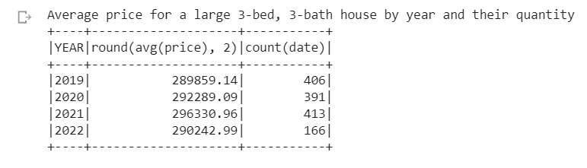

What is the "view" rating for homes costing more than or equal to $350,000? Determine the run time for this query.
Baseline query and time

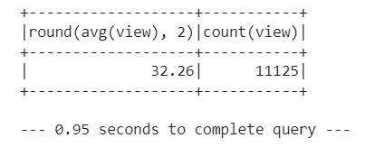
Using the cached data, run the query that filters out the view ratings with an average price of greater than or equal to $350,000. Determine the runtime and compare it to uncached runtime.
Cached query and time

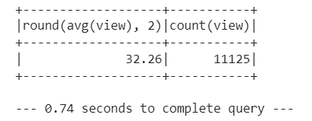

Run the query that filters out the view ratings with an average price of greater than or equal to $350,000. Determine the runtime and compare it to uncached runtime.
Parquet query and time
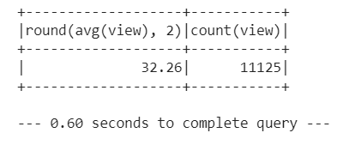

Query Type | Query Response Time
Baseline uncached query | 0.95 seconds
Cached query | 0.74 seconds
Parquet cached query | 0.60 seconds

Appears adding more processes is decreasing the query times. The amount of time saved on this small data set demonstrates the potential to save large amounts of query times with large data sets. Worth the effort to further optimize the data and systems before performing large data queries.

Additionally, the query times are not repeatable. Each time a query is run a different time is reported.

