**Cetacean Monitoring Toolkit**

**User Guide**







Contents

Convert Excel file to Point Shapefile 2

Convert Excel file to Line Shapefile 3

Create Grid 4

Split Tracks by Grid 5

Calculate Line Length 6

Calculate Survey Effort by Grid - Tracks 7

Buffer 8

Split Swathes by Polygon 9

Calculate Area 10

Calculate Survey Effort by Grid - Swathes 11

Count Species per Polygon 12

Join Points to Polygons 13

Join Polygons to Points 14

Convert Grid to Points 15

Extract Raster Values 16

Calculate Field 17

The Cetacean Monitoring Toolkit was created for Colin D. MacLeod, Ph.D., and the University of Aberdeen in the Fall/Winter of 2011 by a geospatial software development team from Idaho State University. Visit <http://gsl.geology.isu.edu/> for more information.

# Convert Excel file to Point Shapefile

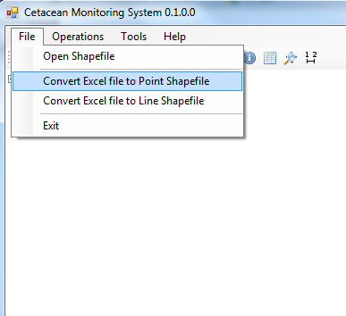

This tool aligns with the requirements of Function 1: **Plot Species Locations**. Using an excel data file it is possible to create a point data layer. This excel file should contain the at least the fields to allow creating the points. Some fields may be: Sighting ID, Latitude, Longitude, Species and Number.

This form is displayed to select the excel file.

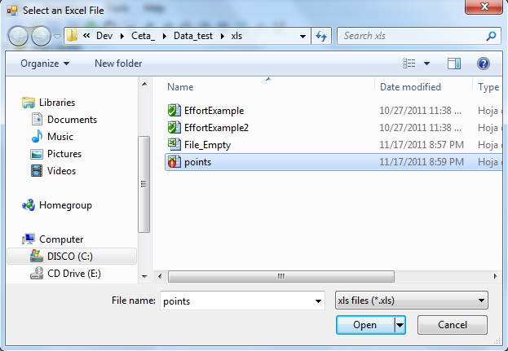❶ This form is displayed after click in the menu. We can select excel files version 97-2003

❷ A new form called Type of Field is displayed with the information of the fields contained in the excel file. The user can select a field if desires editing the type of field

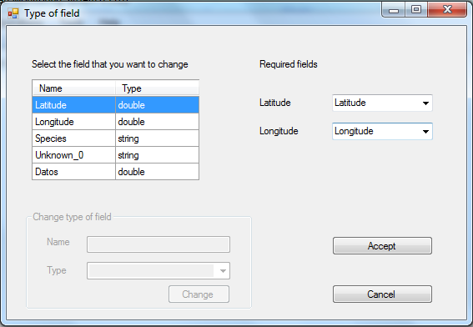❸ These options are enabled when the user select a field in the list of fields.

❹The user should select the fields that contain the geographic information (Latitude, Longitude)

❺ The Accept button only is enabled when the user has selected the Latitude and Longitude fields

# Convert Excel file to Line Shapefile

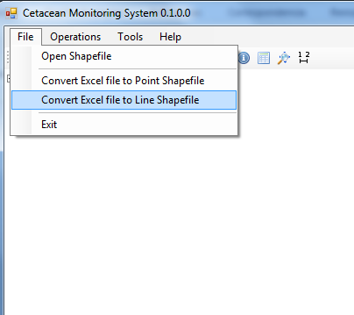

This tool aligns with the requirements of Function 2: **Plot Survey Effort Tracks**. Using an excel data file it is possible to create a line data layer. This excel file should contain the at least the fields to allow creating the points. Some fields may be: Unique Row Number, Date, BeginTime, EndTime, TimeZone, StartLat, StartLon, EndLat, EndLon, TransectID and Segment ID.



**❶** This form is displayed after click in the menu. We can select excel files version 97-2003

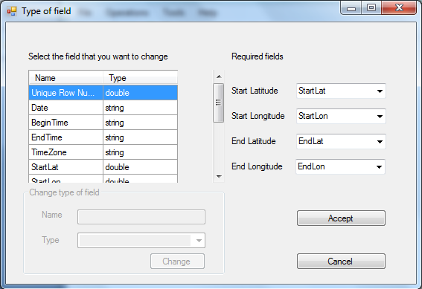❷ A new form called Type of Field is displayed with the information of the fields contained in the excel file. The user can select a field if desires editing the type of field

❸ These options are enabled when the user select a field in the list of fields.

❹The user should select the fields that contain the geographic information (Start Latitude, Start Longitude, End Latitude, End Longitude)

❺ The Accept button only is enabled when the user has selected

# Create Grid

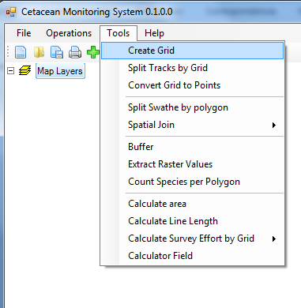

This tool aligns with the requirements of Function 3: **Create a polygon grid**. This tool is capable of creating a polygon data layer where each polygon represents a non-overlapping grid cell across a continuous surface The user needs to be able to define the height and width of each cell (so that rectangular polygons can be created) as well as the extent of the grid. It needs to be capable of creating grids in any projection and coordinate system

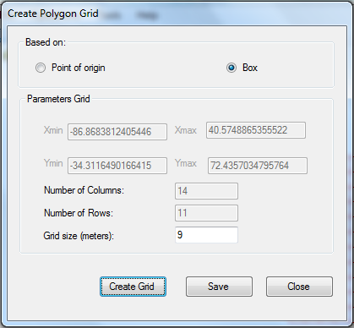**❶** This form is displayed after click in the menu.

❷ This option allows user to create a rectangle area in the map.

❸This option allows user to create a point of origin in the map.

❹This textbox show the information collected by the point of origin and box. This information is guide for the user. The user should introduce the grid size in the option Box. And, the number of columns, number of rows and grid size in the option point of origin.

❺This button create the grid.

❻ The user can save the grid as a Shapefile with this option

# Split Tracks by Grid

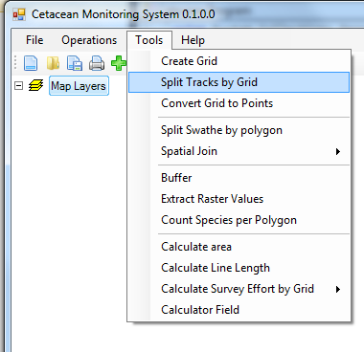

This tool aligns with the requirements of Function 4: Split Survey Tracks by Polygons. Using shapefiles loaded into the map, a polygon grid layer and a line survey track layer are selected. The survey track layer is segmented by the boundaries of each grid in the polygon layer, adding the grid information to the attribute table of the line layer. The user is given to option to name the newly created line layer in the legend and to save the line layer as a new shapefile. Additionally, the length of each line segment is calculated and added to the attribute table.

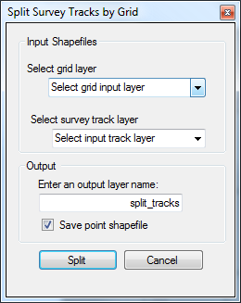

❶ Select the polygon grid layer from the dropdown list.

❷ Select the line survey track layer from the dropdown list.

❸ Enter a layer name for the segmented track line layer. If this is not changed, the layer will be named to the default of “split_tracks”

❹ The checkbox indicates whether the segmented track line data will be saved or not. If checked, a dialogue to save the new shapefile will appear when the tool is executed.

❺ Once all information is entered, click the “Split” button to continue

# Calculate Line Length

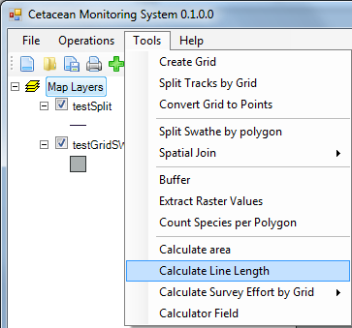

This tool aligns with requirements for Function 5: Calculate Survey Line Length. From shapefiles loaded into the map, the user selects a line layer. The tool will calculate the length of each line feature in the shapefile and add it to the attribute table in a field named by the user. The user may then save the updated attributes to the original shapefile, to a new shapefile, or just keep them temporarily in memory.

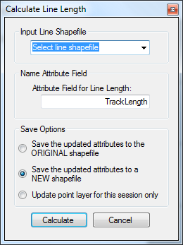

❶ Select the input line layer from the dropdown list

❷ Enter a field name to hold the length value in the line attribute table, or use the default value of “TrackLength”

❸ There are three different options for saving. If the first radio button is selected, the updated attributes will be saved to the original shapefile. This WILL overwrite the original file. The second option creates a new shapefile with the updated attributes. The original file will remain unchanged. The third option updates the attributes in memory and none of the changes will be saved once the application is closed.

❹ Once all information has been entered, click the “Calculate” button to continue

# Calculate Survey Effort by Grid - Tracks

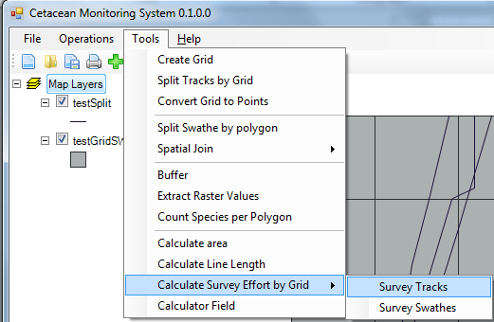

This tool aligns with the functionality of requirement 6: Calculate Survey Effort by Polygon (Survey Tracks). To implement this tool, the user selects a line layer of survey tracks and a polygon layer of the survey grid. The line layer must have been previously split and saved by the grid using the Split Tracks by Grid tool. Once executed, the Survey Effort by Grid tool will calculate the length of the line segments within each grid cell and add this information to the grid attribute table.

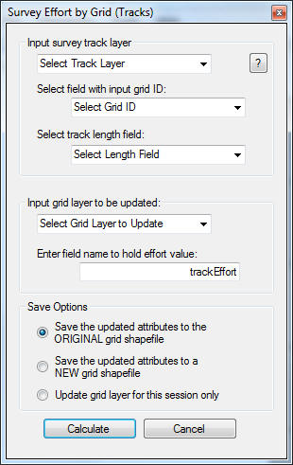

**❶** Select the input survey track line layer from the dropdown list.

❷ Select the field that contains the identification of the polygon grid cell that the line resides in.

❸ Select the field that contains the length of each line segment

❹ Select the grid polygon layer that will be updated

❺ Enter a field name to hold the survey effort value in the polygon grid attribute table

❻ There are three different options for saving. If the first radio button is selected, the updated attributes will be saved to the original shapefile. This WILL overwrite the original file. The second option creates a new shapefile with the updated attributes. The original file will remain unchanged. The third option updates the attributes in memory and none of the changes will be saved once the application is closed.

❼ Once you have entered all of the information, click on the “Calculate” button to continue.

# Buffer

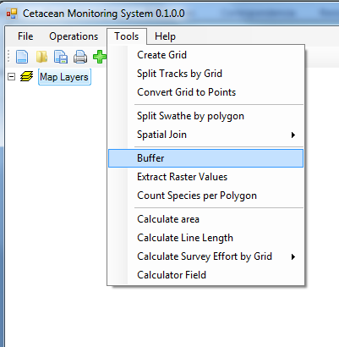

This tool aligns with the requirements of Function 7: **Create Survey Swathe**. This tool is able to create polygons around individual lines in a line data layer, with the width being determined by a value in a field in the attribute table of the line data layer. This is referred in the menu as Buffer. It is possible to calculate a buffer of a different width for the left and right hand sides of the line based the direction of travel when the line was surveyed

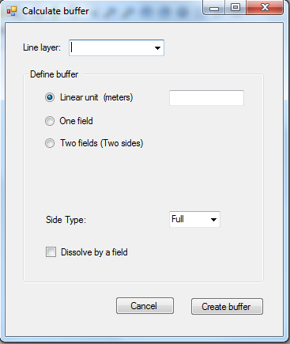

**❶** Select the line layer (This option only shows the line layers)

❷ The Buffer can be created by a linear value.

❸ The user can create a buffer using the information of a field.

❹ This option allows user to create two buffers using the information of two fields.

❺The user can create full, right or left buffer using the previous options (Linear unit and one field)

❻ This option allows dissolving the polygon created using a integer or string field.

❼Create the Buffer.

# Split Swathes by Polygon

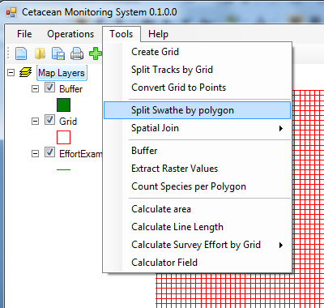

This tool aligns with the requirements of Function 8: **Split Survey Swathes by Polygons**. This tool is able to intersect polygons in one polygon data layer with polygons in a second polygon data layer so that the polygons are cut at the point where they cross the edge of a polygon. The new data layer has information from the second polygon data layer added to new polygon data

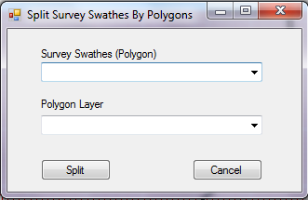

**❶** Select the first polygon layer (this layer will contain all the information of the other polygon layer

❷ Select a second polygon layer.

❸Execute the operation between both layers

# Calculate Area

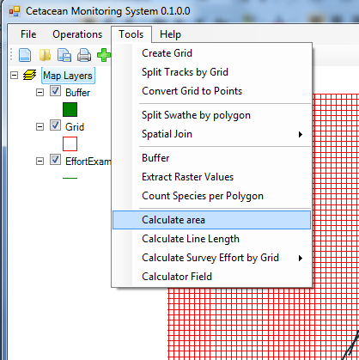

This tool aligns with the requirements of function 9: **Calculate Survey Swathe Area**: This tools needs is able to calculate the area of polygons in a polygon data layer and add this as a field called Area to the attribute table of the layer.

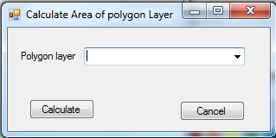

**❶** The user should select the polygon layer.

❷ The button Calculate, add a new field in the table of the polygon layer and calculate the area. If the field already exists, it is updated.

# Calculate Survey Effort by Grid - Swathes

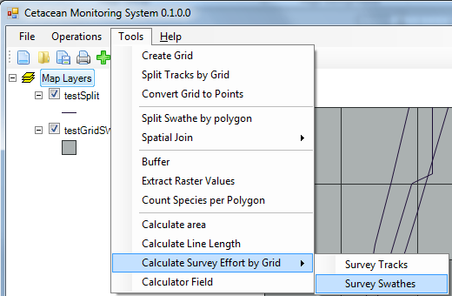This tool aligns with the functionality of requirement 10: Calculate Survey Effort by Polygon (Survey Swathes). To implement this tool, the user selects a polygon layer of survey swathes and a polygon layer of the survey grid. The swathe layer must have been previously split by the grid using the Split Swathes by Polygon tool and saved. Once executed, the Survey Effort by Grid tool will calculate the area of the swathe segments within each grid cell and add this information to the grid attribute table.

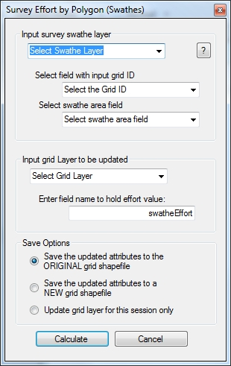

**❶** Select the input survey swathe layer from the dropdown list.

❷ Select the field that contains the identification of the polygon grid cell that the swathe resides in.

❸ Select the field that contains the area of each swathe segment

❹ Select the grid polygon layer that will be updated

❺ Enter a field name to hold the survey effort value in the polygon grid attribute table

❻ There are three different options for saving. If the first radio button is selected, the updated attributes will be saved to the original shapefile. This WILL overwrite the original file. The second option creates a new shapefile with the updated attributes. The original file will remain unchanged. The third option updates the attributes in memory and none of the changes will be saved once the application is closed.

❼ Once you have entered all of the information, click on the “Calculate” button to continue.

# Count Species per Polygon

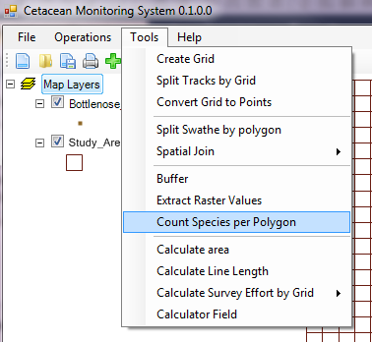

This tool aligns with the requirements of Function 11: Count Species per Polygon. Using shapefiles loaded into the map, the tool counts the number of points in a user selected point data layer which fall within individual polygon features of a user selected polygon data layer. The operation creates a new field in the polygon layer indicating the number of points within each polygon. The user also has the option of creating an additional field in the polygon layer that calculates a total for the values in a specified field.

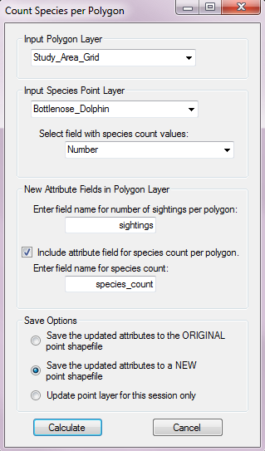

**❶** Select the polygon layer from the dropdown list.

❷ Select the point layer from the dropdown list.

❸ Choose the field within the selected point layer that holds the information about species number. This value will be used to calculate the total species within the polygons.

❹ Enter a field name for the new column that will hold the number of points within each polygon. The default is set to “sightings”.

❺ The checkbox indicates whether an additional field holding the total number of species should be added to the polygon attributes. The default state of the checkbox is “checked”.

❻ Enter a field name for the new column that will hold the number of species within each polygon. The default is set to “species_count”.

❼ There are three different options for saving. If the first radio button is selected, the updated attributes will be saved to the original shapefile. This WILL overwrite the original file. The second option creates a new shapefile with the updated attributes. The original file will remain unchanged. The third option updates the attributes in memory and none of the changes will be saved once the application is closed.

❽ Once you have entered all of the information, click on the “Calculate” button to continue.

# Join Points to Polygons

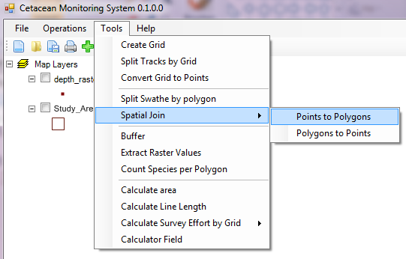

This tool aligns with the requirements of Function 12: Spatially Joins Points to Polygons. Using shapefiles loaded into the map, the tool joins the attributes of a point data layer to a polygon data layer based on their relative spatial proximities. Only one point can be linked to a single polygon, and the user has the option of selecting which attributes to join.

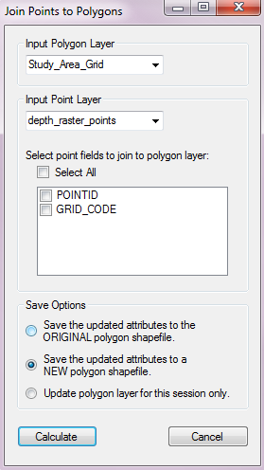

**❶** Select the polygon layer from the dropdown list.

❷ Select the point layer from the dropdown list.

❸ Once a point layer is selected in step two, a list of the attributes for that layer will be shown. Select the attributes to be joined in the operation. Checking “Select All” will join all of the attributes.

❹ There are three different options for saving. If the first radio button is selected, the updated attributes will be saved to the original shapefile. This WILL overwrite the original file. The second option creates a new shapefile with the updated attributes. The original file will remain unchanged. The third option updates the attributes in memory and none of the changes will be saved once the application is closed.

❺ Once you have entered all of the information, click on the “Calculate” button to continue.

# Join Polygons to Points

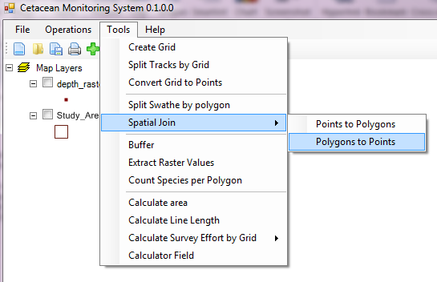

This tool aligns with the requirements of Function 13: Spatially Join Polygons to Points. Using shapefiles loaded into the map, the tool joins the attributes of a polygon data layer to a point data layer based on their relative spatial proximities. One polygon can be linked to several points, with each point assigned the attributes of the polygon layer. The user is given the option of which attributes to include in the join operation.

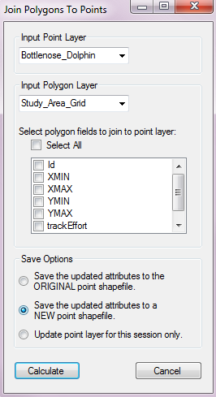

**❶** Select the point layer from the dropdown list.

❷ Select the polygon layer from the dropdown list.

❸ Once a polygon layer is selected in step two, a list of the attributes for that layer will be shown. Select the attributes to be joined in the operation. Checking “Select All” will join all of the attributes.

❹ There are three different options for saving. If the first radio button is selected, the updated attributes will be saved to the original shapefile. This WILL overwrite the original file. The second option creates a new shapefile with the updated attributes. The original file will remain unchanged. The third option updates the attributes in memory and none of the changes will be saved once the application is closed.

❺ Once you have entered all of the information, click on the “Calculate” button to continue.

# Convert Grid to Points

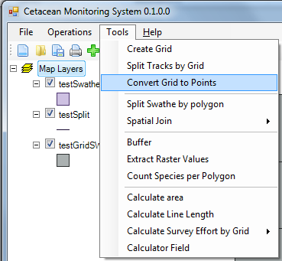This tool aligns with the functionality of requirement 14: Convert Polygon Grid to Points. This tool calculates the center of each grid cell within a polygon grid layer and exports this information as a new point shapefile. Attribute information from the grid file, selected by the user, is added to the attribute table of the new point shapefile, along with Latitude and Longitude position of the point.

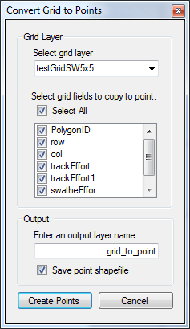

**❶** Select the input grid layer from the dropdown menu.

❷ Once a grid layer is selected in step one, a list of each field name within the grid attribute table is shown. Select which fields should be copied to the new shapefile. To copy all the fields to the new shapefile, check “Select All”.

❸ Enter a name for the point layer that will appear in the legend

❹ If checked, the new point shapefile will be saved. If unchecked, the operation will still be performed, but the new data will not be saved unless it is exported from the map.

❺ Once all information has been entered, click “Create Points” to continue.

# Extract Raster Values

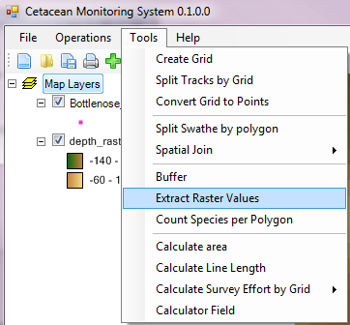

This tool aligns with the requirements of Function 15: Extract Environmental Values to Species Locations. This tool extracts the cell value from a raster data layer at each point feature in a point layer. The raster value is added to a new attribute field in the point shapefile. Values from multiple raster layers can be extracted at the same time as long as they are loaded in the map. The user also has the option of changing the default No Data value.

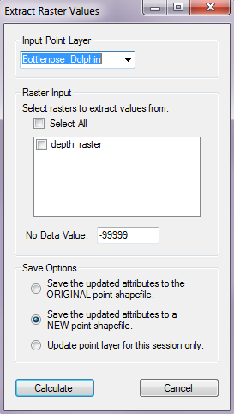

**❶** Select the point layer from the dropdown list.

❷ All raster layers that are loaded in the map will be shown in the list. Select the raster layers where values will be extracted. Multiple rasters can be selected.

❸ The default No Data value is set to -99999. This value can be changed to a custom No Data value by the user.

❹ There are three different options for saving. If the first radio button is selected, the updated attributes will be saved to the original shapefile. This WILL overwrite the original file. The second option creates a new shapefile with the updated attributes. The original file will remain unchanged. The third option updates the attributes in memory and none of the changes will be saved once the application is closed.

❺ Once you have entered all of the information, click on the “Calculate” button to continue.

# Calculate Field

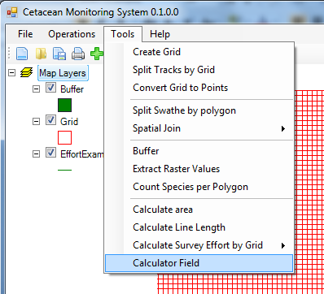This tool aligns with the requirements of function 16: **Calculate Species Per Unit Effort**: This tool is be able to add a new field to the attribute table of a data layer and calculate the value for this new field for each feature based on one or more existing numerical fields within the attribute table based on simple mathematical functions. The user is able to decide which fields and which mathematical functions are used in this calculation.

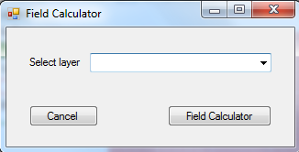

**❶** The user should select a layer.

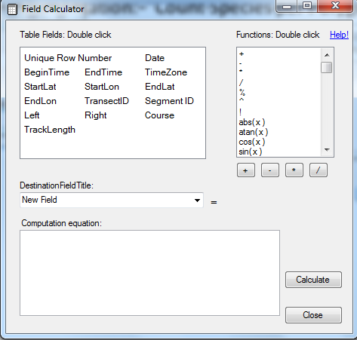

❷ This form show the list of fields available to be used by the user.

❸ List of function that can be used

❹ The result of the operation can be stored in a new field or in a field existed.

❺In this area is possible to create the operation between the fields selected by user.

❻ Execute the operations among fields.