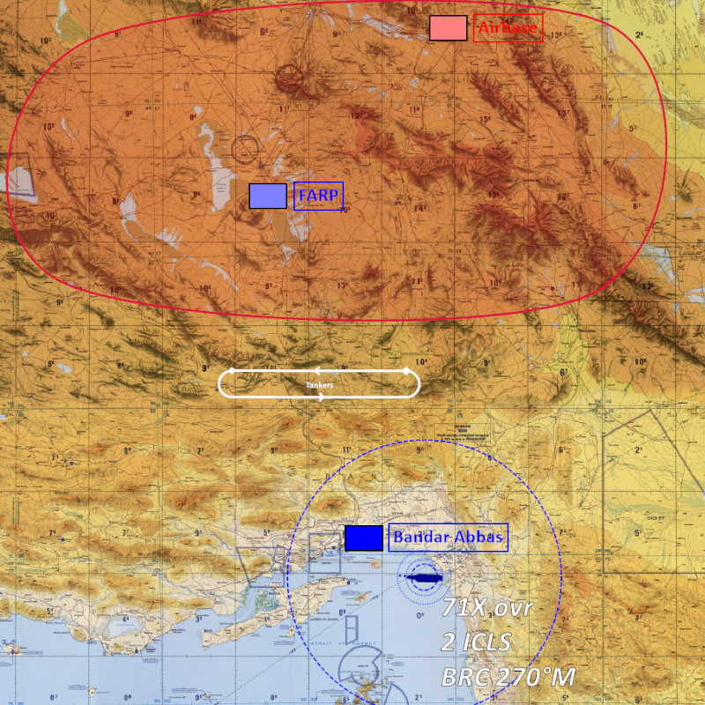
Tensions have escalated between NATO forces and Iran. NATO managed to secure a foothold in Bandar Abbas airbase and is continuing operations further in inland Iran.
Objective:
- Destroy Primary target
SRS IP: 136.243.170.132:5002  SRS Common: 300 MHz AM  ATIS: 275.500 MHz AM  Ground: 275 MHz AM  Tower: 280 MHz AM  AWACS: 240 MHz AM | CVN-71: 127.500 Mhz AM  TACAN 71X  ICLS Channel 2  Shell (Probe): 260 MHz AM  TACAN 11X  Texaco (Drogue): 260 MHz AM  TACAN 12X  Arco (Probe A10): 260 MHz AM  TACAN 13X

