SDM PRACTIACL EXAM (SET 3)

220945920071 Randhir Borkar

1. Create one virtual machine EC2 instance using AWS (named northwind_inc)

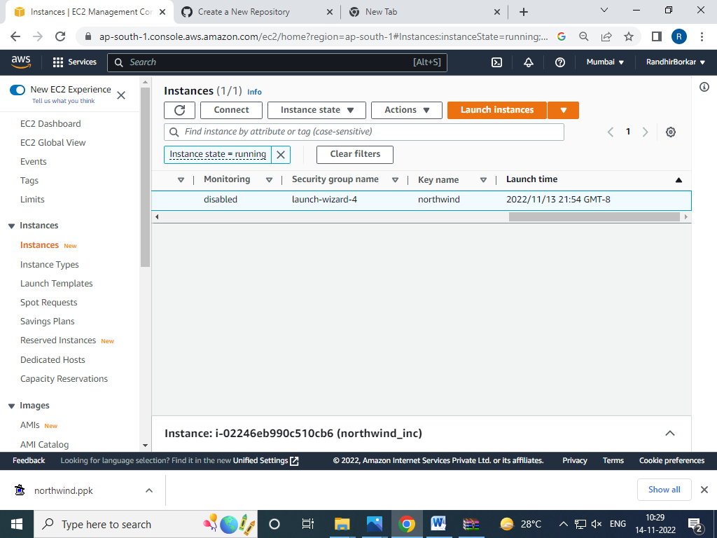

Second screenshot of timing (timing is already wrong and preseted to 2022/11/13 21:54 GMT-8 and can’t change during exam)

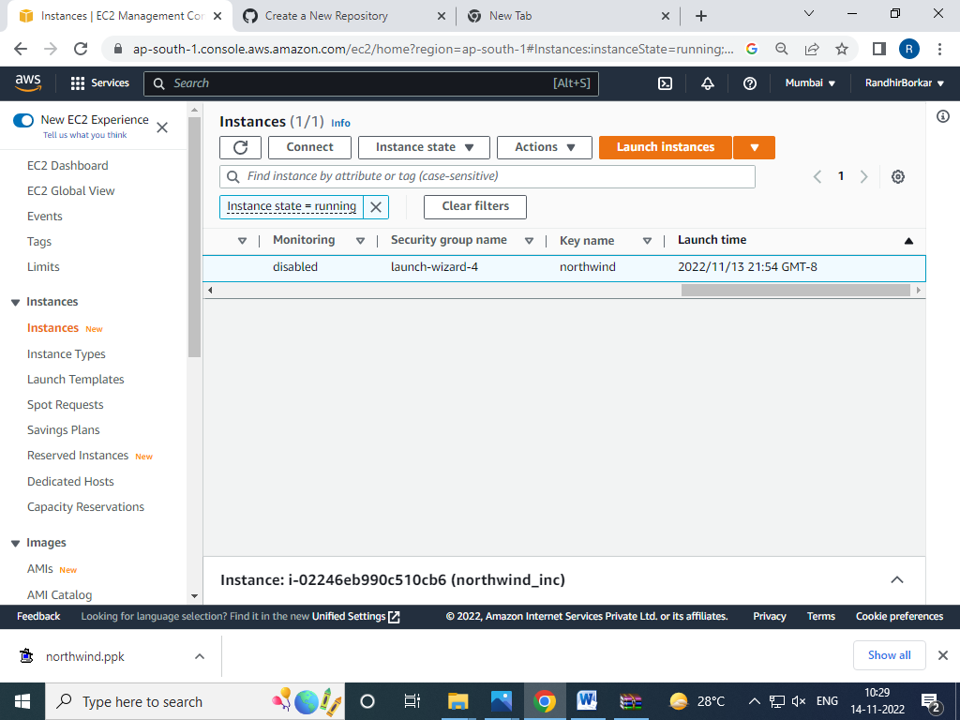

Putty started

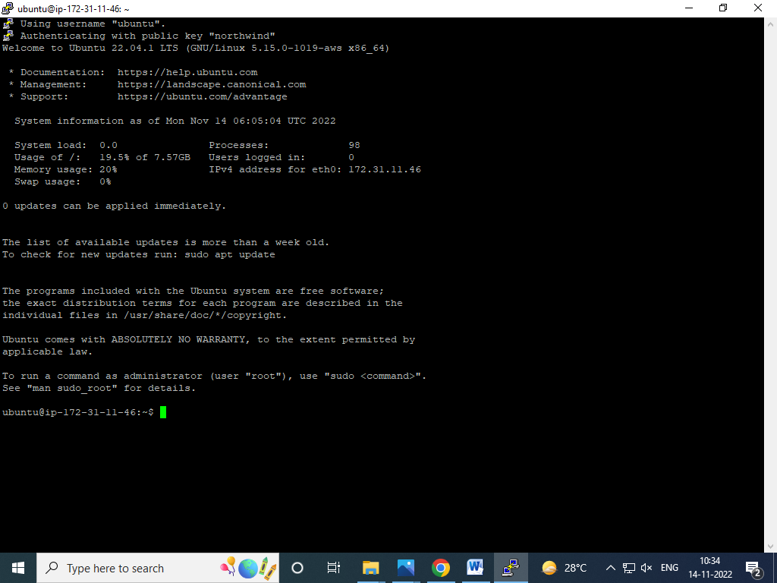

1. Installing docker engine to newly created ec2 instance

Installing docker

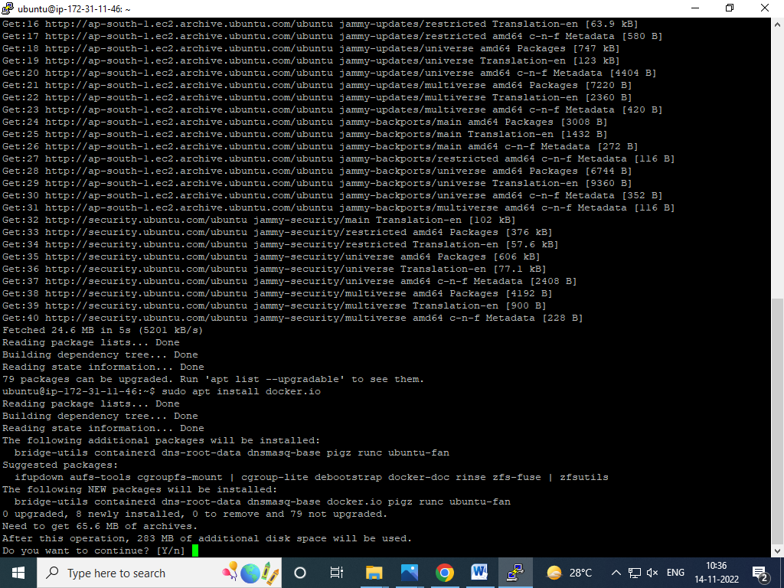

Checking docker status

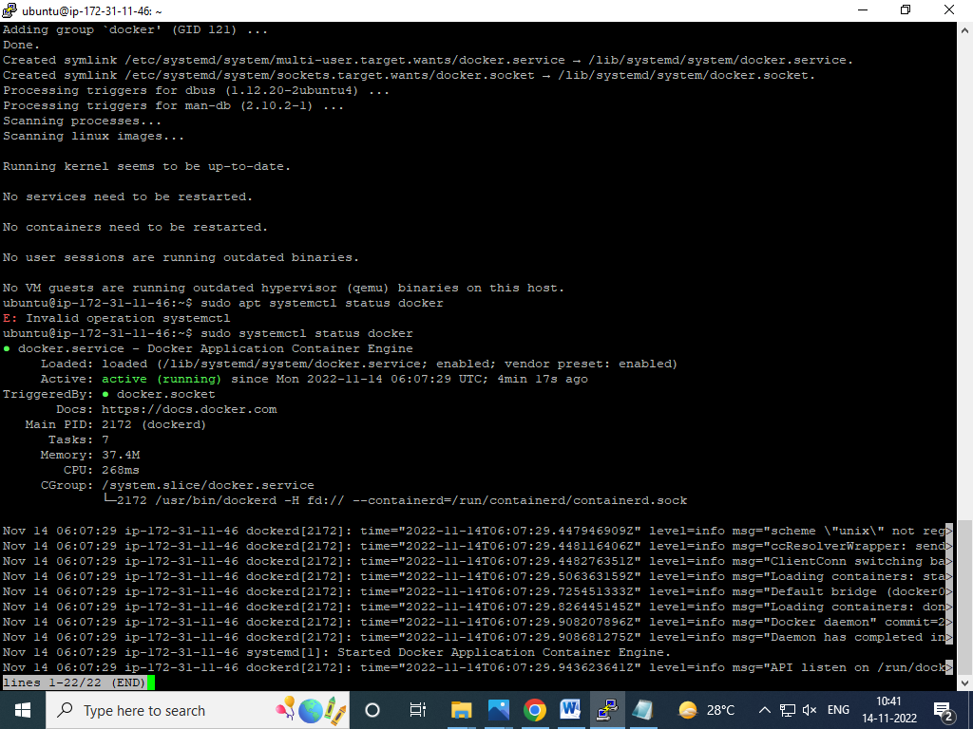

1. Creating github repository named northwind

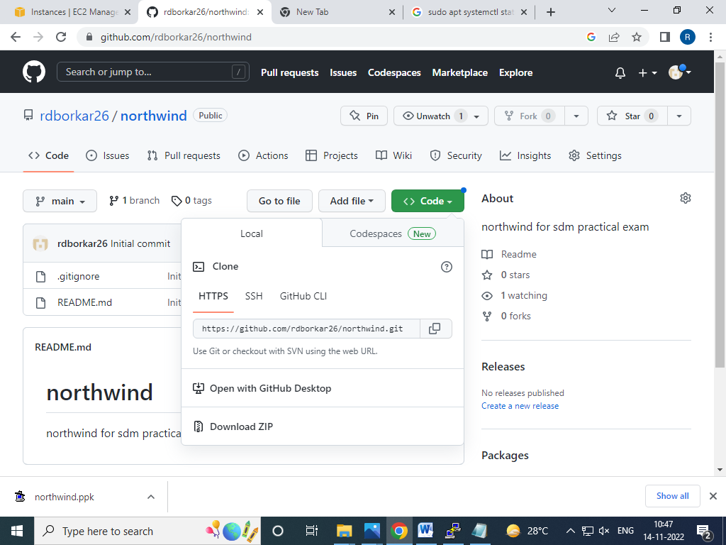

1. Creating local depository on developers machine to clone northwind code repository

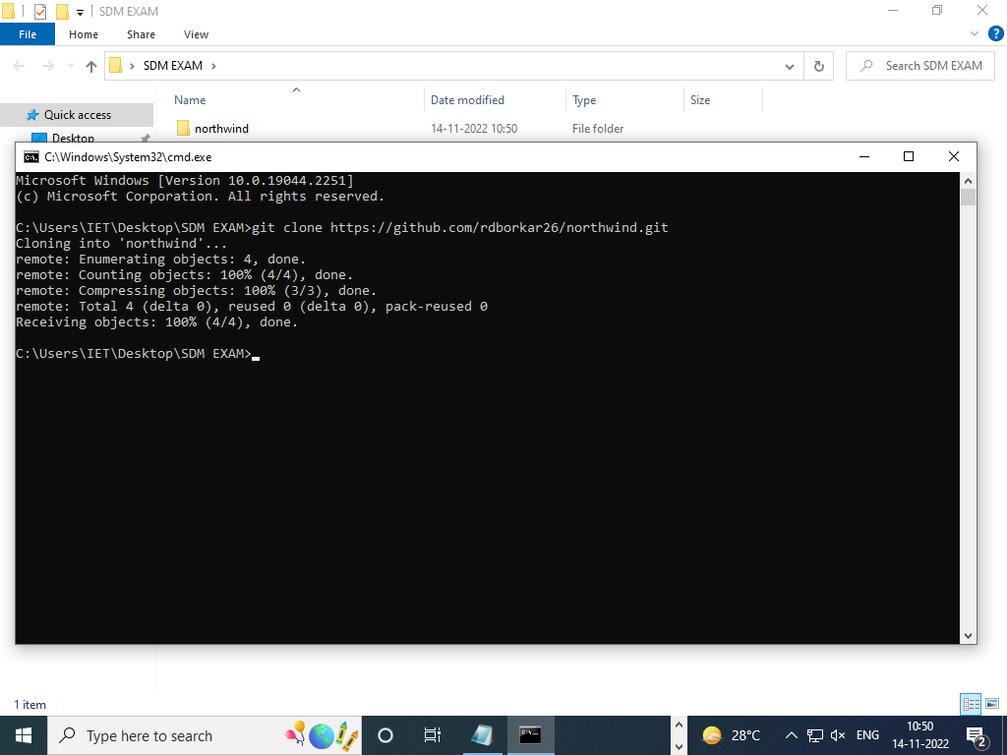

5.0 adding files provided for northwind project on developers machine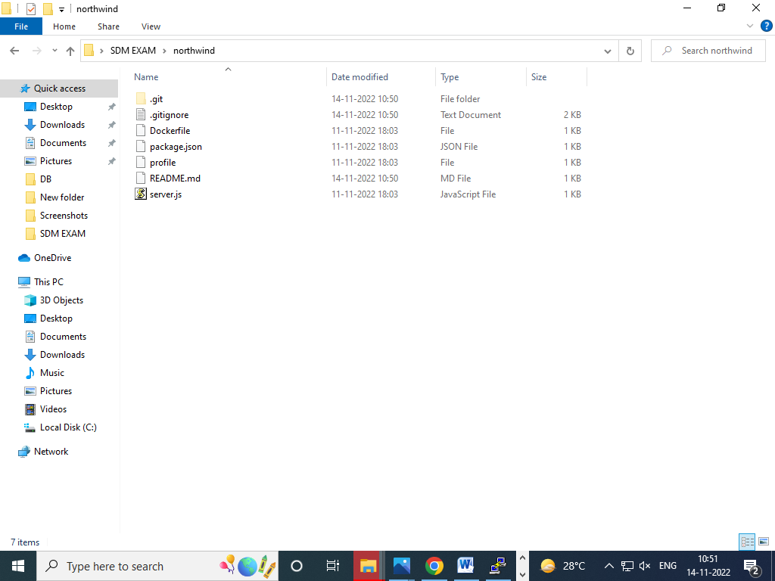

6.Adding docker file

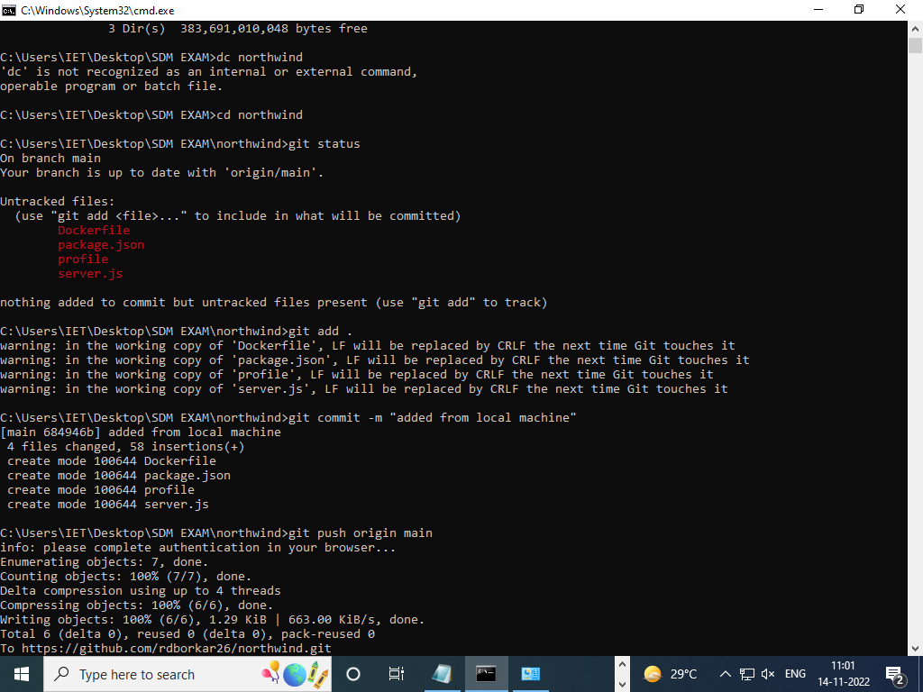

7.0 commiting all added files



8. pushing changer to github repository



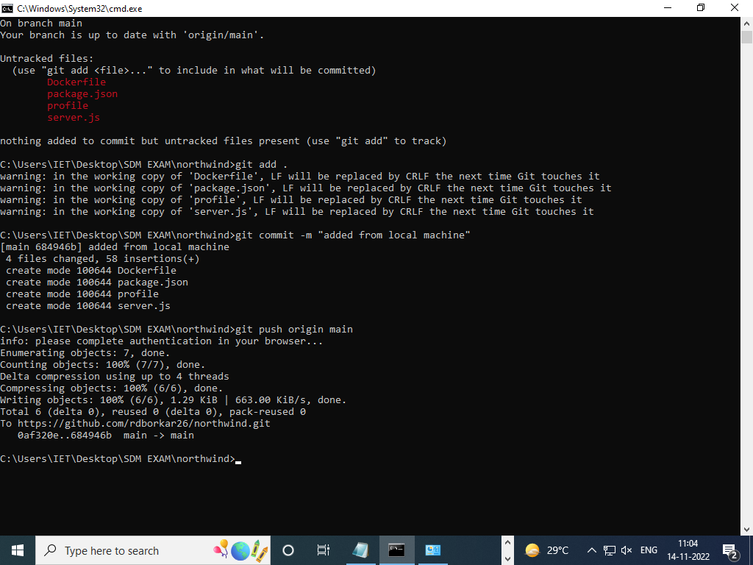

9. Installing git to EC2 instance

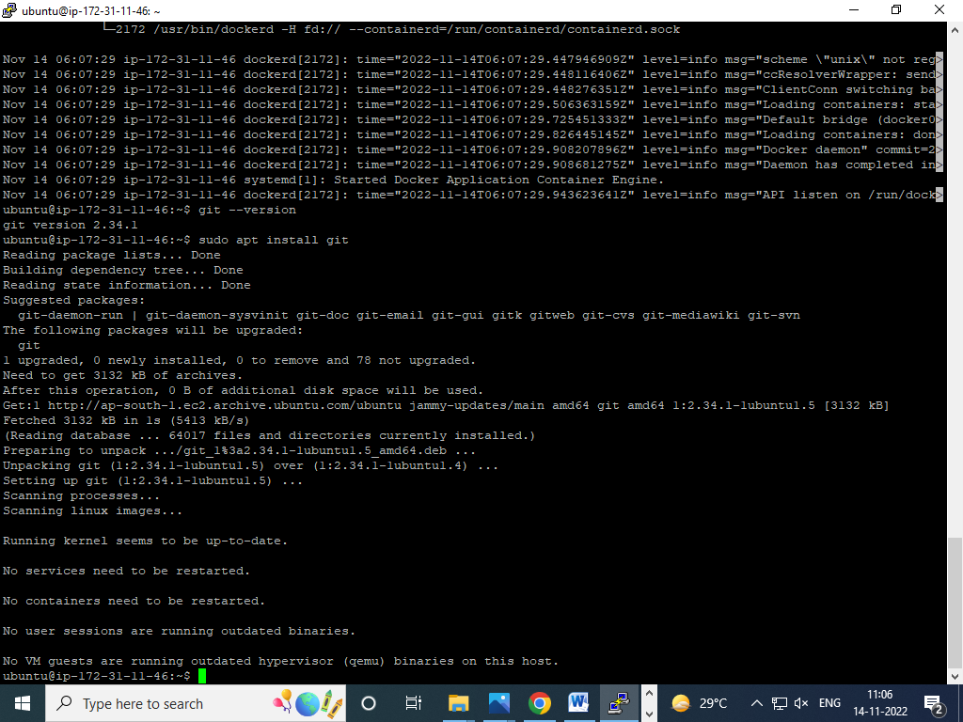

10. clone code repository of northwind to ec2 instance

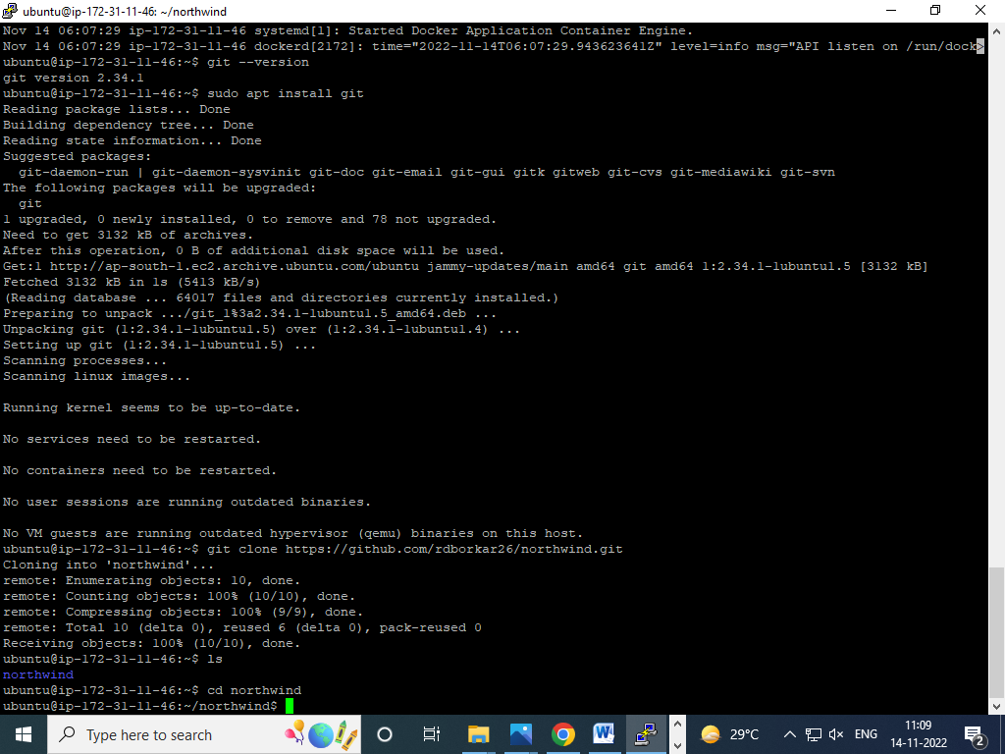

11. creating docker container images for northwind cloned repository in EC2 instance

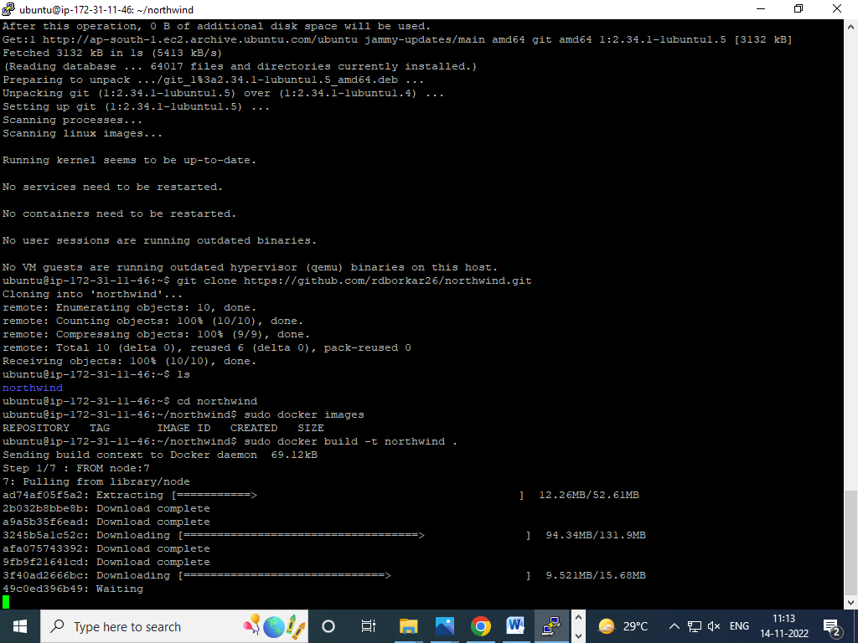

12. listing down the docker container images in EC2 instance

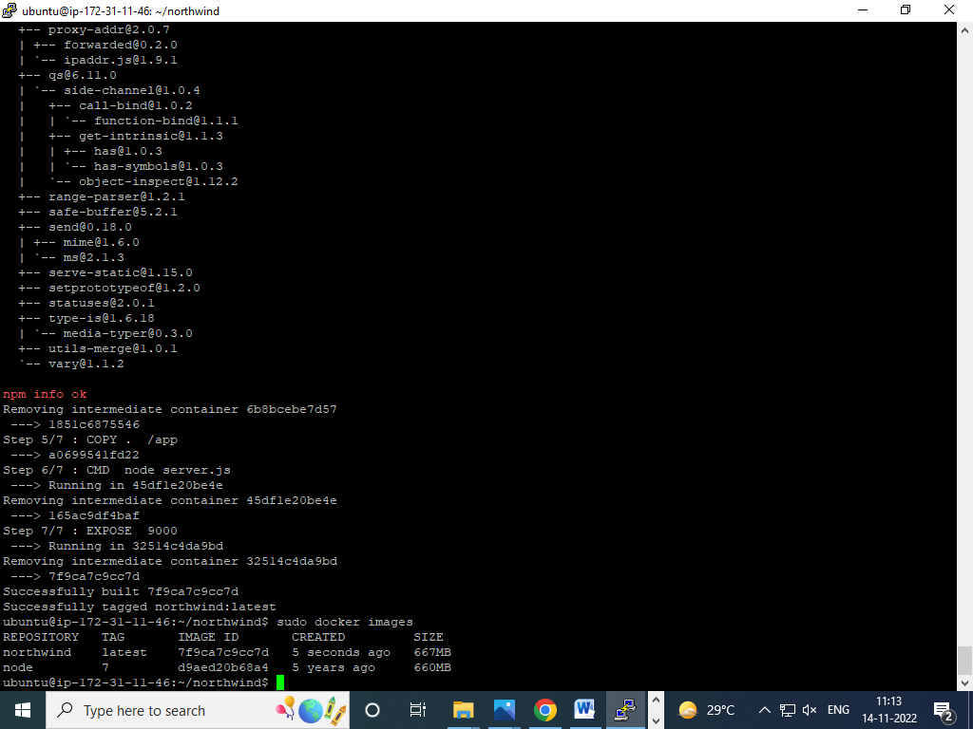

13. running docker container images to launch instance of container

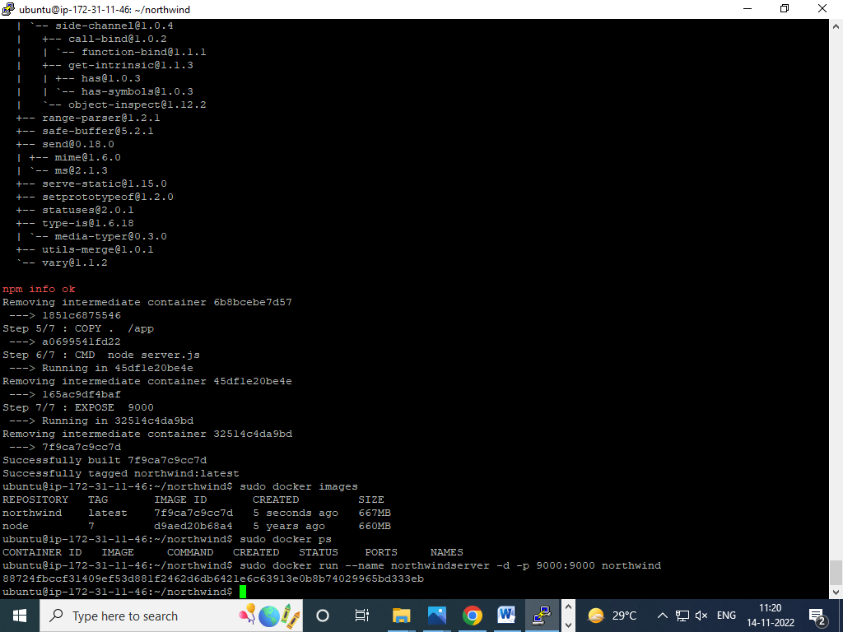

14. listing down container instance using docker in EC2 instance

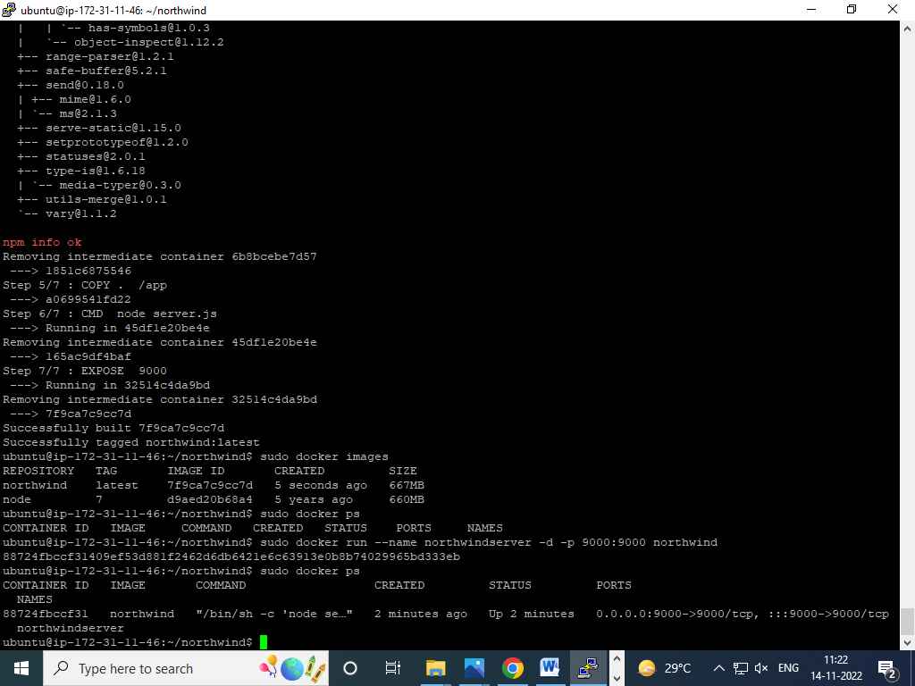

15. enable all traffic from anywhere by setting inbound rule of security group assigned to EC2 instance

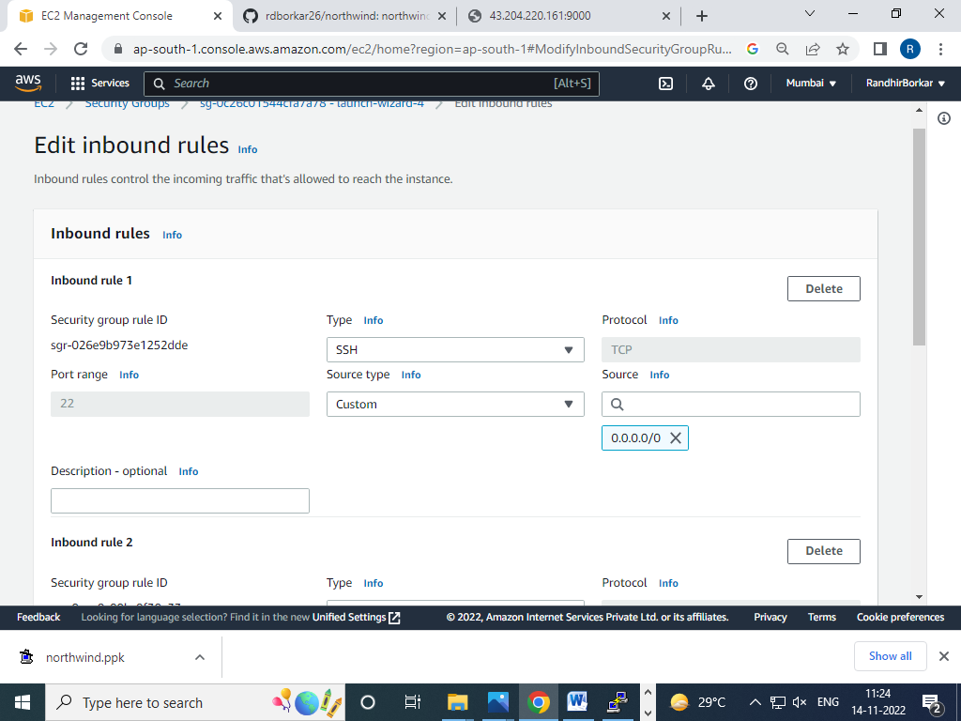

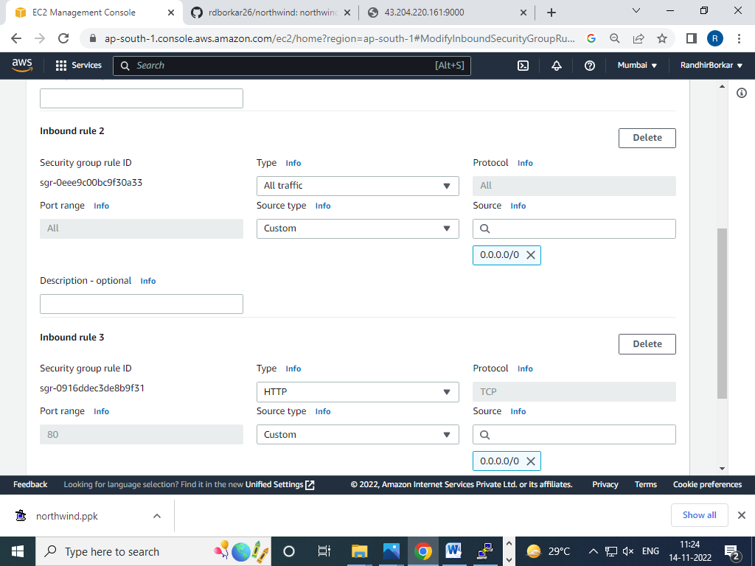

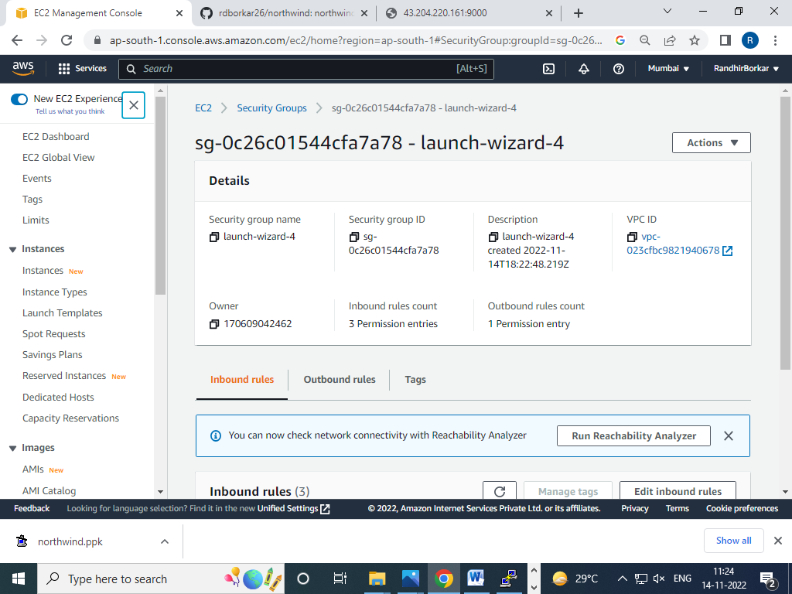

16. invoking url of northwind portal from chrome browser

