**NIELIT Virtual Academy**

**National Institute of Electronics and Information Technology, Chennai**

**Autonomous Scientific Society of Ministry of Electronics & Information Technology (MeitY), Govt. of India, ISTE Complex, 25, Gandhi Mandapam Road, Chennai – 600025**

**Course Prospectus**

**NSQF Aligned**

**Mode:** ONLINE (Blended)

**Artificial Intelligence Application Developer**



|  |  |
| --- | --- |
| **Topic** | **Page No.** |
| **Objective of the Course………………………………………………** | 3 |
| **Outcome of the Course……………………………………………...** | 4 |
| **Course Structure …………………………………………………….** | 4 |
| **Course Fee Structure …………………………………………………** | 5 |
| **Registration Fee ………………………………………………………** | 5 |
| **Eligibility………………………………………………………………** | 6 |
| **Number of Seats……………………………………………………….** | 6 |
| **How to Apply ………………………………………………………….** | 6 |
| **Registration…………………………………………………………….** | 6 |
| **Selection Criteria of candidates……………………………………....** | 6 |
| **Admission………………………………………………………………** | 7 |
| **Discontinuing the course…………………………………………….** | 7 |
| **Important Dates……………………………………………………….** | 8 |
| **Examination & Certification………………………………………….** | 8s |

**Index**

**Course Prospectus**

|  |
| --- |
| **Course Name:** Artificial Intelligence Application Developer  **Course Code: AI181**  **NSQF Level: 4.5**  **Duration: 540 Hours, 4 Month**  **Last Date of Registration: 15-05-2025**  **Date of publishing Provisional Selection List: 16-05-2025**  **Last Date of Payment of 1st Installment fee: 19-05-2025**  **Course Start Date: 19-05-2025** |

# Preamble:

The **AI Application Developer** course is designed to provide students with the knowledge and hands-on experience necessary to design, develop, and deploy AI applications. This course combines theoretical knowledge with practical skills, covering core areas such as machine learning, deep learning, natural language processing (NLP), computer vision, and AI system deployment.

In today’s rapidly evolving technological landscape, Artificial Intelligence (AI) has emerged as a transformative force across industries. From healthcare to finance, entertainment to manufacturing, AI is revolutionizing the way we interact with technology and solve complex problems. The demand for skilled professionals who can develop and deploy AI applications is growing exponentially.

# Objective of the Course:

The Artificial Intelligence (AI) Application Developer Qualification will cover the fundamentals of Python programming and libraries like NumPy and pandas used for data analysis. The course will also cover Visualization with Matplotlib. The course will stress on developing programming skills by providing practical exposure to the aspiring Python developers and also introduce to the concepts of Machine Learning. Participants from any background can develop the skills needed to become an AI Application Developer.

An **AI Application Developer** course typically focuses on building the knowledge and skills needed to design, develop, and deploy applications that utilize Artificial Intelligence. The course objectives can vary depending on the institution, but generally, they aim to provide the following:

1. **Foundational Knowledge in AI Concepts -** Understand the fundamental principles of Artificial Intelligence, including machine learning, neural networks, natural language processing, and computer vision.
2. Hands-on Experience with AI Tools and Technologies - Gain proficiency in programming languages commonly used in AI development such as Python, R, or Java , Learn to work with popular AI frameworks like TensorFlow, PyTorch, Keras, and Scikit-learn , Learn to use cloud services and platforms like Google Cloud AI, Microsoft Azure AI, or Amazon AWS for AI development and deployment.
3. Development of Machine Learning Models
4. Natural Language Processing (NLP)
5. AI Application Design and Deployment
6. Ethics and Responsible AI
7. Continuous Learning in AI and Emerging Trends

**Outcome of the Course:**

The outcomes of an **AI Application Developer** course focus on what students should be able to do by the end of the program. These outcomes often combine technical skills, problem-solving abilities, and a deep understanding of the AI landscape

# Course Structure:

This course contains total three modules. After completing the all modules, the students have to do a project using any of the topics studied in the course.

| **Module No.** | **Module Name** | **Th.** | **Pr.** | **Total** |
| --- | --- | --- | --- | --- |
|  | Programming with Python | 20 | 40 | 60 |
|  | Conceptualizing Data Science with Python | 24 | 36 | 60 |
|  | Data Analysis & Visualization | 34 | 56 | 90 |
|  | Machine Learning fundamentals | 12 | 18 | 30 |
|  | Performance of Machine Learning models | 35 | 55 | 90 |
|  | Fundamentals of Deep Learning | 25 | 35 | 60 |
|  | OJT Mandatory | 90 | | |
|  | Employability Skills(Internal Assesment) | 60 | | |
|  | Major Project |  |  |  |
|  | **Duration (in Hours) / Total Marks** | 150 | 390 | **540** |

**Course Fee Structure:**

|  |  |  |  |
| --- | --- | --- | --- |
|  | **General/OBC/EWS** | **SC/ST** | **Last Date** |
| **Registration Fee** | Rs.1000/- | NIL | 15-05-2025 |
| **Tuition Fee**  **(Including NSQF Registration & Examination Fee)** | | | |
| **1st Installment** | Rs.12,000/- | NIL | 19-05-2025 |
| **2nd Installment** | Rs.12,000/- | NIL | 30-06-2025 |
| **Total** | **Rs 25,000** | **NIL** |  |

**Registration Fee** : Rs 1000/-( Exemption for SC/ST Candidates)

# Registration Fee- Refund Policy:

# (Non-Refundable if candidate is selected for admission but did not join and if a candidate has applied but not eligible.)

# However, the registration fee shall be refunded on few special cases as given below:

1) Candidates are eligible but not selected for admission.

2) Course postponed and new date is not convenient for the student.

3) Course cancelled.

**Eligibility** :

|  |  |  |
| --- | --- | --- |
| S. No. | Academic/Skill Qualification (with Specialization - if applicable) | Required Experience (with Specialization - if applicable) |
| 1 | Completed 1st year of B.Tech/BCA/BSc , or• Pursuing 1st year of B.Tech/BCA/BSc and continuing education ,or• Pursuing 3rd year of 3-year diploma after 10th and continuing education, or• Completed 3-year diploma after 10 ,or• Completed 2nd year of 2-year diploma after 12th ,or• Pursuing 2nd year of 2- year diploma after 12 and continuing education ,or• Previous relevant NSQF Level 4 qualification with minimum 8th Grade pass | -NA- |

Number of Seats: 80(Eighty) – Total

Note: Seats are allocated based on the merit of the Qualification

# How to Apply?

## Candidates can apply online in our website http://nva.nielit.gov.in. Payment towards          non-refundable registration fee can be paid through any of the following modes:

## Payment Gateway

* + **Online transaction: Account No: 31185720641 Branch: Kottur (Chennai), IFS Code: SBIN0001669.**

## GPAY/any UPI, Credit Card

**Note**: *The Institute will not be responsible for any mistakes done by either the bank concerned or by the depositor while remitting the amount into our account*

**Last date of Registration: *15-05-2025***

**Registration Procedure**

All interested candidates are required to fill the Registration form online with registration fees of Rs. 1,000/- (wherever applicable) and with all the necessary information.

# Selection Criteria :

Selection of candidates will be based on their marks in the qualifying examination subject to eligibility and availability of seats.

* The first list of Provisionally Selected Candidates will be published on NIELIT Chennai website ([www.nielit.gov.in/chennai](http://www.nielit.gov.in/chennai)/index.php ) on **16-05-2025** by **5:00 PM**. In case of vacancy, an additional selection list will be prepared and the selection will be intimated by email only.
* Following documents of candidates will be verified:
  + - Qualifying Degree (Consolidated Marksheet/Degree Certificate/Course Completion Certificate), 10th and 12th mark sheet.
    - One passport size photograph.
    - Self-attested copy of Govt. issued photo ID card.
    - AADHAR Copy
* All provisionally selected candidates have to pay first instalment of Rs. ***12,000/-*** on or before **19-05-2025** by payment mode mentioned above.
* Selected candidates are requested to upload the proof of remittance of fee on registration portal and also send the proof of remittance of fee as email to **trng.chennai@nielit.gov.in/dhirendra@nielit.gov.in**

**Admission**:

All provisionally selected who have paid the fees (full or first instalment) and verified by accounts section of NIELIT Chennai will get a welcome message in his login id provided during registration.

***Note-All Provisionally Selected Candidates have to visit NIELIT Chennai for Certificate Verification.***

***Otherwise their candidature will be cancelled without any intimation.***

**The credentials and URL for online portal will be shared through WhatsApp or email.**

**Discontinuing the course**

* No fees under any circumstances, shall be refunded in the event of a student who have completed the process of admission or discontinuing the course in between. No certificate shall be issued for the classes attended.
* If candidates are not uploading consecutive 3 assignments within assigned time, then their candidature will be cancelled without any notice and all fees paid will be forfeited.
* If candidates are not appearing for any internal examinations/practical their candidature will be cancelled without any notice and all fees paid will be forfeited.

**Course Timings**:

This program is a practical oriented one and hence there shall be more lab than theory classes. The classes and labs are online cloud-based from **10 am to 5:30 pm** and Monday to Friday. In between **any 04 hours** can be fixed as your class timings according to the candidate’s convenience and the faculty’s availability and remaining student can do their lab.

**Course enquiries**

Students can enquire about the various courses either on telephone or by personal contact between 9.15 A.M. to 5.15 P.M. (Lunch time 1.00 pm to 1.30 pm) Monday to Friday.

# Placement:

Students who have completed the course successfully and qualified, Placement guidance and career counselling will be given to assist in their interviews.

# Important Dates

|  |
| --- |
| **Last Date of Registration: 15-05-2025**  **Display of Provisional Selection List: 16-05-2025**  **Payment of first installment fee: 19-05-2025**  **Course Start Date: 19-05-2025**  **Payment of second instalment fee: 30-06-2025** |

**Examination & Certification**

* Final Certificates will be issued after successful completion of all the modules including mini project. For getting certificate a candidate has to pass each module individually with minimum required marks of 50%.

**NSQF Examination Pattern:**

* **Means of assessment:**

|  |  |  |  |  |
| --- | --- | --- | --- | --- |
| **S. No** | **Examination Pattern** | **Modules Covered** | **Duration in Minutes** | **Maximum Marks** |
| 1. | Theory Paper-1: | Module 1,2,3 | 90 | 100 |
| 2 | Theory Paper-2: | Module 4,5,6 | 90 | 100 |
| 4 | Practical 1: | Module 1,2,3,4,5,6 | 180 | 90 |
| 6 | Internal Assessment(Employability Skill) |  | - | 50 |
| 7 | Assignment/Project/Presentation |  | - | 60 |
| 8 | Major Project |  | - | 100 |
| **Total** | | | | **500** |

**Examination Centre: NIELIT Chennai, Mode: Online**

**Grading Scheme**

Following Grading scheme (on the basis of total marks) will be followed:

|  |  |  |  |  |  |
| --- | --- | --- | --- | --- | --- |
| Grade | S | A | B | C | D |
| Marks Range (in  %) | >=85% | >=75% and  <85% | >=65% and  <75% | >=55% and  <65% | >=50% and  <55% |

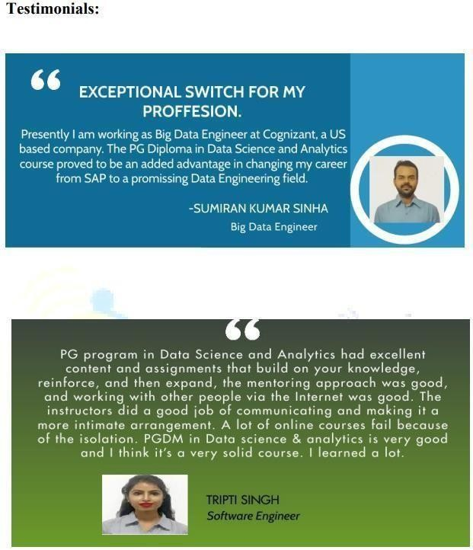

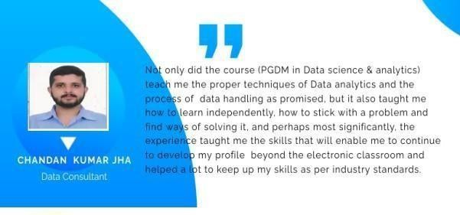

……….many more.

**Detailed curriculum**

|  |
| --- |
| **Module 1:** Programming with Python |
| •Installing and configuring programming environment for python  • Writing basic programs and understanding datatypes, operators, looping constructs, functions  • Exploring various data structures  • Learn to work on modules and packages |
| **Module 2:** Conceptualising Data Science with python |
| • Concept of Data Science and tools used  • Pre- Processing Concepts in Data Science  • Introduction to Numpy and Working on N-d array  • Learning Analysis on Numpy  • Exploring Image handling using Numpy |
| **Module 3:** Data analysis and Visualization |
| • Introduction to Pandas  • Exploring Data Frames and Series  • Learning EDA and Data Analysis  • Performing Analysis on datasets  • Introduction to Visualisation and Learning Tools for making Graphs and plots  • Exploring analysis through visualisation |
| **Module 4:** Fundamentals of Machine Learning |
| • Introduction to Machine Learning  • Learning various ML categories  • Learning to build models on datasets |
| **Module 5:** Performance and Accuracy of Machine Learning Models |
| • Implement Predictive Analysis using various Regression and Classification algorithms  • Learn and apply statistics used in Machine Learning  • Using various metrics and Feature Engineering techniques.  • Develop and Implement Project in Predictive Analysis using ML |
| **Module 6:** Fundamentals of Deep Learning |
| • Understand and implement Deep Learning using Neural Networks  • Work in Computer Vision using CNN and implement Image based models  • Understand NLP and implement Natural Language Processing algorithms |