Computing end-end delay (transmission and propagation delay)

Consider the figure below, with three links, each with the specified transmission rate and link length.
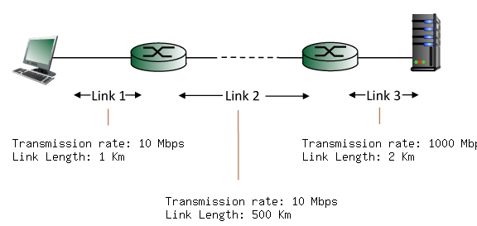

Find the end-to-end delay (including the transmission delays and propagation delays on each of the three links, but ignoring queueing delays and processing delays) from when the left host begins transmitting the first bit of a packet to the time when the last bit of that packet is received at the server at the right. The speed of light propagation delay on each link is 3x10**8 m/sec. Note that the transmission rates are in Mbps and the link distances are in Km. Assume a packet length of 8000 bits. Give your answer in milliseconds.
Solution:
Link 1 transmission delay = L/R = 8000 bits / 10 Mbps = 0.800000 msec.
Link 1 propagation delay = d/s = 1 Km / 3*10**8 m/sec = 0.003333 msec.
Link 2 transmission delay = L/R = 8000 bits / 10 Mbps = 0.800000 msec.
Link 2 propagation delay = d/s = 500 Km / 3*10**8 m/sec = 1.666667 msec.
Link 3 transmission delay = L/R = 8000 bits / 1000 Mbps = 0.008000 msec.
Link 3 propagation delay = d/s = 2 Km / 3*10**8 m/sec = 0.006667 msec.
Thus, the total end-to-end delay is the sum of these six delays: 3.284667 msecs.

