End to End Throughput and Bottleneck Links
Consider the scenario shown below, with four different servers connected to four different clients over four three-hop paths. The four pairs share a common middle hop with a transmission capacity of R = 200 Mbps. The four links from the servers to the shared link have a transmission capacity of RS = 80 Mbps. Each of the four links from the shared middle link to a client has a transmission capacity of RC = 60 Mbps per second. You might want to review Figure 1.20 in the text before answering the following questions:
- What is the maximum achievable end-end throughput (in Mbps) for each of four client-to-server pairs, assuming that the middle link is fair-shared (i.e., divides its transmission rate equally among the four pairs)?
- Which link is the bottleneck link for each session?
- Assuming that the senders are sending at the maximum rate possible, what are the link utilizations for the sender links (RS), client links (RC), and the middle link (R)?
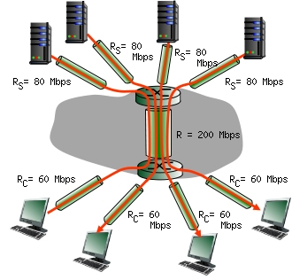

Solution:
- The maximum achievable end-end-throughput is 50 Mbps.
- This is one quarter of the transmission capacity of the shared middle hop, which is the bottleneck link. The overall transmission capacity of the shared hop is 200 Mbps, which is shared equally among the four server-client pairs, giving each an equal share of 50 Mbps. This is less than the first-hop transmission capacity of 80 Mbps and also less than the third-hop transmission capacity of 60 Mbps.
- The utilization of sender links is 62.5% . The utilization of receiver links is 83.33% . The utilization of the middle link is 100% .

