Computing the one-hop transmission delay

Consider the figure below, in which a single router is transmitting packets, each of length L bits, over a single link with transmission rate R Mbps to another router at the other end of the link.
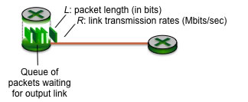
Suppose that the packet length is L= 12000 bits, and that the link transmission rate along the link to router on the right is R = 1 Mbps.
(a) What is the transmission delay (the time needed to transmit all of a packet's bits into the link)? (b) what is the maximum number of packets per second that can be transmitted by the link?
Solution:
(a)The link transmission delay = L/R = 12000 bits / 1 Mbps = 12.000000 msec.
(b) The link can transmit 83.333333 packets per second

