# STATISTICS -TASK DICE 1st QUESTION

## Problem

Determine the probability of obtaining a sum of 30 when ten fair six-sided dice are rolled independently.

* **To calculate exact the probability of making 30 sum form 10 dice.**

## Understanding the scenario

Each dice can show the numbers between 1-6 (1,2,3,4,5,6). Therefore, if we denote this

X1+x2+x3…+x10 as the results of the 10 dice throws, we need to find the number of non-negative integer solutions to the equations.

* X1+X2+X3…x10 =30
* The constrain here will be 1 =< xi =<6 for each I (1,2,3…10)

The values of minimum and maximum values when throwing 10 dices are:

|  |  |  |  |  |  |  |  |  |  |  |  |
| --- | --- | --- | --- | --- | --- | --- | --- | --- | --- | --- | --- |
| 10 dices’ value in one throw | 1 | 2 | 3 | 4 | 5 | 6 | 7 | 8 | 9 | 10 |  |
| Min value | 1+ | 1+ | 1+ | 1+ | 1+ | 1+ | 1+ | 1+ | 1+ | 1 | =10 |
| Max value | 6 + | 6 + | 6 + | 6 + | 6 + | 6 + | 6 + | 6 + | 6 + | 6 | =60 |

## Solving the scenario

To calculate the exact probability of 10 dice throws adding up to exactly the sum of 30, we must find

1. Count of total number of ways to achieve 30
2. Total number of all possible outcomes for 10 dices throws.

Total number of possible outcomes

1 dice 🡪 61  (six sides)

So, there are 6 possible outcomes for each time one dice throws.

10 dice 🡪 610

= 60 446 176

Counting all favorable outcomes

To calculate this, we must use a computational method as this involves large numbers.

Code:

def count_combinations(n_dice, target_sum):  
if n_dice == 0:  
 return 1 if target_sum == 0 else 0  
 count = 0  
 for i in range(1, 7):  
 count += count_combinations(n_dice-1, target_sum-i)  
 return count  
  
  
favorable_outcomes = count_combinations(10, 30)

probability = favorable_outcomes / 6**10 # probability of favourable all outcomes of getting sum 30  
  
unfavorable_outcomes = 6**10 - favorable_outcomes  
un_fav_probability = unfavorable_outcomes / 6**10 # probability of having unfavourable outcomes.  
  
sum_of_all_probabilities = probability + un_fav_probability # probabilities sum

Answer:

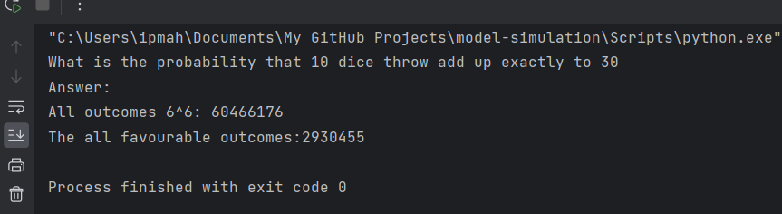

* **Favorable outcomes = 2 930 455**

And to calculate this we use classical method probability finding formula to find the answer since dice all the outcomes are equally likely to happen.

P(E) =n(E) / n(S)

*n(S) is the number of elements in the sample space S and n(E) are the number of elements in the event E.*

* Psum=30 = 2930465 / 60499176

The method used to calculate the probability of 10 dice throws adding up to 30 is classical probability method. The reasons for this are,

1. Equally likely outcomes: Each dice throws have equally likely outcomes.
2. The probability is calculated based on counting the number of favorable outcomes of the total, number of possible outcomes.
3. Don’t rely on actual experiments or real-world data to determine the probability.

### Calculation

P(E) =n(E) / n(S)

Psum=30 = 2930465/ 60499176

Psum=30 = 0.048464367913724195

Round off

probability = favorable_outcomes / 6**10 # probability of favorable all outcomes of getting sum 30

= 0.0485

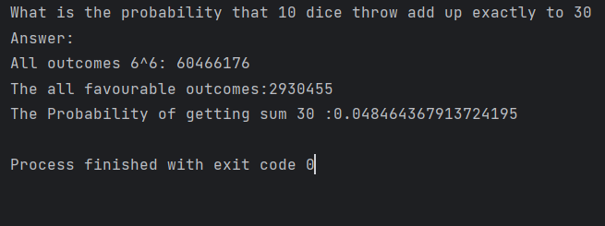

To further confirm this result, we can count the unfavorable outcomes counts and calculate the possibility of getting a sum of 30 when throwing 10 fair dice independently.

***From previous computational calculations***

* Favorable outcomes = N
* All outcomes = 66
* Un-favorable Outcomes =66 – N

Probability of unfavorable outcomes =unfavorable outcomes count /6^6

*Then*

* All unfavorable Outcomes: 57535721
* The probability of not getting a sum of 30: 0.9515356320862758
* Sum of both probabilities

= favorable probability + unfavorable probability

= 0.048464367913724195 + 0.9515356320862758

= 1

Probability of favorable outcomes + probability of unfavorable outcomes = 1

The sum of all probability in probability is always 1 and above calculation prove it.

Probability scale:

0 impossible 0.5 even chance 1 certain

0.048464367913724195

So, the scenario of 10 fair dice throws independently and getting 30 sum is near impossible limit of probability scale.

!!!! Should the entire code must be include in this report?

MAHESHIKA