**Lesson 2 Demo 1**

**Configuring Git Account with GitHub**



Steps to be followed:

1. Creating a GitHub account
2. Configuring Git account with GitHub

**Step 1: Creating a GitHub account:**

* 1. Go to **github.com** and create an account by log in with a username and password or signing in using the Google account

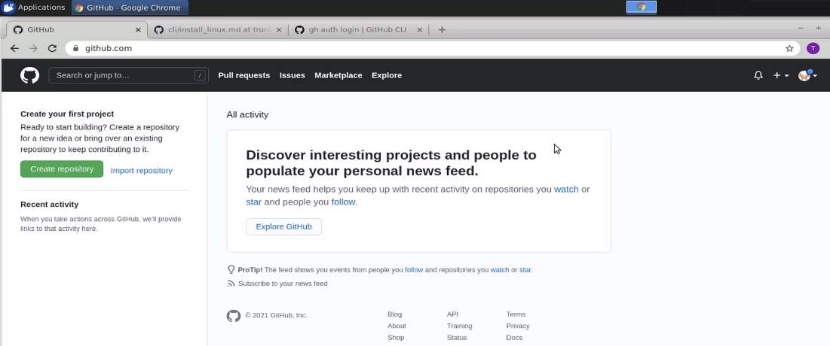

* 1. For this system, the Git is already configured in the Linux environment. So, open the terminal and check for git by typing which git command.

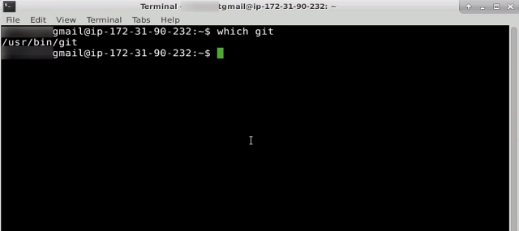

* 1. You can see that Git is already preinstalled in the system. With Git, you also need to install the GitHub CLI. It is needed to access GitHub from your system.

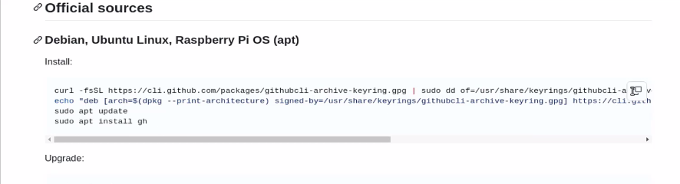

**Step 2: Configuring Git account with GitHub**

* 1. Open the link **github.com/cli** and go to the official sources link as shown above. Copy the command and type: **sudo apt install gh.**

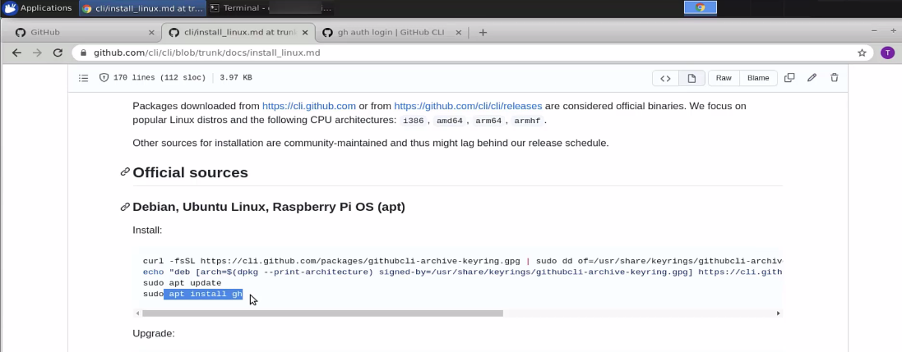

* 1. Once the GitHub CLI is installed, go to the terminal window and type: **gh auth login [flags]**

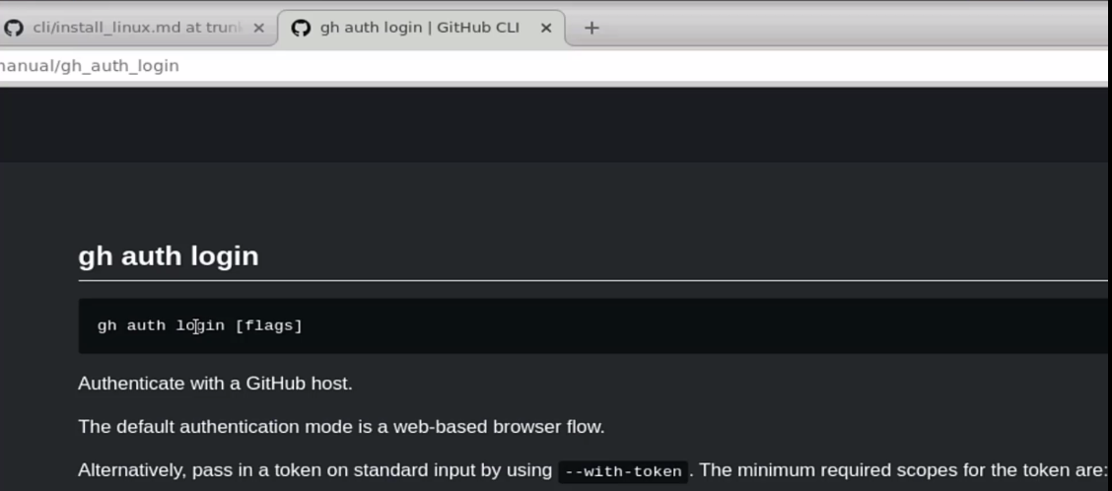

* 1. You will get a personal access token using which you can manage the code on GitHub. Go to the terminal and type: **gh auth login.**

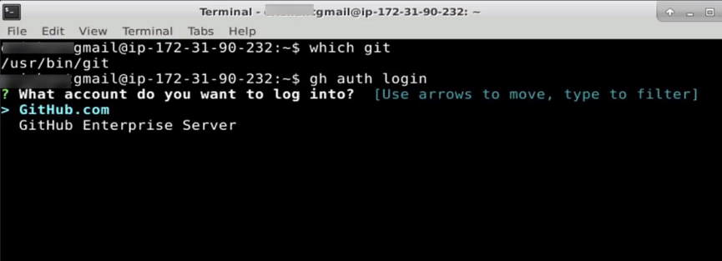

* 1. Select **GitHub.com**

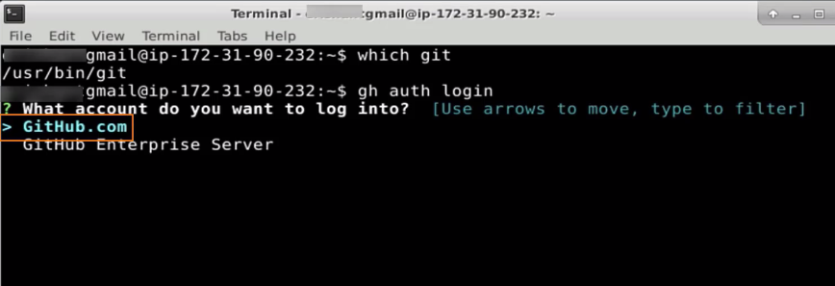

* 1. Enter **Y** to reauthenticate as you are already logged in. In case you are not logged in, it will ask you to log in.

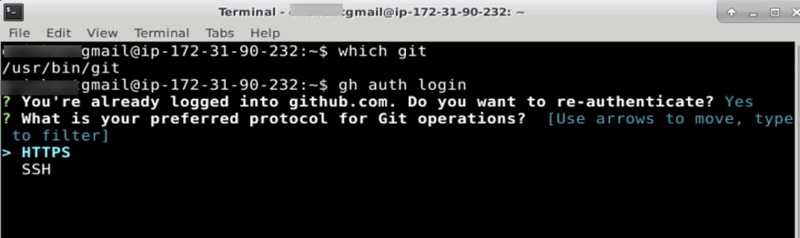

* 1. Choose the HTTPS

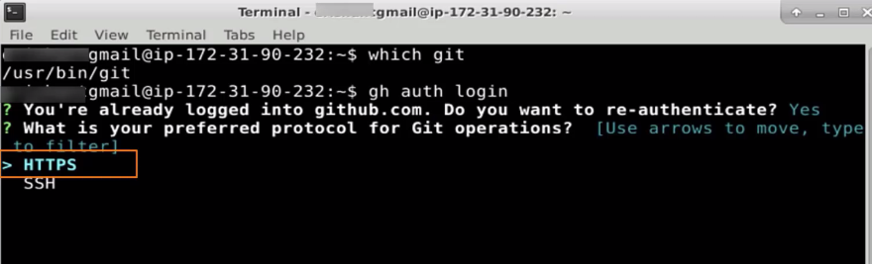

* 1. Select **Login with a web browser**

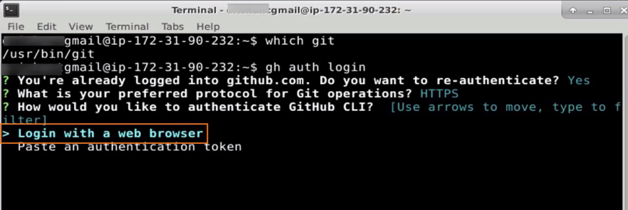

* 1. Press **enter** to open github.com in your browser

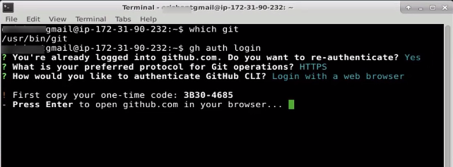

* 1. Enter the device activation code

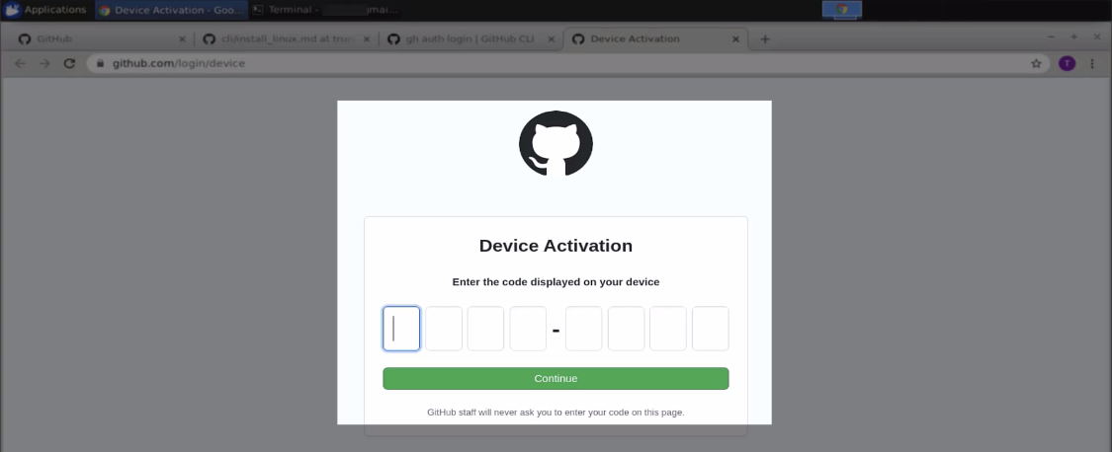

2.10 The device activation code will already be given in the console. Copy and paste the code into the browser.

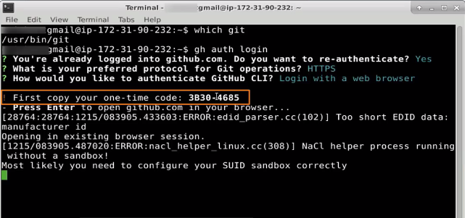

* 1. Click on **continue**

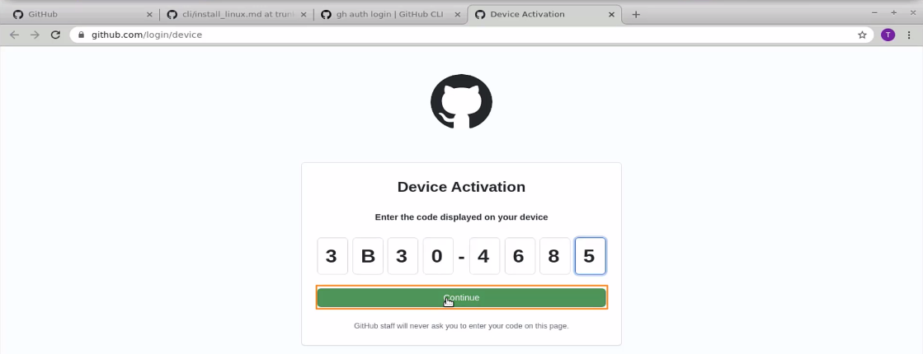

* 1. You can grant access to different resources on GitHub. Click on the **Authorize GitHub** button.

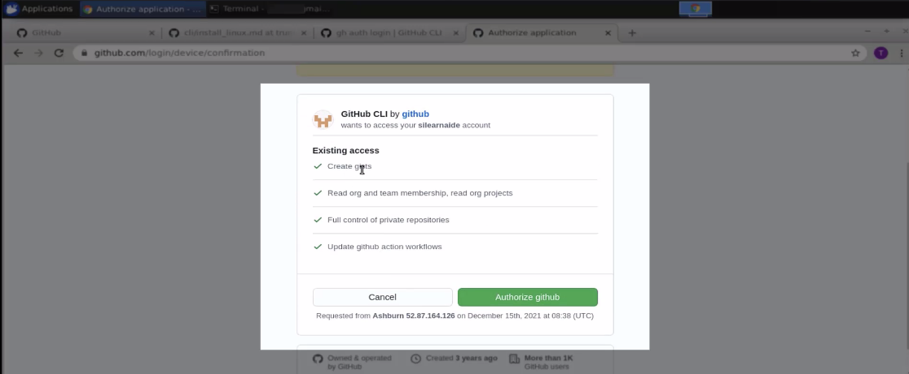

* 1. Enter the password and click on the confirm password button to authenticate yourself



* 1. The GitHub structure will be done

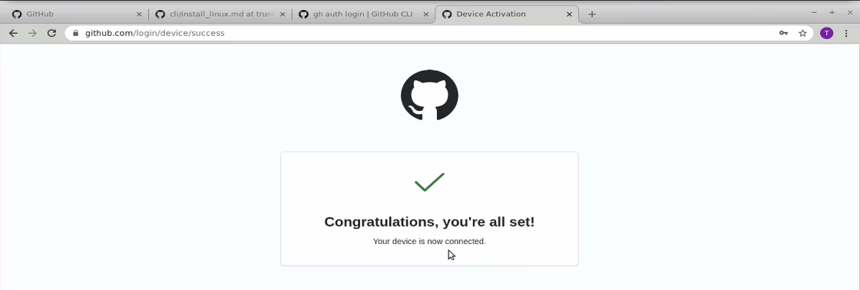

* 1. Go back to the console, and you will see that the authentication is completed

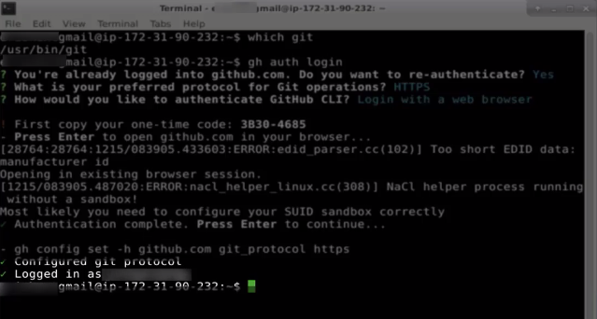

* 1. This is all about the configuration. With the **gh auth login** command in the CLI, you may access GitHub.

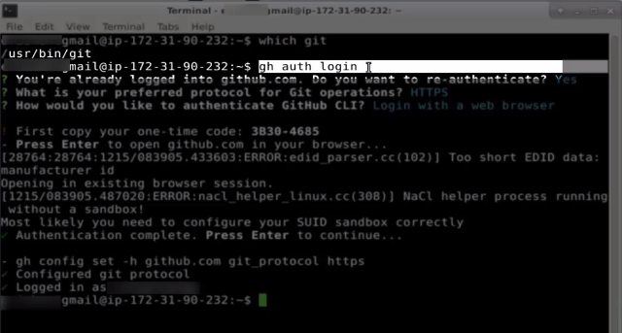

Once you are logged in, you can perform different operations like creating a repository, branch, and so on.