**Lesson 2 Demo 2**

**Configuring Git Account with BitBucket**



Steps to be followed:

1. Create a repository
2. Clone the repository

**Step 1: Create a repository**

* 1. Go to BitBucket’s official website and log in with your Google account or any other account

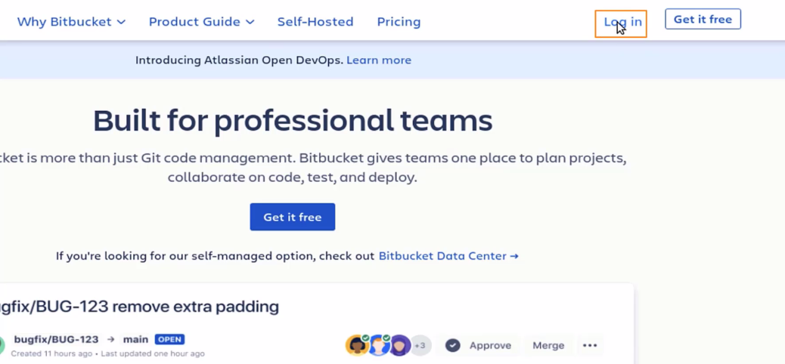

* 1. All the Jira issues will automatically be listed, as shown:

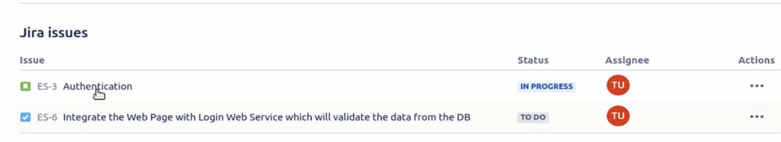

* 1. Create a repository

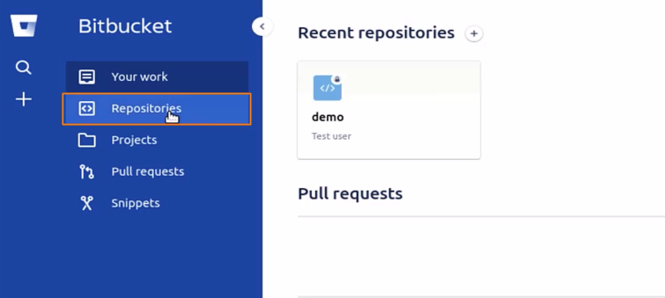

* 1. Click on the **Create repository** button

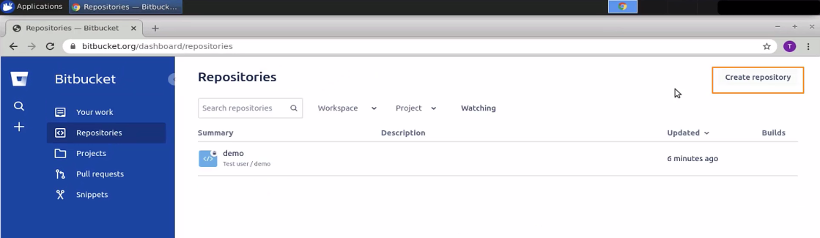

* 1. Select the project called demo. Give the name to the repository, say, webapp. Keep the repository private. Select **yes** for the readme file. Select **yes** for the gitignore file. Once done, click on the **create repository** button

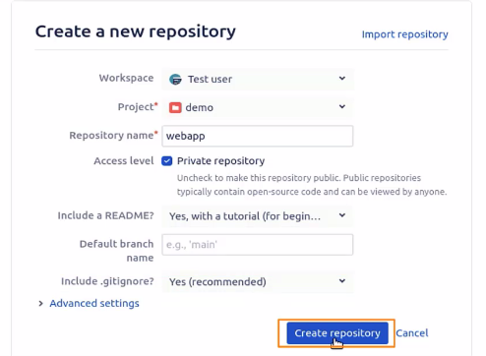

* 1. So, you need to first create the repository, then clone it with the help of a password, and directly access the repositories. Now, go to the account and select the profile

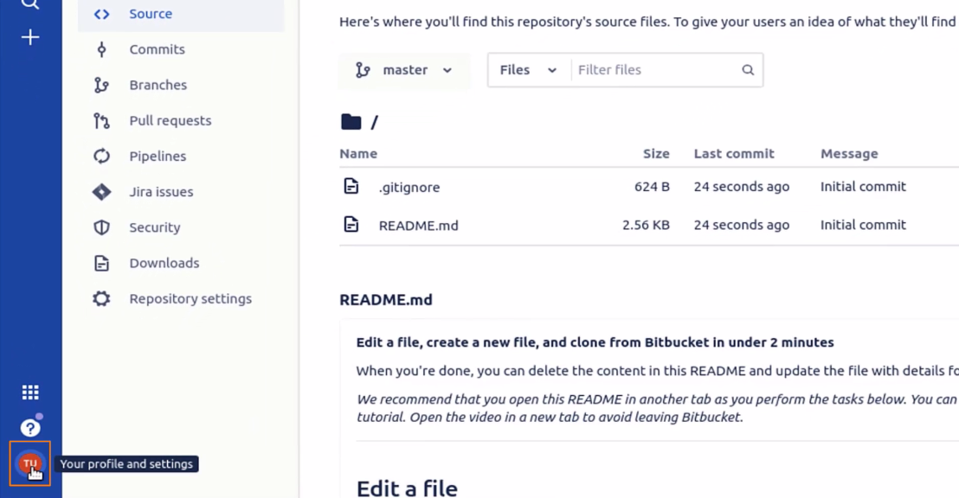

* 1. Go to personal settings

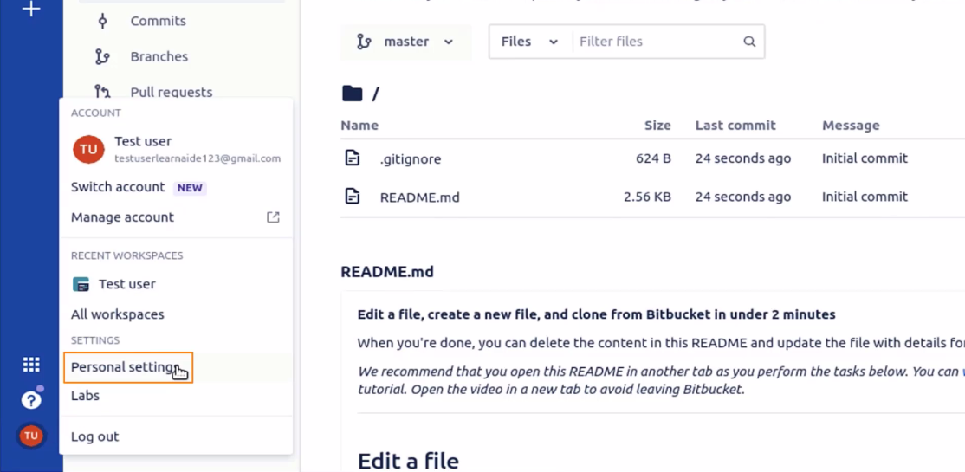

* 1. In the personal settings, go to App passwords

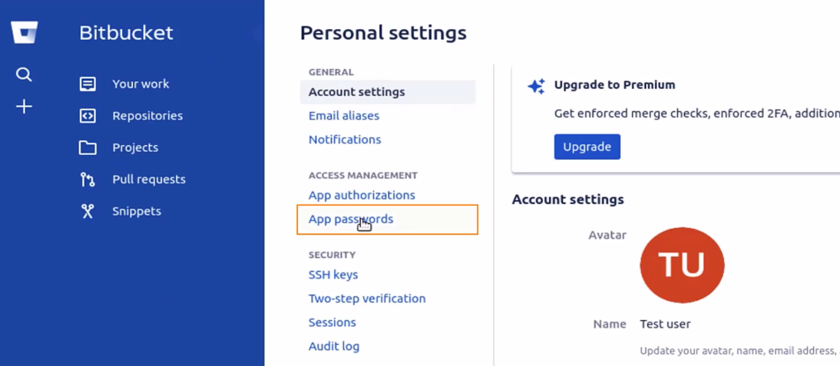

* 1. The app password can be created as soon as you click on the create app password button and you will see that there are so many permissions to work on.

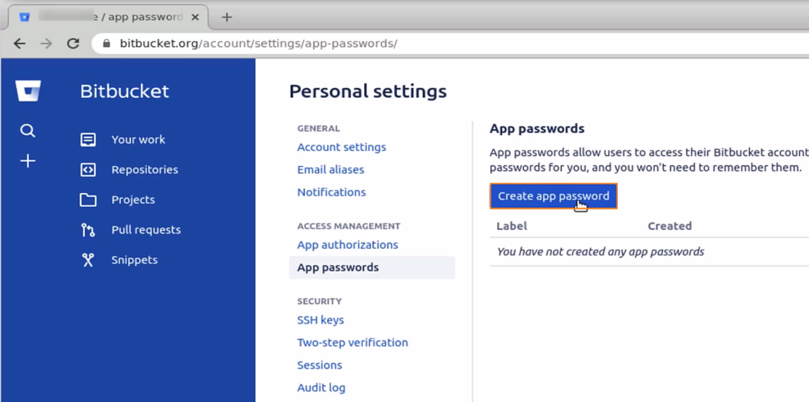

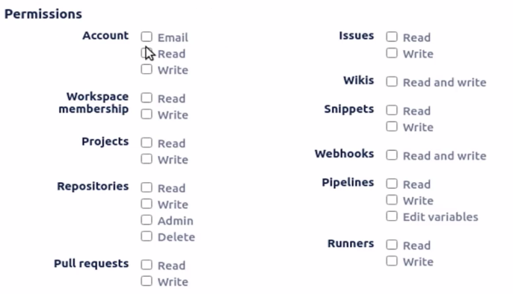

1.10 Select the options required, give a name to the label, and click on the **create** button

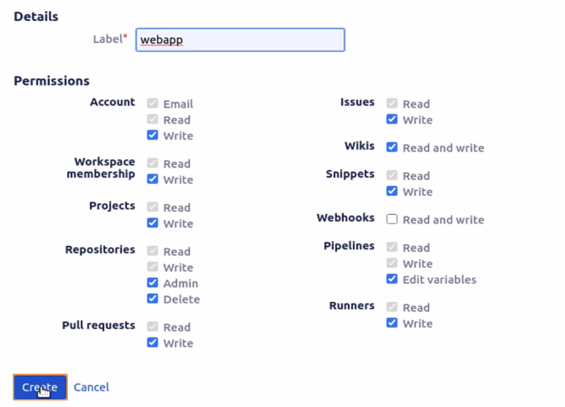

1.11 A new app password will be generated. Copy and save the password somewhere as this will be required later. It also acts like one of the tokens with the help of which you can access one of the repositories.

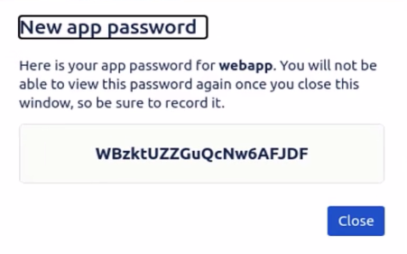

1.12 Now, open the terminal and check if Git is already installed by using the *which git* command

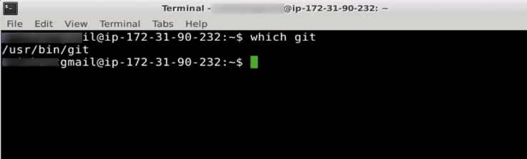

1.13 Now, go back to the repositories and select the webapp as the repository

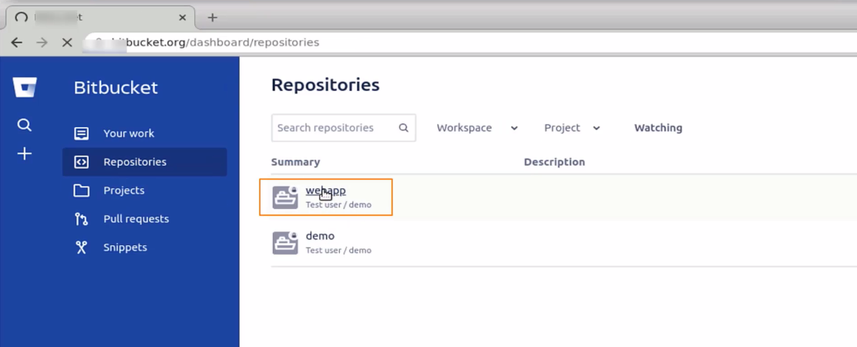

**Step 2: Clone the repository**

* 1. To clone the repository, click on the **clone** button

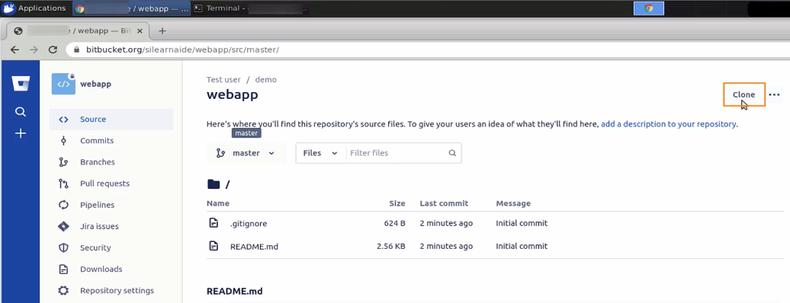

* 1. You will get a link that you need to copy

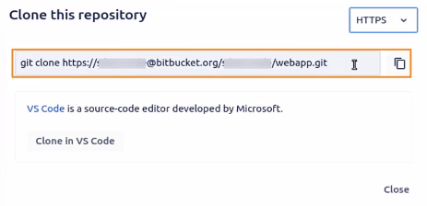

* 1. Now, go to the terminal and change the directory to the downloads directory

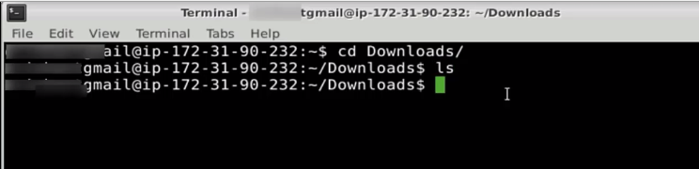

* 1. Currently, there are no files in the downloads directory. Now, paste the git clone link and press **enter.**

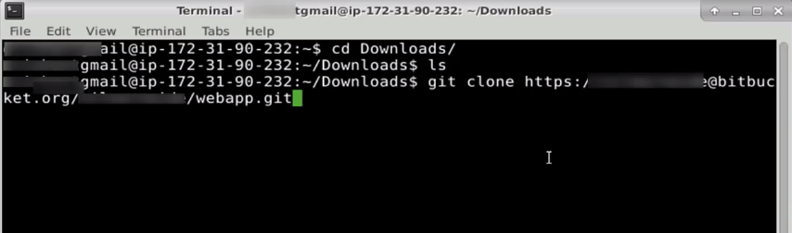

* 1. Now, enter the password, which you had saved earlier. Copy-paste the password and press **enter**

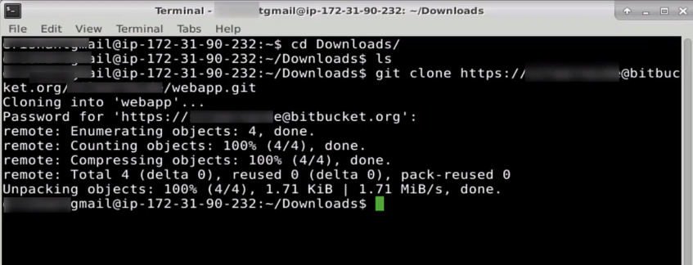

* 1. Type ls and check if the repository is cloned successfully

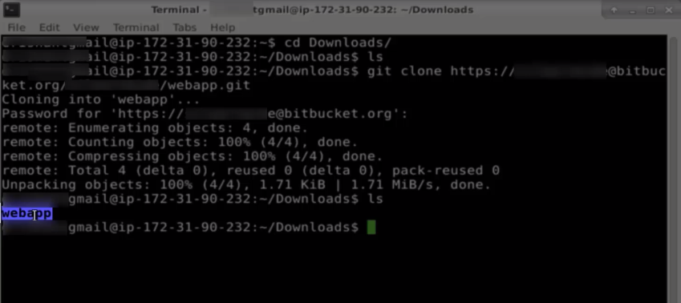

* 1. Move to the webapp directory

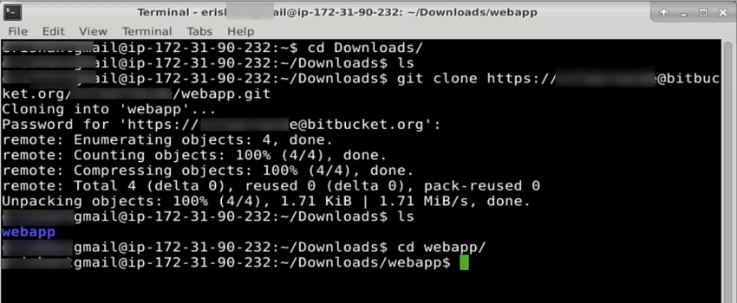

* 1. Type ls and you will be able to see the readme file, which is the default file

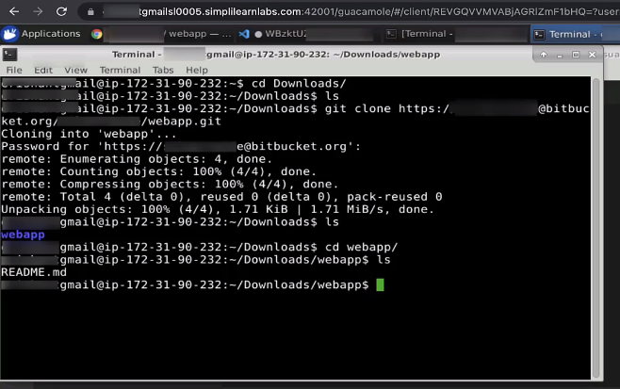

In this way, you can configure GitHub and Bitbucket for our usage. Remember configuration is not just one of the ways. There are different ways to do the configuration. This is through HTTPS. So, in case you want to work on SSH, you need to adopt a separate flow. Typically, for your same personal settings here.

* 1. Go to profile -> personal settings -> SSH Keys. You can configure the SSH keys from here.

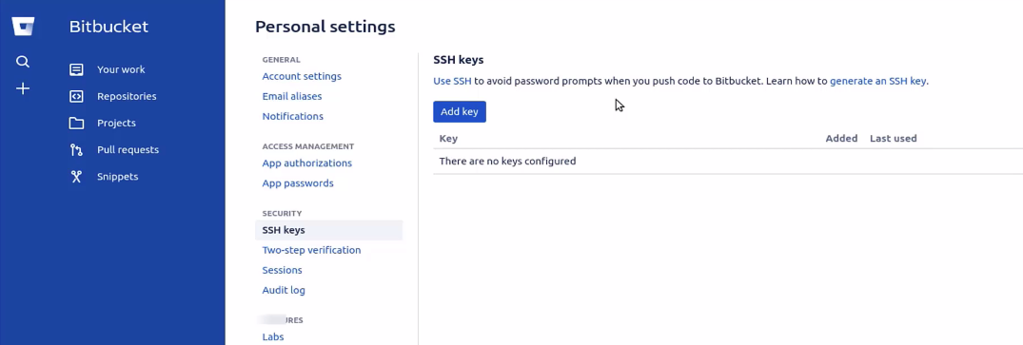

This is how you work on the configuration of the BitBucket.