**Lesson 3 Demo 2**

**Pushing the Code to GitHub**



Steps to be followed:

1. Pushing the code to GitHub

**Step 1: Pushing the code to GitHub**

* 1. Open a terminal window. Enter ‘**git status**’.



* 1. Copy the link to the repository from **github.com**  
       
     Graphical user interface, text, application, email

     Description automatically generated
  2. Enter ‘**git remote add origin**’ and paste the URL  
       
     
  3. Enter ‘**git push -u origin master**’  
       
     Text

     Description automatically generated
  4. Refresh the **github.com** page  
       
     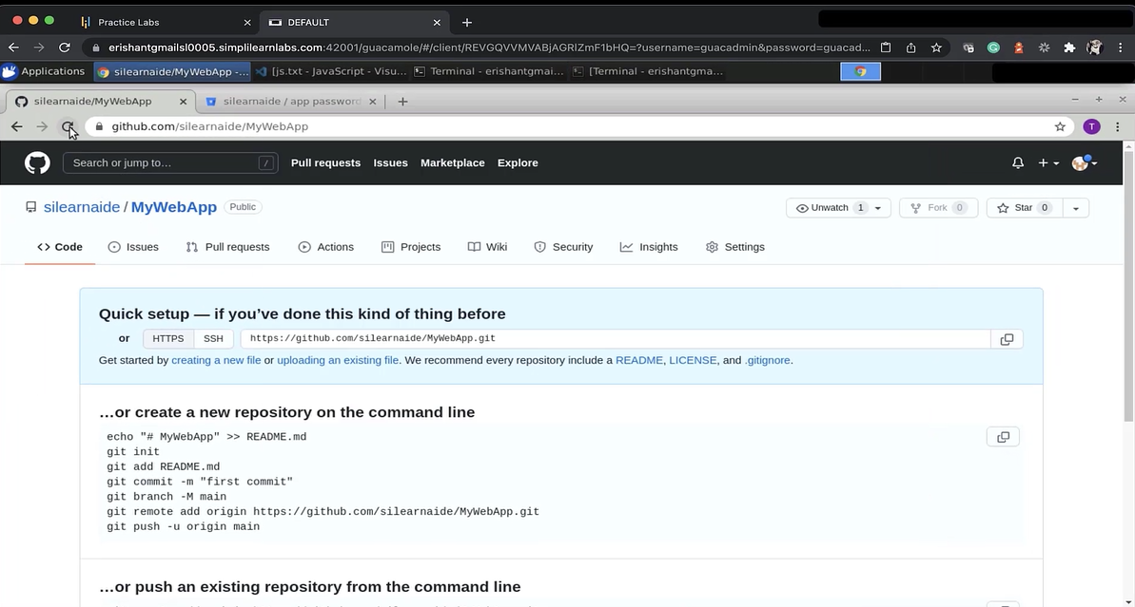
  5. Enter ‘**git status**’  
       
     Text

     Description automatically generated with medium confidence
  6. Enter ‘**git push -u origin master**’. Enter the password from a Bitbucket.  
       
     Text

     Description automatically generated
  7. Go to the Bitbucket  
       
     Graphical user interface, text, application, email

     Description automatically generated
  8. Go to the source and you should be able to see the files pushed  
       
     Graphical user interface, text, application

     Description automatically generated