**Lesson 4 Demo 1**

**Working with Branches**



Steps to be followed:

1. Create and work with a branch

**Step 1: Create and work with a branch**

* 1. Go to GitHub. Open one of the navigated repositories called MyWebApp.

* 1. Click on the **master** to create a branch. Name the branch. Click on the **interface** to create a branch.

* 1. Click on the **view all** branches. You will see the screen below:

* 1. Go to the Bitbucket and then go to the repository  
       
     Graphical user interface, text, application, email

     Description automatically generated
  2. Go to the Branches  
       
     Graphical user interface, text, application

     Description automatically generated
  3. Click on the **create branch** button. Give it a name as feature1, and click on **Create.**  
       
     Graphical user interface, application

     Description automatically generated
  4. Open a terminal window, open a desktop, and then open MyWebApp. Type ‘**git branch**’.  
       
     Text

     Description automatically generated
  5. Give ‘git branch –list’  
       
     
  6. To get a new branch, type ‘**git branch feature2**’, and then type ‘**git branch**’.  
       
     Text

     Description automatically generated
  7. Go back to **GitHub** and refresh the page  
       
     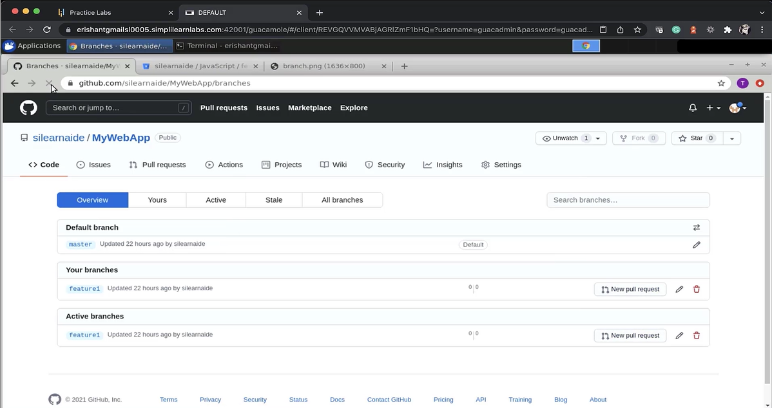
  8. Go to the terminal window. Type ‘**git branch -d feature2**’. Give ‘**git branch**’.  
       
     Text

     Description automatically generated
  9. Create a branch with ‘**git branch feature2**’. Type ‘**git branch**’.  
       
     
  10. To rename a branch, type ‘git branch -m feature2 myfeature’. Type ‘git branch’.  
        
      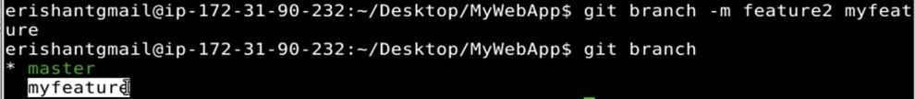
  11. Open a new terminal window. Type ‘desktop’, type a directory called ‘JavaScripts’. Type ‘**git branch**’.  
        
      Text

      Description automatically generated
  12. Open a new terminal. Type **downloads** directory and you have cloned the repository from the Bitbucket.  
        
      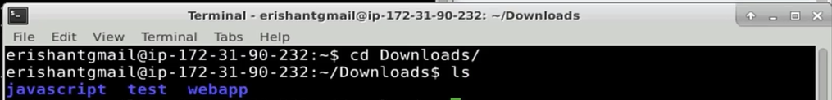
  13. Enter ‘**cd JavaScripts**’. Type ‘**git branch**’.  
        
      
  14. Enter ‘git fetch –all’ which will fetch all the remote branches. Enter the password which is stored in the file  
        
      
  15. Enter ‘**git branch –all**’ in the original terminal window. Enter ‘**git branch**’.  
        
      Text

      Description automatically generated
  16. Enter ‘**git checkout myfeature**, and ‘**git branch**’.  
        
      Text

      Description automatically generated
  17. Enter ‘**git checkout -b yourfeature**’, and ‘**git branch**’  
        
      Text

      Description automatically generated
  18. To switch between the branches, enter ‘git checkout feature1’. Enter ‘git branch’.  
        
      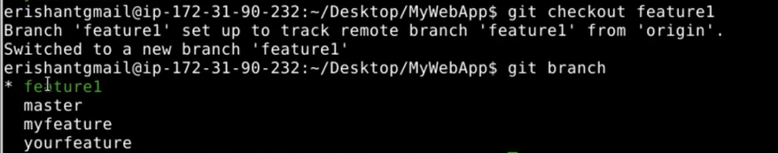
  19. To merge the branches, enter ‘git checkout myfeature’, and enter ‘git branch’  
        
      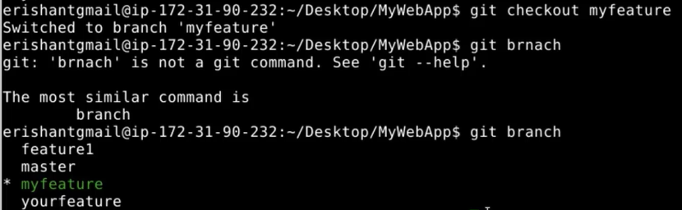
  20. Enter ‘feature1.js’. Enter ‘git add feature1.js’. Run ‘git status’.

* 1. Enter ‘git commit -m *A new feature feature1.js in feature branch*  
       
     Text

     Description automatically generated
  2. Enter ‘touch feature2.js’. Enter ‘git add feature1.js’. Run ‘git status’.  
       
     Text

     Description automatically generated
  3. Enter ‘git commit -m “feature2 for the feature1”. Enter ‘git branch’.  
       
     Text

     Description automatically generated
  4. Enter ‘git checkout master’. Enter ‘git branch’. Enter ‘git merge myfeature’.

* 1. To delete the branch, enter ‘git branch -d myfeature’  
       
     