Riddle & Code

LIBRDDL SDK
Table of Contents
1 DESCRIPTION 3
2 SOFTWARE ARCHITECTURE 4
3.1 API FUNCTIONS 4
3 TESTS 6

Table of Figures

DESCRIPTION

This document includes usage method, software architecture and test results of RDDL SDK.
< What is RDDL SDK? Purpose of RDDL SDK>
< Mention libRDDL repo >
< Mention Planetmint and Liquid>

SOFTWARE ARCHITECTURE
Figure 1 indicates library structure. The library consists of 3 layers:
- libRddlApi: This layer includes user functions.
- libRddlAbst: This layer includes hardware specific functions
- libRddl: This layer includes common software function which are platform independent.

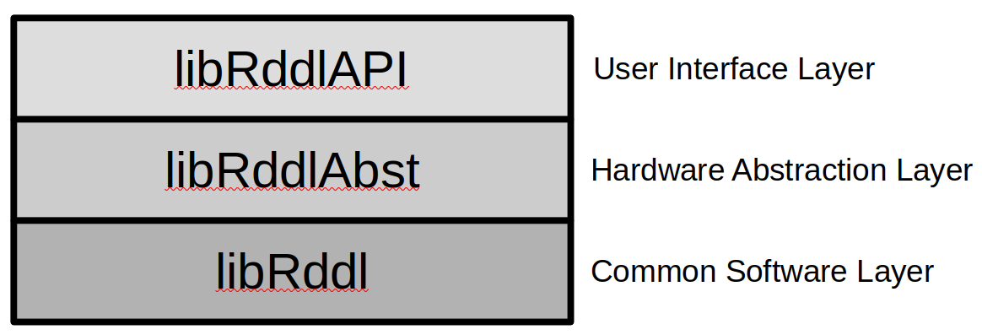Figure 1: General System Overview

3.1 API FUNCTIONS
User can call libRddlAPI functions to use the library:
void runRDDLNotarizationWorkflow(const char* data_str, size_t data_length): This function has two separate tasks. If the device is registered to the network, it creates a transaction using the given data and broadcasts it. If the device is not registered to the network, it creates a registration transaction and broadcasts it. Figure 2 gives flowchart of this function.

The getPlntmntKeys function prepares public and private keys to be used in other functions. It generates the master key from the seed stored in the device. It generates planetmint keys from masterkey with the following derivation path /44'/8680'/0'/0/0 and liquid keys from /44'/1776'/0'/0/0. It also derives the public key from the private key embedded in the machine.

The hasMachineBeenAttested function checks whether the device has been registered before by querying https://testnet-api.rddl.io/planetmint/machine/get_machine_by_public_key. It uses the planetmint external public key for the query which is serialized of planetmint node with PLANETMINT_PMP version.

The registerMachine function creates a message in the google protobuf structure containing machine information. This machine information includes the generated public keys, the machine's domain and device information.

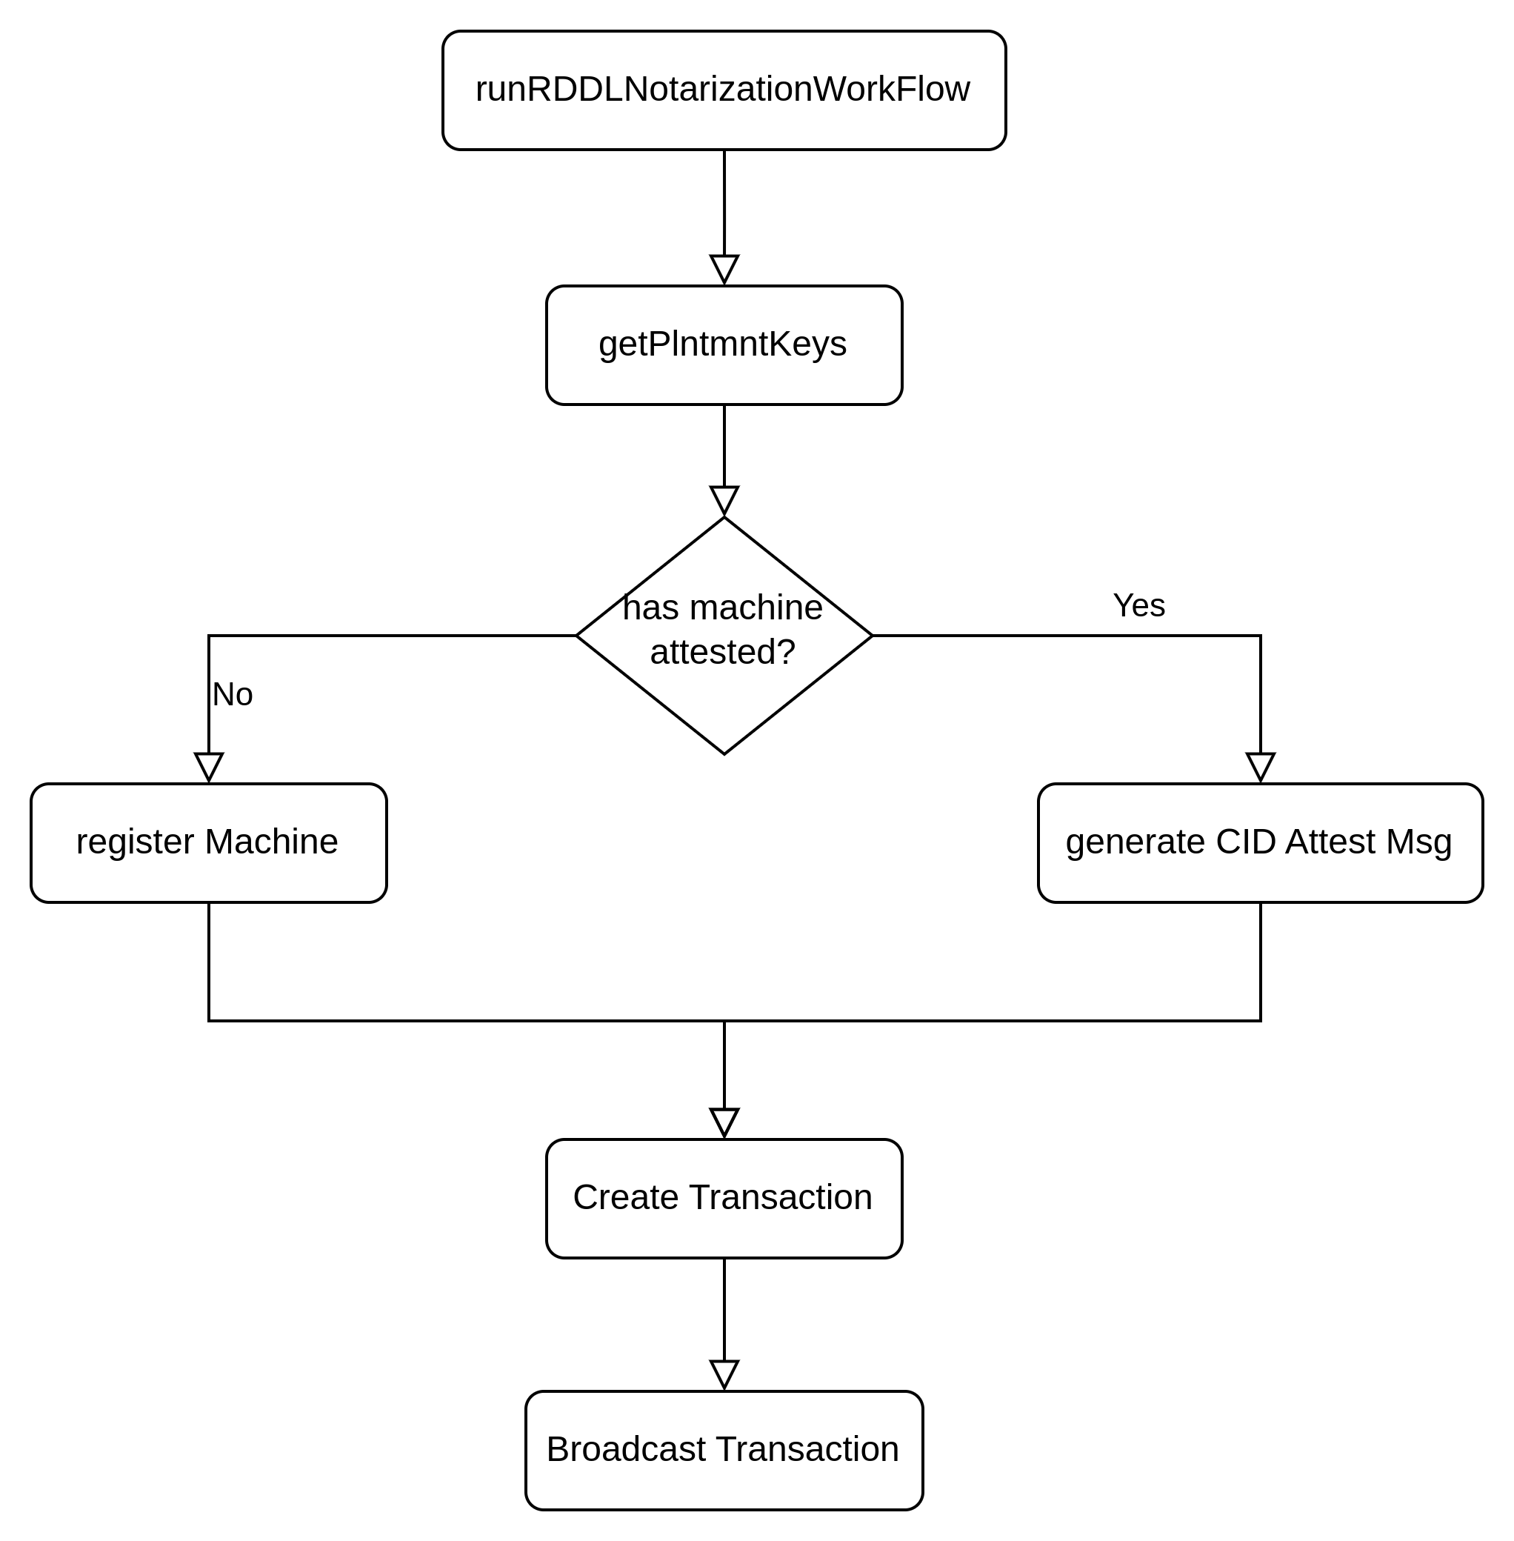Figure 2: flowchart of runRDLLNotarizationWorkflow function
The create transaction function prepares the transaction using the generated message in the google protobuf structure, planetmint keys, denom, sequence, chain id and account id. Denom and chain-id information are retrieved from the device. If it is not saved in the device, default values are used which are plmnt and planetmint-testnet-1 respectively. Sequence and account id information is retrieved by querying https://testnet-api.rddl.io/cosmos/auth/v1beta1/account_info/. The hash160 version of the planetmint public key is used for this query. If the query returns negative, information is retrieved from the device. If it is not saved in the device, default values are used which are 0.
Finally, broadcast transaction function sends the created transaction to https://testnet-api.rddl.io/cosmos/tx/v1beta1/txs address.

TESTS

If the test device is not registered to the network, the following errors will be received when the test program is run.

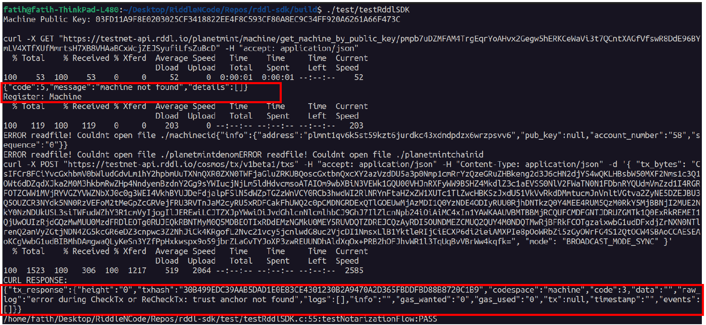Figure 3: Message for Trusted Anchor that has not registered the network
The first message in the red frame indicates that the device is not registered to the network. Second one indicates that the Trusted Anchor used is also not known by the network. Note that Trust Anchor's private key is embedded in the code. If it will be used as a different device, it must be changed in rddl.c.

First, Trust Anchor needs to be registered to the network. To register the Trusted Anchor, we must send a request to the network using the 32-digit Hex number specified by the “Machine Public Key” in Figure 3. This number is public key of Trusted Anchor. To send registration request, we need to use the following message;
curl -X POST https://testnet-ta.rddl.io/register/<32DigitHexValue>

Figure 4: Registration Request for Trusted Anchor
After registering the machine to the network, we will load some coins on it so that it can pay the transaction fees. Otherwise, transactions will be rejected due to insufficient coins.

To do this, we will open https://testnet-faucet.rddl.io/#/default/post_ and upload money to the account ID in Figure 3.
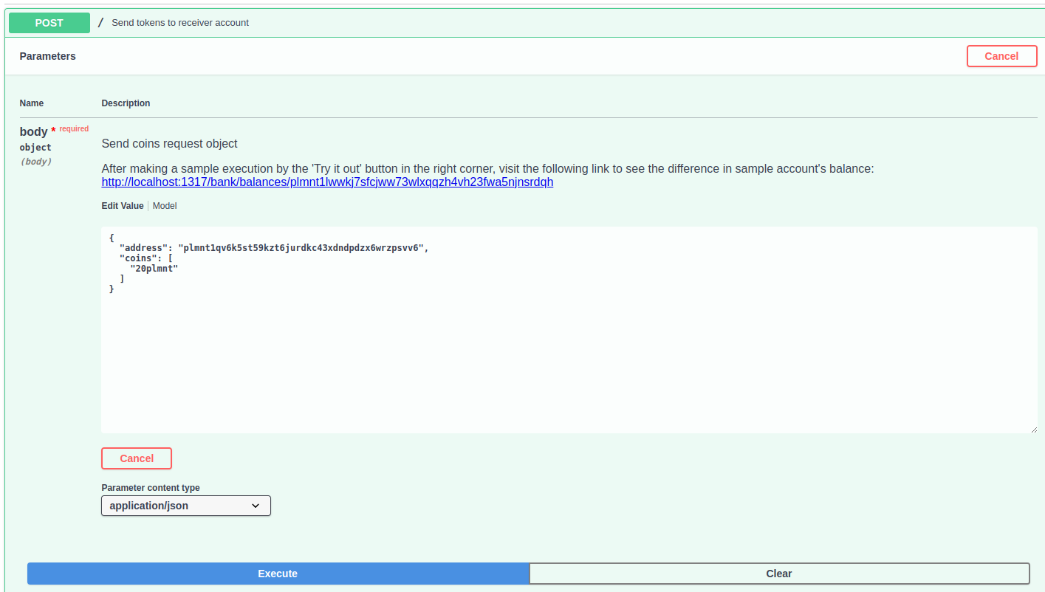
asd

