ME 575

Homework #1 Spring Design

Due Wednesday, January 16, 10:50 a.m.

The specifications and modeling equations for compression spring design are given below. We wish to determine the spring design that maximizes the force of a spring at its preload height, ho, of 1.0 inches. The spring is to operate an indefinite number of times through a deflection δo, of 0.4 inches, which is an additional deflection from ho. The stress at the solid height, hs, must be less than Sy to protect the spring from inadvertent damage.

The variables defining the design of a spring are d, D, n, ho and hf,

where d = wire diameter
D = coil diameter
n = number of coils in the spring
ho = preload height
hf = free height (spring exerting no force)

and other variables/functions, as shown below, are,

δo = deflection from preload height
hdef = deflected height
hs = solid height

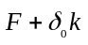
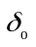
D
F
h_{def}
h_{f}
/d/
F_{s}
h_{s}
h_{o}

The force in a linear spring is given by,

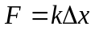

where k is the spring stiffness and Δx is the deflection.

The spring stiffness is,

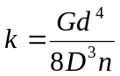

where G is the shear modulus of the material. The stress in a spring with an axial load of F is,
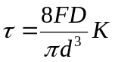

where Κ is the Wahl factor that accounts for stress concentration due to curvature of the spring as well as direct shear:

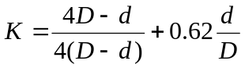

Solid height, hs, is the height at which the coils of the compressed spring close up. It is simply,

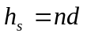

If the spring is to operate indefinitely through a deflection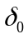, it must be designed so that it does not fail in fatigue. A fatigue criterion for compression spring design is

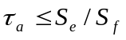

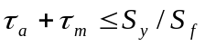
where 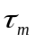 is the mean shear stress and 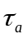is the alternating shear stress, defined to be,

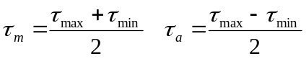

and where Sf is a factor of safety, Se is the endurance limit, and Sy is the yield strength in shear. Sf and Se are constants, but Sy is a function of material properties Q and w, according to the relation,

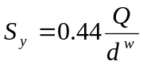

Also, to be reasonable, the ratio 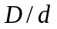should be 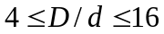. The diameters of wire should be 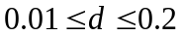inches. The maximum allowable width for the spring, i.e., 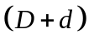, is 0.75 inches. To insure that the spring does not reach solid height in service, a clash allowance of 0.05 inches should be provided. This means the solid height should be at least 0.05 inches below the lowest point of deflection the spring reaches in service.

For this problem, assume
G = 12 x 106 psi Sf = 1.5
Se = 45,000 psi Q = 150,000 psi
w = 0.18

Also assume the number of coils is continuous for optimization.

Sample Design:
(Note, no guarantee this is a feasible design)

wire diameter 0.050 (in)
coil diameter 0.500 (in)
number of coils 10.00
free height 1.500 (in)

Spring constant 7.500 (lb/in)
Wahl Factor 1.14533
Force at Preload height 3.75 (lb)
Alternating Stress 17499 (psi)
Mean Stress 61248 (psi)
Yield Strength 113170 (psi)
Clash Allowance 0.1 (in)
Diameter Sum 0.55 (in)

Assignment:
- From the description, develop the model for the optimization problem.
- Using fmincon in MATLAB, solve for the optimum for several starting points, as mentioned below. Investigate the effects of simple scaling, also described below. Explore the design space by creating the requested contour plots.

Report:
- Model:
  - Provide a table showing the mapping between analysis variables, design variables, analysis functions and design functions, similar to Figure 1.7 in the notes.
  - Give a copy of your MATLAB code showing your computations. Comment your code so I can follow it.
- Results:
  - Provide a table showing the optimum values of all variables and functions (analysis and design). Indicate (with arrows, highlighter, etc.) binding constraints and/or variables at bounds. (Hint: use Courier font to keep values aligned.)
  - Investigate the effects of some simple scaling. From a designated starting point, record the number of function calls without any scaling. Now divide the design functions by a constant before they are sent to fmincon such that their values are between 1-10. Record the function calls. What effect did scaling have?
  - Provide a table giving several starting points which were tried along with the optimal objective value reached from each. Did the algorithm always converge to the same design?
  - Include a “zoomed out” contour plot showing the design space (both feasible and infeasible space) for coil diameter vs. wire diameter, with all constraints shown and the feasible region shaded and optimum marked.
  - Also show a “zoomed in” contour plot of the design space (mostly feasible space) for coil diameter vs. wire diameter, with all constraints shown and the feasible region shaded and optimum marked.

- Additional Discussion:
  - Include any other observations or comments about the model, process of optimization or the design space. Do you feel this is a global optimum? A few sentences should suffice.

Please note: any output from MATLAB should be integrated into the report as given in the sections above. Tables and figures should have explanatory captions. Please do not just staple pages of output to your assignment.

