MetaSource Code Test #3

# Instructions

Write a program that prints the numbers 1 to 100 within a colored (gray) block. However, for multiples of **three** also render a smile icon next to the number. For multiples of **five** render a frown icon next to the number. For multiples of **three** and **five** output both next to the number.

Use HTML, CSS, and JavaScript to create your solution. You can use ASP and/or any JavaScript library you are comfortable with, or vanilla JavaScript.

You can use the attached icon files (smile.png and frown.png) or an icon service (e.g., font awesome)

# Output

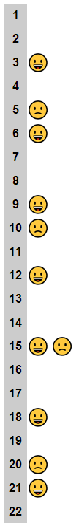Your output should look something like this: