- 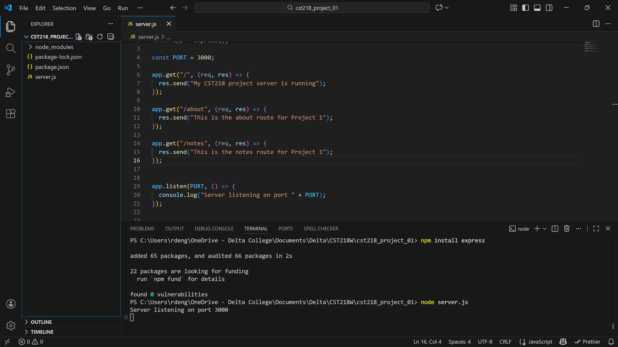
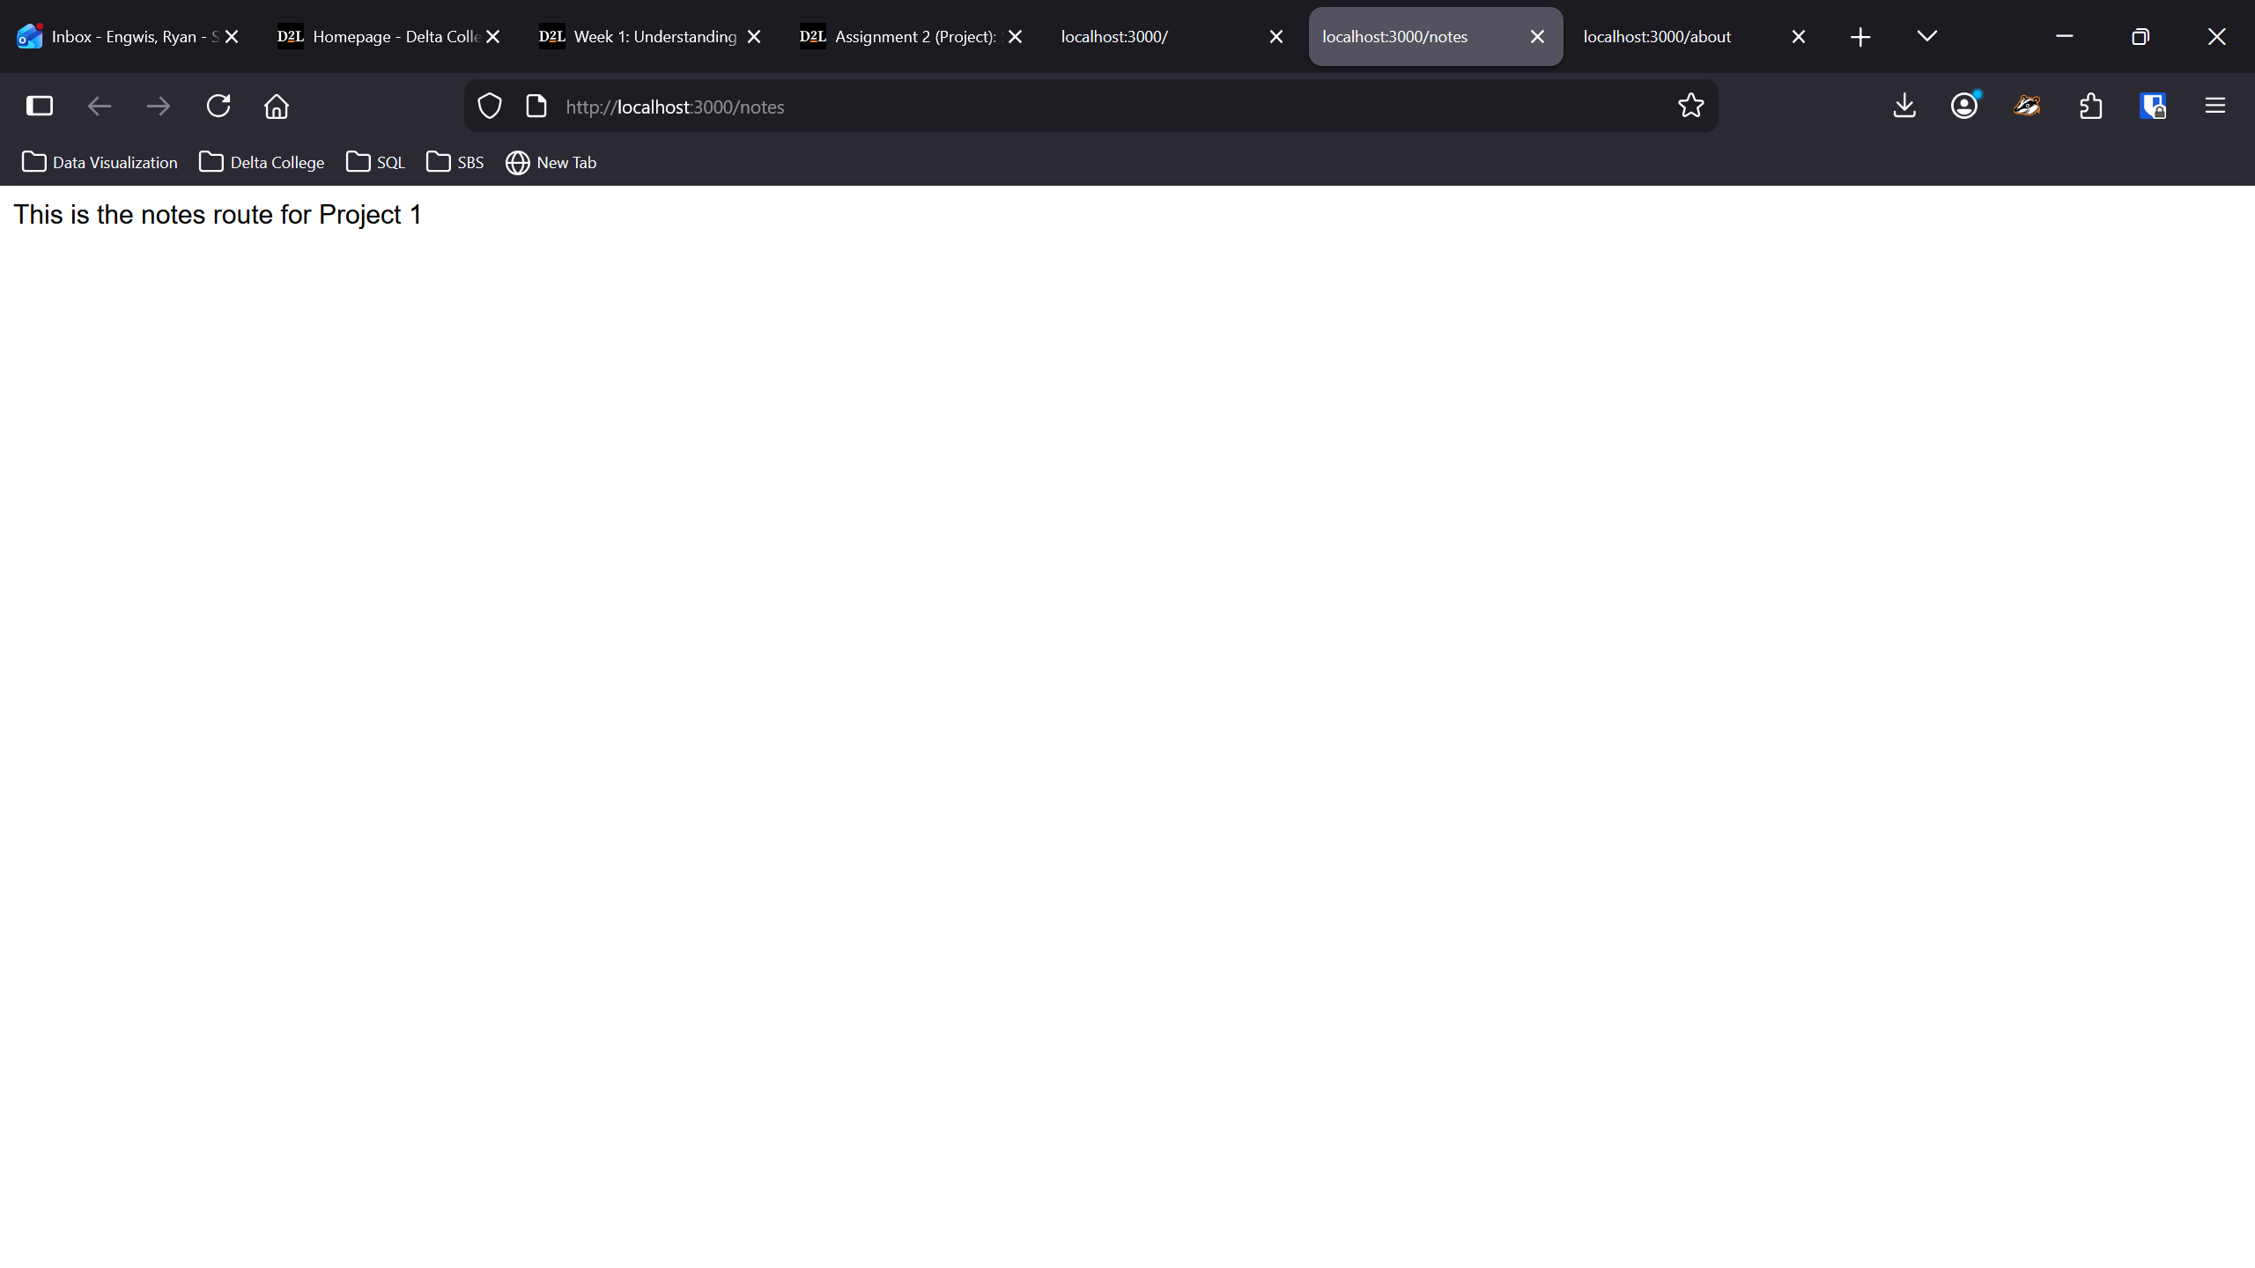
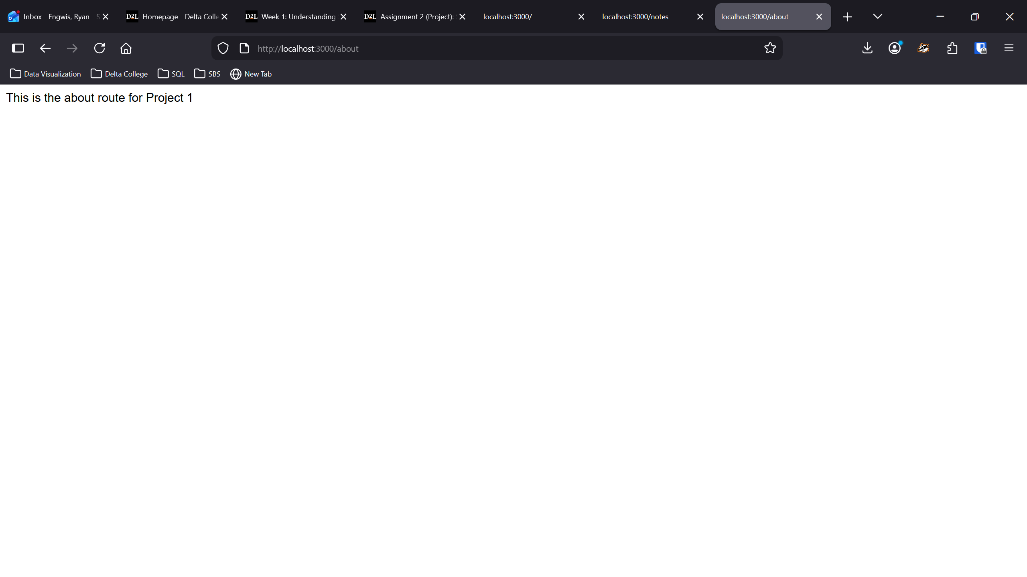
All of this felt very familiar, as we had just completed the steps outlined for this assignment in ‘Assignment 0’ and ‘Assignment 1’. Nothing felt unfamiliar or unclear, and I have no immediate questions regarding the next phase of the course.
Project Idea:
I’d like to develop an application that will interface with my wife and I’s cold-processed soap business (www.sweetbonessoaps.com) to allow us to store and retrieve various business related information, such as current stock, soap recipes, etc.
This application will allow us to easily access other disparate information quickly and easily. This is something often required during face-to-face sales.
My wife and I would be the only two individuals utilizing this application.

