The data I’m choosing to store on my database will be soap recipes. These recipes specify the quantities of components required to combine into various soaps. My app needs this data as it will boost the productivity and effectiveness of our soap business.
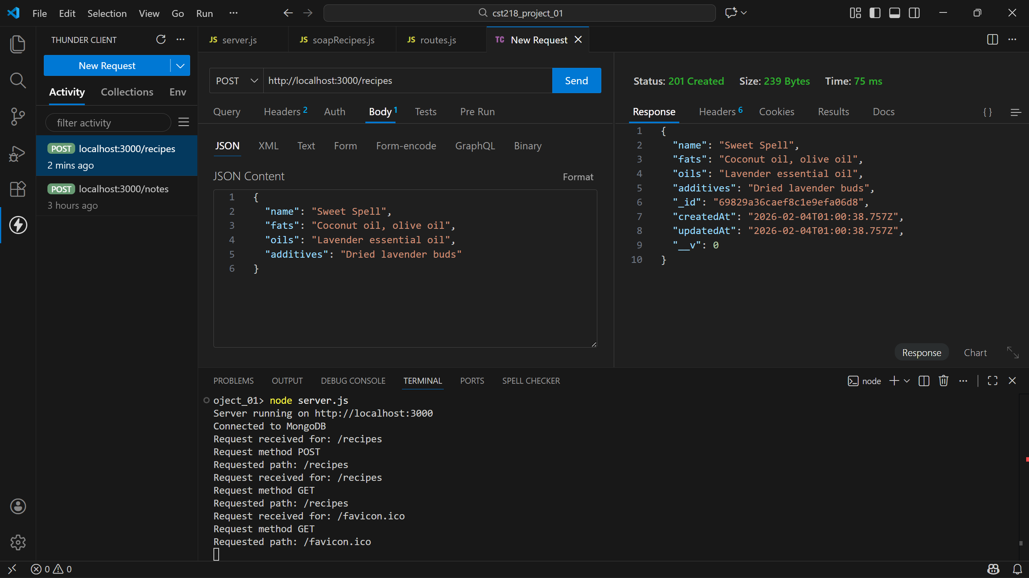
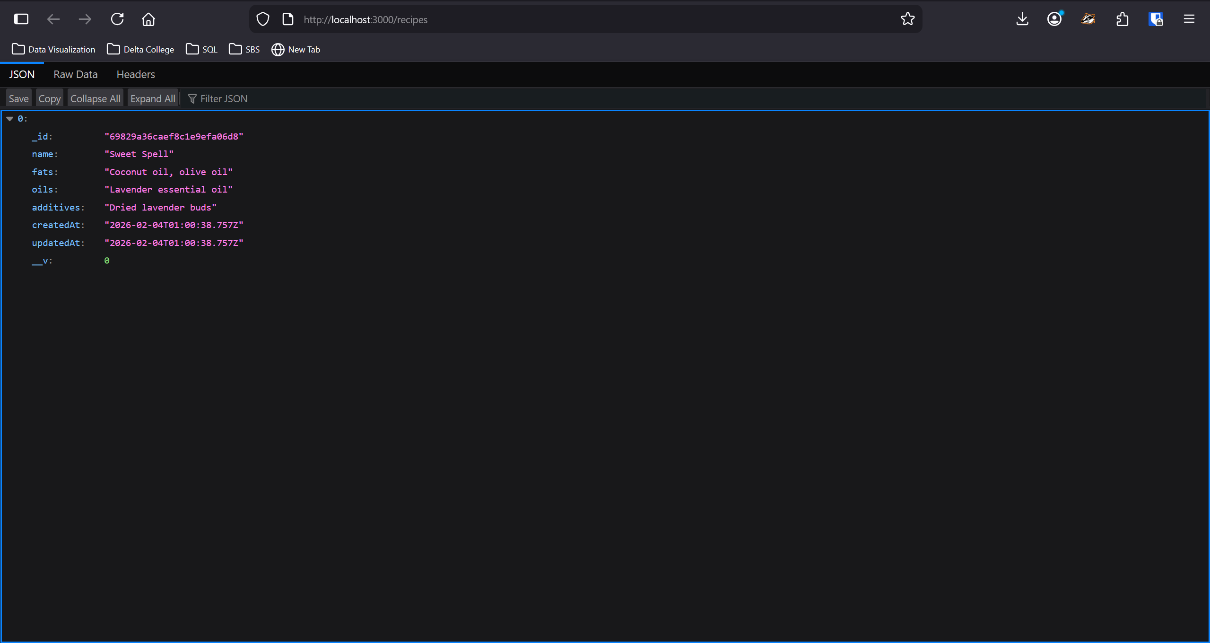

The biggest win was getting the MongoDB database setup and connected, as that was a very challenging process for me. At this point I don’t have too many questions or feel unclear about much. Going forward I’m looking forward to exploring the range of capabilities database integration will offer and learn how to leverage them for our business.

