The data I selected for my app is recipes, specifically soap recipes. This data is important for my app because I’m designing it to help manage the various soap recipes my wife and I’s company utilize in soap production.
A user should be able to utilize all CRUD options to create, edit, and remove soap recipes stored for use within the app.
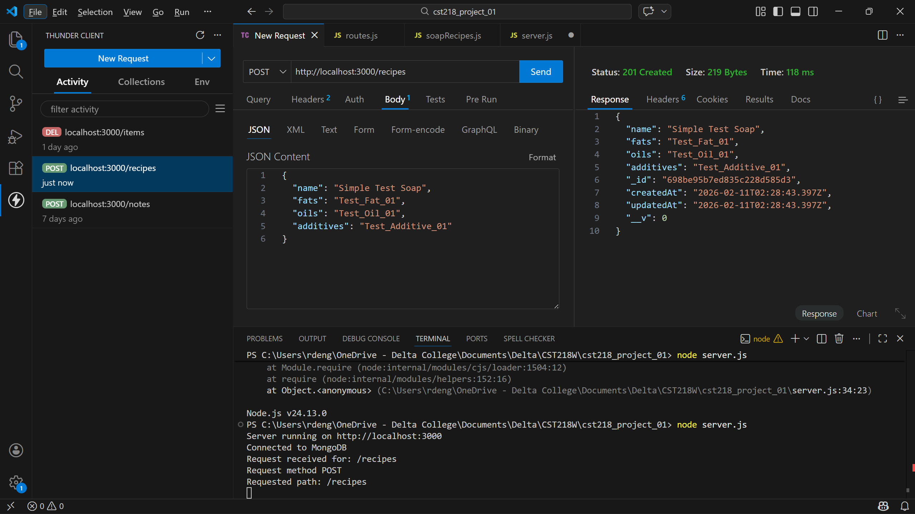
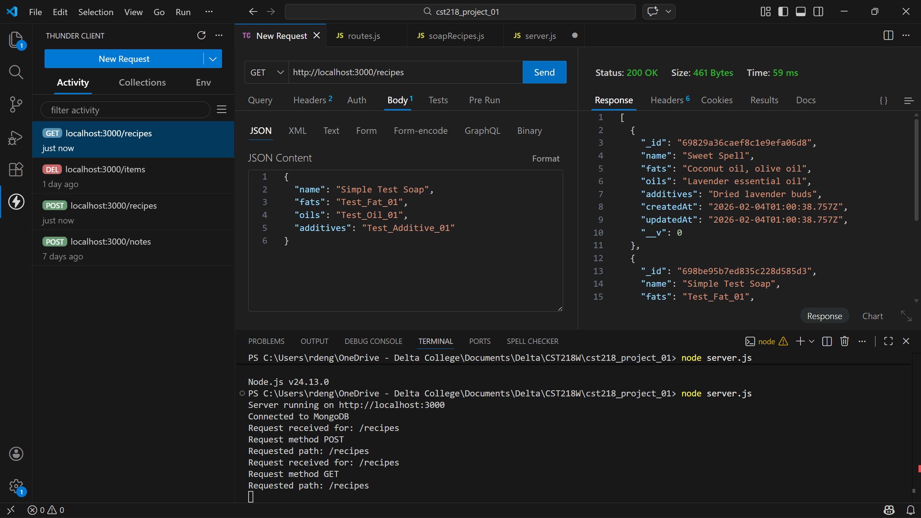
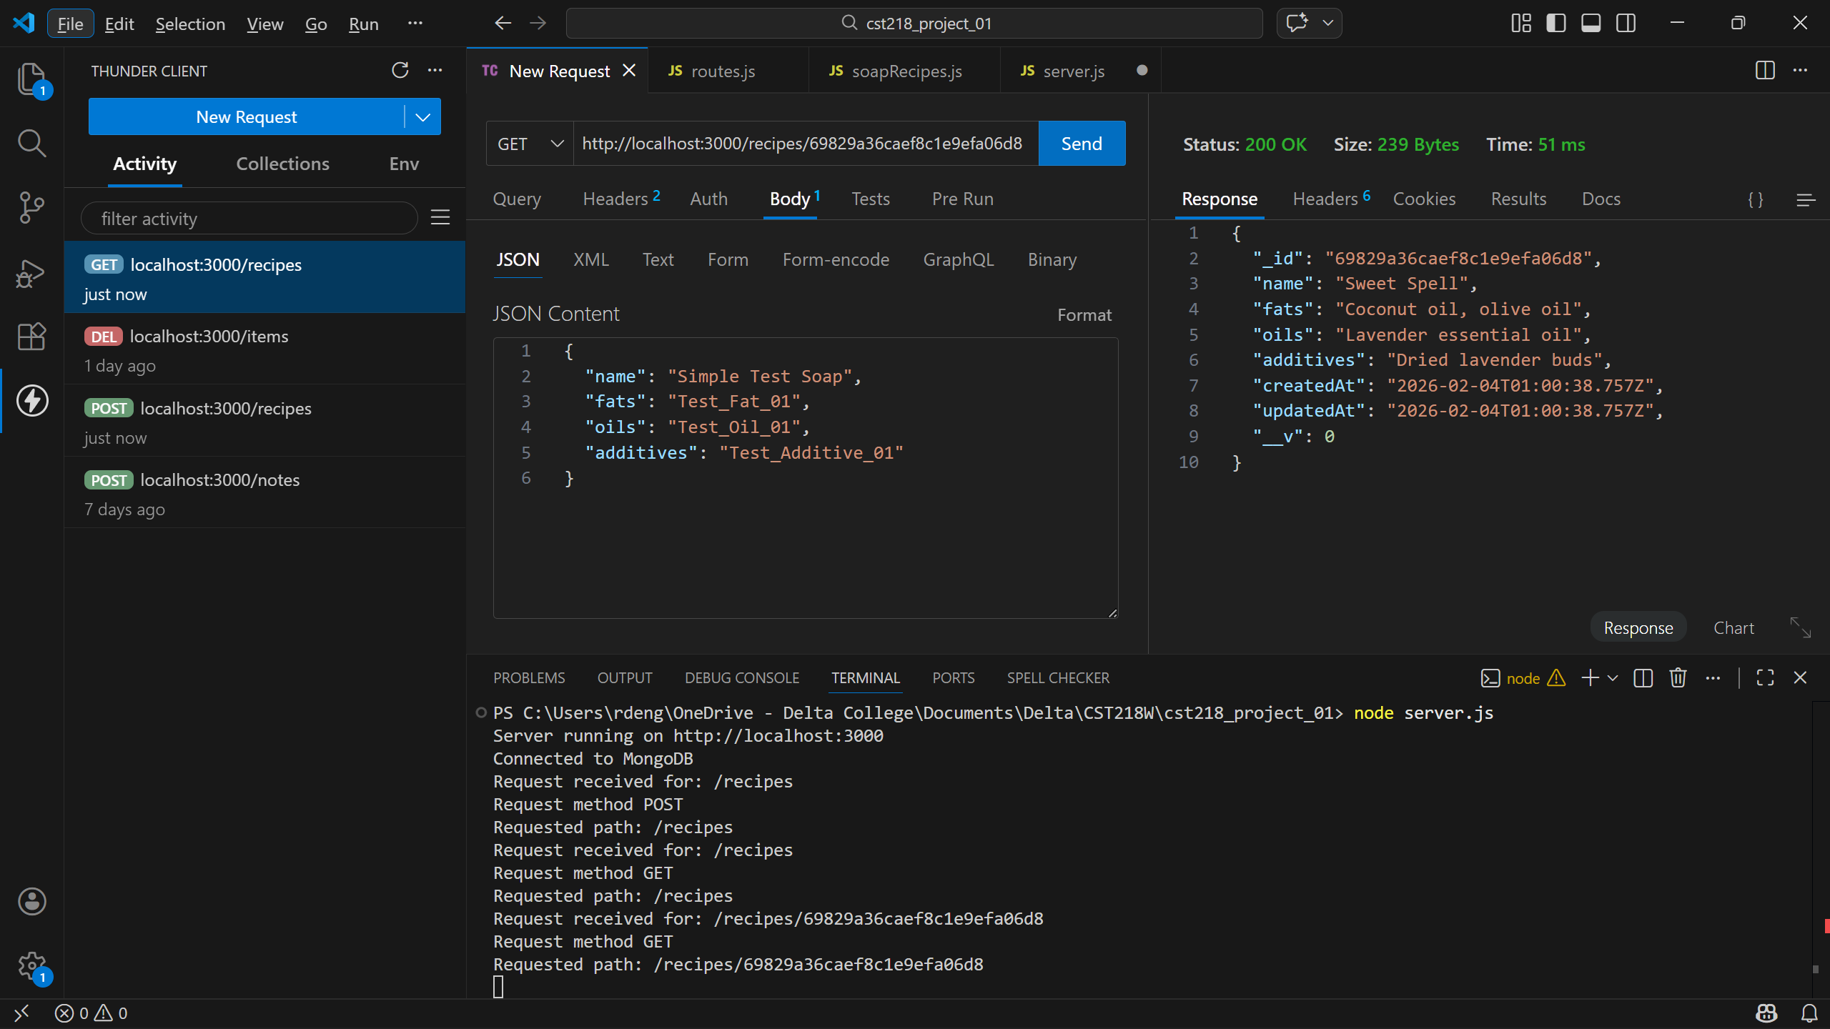
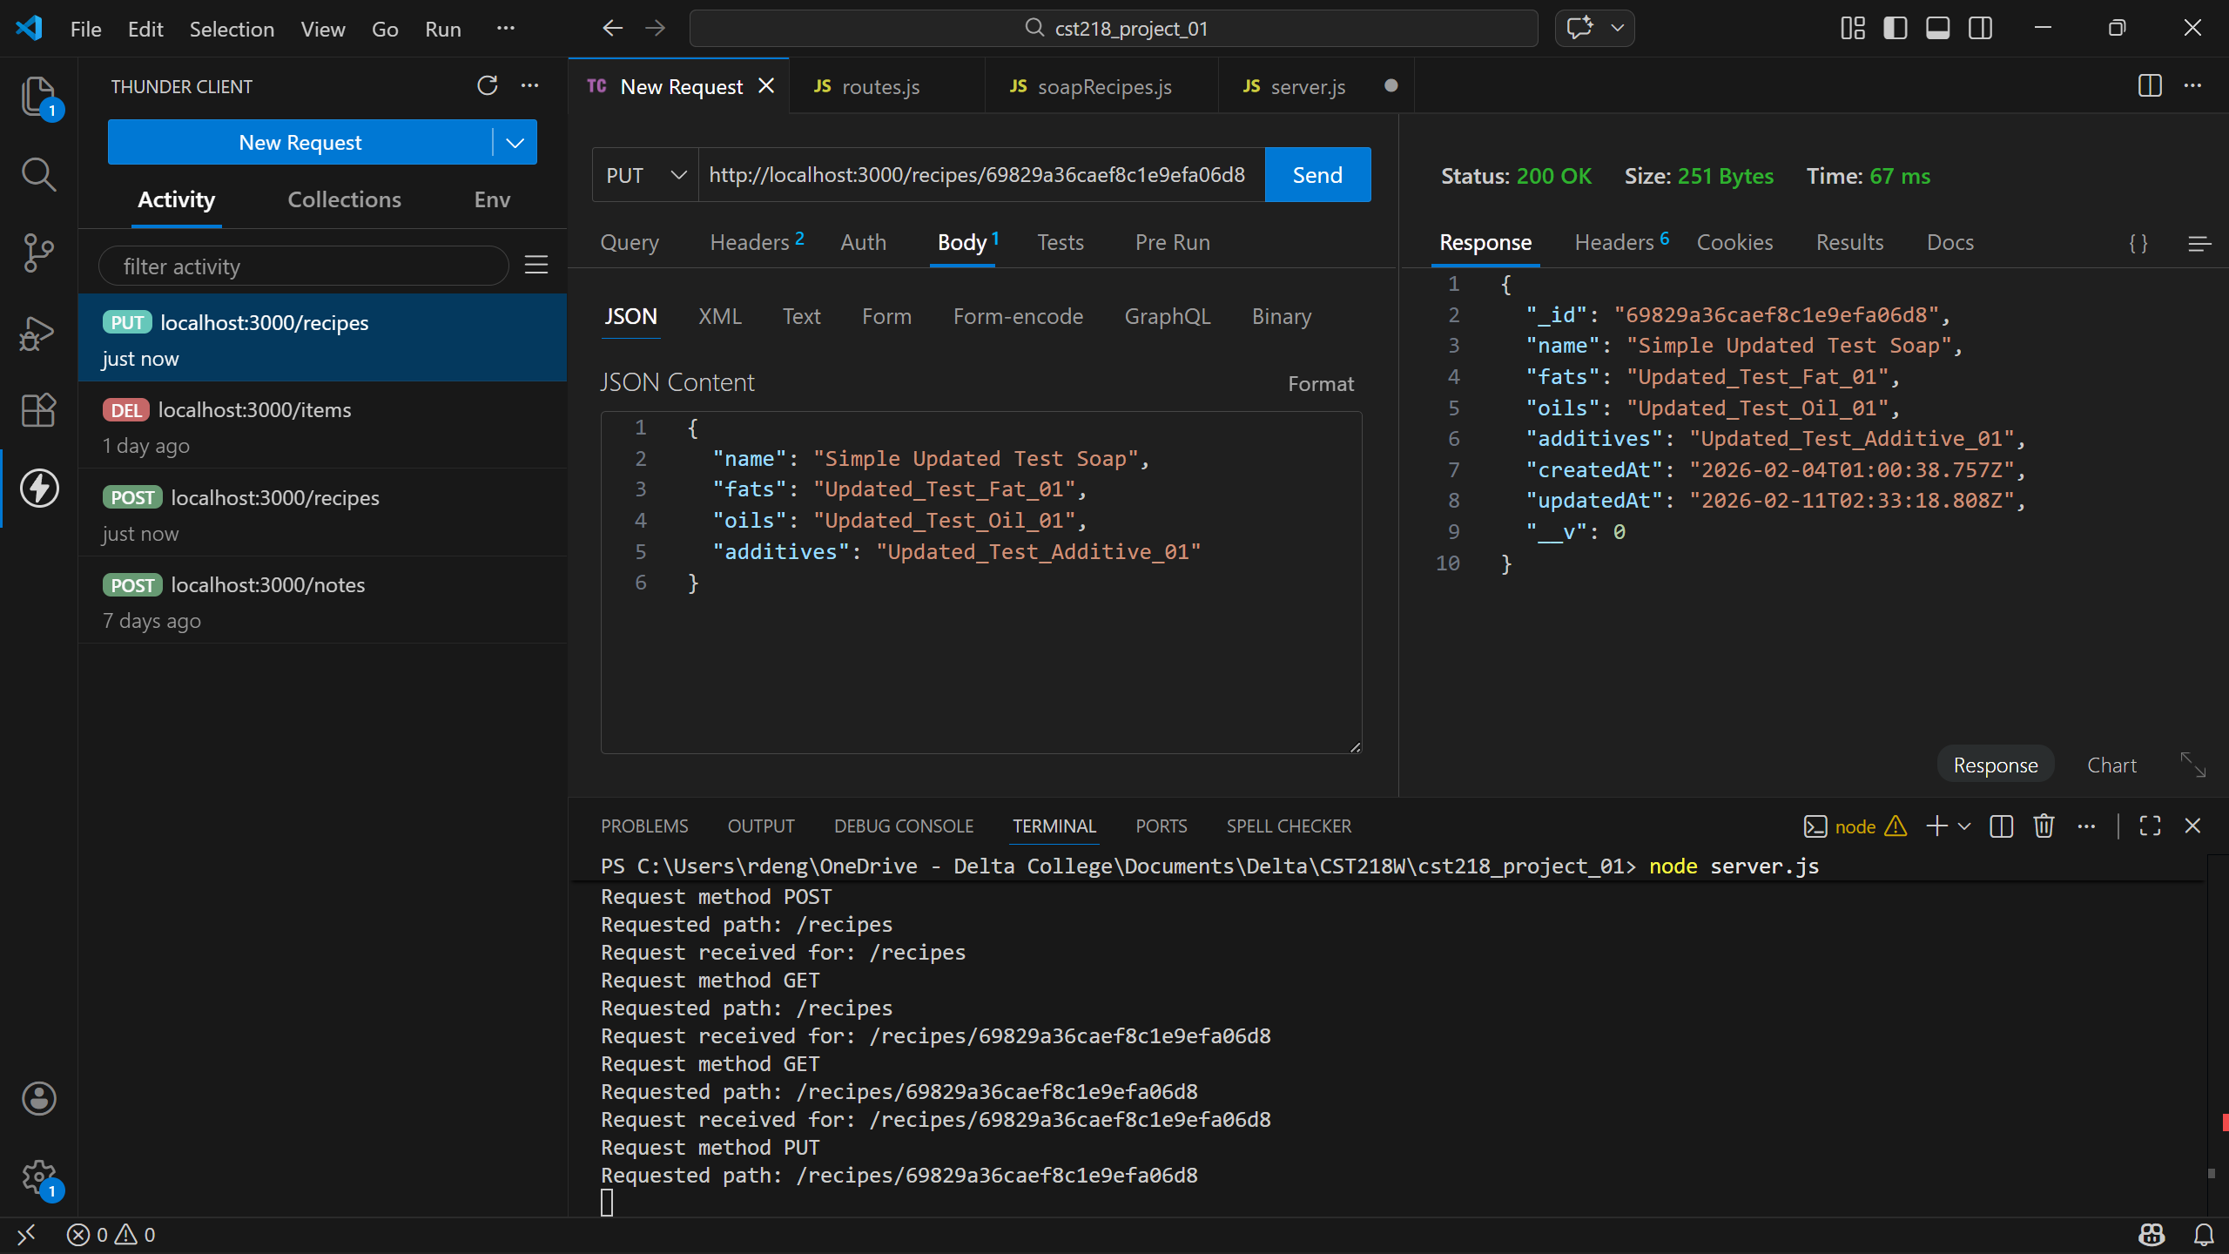
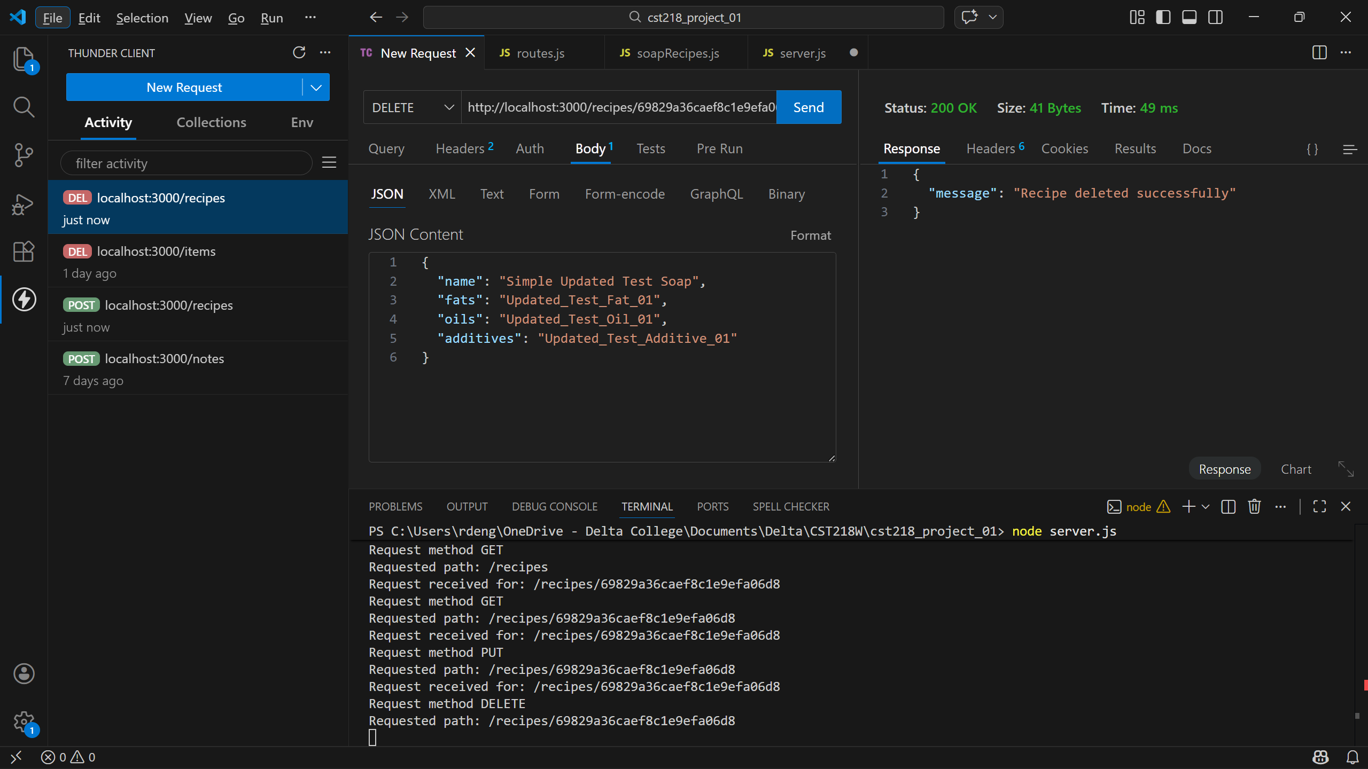

The ability to run CRUD operations on the database definitely makes this project feel more real in the sense of usability and possibilities.
I’d say the challenge that slowed me down the most was updating and improving the validation and error handling. I did some independent research into methods and techniques, and it took me some time to incorporate what I learned into my project.
I’m looking forward to building tools to utilize these CRUD operations within a GUI. I understand that may be outside the scope of this course, but it’s something I’m excited to dig into with the knowledge we’ve gained so far.

