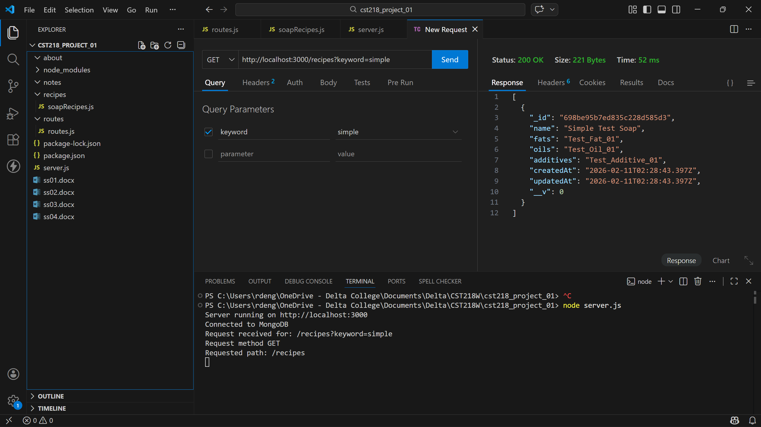

The improved file structure did the most to help make my app feel more professional. Researching how to implement various search filters slowed me down the most this week. I considered implementing others but decided to stick with only the keyword search this week to keep it clean and simple. I’m looking forward to getting to a point where we actually implement some sort of API and to see how that integrates with our app.

