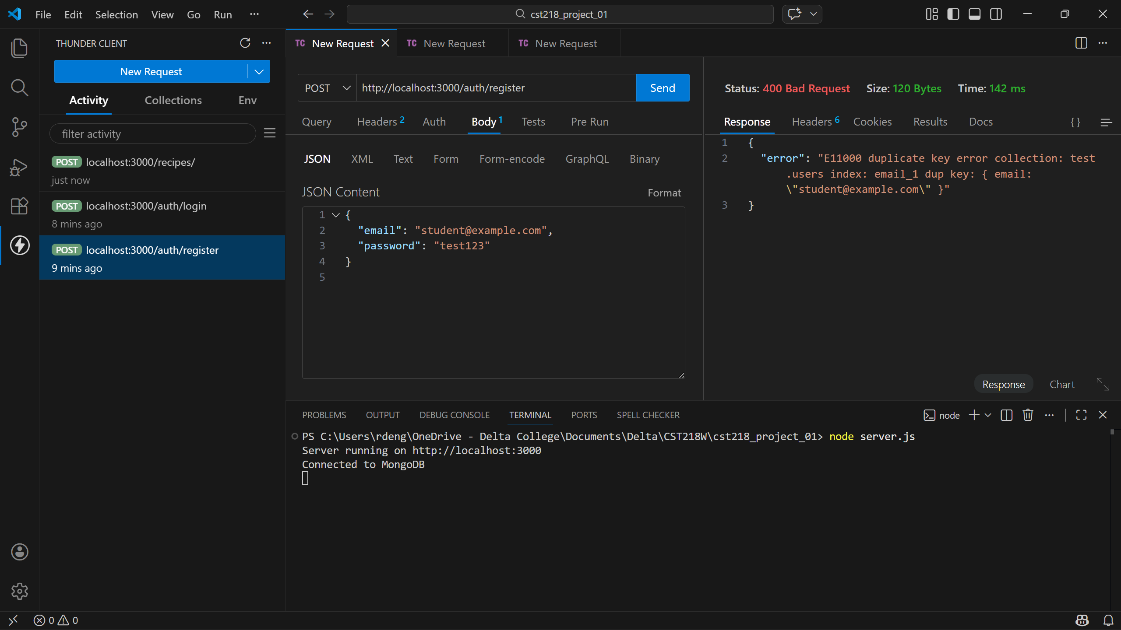
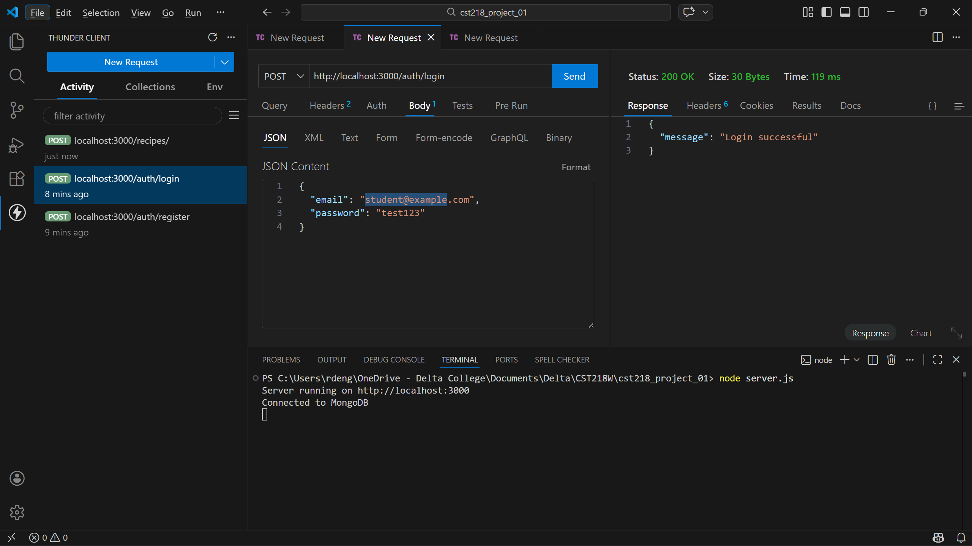
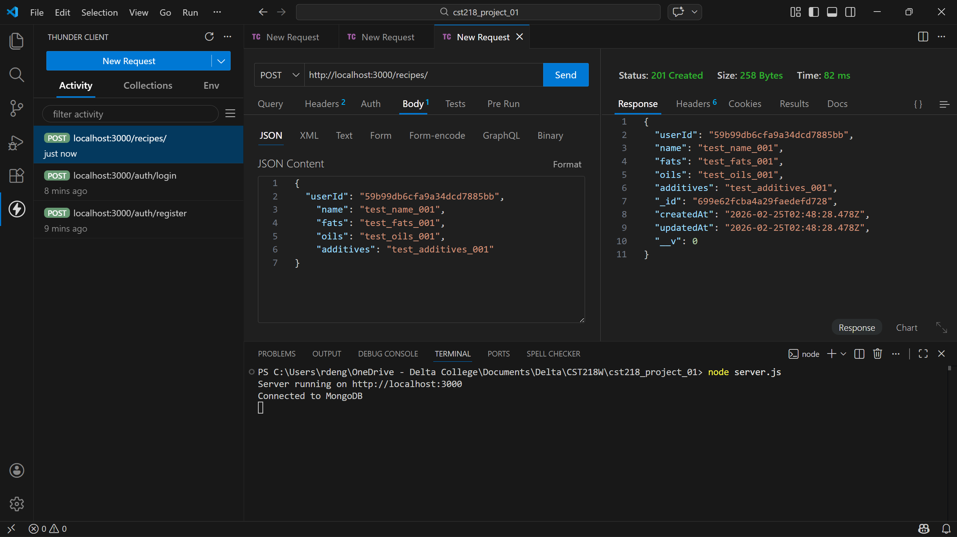

Adding user authentication and password hashing definitely made this project feel more like a real application.
The trickiest part was figuring out where the MongoDB userIDs were stored to utilize with the recipe GET request, though overall it wasn’t that bad.
After spring break I’m looking forward to refining user authentication and eventually exploring crafting a GUI to utilize with this app.

