User 1 POST login:
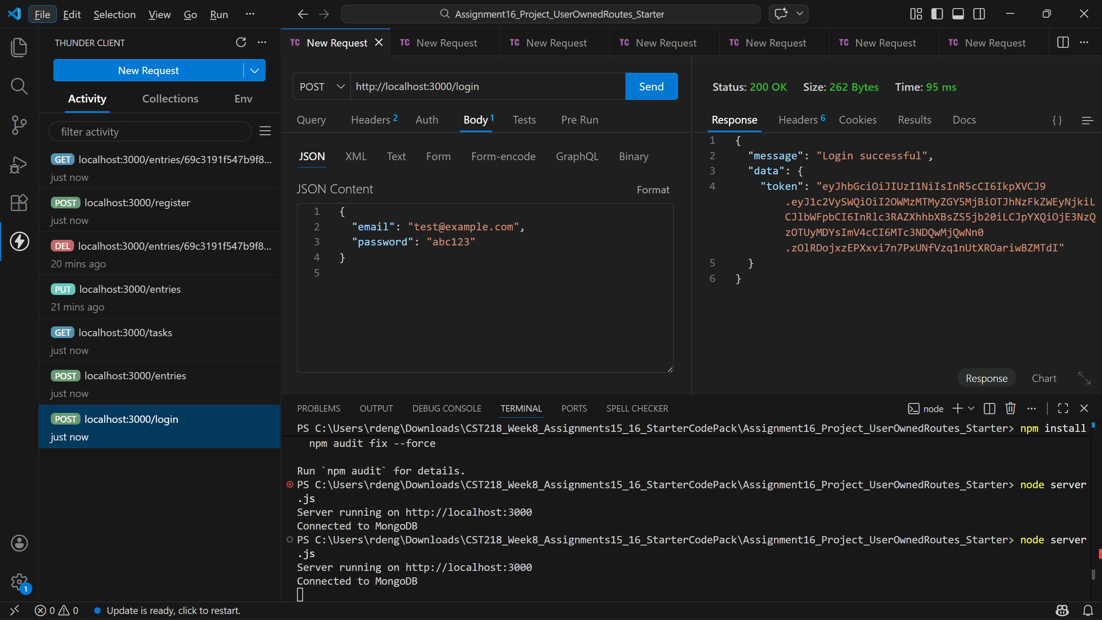
User 1 POST entries:
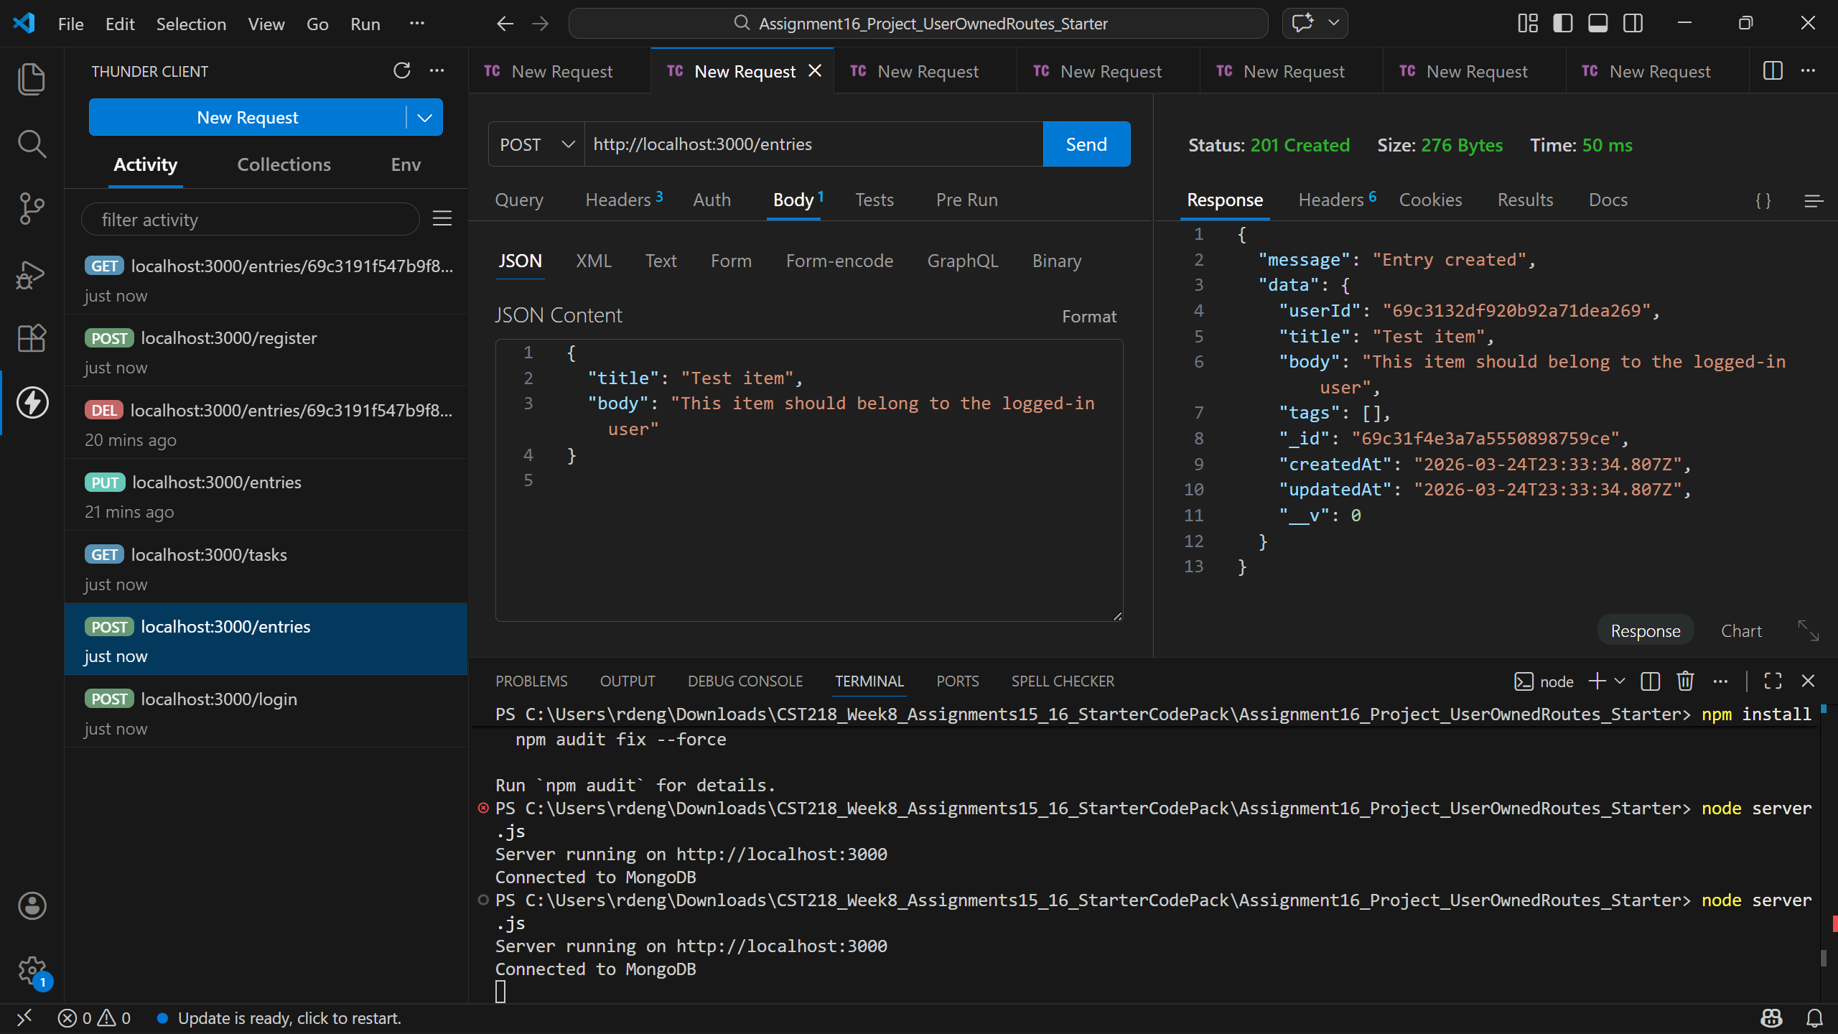
User 1 GET entries:
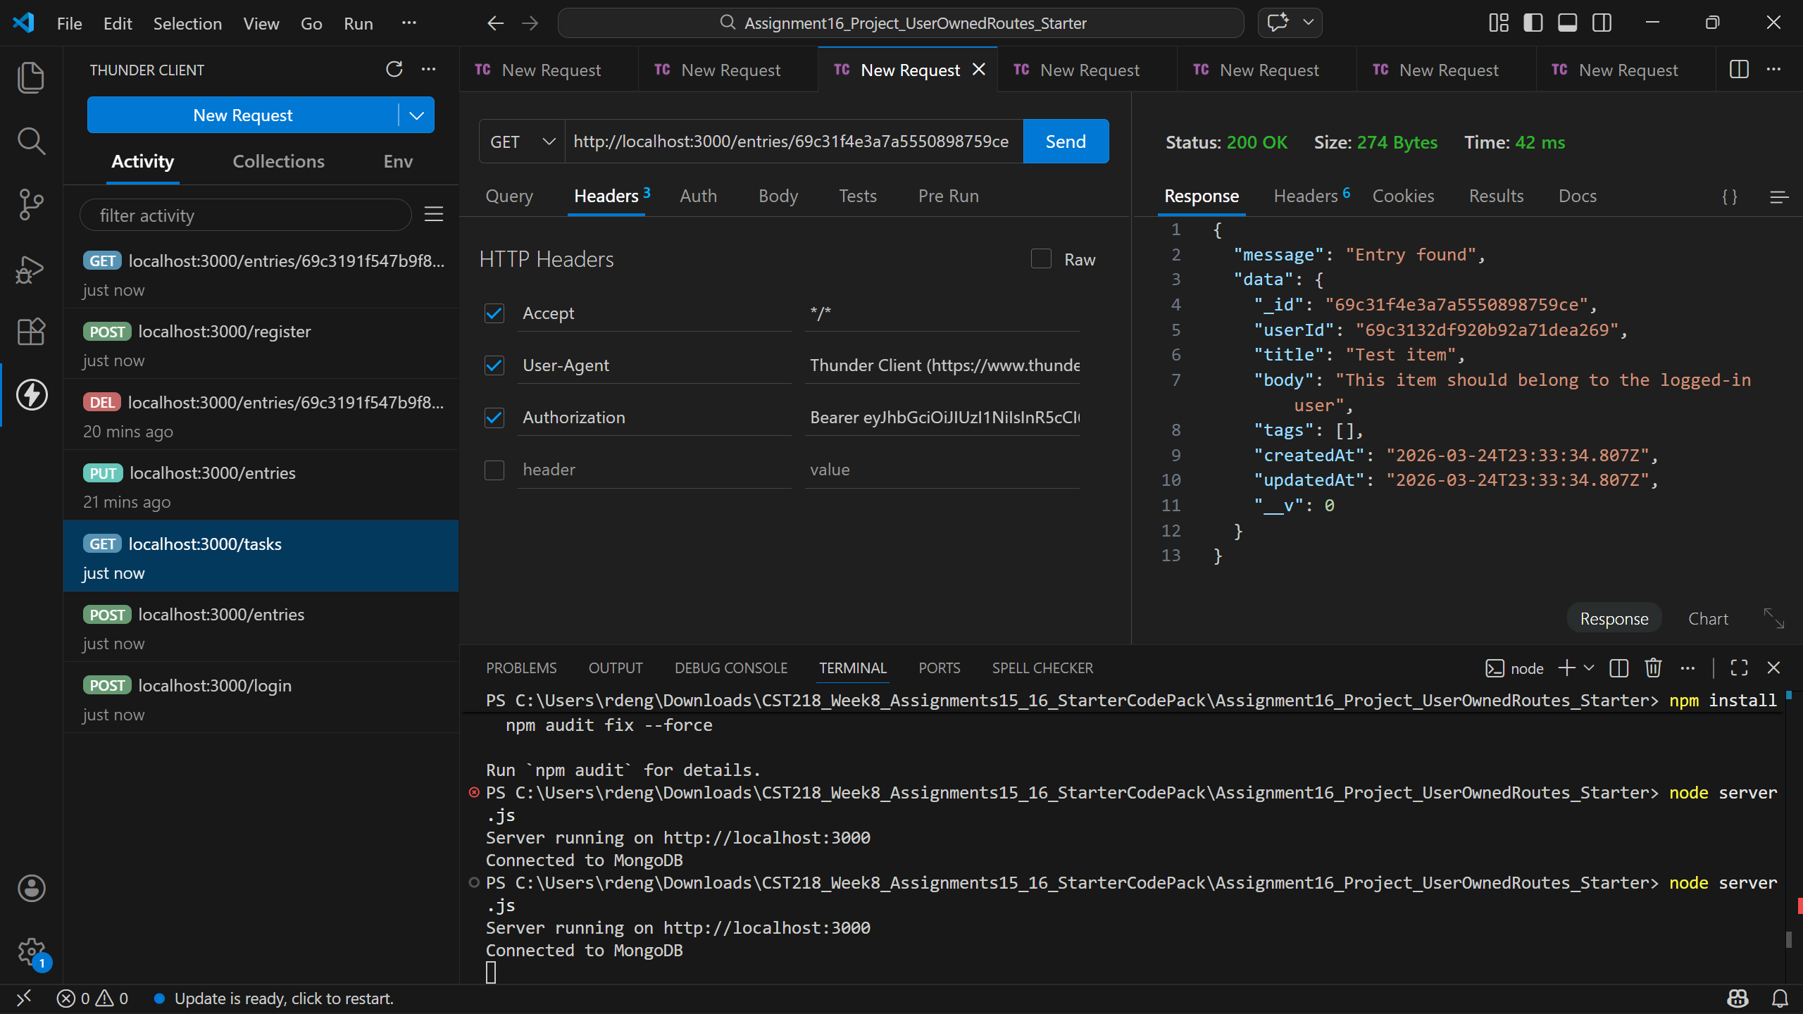
User 1 PUT entries:
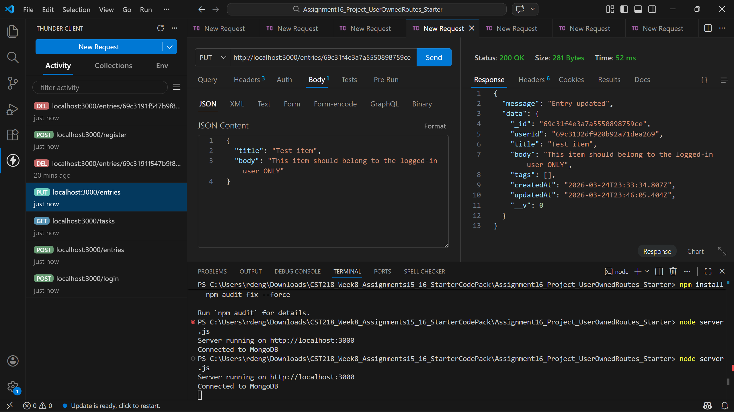
User 1 DEL entries:
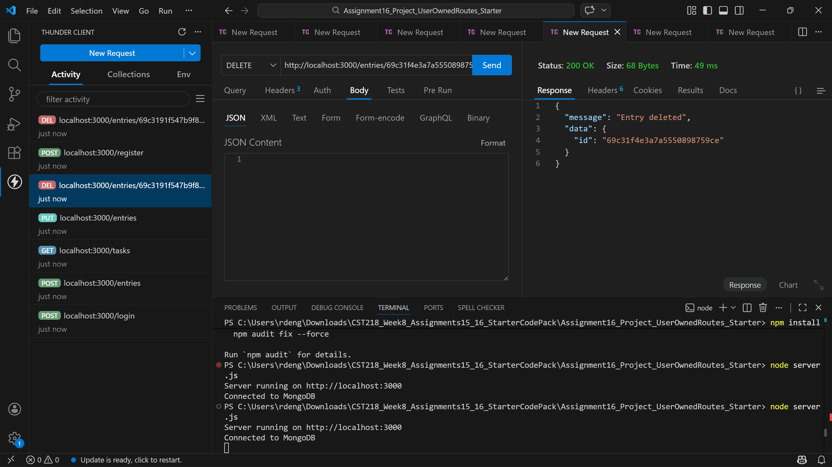
User 2 POST login:
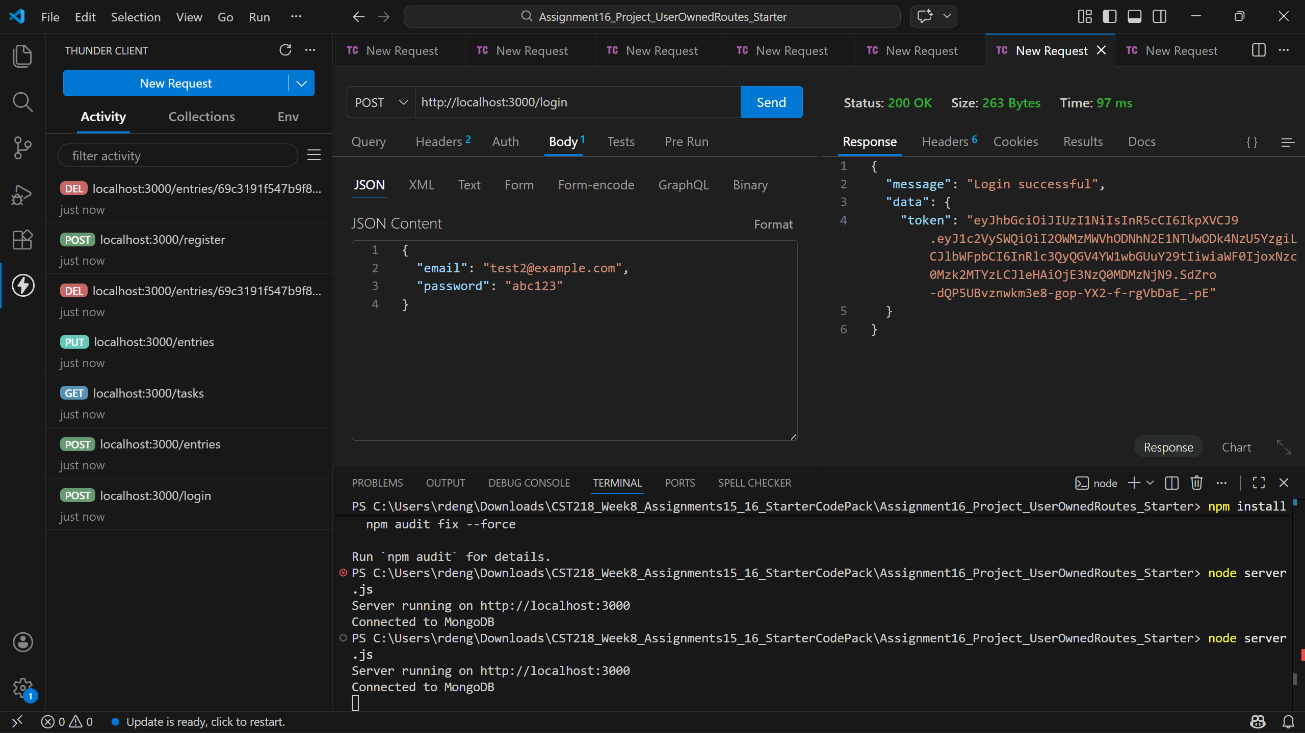
User 2 PUT User 1 POST entry:
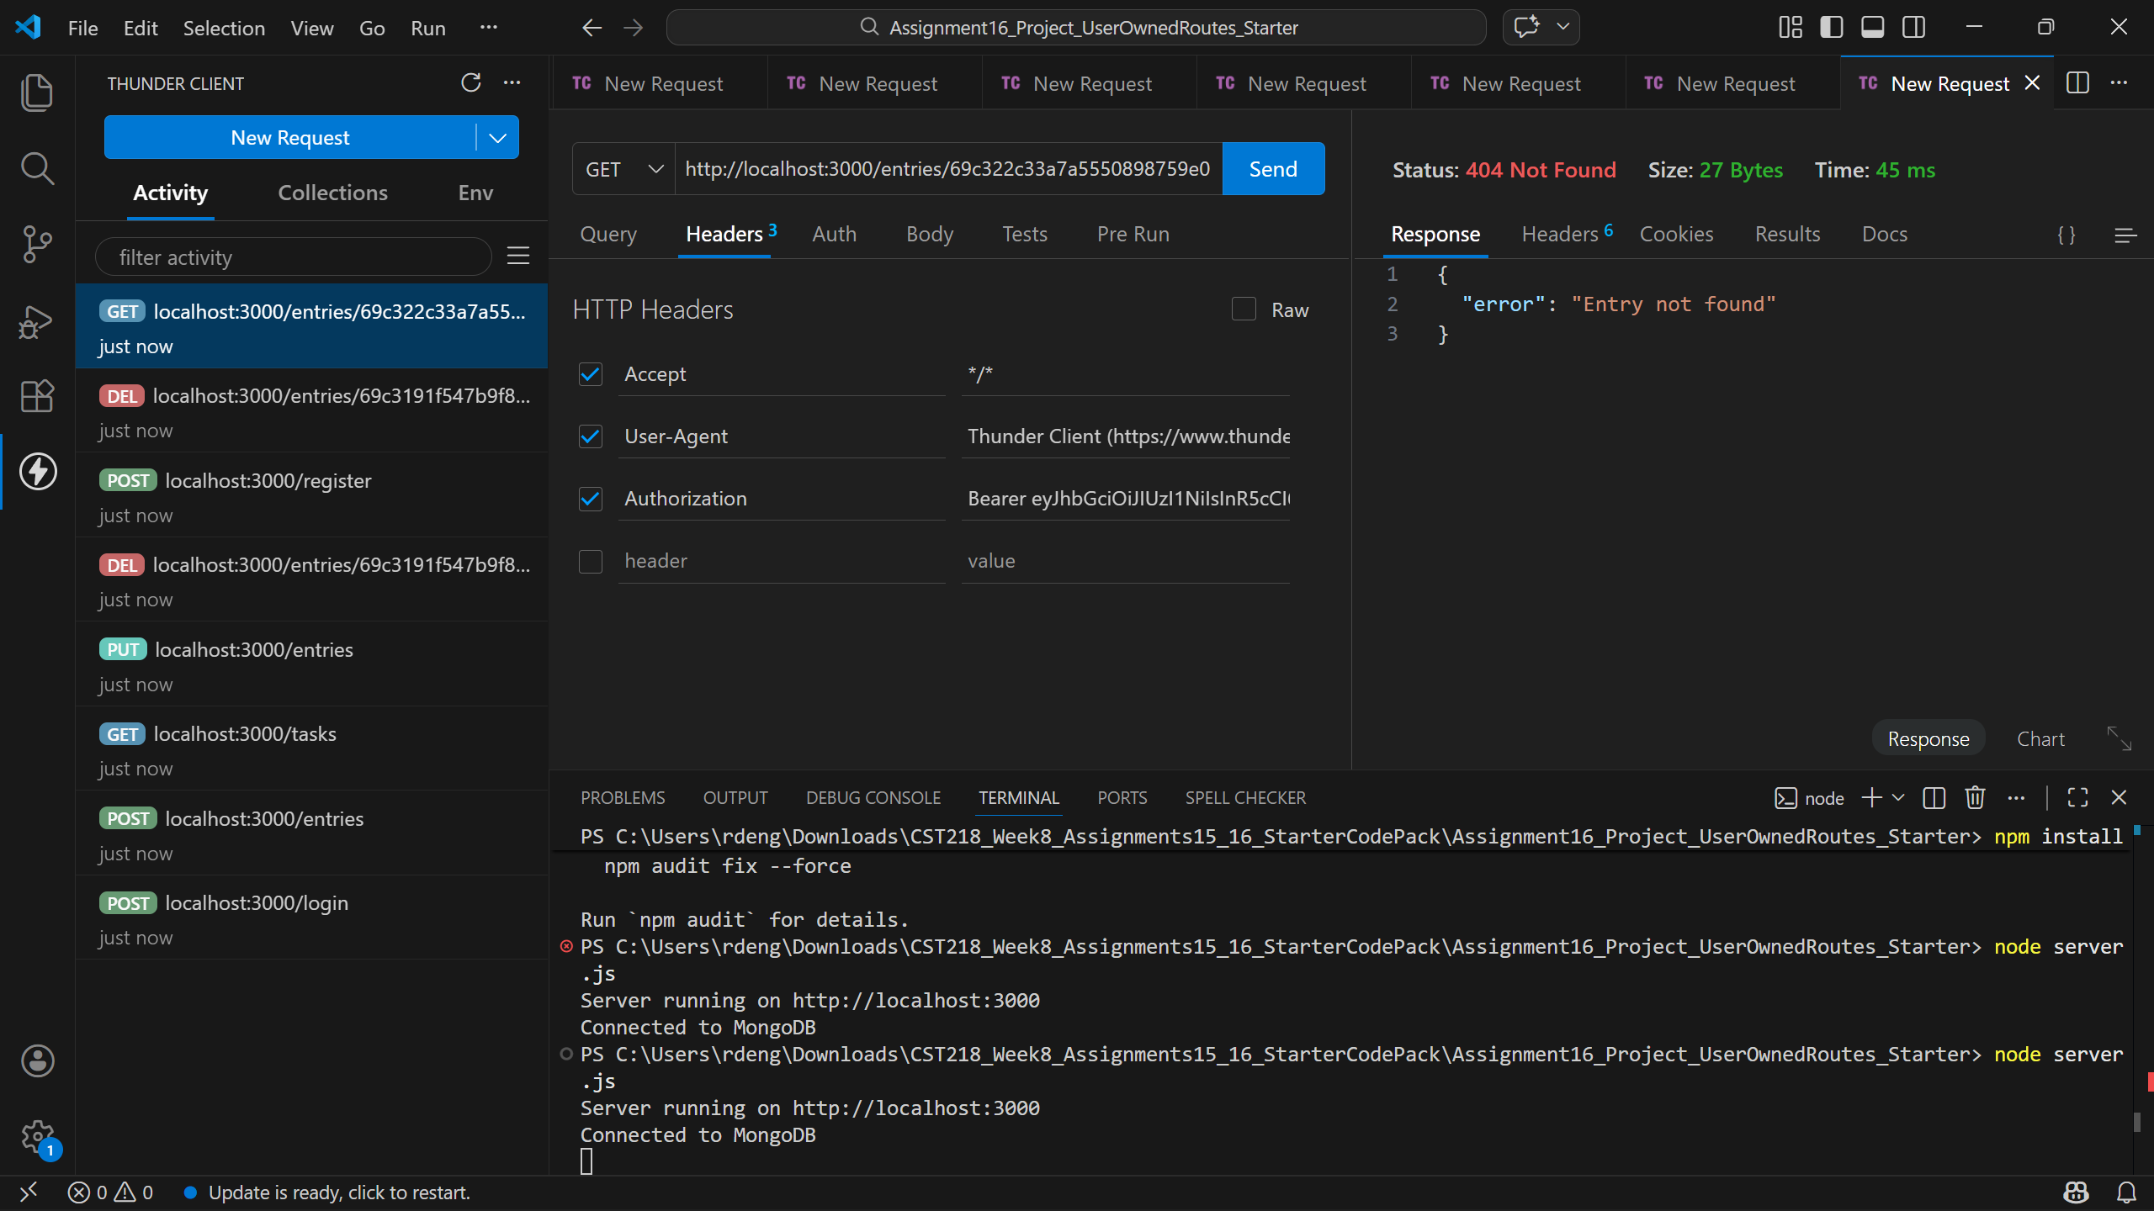

This week’s lesson was a big step forward in making our project app feel like a true app. Now that all CRUD operations are tied to user account, it gives users agency over their interactions with the app.
I’m looking forward to expanding my knowledge of enforced ownership and exploring how accounts can interact, such as through messaging or other features.

