Login success (token returned)
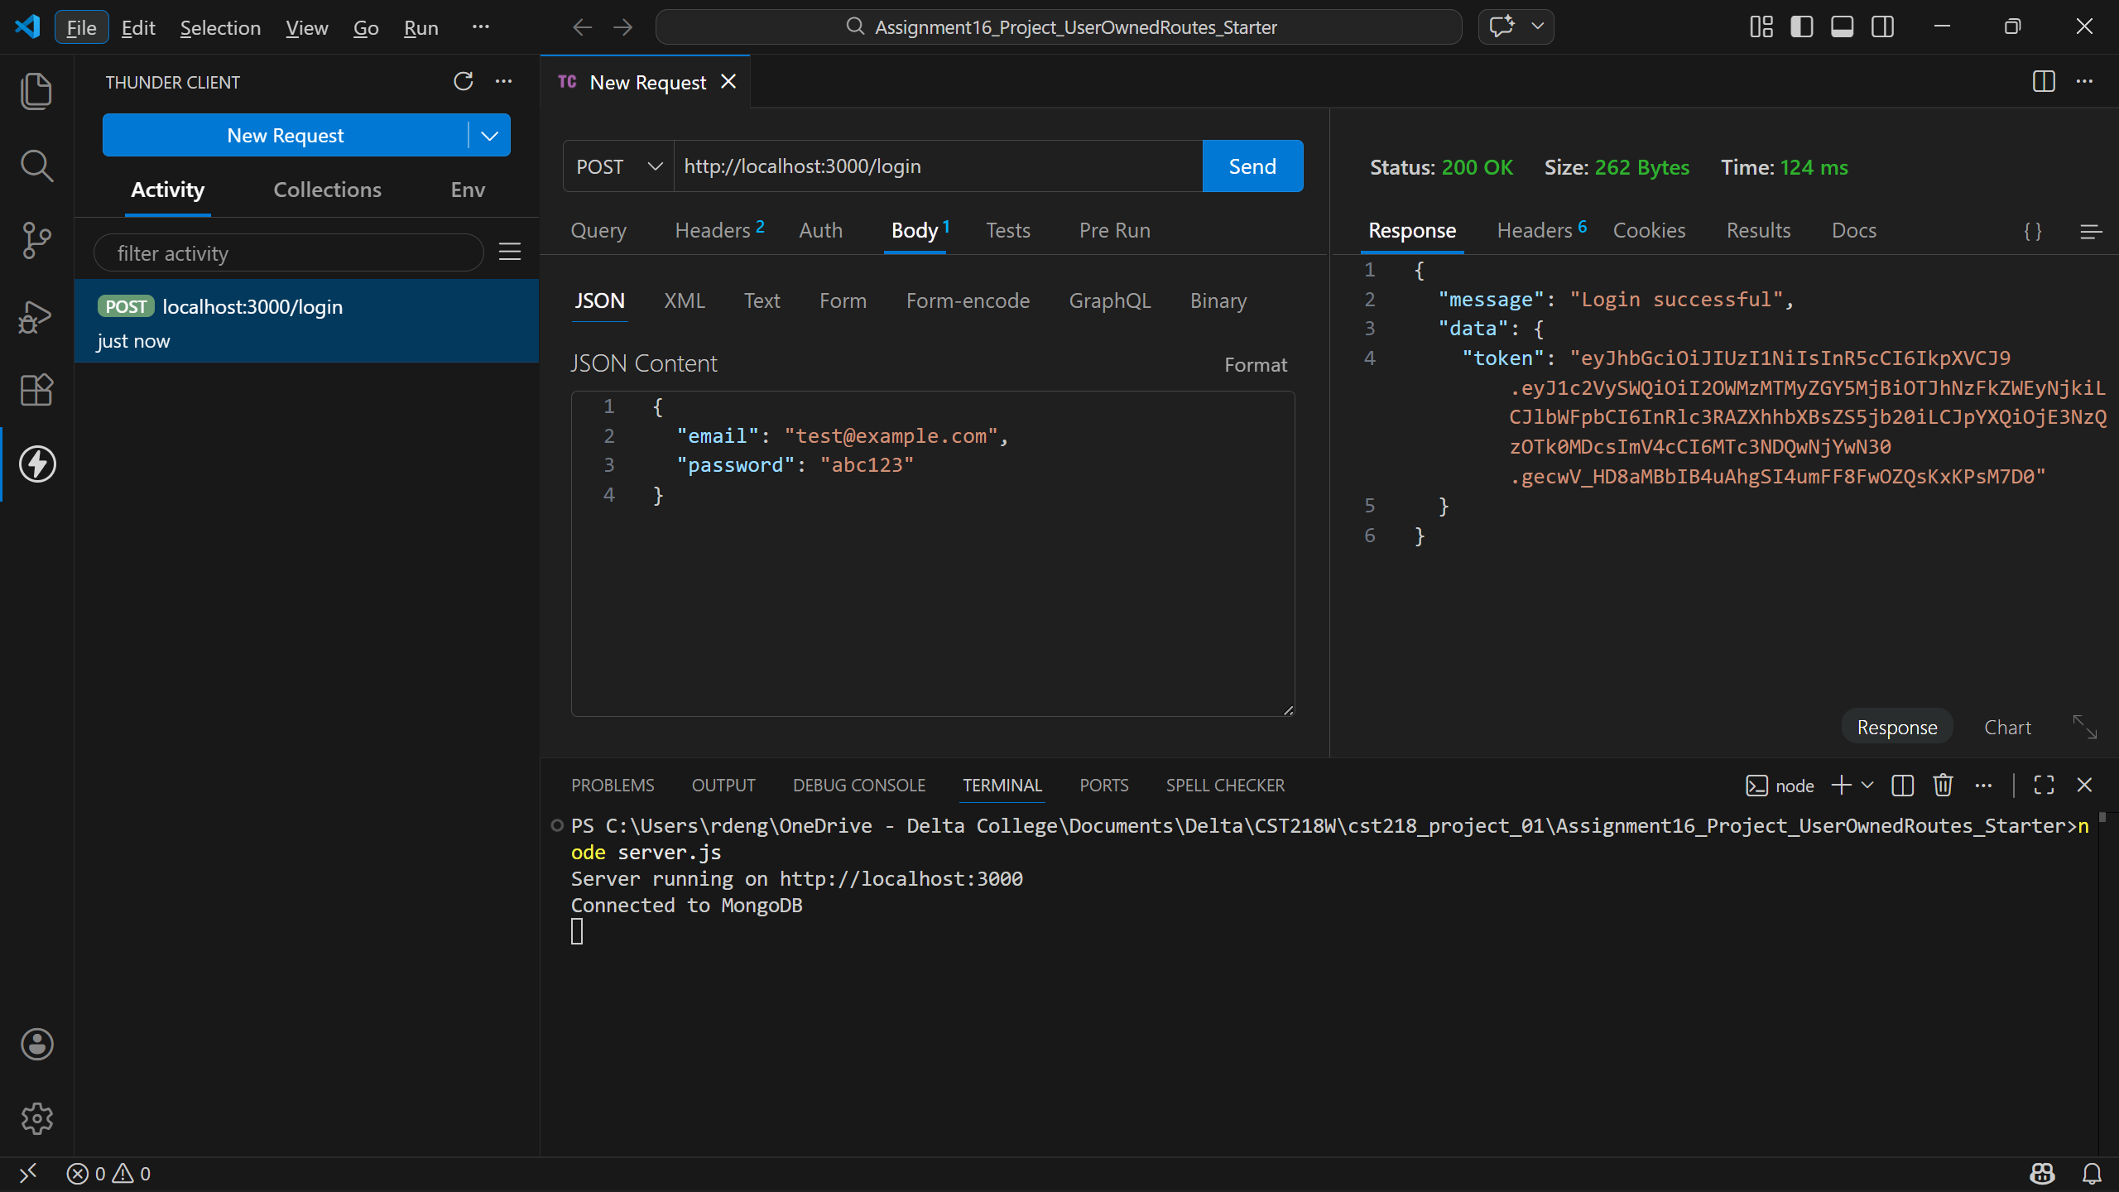
Create success (201)
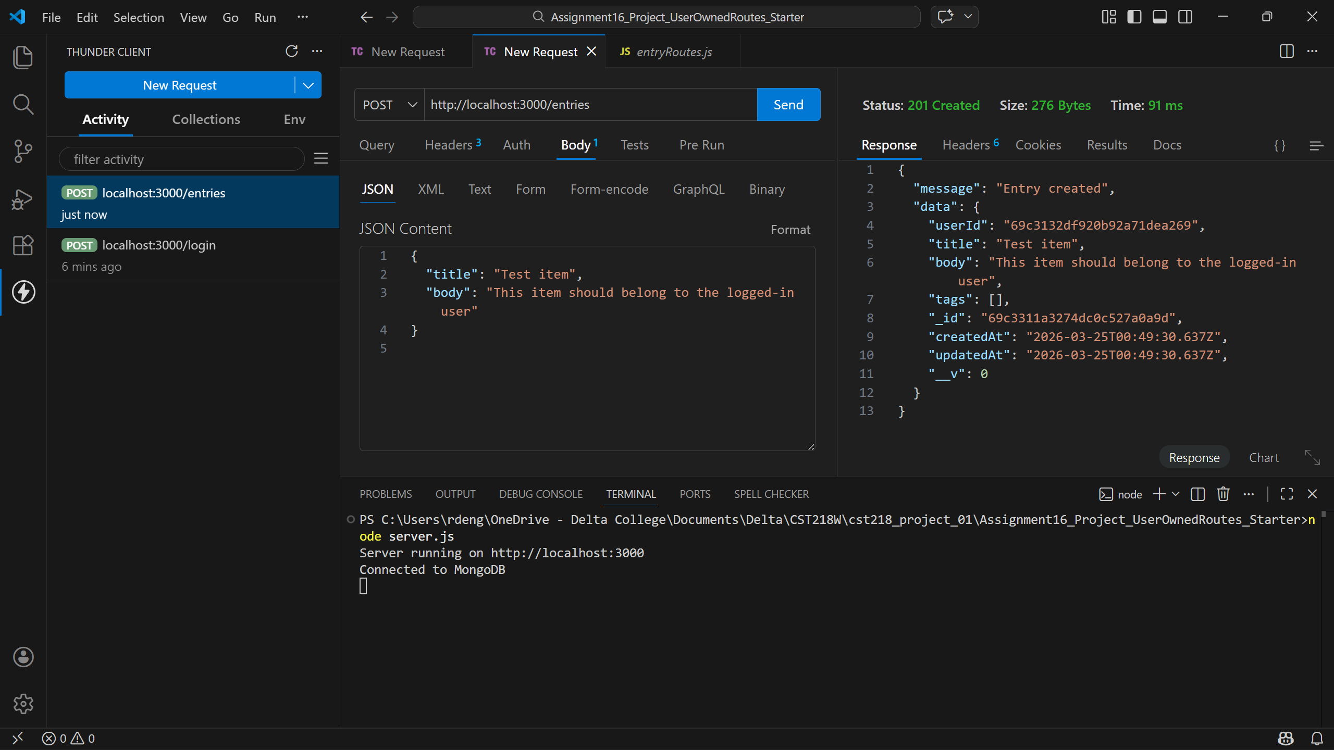
Get all success (200)
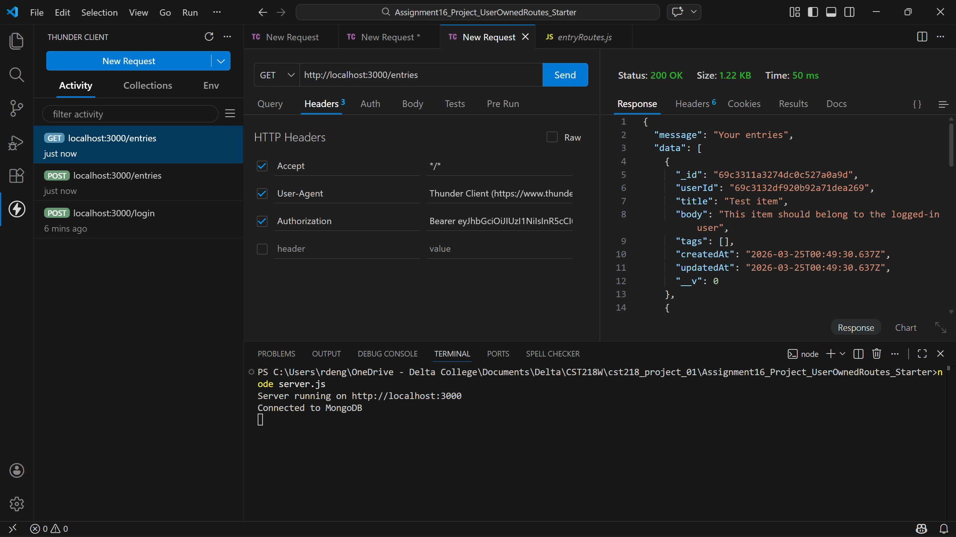
Update success (200)
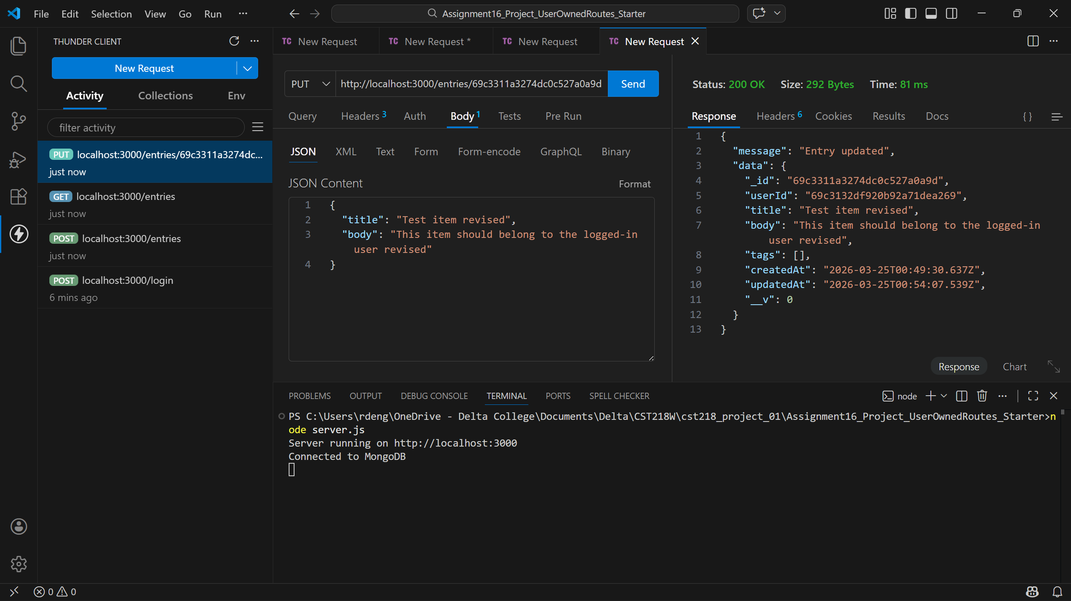
Delete success (200)
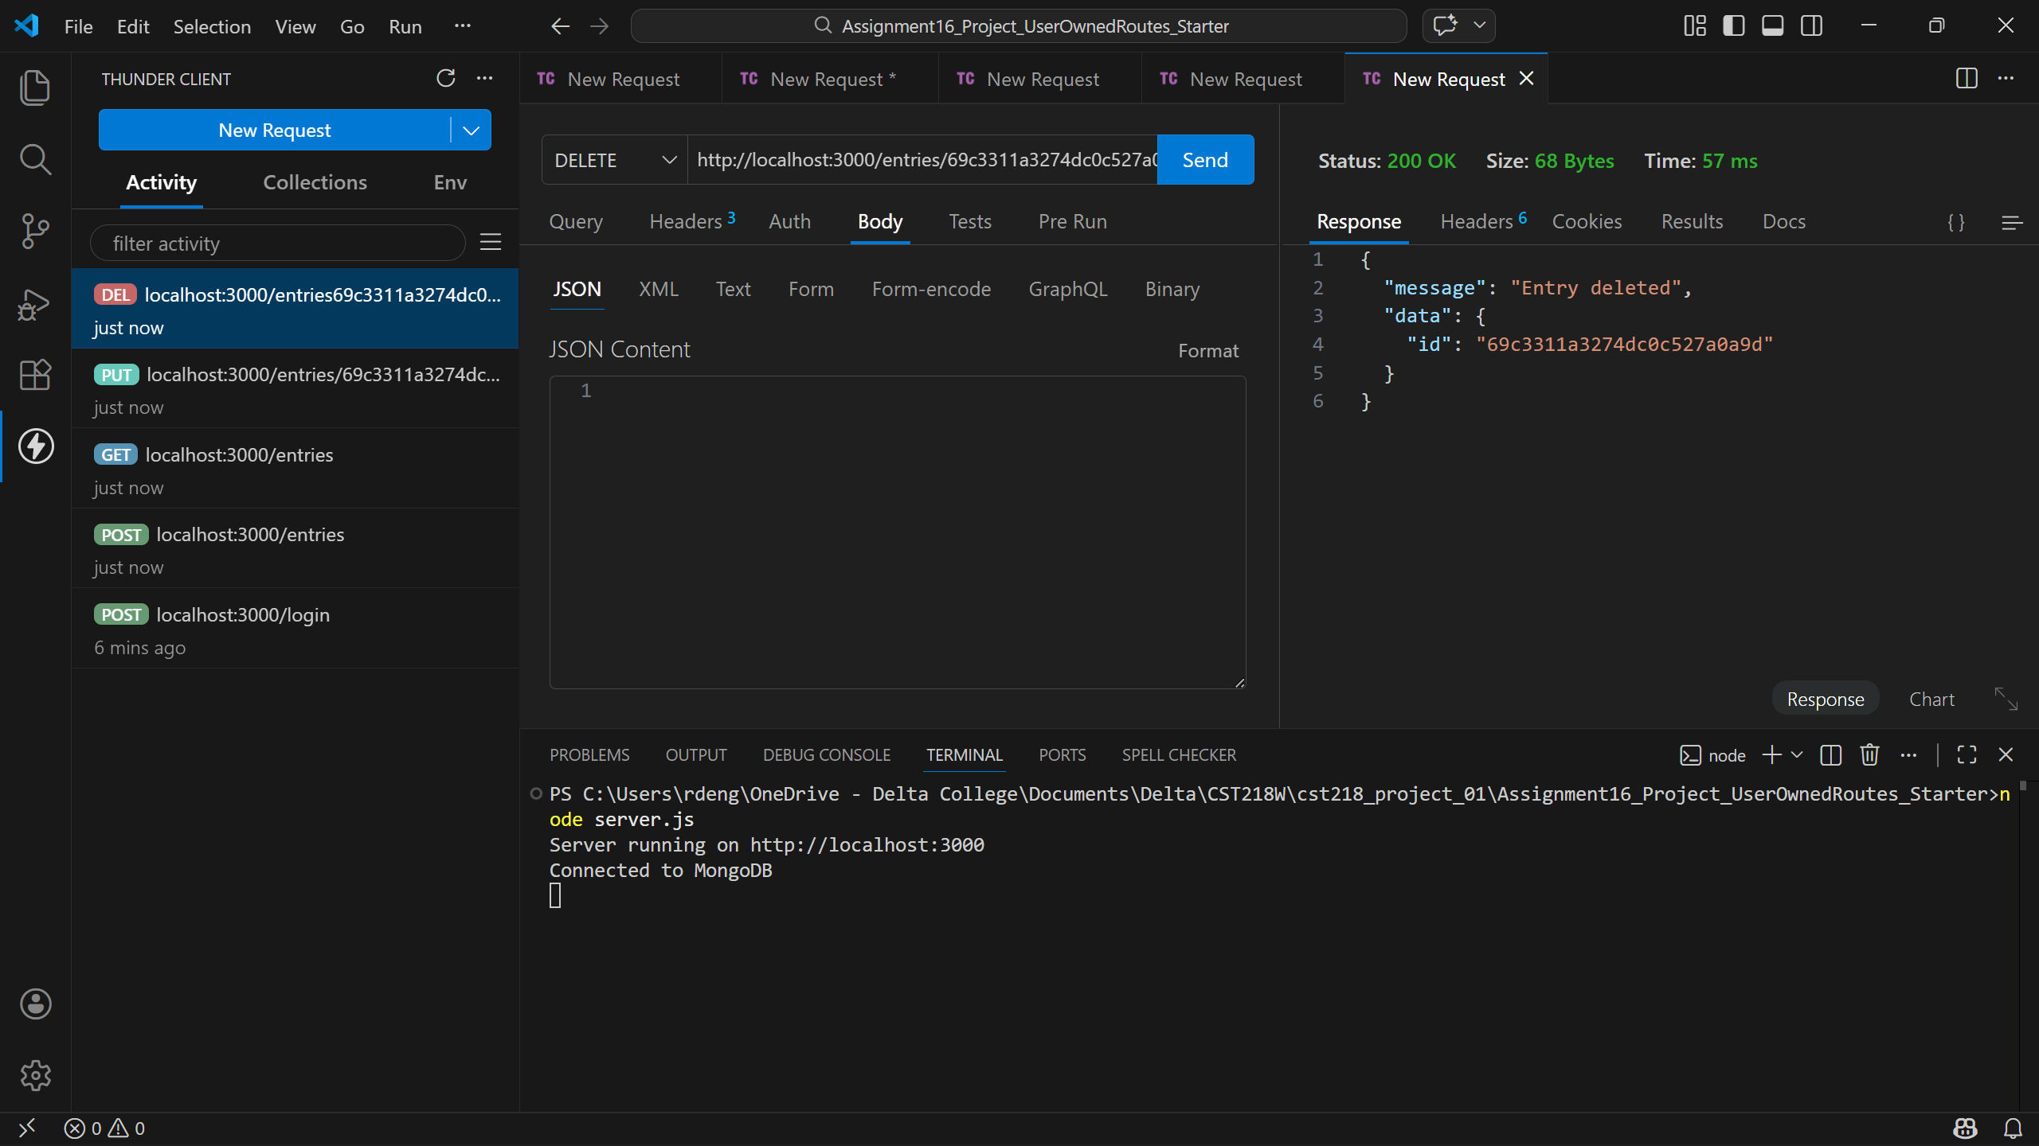
Validation Failure (400)
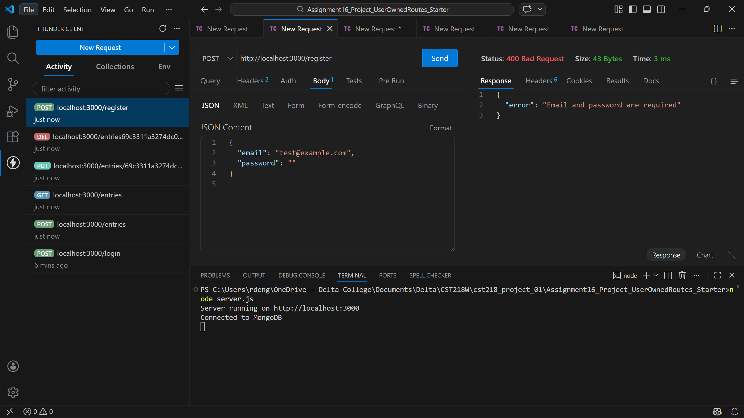
Not found (404)
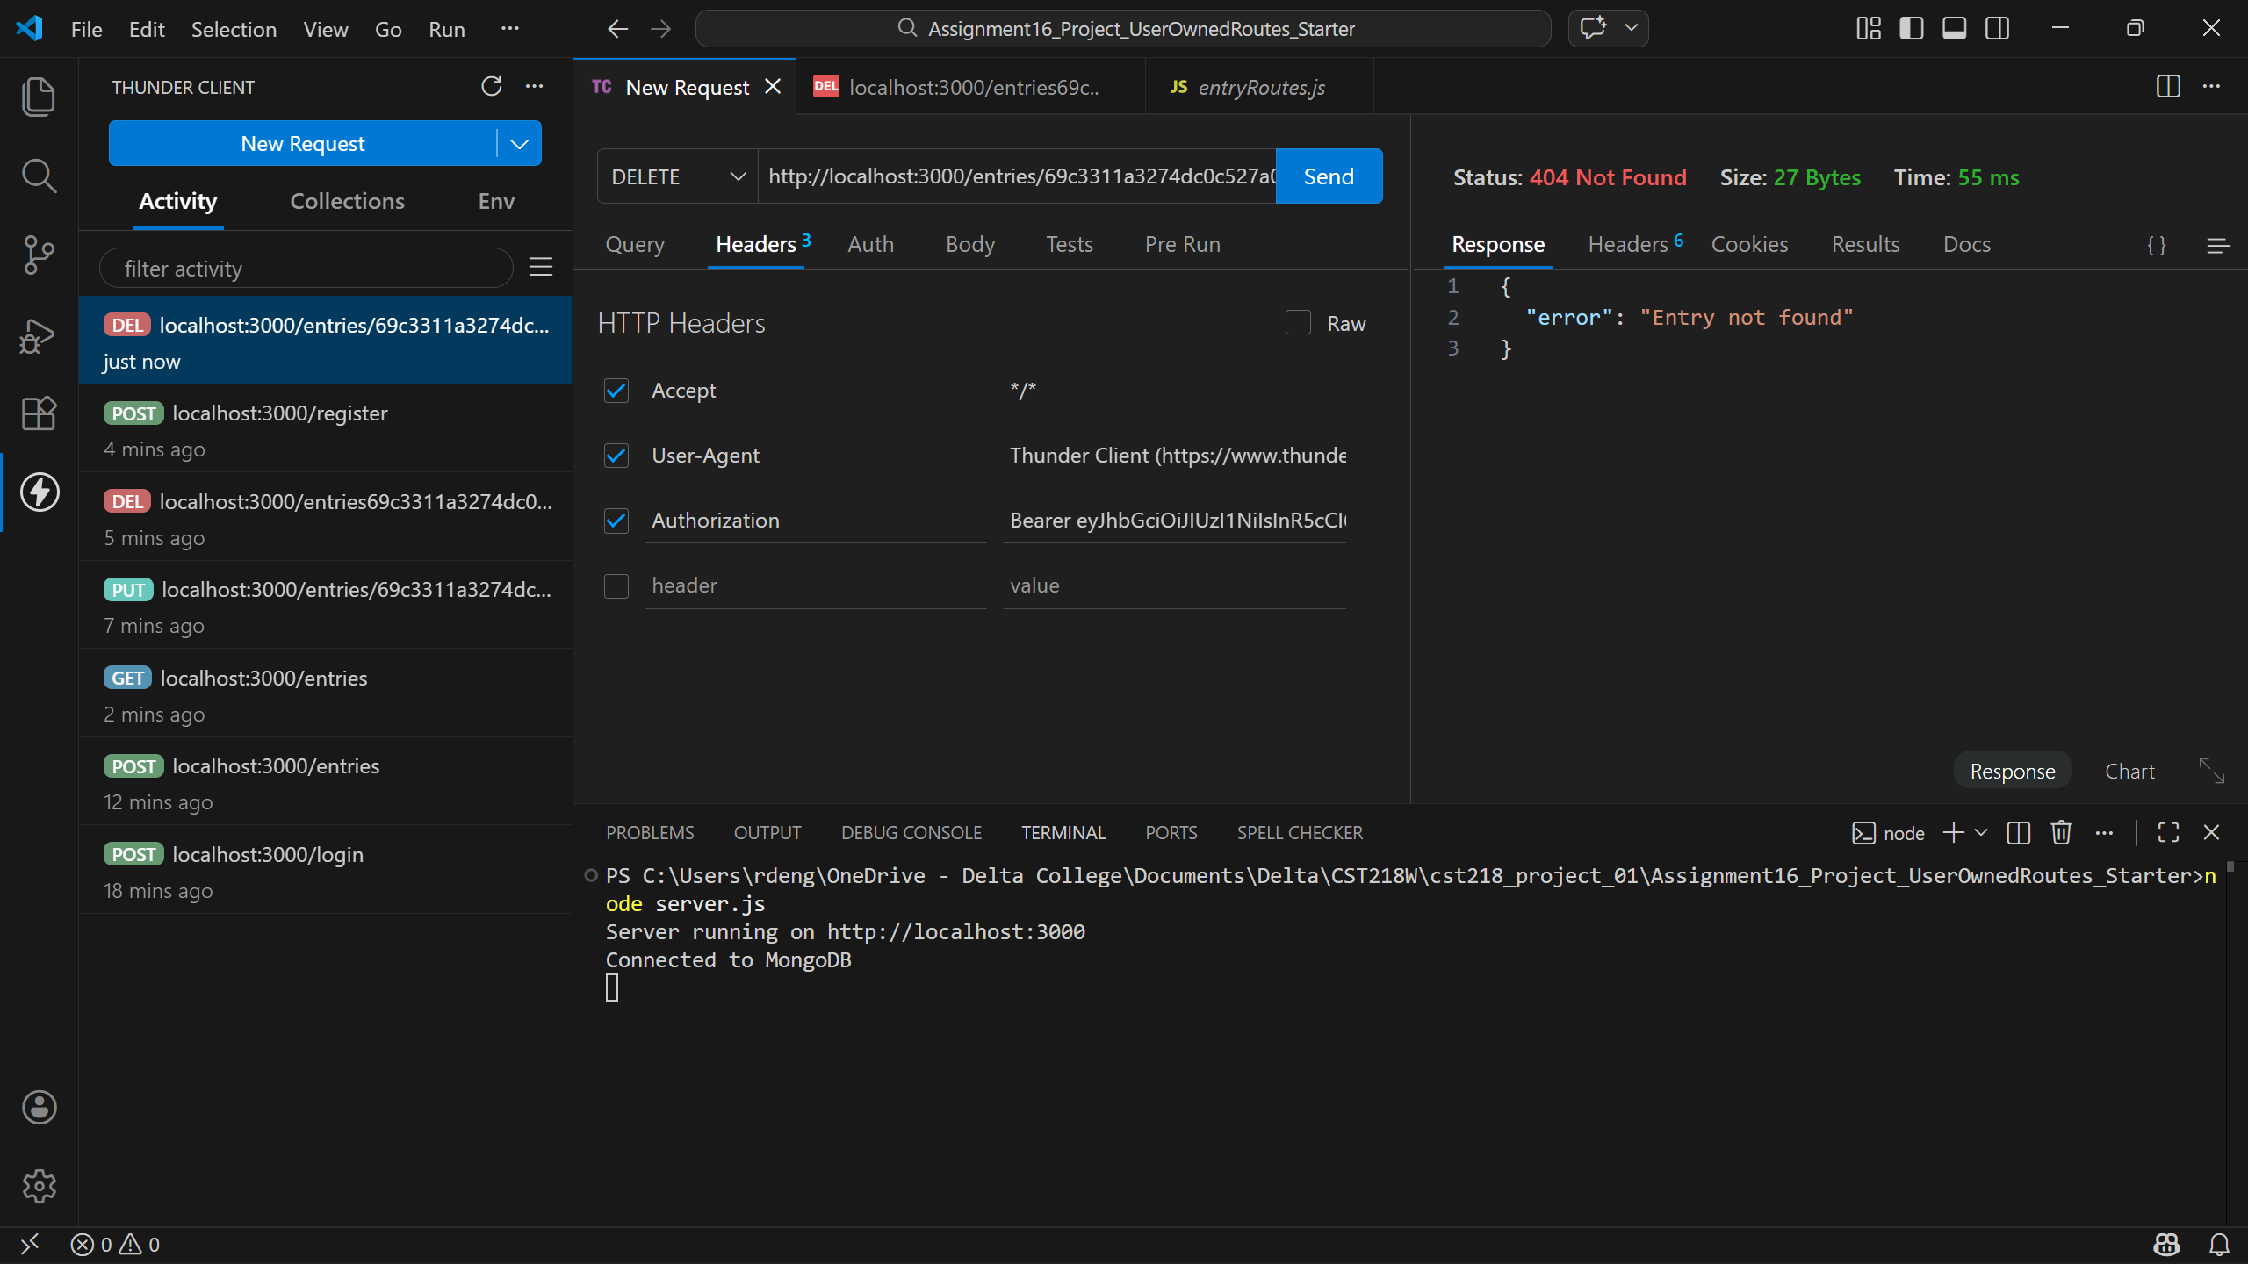

Definitely refining the status codes to more specifically highlight issues made this project feel more professional. I feel like I handled missing token error cases better after having some practice with them. I’m looking forward to improving interactions between user accounts to learn about things like messaging systems.

